Assignment 1 - SRT411

Thomas Reid Zuk

2016-01-28

#### TODO #1

((2014-2014)/(2014-1991))*100

## [1] 0

#### TODO #2

startDiff = 2014 - 2014  
birthDiff = 2014 - 1991  
  
decPer = startDiff/birthDiff  
  
per = decPer * 100   
per

## [1] 0

#### TODO #3

nums = c(4,5,8,11)  
sum(nums)

## [1] 28

#### TODO #4

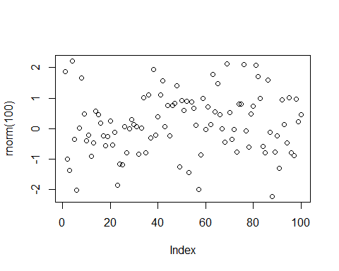

#### TODO #5

help (sqrt)

#### TODO #6

source("firstScript.R")

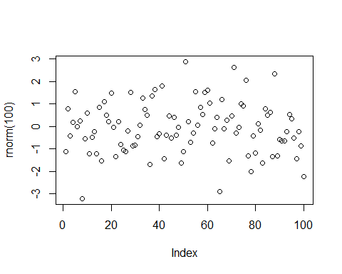

#### TODO #7

P = seq(from=31, to=60, by=1)  
Q = matrix(data=P, ncol=5)  
P

## [1] 31 32 33 34 35 36 37 38 39 40 41 42 43 44 45 46 47 48 49 50 51 52 53  
## [24] 54 55 56 57 58 59 60

Q

## [,1] [,2] [,3] [,4] [,5]  
## [1,] 31 37 43 49 55  
## [2,] 32 38 44 50 56  
## [3,] 33 39 45 51 57  
## [4,] 34 40 46 52 58  
## [5,] 35 41 47 53 59  
## [6,] 36 42 48 54 60

#### TODO #8

source("secondScript.R")

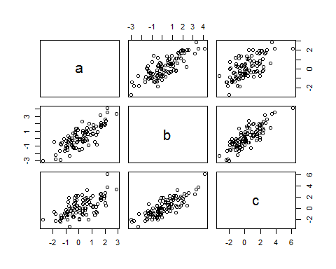

#### TODO #9

source("secondScriptV2.R")

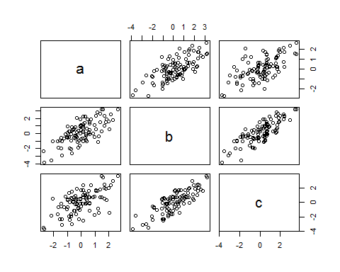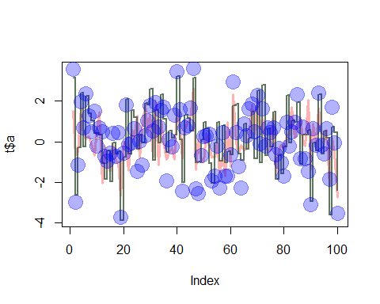

* rgb is a function that sets colour based on RGB values and transparency based on alpha
* lwd is the line width, default value of 1 if not specified
* pch a integer or character that draws a sequence of points at the specified coordinates
* cex number value that specifies the magnification (size) or elements like text or symbols

#### TODO #10

data = read.table(file="tst1.txt", header=TRUE)  
newData = data$g*5  
write.table(newData, file="tst2.txt", row.names=FALSE)  
read.table(file="tst2.txt")

## V1  
## 1 x  
## 2 10  
## 3 20  
## 4 40  
## 5 80  
## 6 160  
## 7 320

#### TODO #11

vec = c(rnorm(100))  
mean(sqrt(vec))

## Warning in sqrt(vec): NaNs produced

## [1] NaN

-- NaN's produced because the square root of a negative integer is an imaginary number,which for the purpose of this demonstration and simplicity does not exist.

#### TODO #12

dates = strptime(c("20160123", "20161225", "20161206"), format="%Y%m%d")  
pres = c(1,8,10)  
plot(dates,pres, xlab="Dates", ylab="Expected Presents")

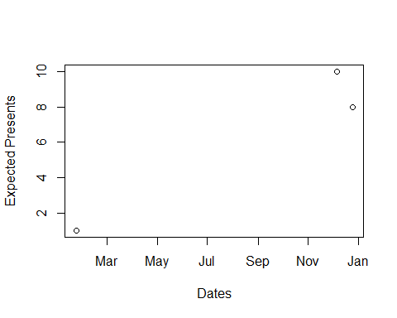

#### TODO #13

loopVec = seq(1:100)  
newVec = c()  
for(i in loopVec){  
 if(i<5 || i>90){  
 newVec[i]=loopVec[i]*10  
 }else{  
 newVec[i]=loopVec[i]*0.1  
 }  
}  
print(newVec)

## [1] 10.0 20.0 30.0 40.0 0.5 0.6 0.7 0.8 0.9 1.0  
## [11] 1.1 1.2 1.3 1.4 1.5 1.6 1.7 1.8 1.9 2.0  
## [21] 2.1 2.2 2.3 2.4 2.5 2.6 2.7 2.8 2.9 3.0  
## [31] 3.1 3.2 3.3 3.4 3.5 3.6 3.7 3.8 3.9 4.0  
## [41] 4.1 4.2 4.3 4.4 4.5 4.6 4.7 4.8 4.9 5.0  
## [51] 5.1 5.2 5.3 5.4 5.5 5.6 5.7 5.8 5.9 6.0  
## [61] 6.1 6.2 6.3 6.4 6.5 6.6 6.7 6.8 6.9 7.0  
## [71] 7.1 7.2 7.3 7.4 7.5 7.6 7.7 7.8 7.9 8.0  
## [81] 8.1 8.2 8.3 8.4 8.5 8.6 8.7 8.8 8.9 9.0  
## [91] 910.0 920.0 930.0 940.0 950.0 960.0 970.0 980.0 990.0 1000.0

#### TODO #14

func1 = function(arg1){  
 resVec = c()  
 for(i in 1:length(arg1)){  
 if(i<5 || i>90){  
 resVec[i]=arg1[i]*10  
 }else{  
 resVec[i]=arg1[i]*0.1  
 }  
 }  
 return(resVec)  
}  
  
vec14a = c(0,1,2,3,5,10,25,30,99,150)  
func1(vec14a)

## [1] 0.0 10.0 20.0 30.0 0.5 1.0 2.5 3.0 9.9 15.0

#### TODO #15/Footnote challenge

vect1 = c(-2,-3,-1,0,1,2,3,5,5,7,10,25,30,50,70,80,99,101,110,150,200)  
  
func2 = function(arg1){  
 result <- ifelse(arg1 < 5 | arg1 > 90, arg1 * 10, arg1 * 0.1)  
 return(result)  
}  
vect2 = func2(vect1)  
vect2

## [1] -20.0 -30.0 -10.0 0.0 10.0 20.0 30.0 0.5 0.5 0.7  
## [11] 1.0 2.5 3.0 5.0 7.0 8.0 990.0 1010.0 1100.0 1500.0  
## [21] 2000.0

### Sources:

<https://cran.r-project.org/doc/contrib/Torfs+Brauer-Short-R-Intro.pdf>

<http://rmarkdown.rstudio.com/>

<http://kbroman.org/knitr_knutshell/pages/markdown.html>

<https://www.rstudio.com/wp-content/uploads/2015/02/rmarkdown-cheatsheet.pdf>

<http://www.r-bloggers.com/using-apply-sapply-lapply-in-r/>