# TowerDefense

## Statistics of efforts:

### Hours per person and major contributions:

* Team: Project Management, Bugfixing
* Johannes: Waypoints, Health System, Tower menu
* Lukas: Drag-And-Drop, QA, UI Management
* Nico: Design, Testing
* Paul: Financial System, UI Management, Waves
* Tim: Tower, Start menu, Target System

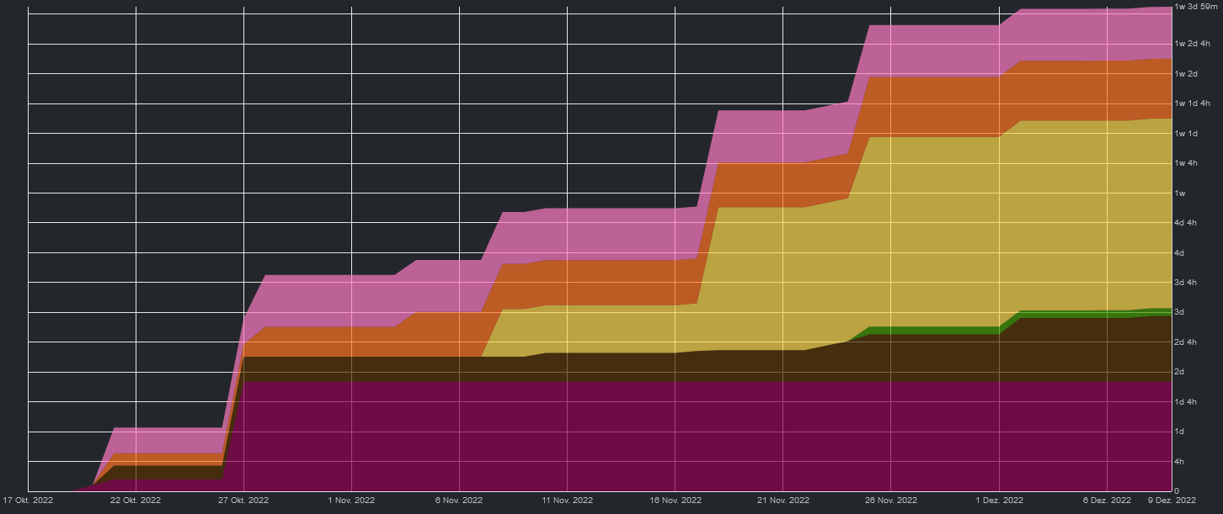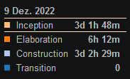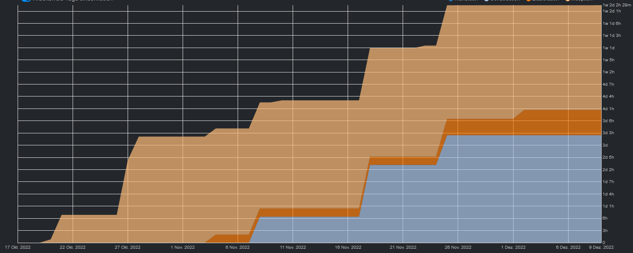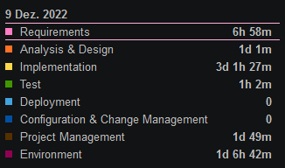

### Hours per Workflows:

### Hours per Phases:

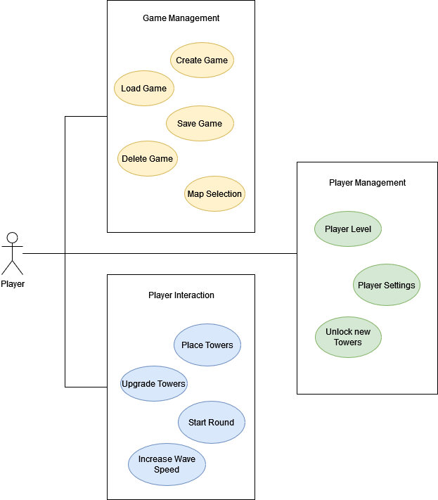

## Goal:

Inspired by games like Bloons TD we want to make a unique take on the Tower Defense genre. To achieve that we create our own individual design for the map, towers and enemies. Additionally we try to add new features which popular Tower Defense games haven't implemented yet.

## Architecture Style:

Our game is based on an event-driven software architecture design with mediator topology. The game will be developed entirely with Unity using C#-Scripts for coding the logic.

We decided to use Unity because it is one of the most popular game engines for mobile game development. The event-driven software architecture is given by Unity.

## Software Tools:

* Unity
* C#
* GitHub
* YouTrack