Technical Concept for Project “SpielBar”

“SpielBar” is the integration of a gaming interface in bar tables like over smart-tables or tablets, which are fix integrated in those tables.
We are planing this concept with tablets, who are integrated in the tables and an app to download from the app store, for the smartphones of the guests.

There are 4 cases we want to look at:

Case 1: a group come to the bar and want to play on there own
they register themselves over the tablets in the table or over their own smartphones and the first person will be the administrator of the group. He defines it as a closed group, names it and has to check all the persons, who want to join. After all participants joined successfully they can choose a game or a challenge like 2 against 2 or a competition over 4 rounds.

Case 2: a single person or maybe two come to the bar and want to play with other people
they register themselves like in case 1 but do not open a private group. They choose the option “Play with other people”. They can decide if they want to play with people only in this bar or also with people in other bars. They can also decide if they want to play any ransom game, other people which like to play to or to search players for one game they choose.
With all these information the system shuffles the players into ransom groups.
After the end of each game the player can decide to leave the current group or to stay and play another round.
If they like each other and want to play for a longer time and nobody else should join the group, they can fix it and change it to a private group. The also could start challenges, where the winner can get a price e.g. drinks or such things. The player can also share messages and maybe at the end join at one table.

Case 3: organized events like “singlesPlaying” or “QuizNight” or such themes
the bar owner can start an event on a fixed date. All other games especially the event game will be blocked while the event is ongoing. The system organizes all joined guests into teams just like it is defined in the event game. At the end teams or single guests could win some prices like free drinks or such things. The prices will be defined by the bar owner or maybe someone else who organized the event.

Case 4 or for better Case 3.1: events between two bars
events can also be organized by one bar which challenges another bar maybe in another city or country. It will be played like in case 3.

Technical Design

Location 1
Devices

SSID -
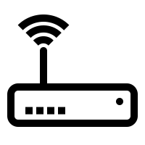

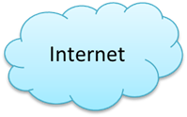

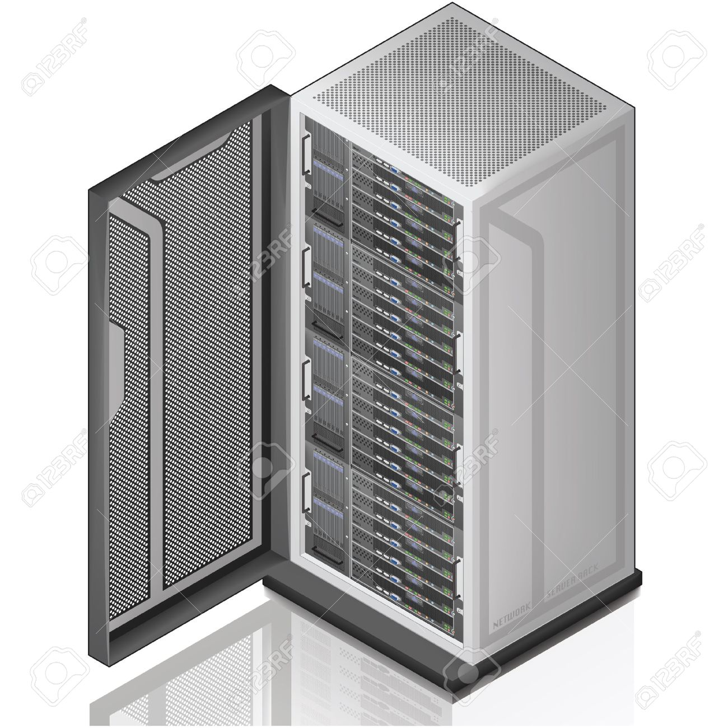
Location 2
Devices
Technical Details:

The Server managed all location. The devices could be identified by there location, the local IP-Address from the WLAN of the location and the choosen username, which won’t be saved. So the
Anonymity for the user is given.
The WLAN for the devices is only for the gaming traffic and all other services and traffic should be blocked.
For example this could done by a firewall in the router or the server could be defined as DNS-Server, without routing DNS-Calls to root-DNS-Server.
The location only have to host the WLAN and the tablets but no more.

