Determining Potential Yeast Longevity Genes via K-means Clustering Analysis
Group 3: Hoang Trong Nam, Nguyen Nam Phong, Le Minh Son, Tran Duc Thanh
Hanoi University of Science and Technology
Troy University
RESULT & CONCLUSION
The dataset was filtered using the interested gene list before clustering. The program read 121 candidate genes and 86 known longevity genes. After matching with Longotor1delta.csv, 173 genes were used for clustering, while 31 genes were skipped because they were not found in the dataset. The selected expression values were normalized by min-max normalization and then fed into the K-means algorithm.
The experiment was repeated with K values from 2 to 6. For each value of K, the program calculated the Sum of Squared Errors (SSE), the size of each cluster, and the percentage of known longevity genes in the best cluster. Following the logic of the reference Results section, candidate genes in clusters enriched with known longevity genes were treated as higher-priority predictions.
Table 1: K-means results for different K values
K | Iter. | SSE | Cluster sizes | Best cl. | Known %
2 | 4 | 3.8341 | 75-98 | 2 | 41.84%
3 | 9 | 3.4822 | 23-77-73 | 1 | 47.83%
4 | 9 | 2.7363 | 23-41-53-56 | 1 | 52.17%
5 | 13 | 2.3939 | 20-31-46-52-24 | 5 | 50.00%
6 | 9 | 2.1979 | 26-11-22-38-30-46 | 2 | 54.55%

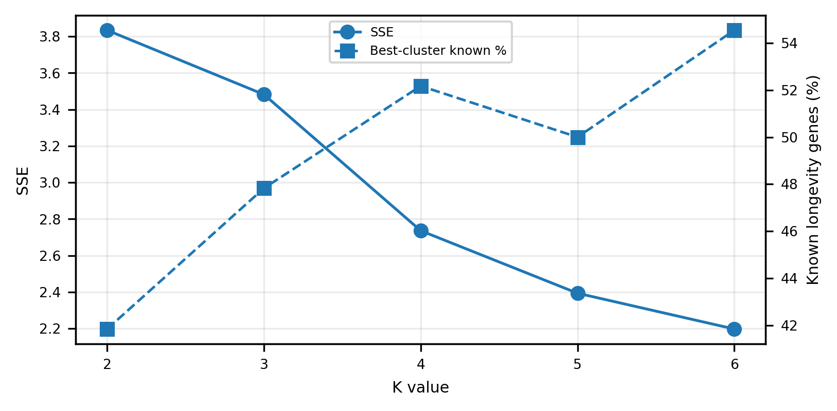
Figure 1 – SSE decreases as K increases, while the best-cluster known longevity percentage is highest at K = 6.

As shown in Table 1 and Figure 1, SSE decreases from 3.8341 at K = 2 to 2.1979 at K = 6. This means the clusters become more compact as more centroids are used. However, SSE alone is not enough to choose the best result, because too many clusters can make the result less meaningful. Therefore, the known longevity percentage inside the best cluster was also considered.
Among all tested values, K = 6 gives both the lowest SSE and the highest best-cluster known longevity percentage. This makes K = 6 the most suitable clustering result for the final interpretation.
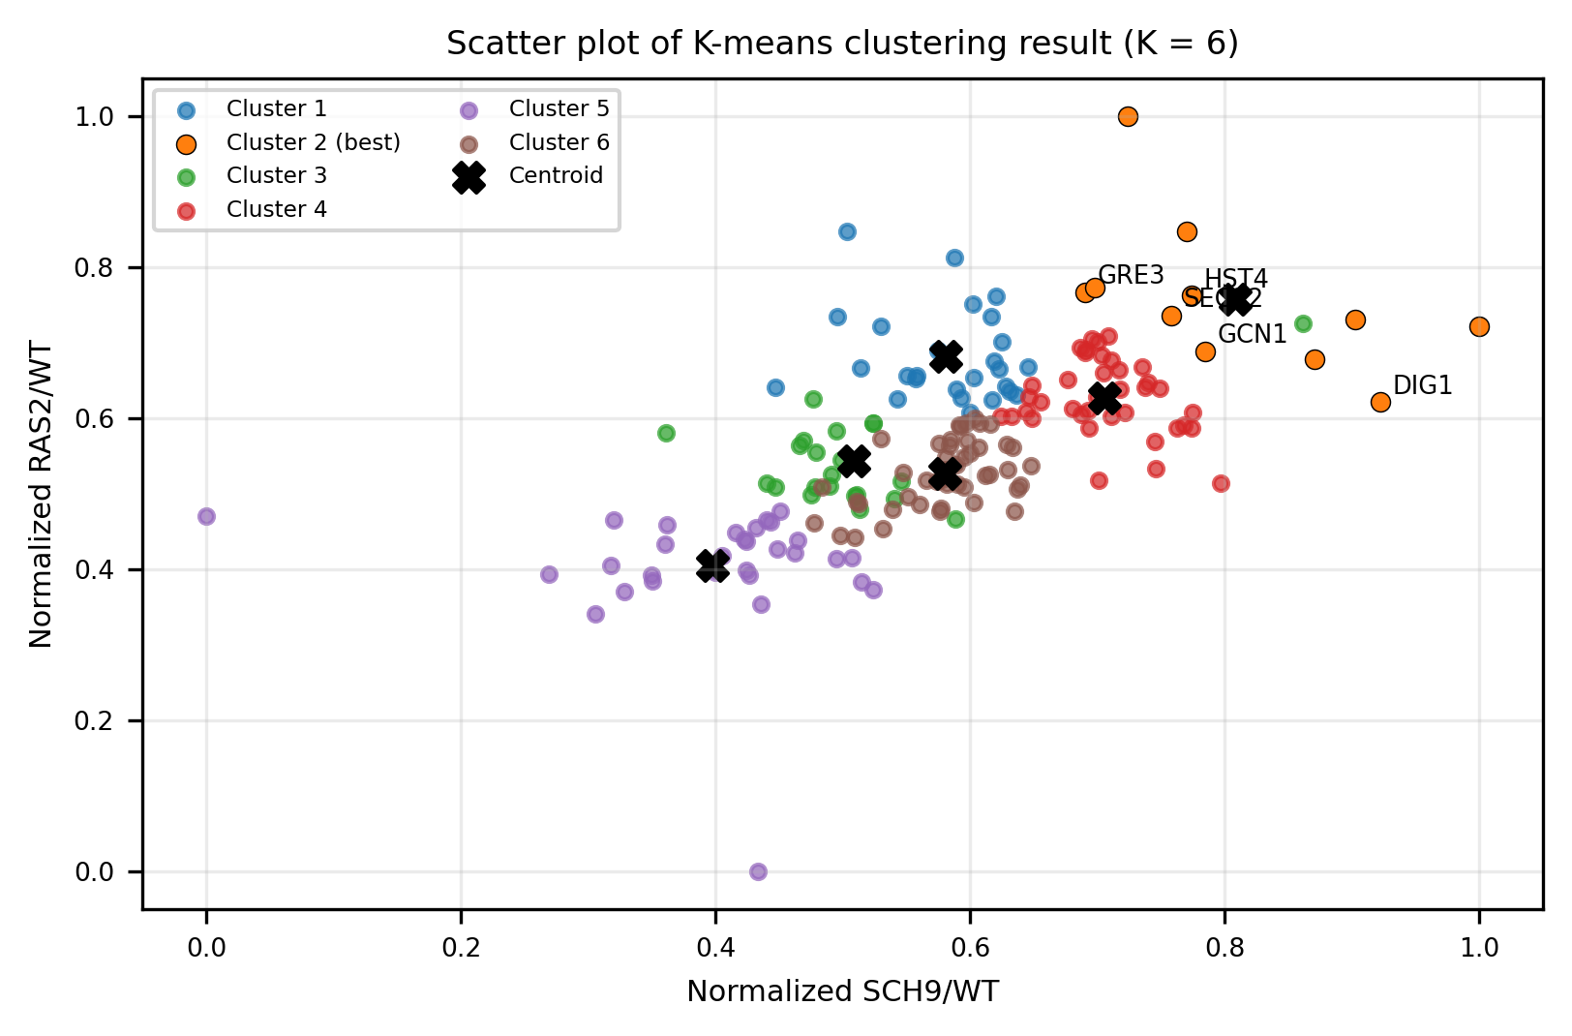
Figure 2 - Scatter plot of the K = 6 clustering result using normalized SCH9/WT and RAS2/WT values. Candidate genes in the selected best cluster are labeled.

Table 2: Detailed cluster composition for K = 6
Cluster | Size | Known | Candidate | Known %
1 | 26 | 13 | 13 | 50.00%
2 | 11 | 6 | 5 | 54.55%
3 | 22 | 11 | 11 | 50.00%
4 | 38 | 14 | 24 | 36.84%
5 | 30 | 14 | 16 | 46.67%
6 | 46 | 14 | 32 | 30.43%

Table 3: Final high-priority candidate genes
Potential Candidate Genes
HST4
GCN1
GRE3
SEC22
DIG1
The selected best cluster for K = 6 is Cluster 2. It contains 11 genes in total, including 6 known longevity genes and 5 candidate genes. Therefore, its known longevity percentage is 54.55%, the highest best-cluster value among the tested K parameters.
The final candidate genes found in this cluster are HST4, GCN1, GRE3, SEC22, and DIG1. Because these genes are grouped with a relatively high proportion of known longevity genes, they should be considered high-priority longevity-related candidates, not confirmed longevity genes.
In conclusion, the K-means clustering program successfully grouped yeast genes based on normalized microarray expression values. The best result was obtained at K = 6 because it produced the most compact clusters and the strongest enrichment of known longevity genes in the selected cluster.

