Activity No. 1

my_dict = {  
 'A': 'Alejandro',  
 'U': 'Uy',  
 'J': 'Jejomar',  
 'M': 'Magsala',  
 'B': 'Belatar'  
}

#Write your solution here  
print(my_dict['J'])

OUTPUT:

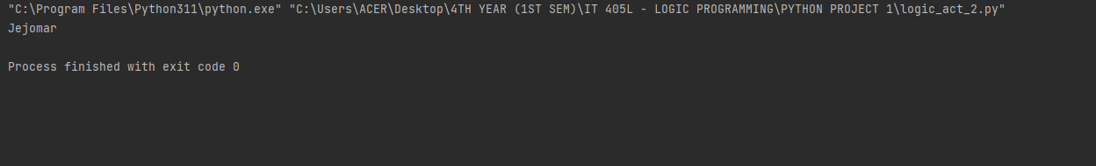

Activity No. 2

person_details = {  
 "name" : "Cody",  
 "age" : "4",  
 "color": "blue",  
 "nickname" : "Chum"  
}  
  
key = input("Enter a Key: ")  
  
#Write your solution here  
if key in person_details:  
 print(f"The '{key}' exists in the dictionary.")  
else:  
 print(f"The '{key}' does not exist in the dictionary.")

OUTPUT:

