Frederick Kelemen

2715308

09/11/2021

CIS 496 Project 1

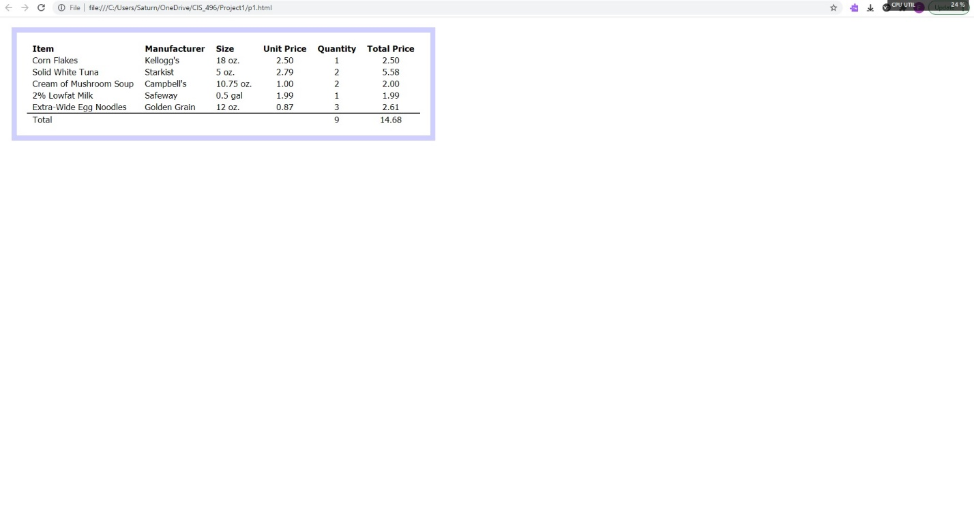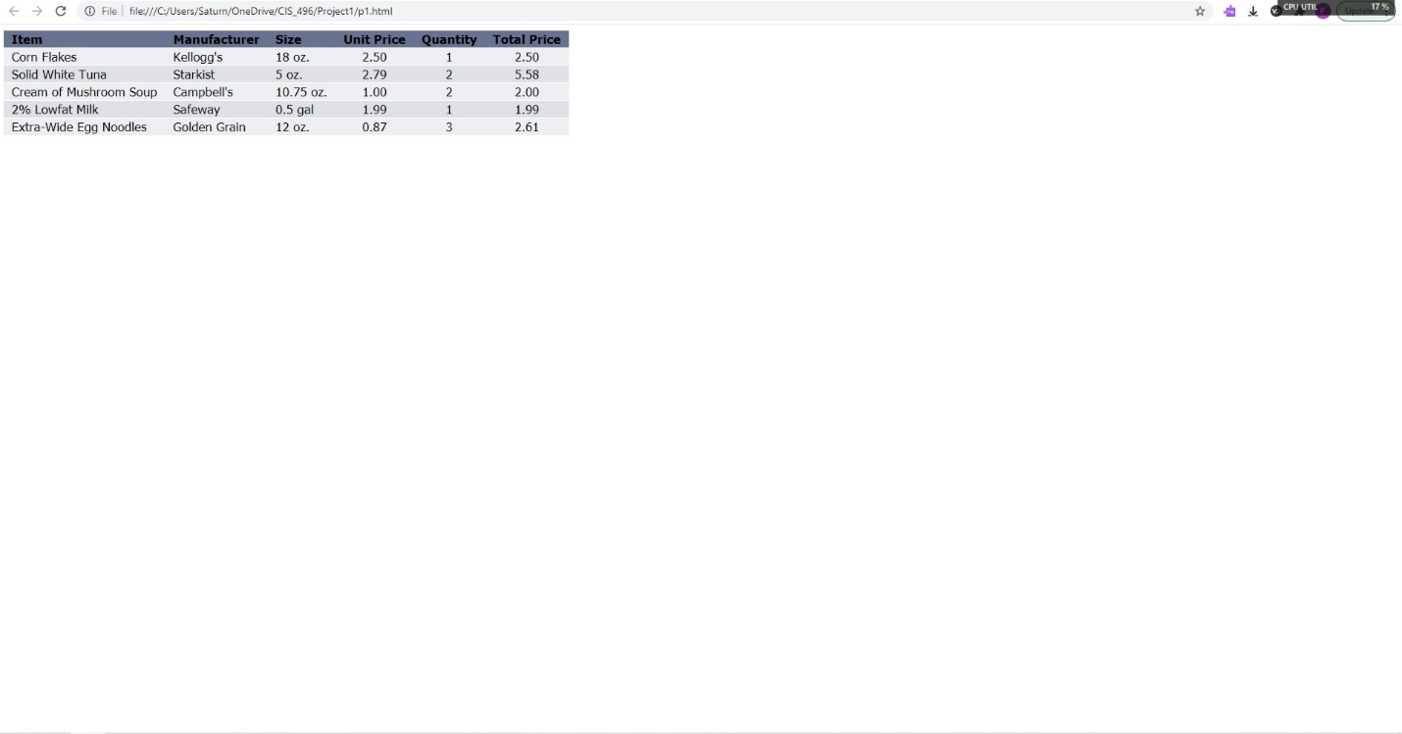Problem 1 Images

**p1.html**

<!DOCTYPE html>

<html lang="en">

<head>

<meta charset="utf-8">

<title>CIS 496 Project 1 Problem 1</title>

<link rel="stylesheet" href="p1b.css">

</head>

<body>

<table class="table1">

<tr class="rHead">

<th class="cLeft"><div class="rMarg">Item</div></th>

<th class="cLeft"><div class="rMarg">Manufacturer</div></th>

<th class="cLeft"><div class="rMarg">Size</div></th>

<th class="cCent"><div class="rMarg">Unit Price</div></th>

<th class="cCent"><div class="rMarg">Quantity</div></th>

<th class="cCent"><div class="rMarg">Total Price</div></th>

</tr>

<tr class="rOdd">

<td class="cLeft"><div class="rMarg">Corn Flakes</div></td>

<td class="cLeft"><div class="rMarg">Kellogg's</div></td>

<td class="cLeft"><div class="rMarg">18 oz.</div></td>

<td class="cCent"><div class="rMarg">2.50</div></td>

<td class="cCent"><div class="rMarg">1</div></td>

<td class="cCent"><div class="rMarg">2.50</div></td>

</tr>

<tr class="rEven">

<td class="cLeft"><div class="rMarg">Solid White Tuna</div></td>

<td class="cLeft"><div class="rMarg">Starkist</div></td>

<td class="cLeft"><div class="rMarg">5 oz.</div></td>

<td class="cCent"><div class="rMarg">2.79</div></td>

<td class="cCent"><div class="rMarg">2</div></td>

<td class="cCent"><div class="rMarg">5.58</div></td>

</tr>

<tr class="rOdd">

<td class="cLeft"><div class="rMarg">Cream of Mushroom Soup</div></td>

<td class="cLeft"><div class="rMarg">Campbell's</div></td>

<td class="cLeft"><div class="rMarg">10.75 oz.</div></td>

<td class="cCent"><div class="rMarg">1.00</div></td>

<td class="cCent"><div class="rMarg">2</div></td>

<td class="cCent"><div class="rMarg">2.00</div></td>

</tr>

<tr class="rEven">

<td class="cLeft"><div class="rMarg">2% Lowfat Milk</div></td>

<td class="cLeft"><div class="rMarg">Safeway</div></td>

<td class="cLeft"><div class="rMarg">0.5 gal</div></td>

<td class="cCent"><div class="rMarg">1.99</div></td>

<td class="cCent"><div class="rMarg">1</div></td>

<td class="cCent"><div class="rMarg">1.99</div></td>

</tr>

<tr class="rOdd">

<td class="cLeft"><div class="rMarg">Extra-Wide Egg Noodles</div></td>

<td class="cLeft"><div class="rMarg">Golden Grain</div></td>

<td class="cLeft"><div class="rMarg">12 oz.</div></td>

<td class="cCent"><div class="rMarg">0.87</div></td>

<td class="cCent"><div class="rMarg">3</div></td>

<td class="cCent"><div class="rMarg">2.61</div></td>

</tr>

<tr class="rTot">

<td class="cTotLeft"><div class="rMarg">Total</div></td>

<td class="cTotLeft"><div class="rMarg"></div></td>

<td class="cTotLeft"><div class="rMarg"></div></td>

<td class="cTotCent"><div class="rMarg"></div></td>

<td class="cTotCent"><div class="rMarg">9</div></td>

<td class="cTotCent"><div class="rMarg">14.68</div></td>

</tr>

</table>

</body>

**p1a.css**

.table1 {

font-family: Tahoma;

font-size: 13pt;

color: black;

display: block;

white-space: nowrap;

text-decoration: none;

border-collapse: collapse;

}

.rHead {

background-color: #687291;

}

.rEven {

background-color: #dfe1e7;

}

.rOdd {

background-color: #eeeff2;

}

.cCent {

text-align: center;

border-bottom: solid 1px;

border-bottom-color: white;

}

.cLeft {

text-align: left;

border-bottom: solid 1px;

border-bottom-color: white;

}

.rMarg {

margin-left: 10px;

margin-right: 10px;

}

.rTot {

display: none;

}

**p1b.css**

.table1 {

font-family: Tahoma;

font-size: 13pt;

color: black;

display: table;

white-space: nowrap;

text-decoration: none;

margin: 20px;

padding: 20px;

border: solid 10px;

border-color: #d0d0ff;

border-spacing: 0;

}

.rHead {

display: table-row;

}

.rEven {

display: table-row;

}

.rOdd {

display: table-row;

}

.cCent {

text-align: center;

}

.cLeft {

text-align: left;

}

.rMarg {

margin-left: 10px;

margin-right: 10px;

}

.rTot {

display: table-row;

border-collapse: collapse;

}

.cTotCent {

text-align: center;

border-top: solid 2px;

border-top-color: black;

}

.cTotLeft {

text-align: left;

border-top: solid 2px;

border-top-color: black;

}

Problem 2 Images

**p2.html**

<!DOCTYPE html>

<html lang="en">

<head>

<meta charset="utf-8">

<title>CIS 496 Project 1 Problem 2</title>

</head>

<body>

<p style="width:200px;margin:10px;height:200px;display:inline-block;text-align:center;">

<a href="http://cis.csuohio.edu/~sschung/CIS408/CIS408IDS.html">

<img src="pic1.jpg" alt="pic1" style="width:200px;margin:10px;height:200px;">

</a>

CIS 496 Web Page

</p>

<p style="width:200px;margin:10px;height:200px;display:inline-block;text-align:center;">

<a href="https://engineering.csuohio.edu/eecs/research-13">

<img src="pic2.jpg" alt="pic2" style="width:200px;margin:10px;height:200px;">

</a>

CSU Research Site

</p>

<br>

<p style="width:200px;margin:10px;height:200px;display:inline-block;text-align:center;">

<a href="https://www.yahoo.com/?ncid=dcm_23818180_269614055_463453844_129322662&gclid=CjwKCAjwhOyJBhA4EiwAEcJdcbMhcxeZh3vNqHYCUGKabHhpdCIwe_wG_kAyYak6IRFuPgRtL72wABoClhEQAvD_BwE">

<img src="pic3.jpg" alt="pic3" style="width:200px;margin:10px;height:200px;">

</a>

Yahoo News Site

</p>

<p style="width:200px;margin:10px;height:200px;display:inline-block;text-align:center;">

<a href="https://www.nba.com/cavaliers/">

<img src="pic4.jpg" alt="pic4" style="width:200px;margin:10px;height:200px;">

</a>

Cleveland CAVS Site

</p>

</body>

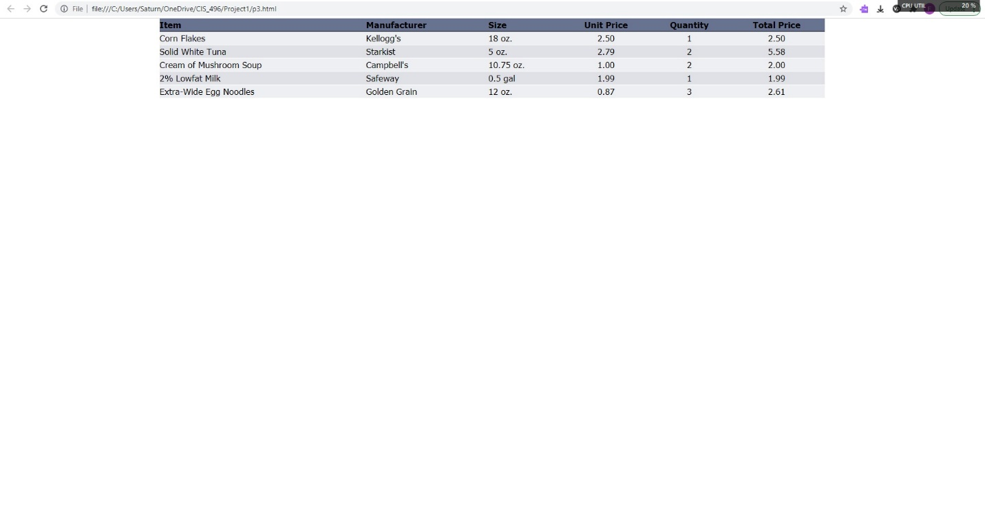Problem 3 Images

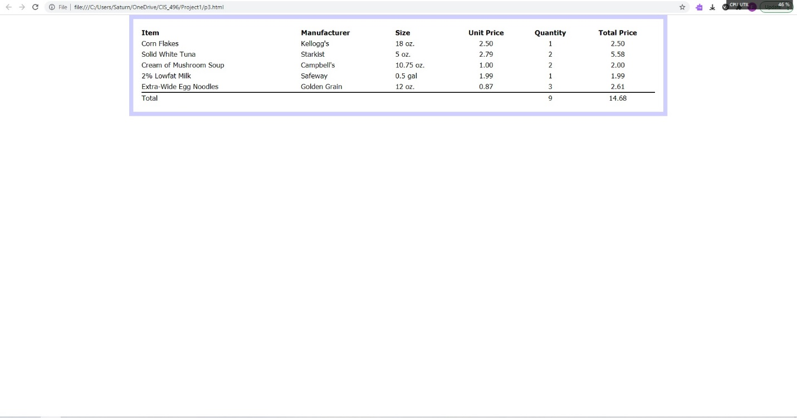

**p3.html**

<!DOCTYPE html>

<html lang="en">

<head>

<meta charset="utf-8">

<meta name="viewport" content="width=device-width, initial-scale=1">

<title>CIS 496 Project 1 Problem 1</title>

<link rel="stylesheet" href="css/bootstrap.min.css">

<link rel="stylesheet" href="p3b.css">

<script src="https://ajax.googleapis.com/ajax/libs/jquery/3.5.1/jquery.min.js"></script>

<script src="js/bootstrap.min.js"></script>

</head>

<body>

<div class="container">

<div class="table-responsive">

<table class="table table1">

<thead>

<tr class="rHead">

<th class="cLeft">Item</th>

<th class="cLeft">Manufacturer</th>

<th class="cLeft">Size</th>

<th class="cCent">Unit Price</th>

<th class="cCent">Quantity</th>

<th class="cCent">Total Price</th>

</tr>

</thead>

<tbody>

<tr class="rOdd">

<td class="cLeft">Corn Flakes</td>

<td class="cLeft">Kellogg's</td>

<td class="cLeft">18 oz.</td>

<td class="cCent">2.50</td>

<td class="cCent">1</td>

<td class="cCent">2.50</td>

</tr>

<tr class="rEven">

<td class="cLeft">Solid White Tuna</td>

<td class="cLeft">Starkist</td>

<td class="cLeft">5 oz.</td>

<td class="cCent">2.79</td>

<td class="cCent">2</td>

<td class="cCent">5.58</td>

</tr>

<tr class="rOdd">

<td class="cLeft">Cream of Mushroom Soup</td>

<td class="cLeft">Campbell's</td>

<td class="cLeft">10.75 oz.</td>

<td class="cCent">1.00</td>

<td class="cCent">2</td>

<td class="cCent">2.00</td>

</tr>

<tr class="rEven">

<td class="cLeft">2% Lowfat Milk</td>

<td class="cLeft">Safeway</td>

<td class="cLeft">0.5 gal</td>

<td class="cCent">1.99</td>

<td class="cCent">1</td>

<td class="cCent">1.99</td>

</tr>

<tr class="rOdd">

<td class="cLeft">Extra-Wide Egg Noodles</td>

<td class="cLeft">Golden Grain</td>

<td class="cLeft">12 oz.</td>

<td class="cCent">0.87</td>

<td class="cCent">3</td>

<td class="cCent">2.61</td>

</tr>

<tr class="rTot">

<td class="cTotLeft">Total</td>

<td class="cTotLeft"></td>

<td class="cTotLeft"></td>

<td class="cTotCent"></td>

<td class="cTotCent">9</td>

<td class="cTotCent">14.68</td>

</tr>

</tbody>

</table>

</div>

</div>

</body>

**p3a.css**

.table1 {

font-family: Tahoma;

font-size: 13pt;

color: black;

white-space: nowrap;

text-decoration: none;

border-collapse: collapse;

}

.rHead {

background-color: #687291;

}

.rEven {

background-color: #dfe1e7;

}

.rOdd {

background-color: #eeeff2;

}

.cCent {

text-align: center;

border-bottom: solid 1px;

border-bottom-color: white;

padding: 0px !important;

}

.cLeft {

text-align: left;

border-bottom: solid 1px;

border-bottom-color: white;

padding: 0px !important;

}

.rTot {

display: none;

}

**p3b.css**

.table1 {

font-family: Tahoma;

font-size: 13pt;

color: black;

display: table;

white-space: nowrap;

text-decoration: none;

padding: 20px !important;

border: solid 10px;

border-color: #d0d0ff;

border-spacing: 0;

border-collapse: separate !important;

}

.cCent {

border-color: white !important;

text-align: center;

padding: 0px !important;

}

.cLeft {

text-align: left;

border-color: white !important;

padding: 0px !important;

}

.rTot {

display: table-row;

border-collapse: collapse;

}

.cTotCent {

text-align: center;

border-top: solid 2px !important;

border-top-color: black;

border-bottom-color: white !important;

padding: 0px !important;

}

.cTotLeft {

text-align: left;

border-top: solid 2px !important;

border-top-color: black;

border-bottom-color: white !important;

padding: 0px !important;

}

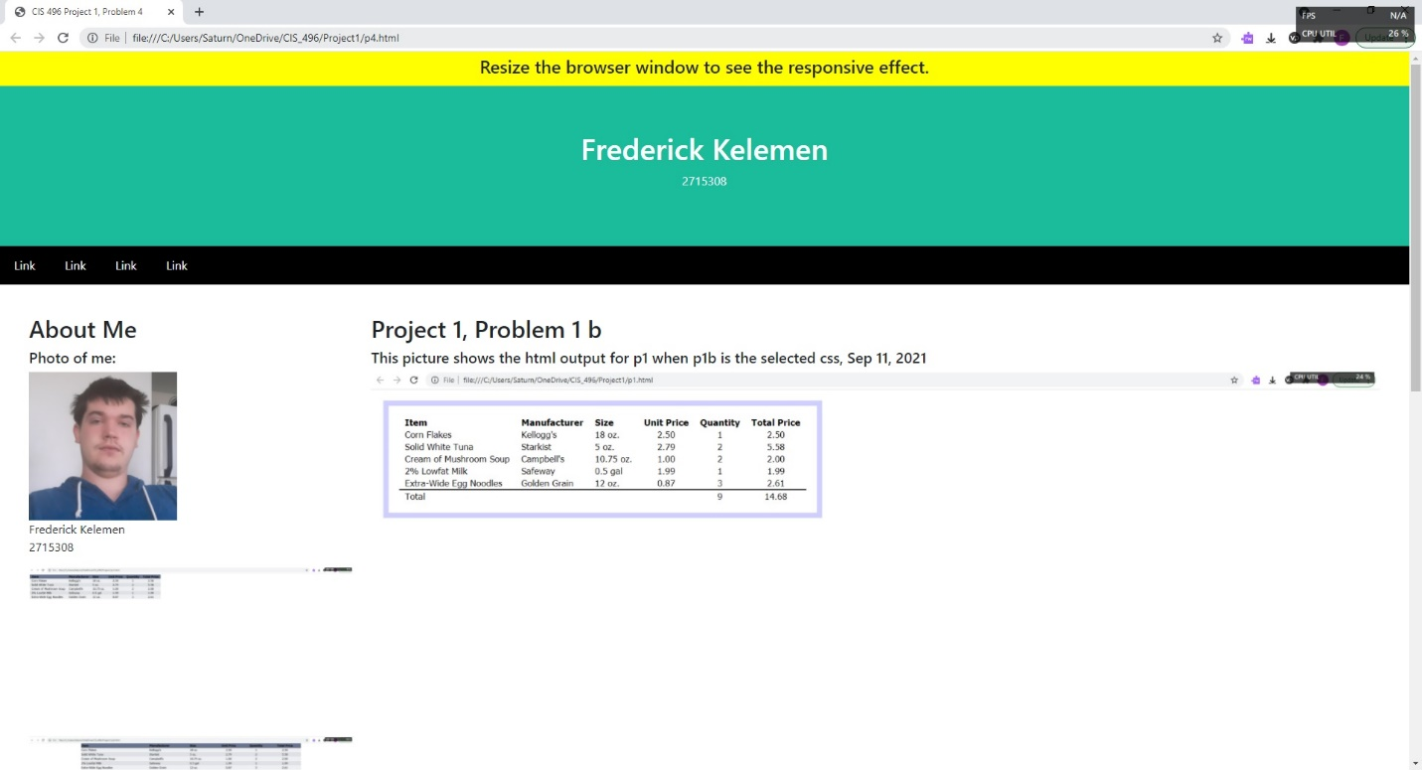Problem 4 Images

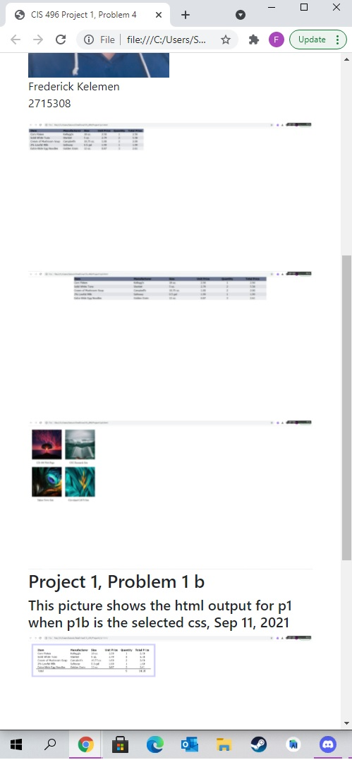

**p4.html**

<!DOCTYPE html>

<html>

<head>

<title>CIS 496 Project 1, Problem 4</title>

<meta charset="UTF-8">

<meta name="viewport" content="width=device-width, initial-scale=1">

<link rel="stylesheet" href="css/bootstrap.min.css">

<script src="https://ajax.googleapis.com/ajax/libs/jquery/3.5.1/jquery.min.js"></script>

<script src="js/bootstrap.min.js"></script>

</head>

<body>

<div style="background:yellow;padding:5px">

<h4 style="text-align:center">Resize the browser window to see the responsive effect.</h4>

</div>

<div style="background:#1abc9c;padding:60px;text-align:center;color:white;">

<h1>Frederick Kelemen</h1>

<p>2715308</p>

</div>

<div style="background:black;display:flex;">

<a style="padding:14px 20px;color:white;text-decoration:none;" href="#">Link</a>

<a style="padding:14px 20px;color:white;text-decoration:none;" href="#">Link</a>

<a style="padding:14px 20px;color:white;text-decoration:none;" href="#">Link</a>

<a style="padding:14px 20px;text-decoration:none;color:white;" href="#">Link</a>

</div>

<div class="container-flex" style="margin:40px;">

<div class="row">

<div class="col-sm-3">

<h2>About Me</h2>

<h5>Photo of me:</h5>

<img src="pic10.jpg" style="height:200px;"></img>

<p>Frederick Kelemen<br>2715308</p>

<img src="pic5.jpg" style="width:100%;"></img>

<img src="pic7.jpg" style="width:100%;"></img>

<img src="pic6.jpg" style="width:100%;"></img>

</div>

<div class="col-sm-9">

<h2>Project 1, Problem 1 b</h2>

<h5>This picture shows the html output for p1 when p1b is the selected css, Sep 11, 2021</h5>

<img src="pic8.jpg" style="width:100%;"></img>

<p></p>

<h2>Project 1, Problem 3 b</h2>

<h5>This picture shows the html output for p3 when p3b is the selected css, Sep 11, 2021</h5>

<img src="pic9.jpg" style="width:100%"></img>

<p></p>

</div>

</div>

</div>

<div class="footer">

<h2>Footer</h2>

</div>

</body>

</html>