Proposal

<HF-Happy Fitting>

<Yi Rong, Zipei Chen, Zhenyang Guo>

Advisor: < Vanessa Aguiar>

Submitted in partial fulfillment

Of the requirements of CSC-431

Software Engineering course project

<02.11.2021>

# Preface

This is a proposal for the < HF-Happy Fitting> project for partial fulfillment of the requirements of a Software Engineering course (CSC431) project in the Department of Computer Science at the University of Miami.

This proposal provides the scope and context of the project to be undertaken. It details the intended user group and the value that the system will have to them.

The intended audience of this document is the course professor and teaching assistants so that they can determine whether the project should be approved as proposed, approved with modifications, or not approved.

# Table of Contents

# Overview

## Purpose, Scope, and Objectives

## Project description

* 1. Purpose, Scope, and Objectives

Our software aims at those who are overweight or want to have better control over their weight. Fitness instructors also can be user groups, since the software can get knowledge about calories of each kind of food, offer healthy menu set, body control and even sell our healthy products. Also, due to its intended user, the software shouldn’t have a high level of hardware requirement, so the software is available on smartphones and both windows and mac’s computers.

Due to the requirement for calculating calories for different foods or activities, the software will require a database and calculating software. Since we want to make our software more popular, we want our software to contain chatting and blogs function so that user can share their everyday lives and even use our software as ‘message’.

* 1. Project description

We think a popular software should have both clear and beautiful interface and functions sufficient for most people groups, so the software can divide into the professional and ordinary version which professional contain more function and aims to fit coach or dietician. Our software should be able to tell the user what kind of sports or action to make to lose or gain weight; online shopping for sports equipment or healthy diet products; recommended for healthy tips and A community for share or exchange healthy experiences.

The database for the software should be strong as well so that the use of outer searching-systems can be as little as possible, the users can keep staying in the software instead of switchover between the web and our software. As a result, the system should have its searching engine over its database. Also due to the requirement for social function for our system, the software should have its online communication system to make chatting and sharing everyday life possible on our software.

A successful software also needs the ability to keep update with user’s needs and fixing the bug. Our software should able to report the bug whenever the bug has happened, and we should able to get users’ feedback through questionnaires or community’s voice.

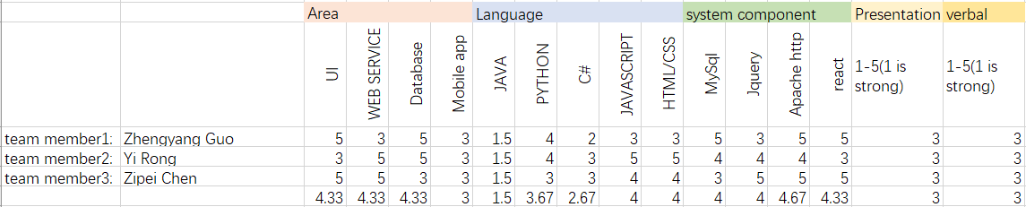

The ability graph for the team members