Durability of COVID-19 vaccine and infection induced immunity: a meta-regression analysis

Mia Moore, Larissa Anderson, Joshua T. Schiffer, Laura Matrajt, Dobromir Dimitrov

2024-05-13

# Abstract

Despite the successful development and rollout of mRNA vaccines, COVID-19 remains a significant public health threat. Waning of immune memory over time as well as the emergence of new strains can degrade population-level protection and contribute to ongoing morbidity. Projecting future COVID-19 outbreaks and evaluating potential interventions requires a quantitative understanding of the protection against infection and disease following vaccination, booster doses, and recovery from SARS-CoV-2 infections. In this meta-regression, we analyze data from 123 studies stratified by prior infection, number of booster doses and time since immune conferring event. We estimated that booster doses of mRNA vaccines reduce severe disease due to Omicron by 90.0% (95% confidence interval 86.2 - 93.8) initially, but protection drops to 73.4% (64.4 - 82.4) at 30 weeks following boosting. We found that hybrid immunity was more durable than immunity from either vaccination or prior infection alone, but that protection against Omicron reinfection was only 36.2% (17.0 - 55.3) at 30 weeks following vaccination. Overall, our results suggest that timely deployment of pre-existing boosters can greatly mitigate seasonal COVID outbreaks.

# Main Text

## Introduction

Following the approval of first COVID-19 mRNA vaccines in late 2020, an unprecedented vaccination campaign took place worldwide. In the US 82.5% of the adult population received at least one dose by January 2024 though uptake varied by region.(COVIDVaxView 2024) The mRNA vaccines used in the majority of these vaccinations proved to be highly efficacacious against infection and disease caused by ancestral strains and subsequently emerging variants of concern such as Alpha, Beta, Gamma, and Delta (Meggiolaro, Sane Schepisi, Nikolaidis, et al. 2022; Harder et al. 2021). However, the emergence of the Omicron strain and its subvariants in late 2021 demonstrated that vaccine-induced immunity wanes over time and is not always necessarily to strain replacement (Feikin et al. 2022; Meggiolaro, Sane Schepisi, Farina, et al. 2022; Zeng et al. 2022; Sabu et al. 2022; Higdon et al. 2022; Mohammed et al. 2023; Wu et al. 2023). Moreover, uptake of booster doses has been much lower than primary vaccination with only 20.9% of US adults receiving a booster dose between September 14, 2023 and January 2024.(COVIDVaxView 2024)

Projecting ongoing morbidity and mortality due to SARS-CoV-2 requires reliable time-varying estimates of reductions in susceptibility to infection, symptomatic disease, and severe disease followimg vaccination or infection. (Basta et al. 2008; Antia and Halloran 2021). Mathematical modeling has demonstrated that the interplay between different types of immunity may strongly impact population-level reduction of SARS CoV-2 transmission due to vaccination programs even when the overall reduction of symptomatic infections is roughly the same. (Swan et al. 2021) In this study we consider three different immunity against three different outcomes.

1. : The percent reduction in the rate of newly acquired SARS-CoV-2 infections among individuals with vaccine-induced and/or infection-induced immunity relative to those with no pre-existing immunity (the naive population).
2. The percent reduction in the rate of symptomatic COVID-19 disease among individuals with vaccine-induced and/or infection-induced immunity relative to the naive population.
3. The percent reduction in the rate of severe COVID-19 disease among individuals with vaccine-induced and/or infection-induced relative to the naive population.

Previous meta-analyses have found that all three forms of immunity are 1) augmented by vaccination, including booster vaccines, as well as prior infection, and 2) wane over time with reduction of the risk of hospitalization or severe disease () being the most durable, but that 3) vaccine-induced immunity was markedly lower against Omicron variants than pre-Omicron variants. (Bobrovitz et al. 2023; Stein et al. 2023; Wu et al. 2023; Mohammed et al. 2023; Feikin et al. 2022).

In this meta-analysis, we aim to update the current knowledge of naturally-acquired, mRNA vaccine-induced and hybrid immunity, by including studies through January 2023. Using a multi-level meta-regression approach, we investigate the impact of infecting strain, vaccination status, prior infection, and time since immune conferring event on , and . In addition to reproducing the findings from previous meta-analyses with an expanded data set, we also analyze 1) the relative-durability of vaccine-induced, booster-induced, naturally acquired, and hybrid immunity and 2) the impact of prior infection on booster dose efficacy.

## Methods

### Search and Inclusion Criteria

We conducted a literature search in PubMed, medRxiv and bioRxiv for manuscripts published or posted January 1, 2020 - January, 2023 using the search query (“SARS–CoV-2” or “COVID-19”) AND (“BNT162b2” or “mRNA-1273”) AND (“vaccine efficacy” OR “vaccine effectiveness”) AND (“waning” or “wane”). Manuscripts or publications available on these platforms from January 1,2020 – January 1, 2023 were screened for estimates of at least one of the following:reduction of SARS-CoV-2 infection (), symptomatic COVID-19 disease (), and hospitalization or severe disease due to COVID-19 () among those with mRNA vaccine-derived and/or infection-derived immunity compared to those with no immunity. We excluded studies which pooled mRNA vaccination with other types of vaccination and further required a study population size of at least 1000 individuals. Reviews and modeling-only studies were also excluded from our analysis. Of the 828 studies reviewed, 123 matched the criteria and were included in the final analysis (Figure 1A).

For each reviewed study, we recorded point estimates and accompanying 95% CI for vaccine effectiveness were recorded for each time point at or after complete coverage was reached; generally defined as two weeks post second mRNA vaccine dose or one week post booster mRNA vaccine dose. From the 123 studies we recorded 1895 distinct estimates of , , and , of which 1621 were used for analysis (Figure 1B). We categorized each estimate according to vaccination status of the participants, the infecting strain, the timing of any prior infection, and the minimum time since the immune conferring event. Vaccination status was defined as either 1) “Natural” or unvaccinated, 2) “Primary” vaccination corresponding to having exactly 2 doses of the mRNA vaccines BNT162b2 or mRNA-1273, or 3) “Boosted” with 3+ doses of an mRNA vaccine) (Table 1). We dichotomized infecting strains into either “Pre - Omicron” comprising ancestral, alpha, beta, and delta strains or “Omicron” comprising Omicron and sub variants BA.1, BA.2, BA.2.75, BA.4, and BA.5. When applicable, we also dichotomized participants’ prior infections into “Pre - Omicron” and “Omicron” based on the window of time during which such an infection could have occurred. Any infection that could not have occurred after Dec 1st, 2021 was designated “Pre - Omicron” whereas all other infections were considered “Omicron” for our analysis.

The time since most recent vaccination dose, or in the case of natural immunity time since prior infection, was reported over either closed or open time intervals. In our analysis we defined to be the lower bound for all time intervals, likely making our efficacy estimates conservative.

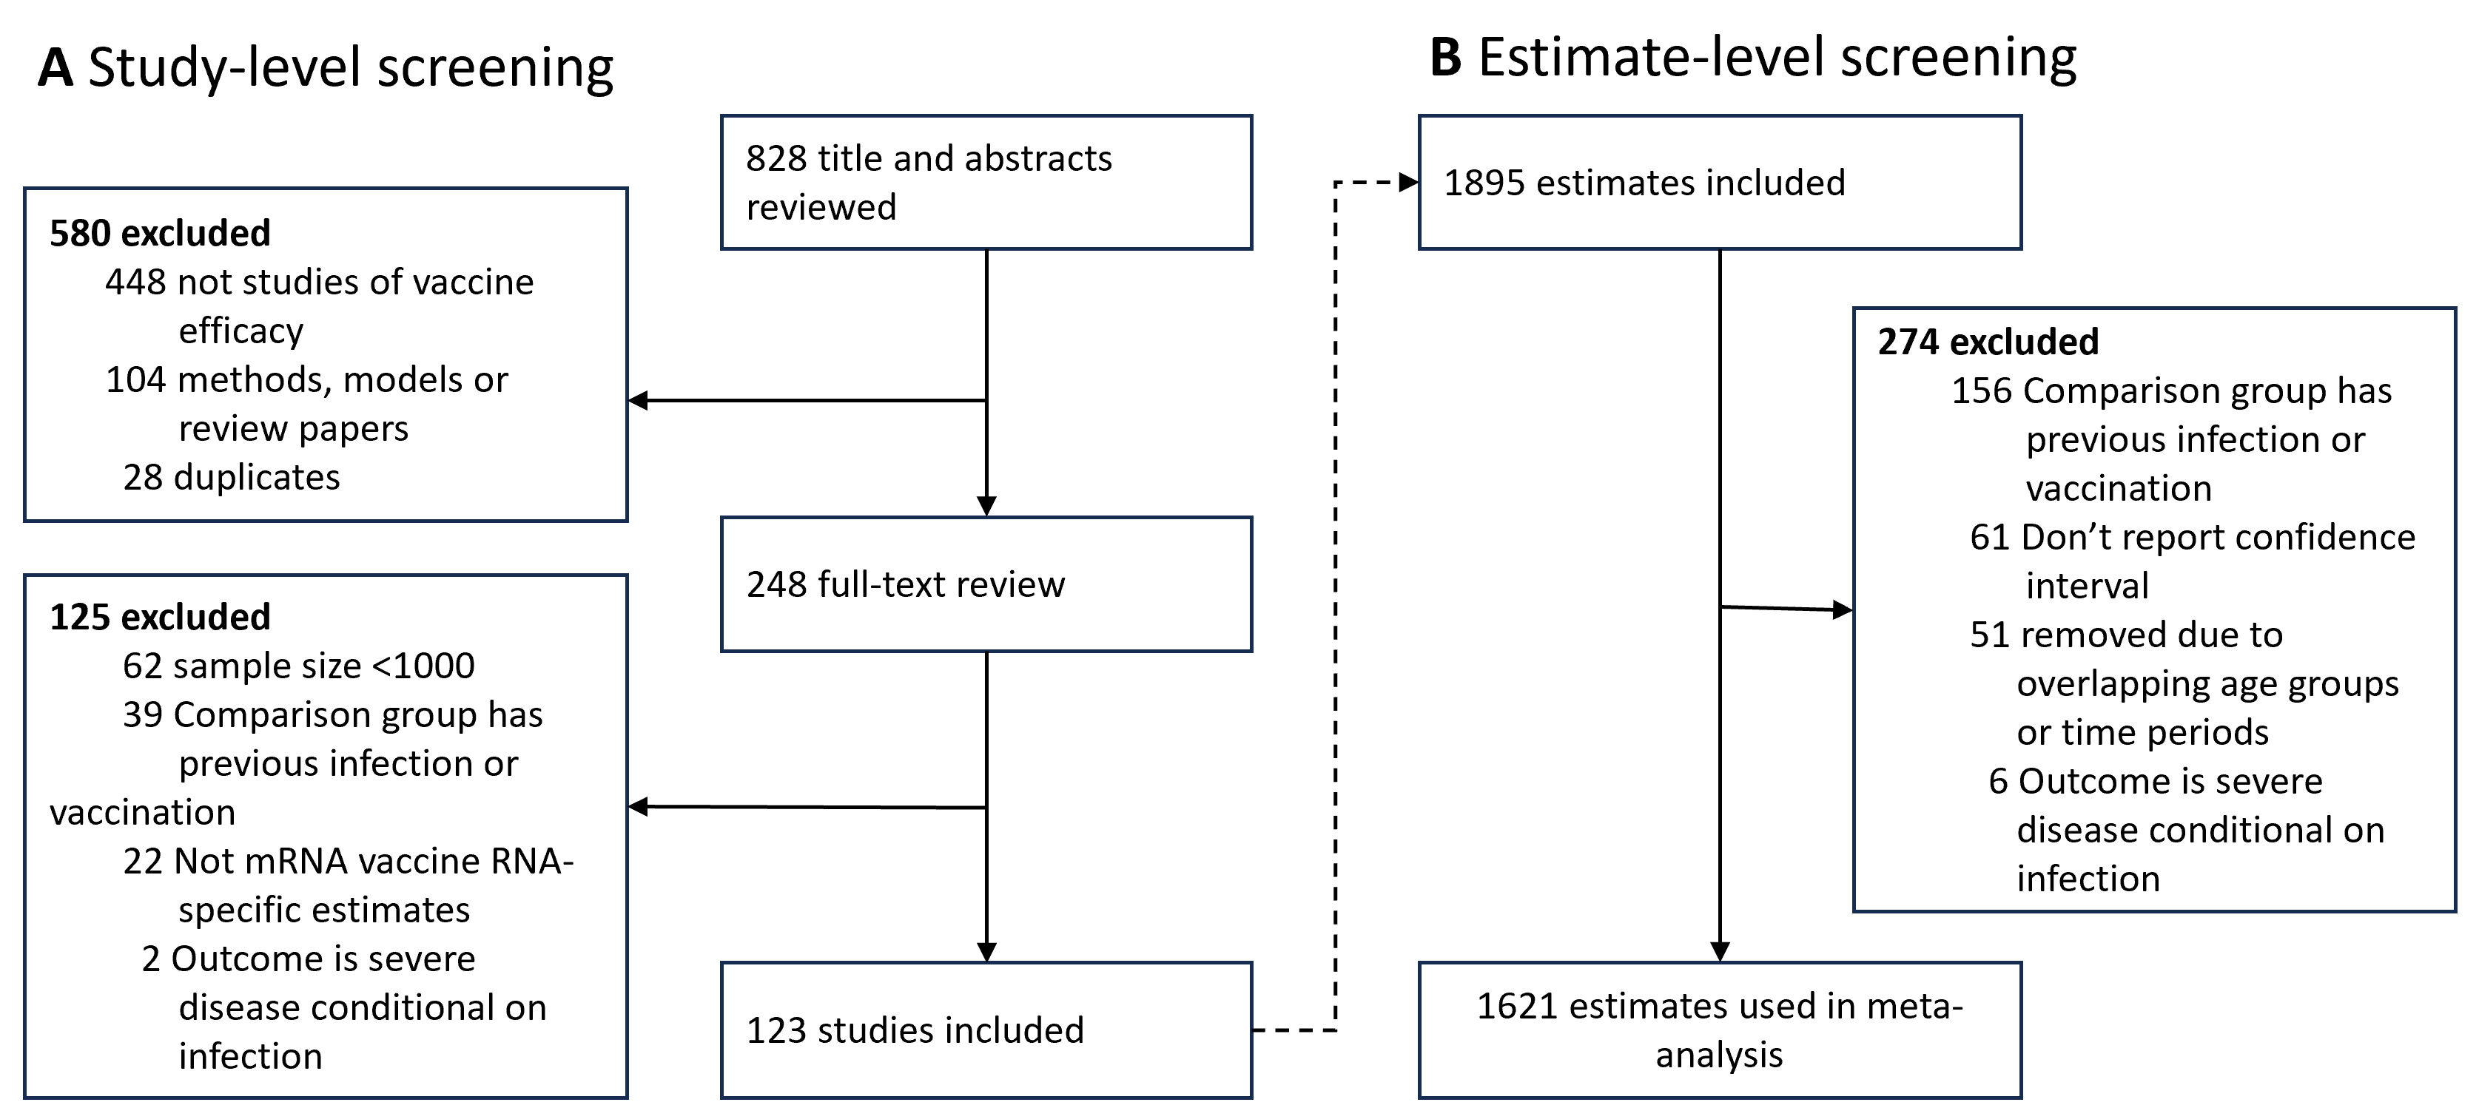

Figure 1: Study inclusion flowchart

Table 1: Number of studies (estimates) for each type of protection used in this meta-analysis.

| Vaccination | Prior Infection | Number of studies (time points) measure protection against... | | | | | |
| --- | --- | --- | --- | --- | --- | --- | --- |
| Any Infection (ES) | | Symptomatic  Disease (ED) | | Severe Disease (EM) | |
| Pre-Om | Om | Pre-Om | Om | Pre-Om | Om |
| Primary | None | 63 (412) | 21 (71) | 32 (207) | 15 (78) | 43 (344) | 20 (74) |
| Boosted | None | 11 (27) | 16 (75) | 6 (33) | 11 (73) | 12 (30) | 17 (100) |
| None | Pre - Omicron:   Infection occurred during  a window ending  prior to Dec 1st, 2021 | 13 (43) | 8 (19) | 6 (21) | 7 (15) | 4 (15) | 3 (5) |
| Primary | Pre - Omicron:   Infection occurred during  a window ending  prior to Dec 1st, 2021 | 4 (19) | 6 (20) | 1 (1) | 3 (8) | 1 (2) | 1 (2) |
| Boosted | Pre - Omicron:   Infection occurred during  a window ending  prior to Dec 1st, 2021 | - | 4 (7) | - | 3 (4) | - | 1 (2) |
| None | Omicron:   Infection occurred during  a window ending  on or after Dec 1st, 2021 | N/A | 6 (12) | N/A | 4 (6) | N/A | - |
| Primary | Omicron:   Infection occurred during  a window ending  on or after Dec 1st, 2021 | N/A | 3 (11) | 2 (3) | N/A | - |
| Boosted | Omicron:   Infection occurred during  a window ending  on or after Dec 1st, 2021 | N/A | 4 (15) | 2 (3) | N/A | - |

### Data Analysis

To quantify the waning of , and , we fit a series of mixed-effects linear models to the data, each including different covariates, , using a different subset of the data, and targeting different questions (Table 2)(Van den Noortgate et al. 2015). Each model uses a multilevel structure in which the estimate in study , , potentially depends on 1) a global estimates of initial immunity, , a linear rate of waning, , and a dependence covariate , 2) corresponding study-level effects and estimate-level effects and 3) sampling effects . The estimate-level random effects, are also normally distributed with a variance computed from the width of the corresponding estimate’s confidence interval. The generic model is given by

We also considered model forms with one or both of the following simplifications:

1. or , but not both
2. or

For each model and each stratum, we selected the best-fit model based on the Bayesian Information Criterion (BIC). For example in for Model 1, and were fit with the full model, whereas for we set as it improved BIC. All models were implemented in R version 4.1.0 (2021-05-18) using the metafor package.

Table 2: Meta-regression model structure and purpose

| Model | Purpose | Covariates | Stratification | Subset |
| --- | --- | --- | --- | --- |
| Model 1 | Evaluate impact of infecting strain | Strain (Omicron vs pre-Omicron) | Outcome | Two or more mRNA Vaccine Doses |
| Model 2 | Evaluate impact of booster doses | Number of doses (3+ vs 2)) | Outcome and Strain | No prior infection |
| Model 3 | Compare durability of natural and vaccine derived immunity | Type of immunity (Primary vaccination, Prior Infection, or Primary vaccination + Prior Infection) | Outcome and Strain | Two or fewer mRNA Vaccine Doses (i.e. no booster doses) |
| Model 4 | Evaluate impact of prior infecting strain on durability of natural immunity | Type of immunity (Primary vaccination, Prior Infection pre-Omicron, Prior Infection Post Omicron, Primary vaccination + Prior Infection pre-Omicron, or Primary vaccination + Prior Infection Post-Omicron | Outcome | Two or fewer mRNA Vaccine Doses (i.e. no booster doses) |
| Model 5 | Evaluate impact of natural immunity on individuals with booster doses | Prior Infection (None vs Any) | Outcome and Strain | Three or more mRNA Vaccine Doses |

## Results

### Vaccine protection against infection and symptomatic disease, but not severe disease, were muc lower against the Omicron variants

We found a consensus in the literature that vaccine efficacy against infection, symptomatic disease, and severe disease wanes over time both due to an increase in time since the most recent vaccine dose and due to the replacement of the circulating strain by the Omicron strain or its subvariants. The magnitude of the loss of this immunity varied by type of protection and the dominant circulating strain at the time of vaccination (Figure 2). For each of the vaccine effectiveness measures (, , and ), the predicted values for protection two weeks after completion of the primary series was lower for Omicron than for pre-Omicron variants (Table 3). Initial vaccine protection against infection (, Figure 2 top panel) against pre-Omicron variants was 83.5 (81.2 - 85.8) compared to 50.3 (43.8 - 56.7) against Omicron variants. After thirty weeks, decreased to 50.7 (41.9 - 59.5) and -8.7 (-25.6 - 8.3), against pre-Omicron and Omicron variants, respectively. Estimates of protection against symptomatic disease (, Figure 2 bottom left) were quite similar: at two weeks post-second dose was 87.0 (84.0 - 90.1) and 60.6 (54.2 - 67.0)against pre-Omicron and Omicron variants respectively and after thirty weeks was 54.3 (42.8 - 65.8) and 2.6 (-10.5 - 15.6) against pre-Omicron and Omicron variants respectively.

Vaccine protection against severe outcomes (, Figure 2 bottom right) was both more durable over time and robust to the immune evasion of omicron. At two weeks post vaccination was 92.0 (89.9 - 94.0) against pre-Omicron variants and 86.0 (83.3 - 88.6) against Omicron variants. After 30 weeks, decreased to 82.0 (78.0 - 86.1) and 67.8 (62.2 - 73.4) against pre-Omicron and Omicron variants, respectively.

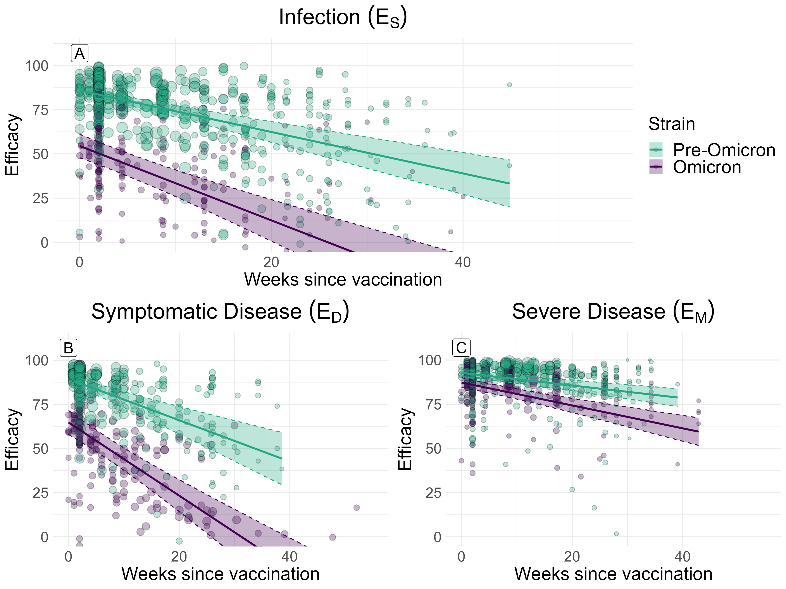

Figure 2: Protection against infection, symptomatic disease, and severe disease by infecting strain and time since most recent vaccination relative to an immune-naive population.

Table 3: Unadjusted estimates of vaccine efficacy by strain at two and thirty weeks since most recent dose and the change over that time frame with 95% confidence intervals. Analysis was stratified by clinical outcome. Significance of the impact of strain replacement and of time since vaccination was evaluated with a two-sided t-test. Listed p-values indicate the significance of the strain replacement. Significance of the change over time is indicated by *(p<.05), **(p<.01), and ***(p<.001).

| Outcome | Strain | Initial (Week 2) | Waned (Week 30) | Change |
| --- | --- | --- | --- | --- |
| Any Infection | Pre-Omicron | 83.5 (81.2 - 85.8) | 50.7 (41.9 - 59.5) | 32.8 (24.2 - 41.5)*** |
| Omicron | 50.3 (43.8 - 56.7) | -8.7 (-25.6 - 8.3) | 58.9 (42.5 - 75.4)*** |
| p-value | <.001 | <.001 | 0.002 |
| Symptomatic Disease | Pre-Omicron | 87.0 (84.0 - 90.1) | 54.3 (42.8 - 65.8) | 32.8 (21.7 - 43.8)*** |
| Omicron | 60.6 (54.2 - 67.0) | 2.6 (-10.5 - 15.6) | 58.0 (44.4 - 71.6)*** |
| p-value | <.001 | <.001 | <.001 |
| Severe Disease | Pre-Omicron | 92.0 (89.9 - 94.0) | 82.0 (78.0 - 86.1) | 10.0 (6.6 - 13.3)*** |
| Omicron | 86.0 (83.3 - 88.6) | 67.8 (62.2 - 73.4) | 18.2 (12.9 - 23.4)*** |
| p-value | <.001 | <.001 | 0.007 |

### Booster doses provide longer-lasting protection against pre-Omicron variants but not Omicron variants

Booster doses of mRNA vaccines restored , , and against pre-Omicron variants to similar levels as following primary vaccination (Figure 3A-C and Table 4). against pre-Omicron strains was more durable following booster doses than primary vaccination. Between two weeks and thirty week post-booster dose, protection dropped by only13.0 (-1.0 - 27.0) percentage points compared to 37.1 (26.4 - 47.8)*** percentage points following primary series alone (p = <.001) (Figure 3B). A similar trend was observed for but the effect was not significant (Figure 3A).

Booster doses provided better initial protection against Omicron variants than primary vaccination alone (Figure 3 D-F). For each outcome, protection was greater following booster doses than primary vaccination at two weeks after the last dose: was 58.2 (50.5 - 66.0) following a booster vs 39.2 (31.8 - 46.6) following primary vaccination , was 59.8 (56.9 - 62.8) vs 76.0 (71.8 - 80.2), and was 90.0 (86.2 - 93.8) vs 76.0 (71.8 - 80.2). By thirty weeks post-boosting and had declined substantially to 3.0 (-26.5 - 32.5) and 8.6 (-9.0 - 26.2), respectively. Both these boosting efficacies were greater but not significantly than the corresponding efficacies following primary vaccination alone. also declined after thirty weeks but remained high at 73.4 (64.4 - 82.4), similar to the protection following primary vaccination 67.3 (58.4 - 76.1).

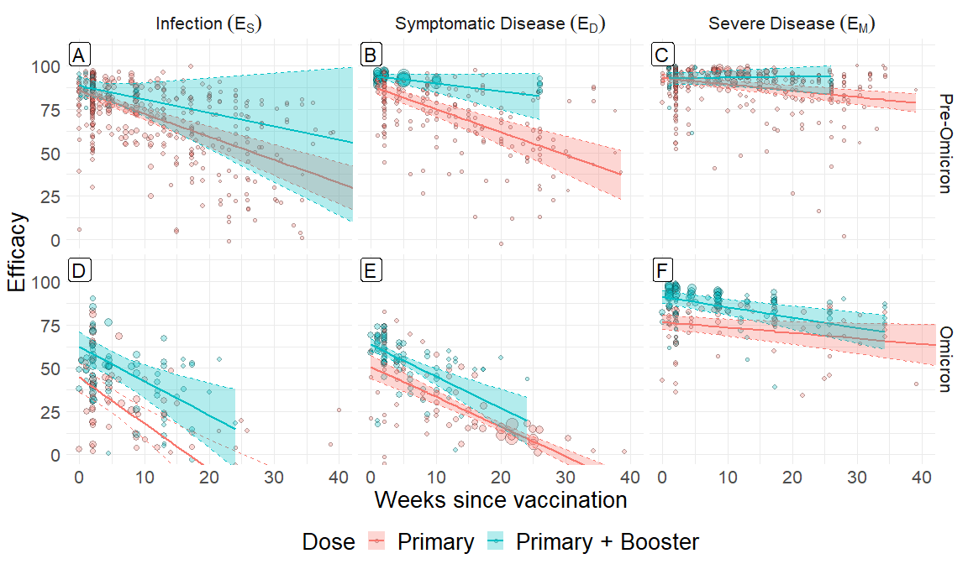

Figure 3: Protection against any infection, symptomatic disease, and severe disease by booster status and time since most recent vaccination relative to an immune-naive population. Top and bottom rows show protection against pre-Omicron and Omicron variants, respectively.

Table 4: Unadjusted estimates of vaccine efficacy by booster status at two and thirty weeks since most recent dose and the change over that time frame with 95% confidence intervals. Analysis was stratified by clinical outcome and infecting strain. Significance of the impact of strain replacement and of time since vaccination was evaluated with a two-sided t-test. Listed p-values indicate the significance of the strain replacement. Significance of the change over time is indicated by *(p<.05), **(p<.01), and ***(p<.001).

| Outcome | Strain | Dose | Initial (Week 2) | Waned (Week 30) | Change |
| --- | --- | --- | --- | --- | --- |
| Any Infection | Pre-Omicron | Primary | 83.1 (80.8 - 85.4) | 45.9 (36.9 - 54.8) | 37.2 (28.5 - 45.9)*** |
| Primary + Booster | 86.9 (82.2 - 91.7) | 65.2 (33.4 - 97.1) | 21.7 (-10.8 - 54.1) |
| p-value | 0.13 | 0.23 | 0.34 |
| Omicron | Primary | 39.2 (31.8 - 46.6) | -35.2 (-62.9 - -7.6) | 74.4 (45.1 - 100.0)*** |
| Primary + Booster | 58.2 (50.5 - 66.0) | 3.0 (-26.5 - 32.5) | 55.2 (24.0 - 86.5)*** |
| p-value | <.001 | 0.06 | 0.45 |
| Symptomatic Disease | Pre-Omicron | Primary | 85.8 (82.3 - 89.2) | 48.7 (37.8 - 59.6) | 37.1 (26.4 - 47.8)*** |
| Primary + Booster | 93.7 (92.0 - 95.4) | 80.7 (65.5 - 95.8) | 13.0 (-1.0 - 27.0) |
| p-value | <.001 | <.001 | <.001 |
| Omicron | Primary | 47.2 (41.0 - 53.4) | -1.0 (-5.1 - 3.0) | 48.2 (39.2 - 57.3)*** |
| Primary + Booster | 59.8 (56.9 - 62.8) | 8.6 (-9.0 - 26.2) | 51.2 (32.4 - 70.0)*** |
| p-value | 0.005 | 0.61 | 0.66 |
| Severe Disease | Pre-Omicron | Primary | 92.4 (90.4 - 94.4) | 82.1 (77.9 - 86.3) | 10.3 (6.7 - 13.9)*** |
| Primary + Booster | 92.9 (89.4 - 96.3) | 94.6 (82.5 - 100.0) | -1.7 (-14.2 - 10.7) |
| p-value | 0.78 | 0.04 | 0.06 |
| Omicron | Primary | 76.0 (71.8 - 80.2) | 67.3 (58.4 - 76.1) | 8.8 (1.2 - 16.4)* |
| Primary + Booster | 90.0 (86.2 - 93.8) | 73.4 (64.4 - 82.4) | 16.6 (9.2 - 24.0)*** |
| p-value | <.001 | 0.007 | 0.02 |

### Natural and hybrid immunity were more durable that vaccine-induced immunity

Immune responses were much more durable following natural infection than vaccination alone (Figure 4 and Table 5). Initial protection against pre-Omicron variants was similar following natural infection and vaccination for both infections (, Figure 4 top left), 84.2 (78.9 - 89.5) vs 83.0 (80.7 - 85.4), and symptomatic disease (, Figure 4 top right), 85.8 (78.9 - 92.7) vs 86.1 (83.2 - 89.1). However by thirty weeks after the immune conferring event, both and were significantly greater following natural infection than vaccination: 77.0 (64.3 - 89.7) vs 47.1 (39.4 - 54.8), and 81.0 (47.4 - 114.6) vs 46.0 (33.5 - 58.6), respectively.

Natural immunity was also more durable following the strain replacement of Omicron (Figure 4 bottom row). against Omicron variants was significantly greater than vaccine-induced immunity at both two weeks, 51.3 (40.5 - 62.1) vs 40.0 (31.5 - 48.5) , and thirty weeks, 36.8 (25.3 - 48.4) vs -6.6 (-20.4 - 7.2). against Omicron variants was also significantly greater at thirty weeks following infection, 25.8 (9.7 - 41.9), than thirty weeks following vaccination, -1.5 (-10.4 - 7.4).

Vaccine-induced immunity was also significantly more durable among those with prior infection (i.e among those with hybrid immunity) compared to those with no history of infection. against pre-Omicron variants was 86.7 (77.5 - 95.9) at two weeks and remained at 90.1 (73.5 - 106.8), significantly greater than in those with no prior infection. against Omicron variants was also higher in those with hybrid immunity than among those with no prior infection at both two weeks, 73.5 (61.7 - 85.3) , and thirty weeks, 43.1 (28.2 - 57.9).

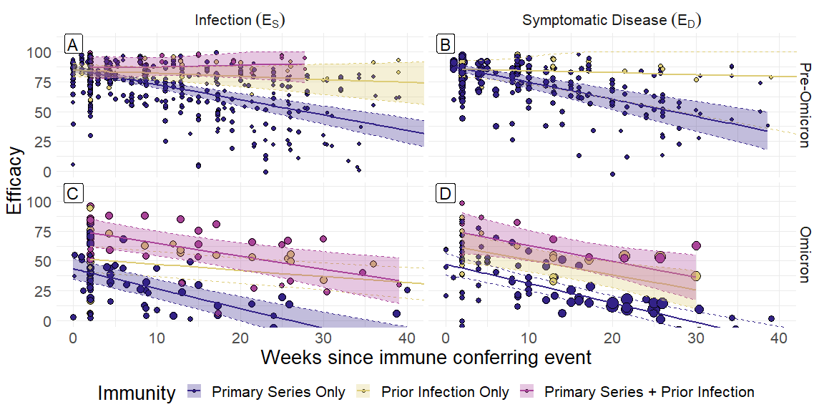

Figure 4: Protection against any infection and symptomatic disease by immune status and time since most recent immune conferring event relative to an immune-naive population. For individuals who received primary vaccination with prior infection time since immune conferring event refers to time since vaccination.

Table 5: Unadjusted estimates of immune efficacy by immune type at two and thirty weeks since most recent immune conferring event and the change over that time frame with 95% confidence intervals. Primary = Primary series only, Natural Imm. = Prior infection onlu, Hybrid = Prior Infection followed by Primary series. Analysis was stratified by infecting strain and clinical outcome. Significance of the impact of strain replacement and of time since vaccination was evaluated with a two-sided t-test. Listed p-values indicate the significance of the strain replacement. Significance of the change over time is indicated by *(p<.05), **(p<.01), and ***(p<.001).

| Outcome | Infecting Strain | Immunity | Initial (Week 2) | Waned (Week 30) | Change |
| --- | --- | --- | --- | --- | --- |
| Any Infection | Pre-Omicron | Primary | 83.0 (80.7 - 85.4) | 47.1 (39.4 - 54.8) | 36.0 (28.3 - 43.6)*** |
| Natural Imm. | 84.2 (78.9 - 89.5) | 77.0 (64.3 - 89.7) | 7.2 (-5.8 - 20.2) |
| Hybrid | 86.7 (77.5 - 95.9) | 90.1 (73.5 - 106.8) | -3.4 (-23.5 - 16.7) |
| Imm. vs Pri. | 0.67 | <.001 | <.001 |
| Hyb. vs Pri. | 0.43 | <.001 |
| Omicron | Primary | 40.0 (31.5 - 48.5) | -6.6 (-20.4 - 7.2) | 46.6 (32.9 - 60.3)*** |
| Natural Imm. | 51.3 (40.5 - 62.1) | 36.8 (25.3 - 48.4) | 14.5 (7.0 - 21.9)*** |
| Hybrid | 73.5 (61.7 - 85.3) | 43.1 (28.2 - 57.9) | 30.5 (13.8 - 47.1)*** |
| Imm. vs Pri. | 0.06 | <.001 | <.001 |
| Hyb. vs Pri. | <.001 | <.001 | 0.14 |
| Symptomatic Disease | Pre-Omicron | Primary | 86.1 (83.2 - 89.1) | 46.0 (33.5 - 58.6) | 40.1 (29.1 - 51.1)*** |
| Natural Imm. | 85.8 (78.9 - 92.7) | 81.0 (47.4 - 114.6) | 4.8 (-28.2 - 37.8) |
| Imm. vs Pri. | 0.93 | 0.05 | 0.05 |
| Omicron | Primary | 44.0 (35.7 - 52.2) | -1.5 (-10.4 - 7.4) | 45.5 (33.0 - 58.0)*** |
| Natural Imm. | 60.9 (48.3 - 73.5) | 25.8 (9.7 - 41.9) | 35.1 (13.6 - 56.6)** |
| Hybrid | 73.4 (56.4 - 90.4) | 36.2 (17.0 - 55.3) | 37.2 (10.0 - 64.4)** |
| Imm. vs Pri. | 0.03 | 0.004 | 0.41 |
| Hyb. vs Pri. | 0.002 | <.001 | 0.58 |

The strength and durability of natural and hybrid immunity depended on the variant of the prior infection as well as time since most recent immune conferring event (Figure 5 and Table 6). Although some studies explicitly recorded the infecting strain of previously infected individuals, in general we categorized infection during a window including any time after December 1, 2021 as “Omicron” and the remainder as “Pre - Omicron”. against Omicron variants were similar two weeks following either a “Pre - Omicron” infection or primary vaccination ,37.4 (25.5 - 49.3) vs 39.6 (31.5 - 47.7); though natural immunity was greater after thirty weeks,30.0 (18.7 - 41.3) vs -6.6 (-19.4 - 6.3). Hybrid immunity provided the most protection at both time points (Figure 5 top left). A similar trend was observed in : natural immunity from a pre-Omicron variant provided similar protection against Omicron variants as primary vaccination at two weeks, 52.4 (38.2 - 66.5) vs 44.0 (36.2 - 51.8), and this protection proved to be more robust at thirty weeks,38.6 (21.1 - 56.0), 36.8 (16.8 - 56.8), 49.3 (39.9 - 58.8), 38.5 (26.5 - 50.4), 28.6 (11.8 - 45.4), 13.2 (-51.7 - 78.1), 41.2 (23.7 - 58.8) vs -1.4 (-10.6 - 7.8). Prior infection with Omicron provided robust protection against subsequent reinfection with Omicron,71.1 (57.3 - 84.9), and symptomatic disease,81.6 (61.5 - 100.0), significantly greater than that conferred by primary vaccination (Figure 5 bottom row).

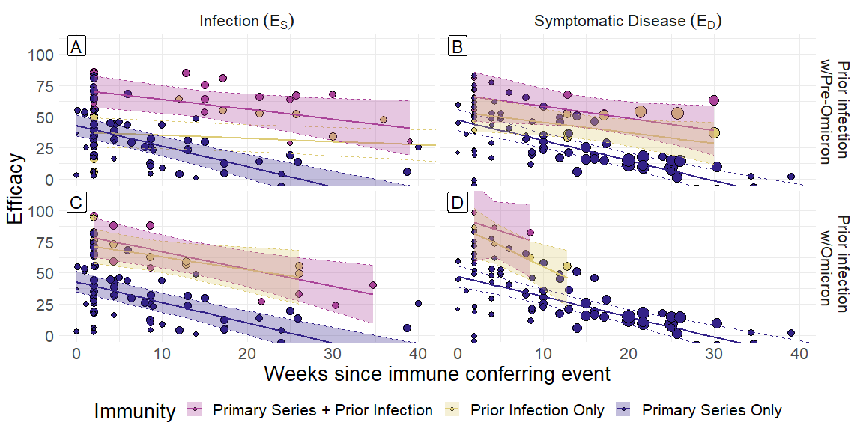

Figure 5: Protection against any Omicron infection and symptomatic disease by type of prior infection and time since most recent immune conferring event relative to an immune-naive population. For individuals who received primary vaccination with prior infection time since immune conferring event refers to time since vaccination.

Table 6: Unadjusted estimates of immune efficacy from by immune type at two and thirty weeks since most recent dose and the change over that time frame with 95% confidence intervals. Analysis was stratified by the variant of the prior infection. Significance of the impact of strain replacement and of time since vaccination was evaluated with a two-sided t-test. Listed p-values indicate the significance of the strain replacement. Significance of the change over time is indicated by *(p<.05), **(p<.01), and ***(p<.001).

| Outcome | Prior Infection | Immunity | Initial (Week 2) | Waned (Week 30) | Change |
| --- | --- | --- | --- | --- | --- |
| Symptomatic Disease |  | Primary | 44.0 (36.2 - 51.8) | -1.4 (-10.6 - 7.8) | 45.4 (32.5 - 58.3)*** |
| Pre-Omicron | Natural Imm. | 52.4 (38.2 - 66.5) | 28.6 (11.8 - 45.4) | 23.7 (-0.6 - 48.1) |
| Hybrid | 66.0 (46.4 - 85.7) | 39.1 (19.3 - 58.9) | 26.9 (-3.6 - 57.4) |
| Imm. vs Pri. | 0.30 | 0.002 | 0.12 |
| Hyb. vs Pri. | 0.04 | <.001 | 0.27 |
| Omicron | Natural Imm. | 81.6 (61.5 - 100.0) | -10.8 (-77.4 - 55.8) | 92.4 (13.9 - 100.0)* |
| Hybrid | 90.3 (58.9 - 100.0) | 28.4 (-136.7 - 100.0) | 61.9 (-125.5 - 100.0) |
| Imm. vs Pri. | <.001 | 0.78 | 0.25 |
| Hyb. vs Pri. | 0.005 | 0.72 | 0.86 |
| Any Infection |  | Primary | 39.6 (31.5 - 47.7) | -6.6 (-19.4 - 6.3) | 46.2 (33.6 - 58.7)*** |
| Pre-Omicron | Natural Imm. | 37.4 (25.5 - 49.3) | 30.0 (18.7 - 41.3) | 7.4 (-0.1 - 14.8) |
| Hybrid | 70.2 (57.6 - 82.8) | 48.1 (31.3 - 64.9) | 22.1 (2.7 - 41.4)* |
| Imm. vs Pri. | 0.73 | <.001 | <.001 |
| Hyb. vs Pri. | <.001 | <.001 | 0.04 |
| Omicron | Natural Imm. | 71.1 (57.3 - 84.9) | 42.7 (17.9 - 67.5) | 28.4 (1.0 - 55.9)* |
| Hybrid | 78.3 (62.1 - 94.4) | 39.3 (19.1 - 59.5) | 39.0 (13.6 - 64.4)** |
| Imm. vs Pri. | <.001 | <.001 | 0.25 |
| Hyb. vs Pri. | <.001 | <.001 | 0.61 |

Finally, we compared and following booster doses in individuals with and without prior infection (Figure 6 and Table 7). At two weeks following a booster dose, individuals with a prior infection had significantly greater , vs and , vs than those with no prior infection. 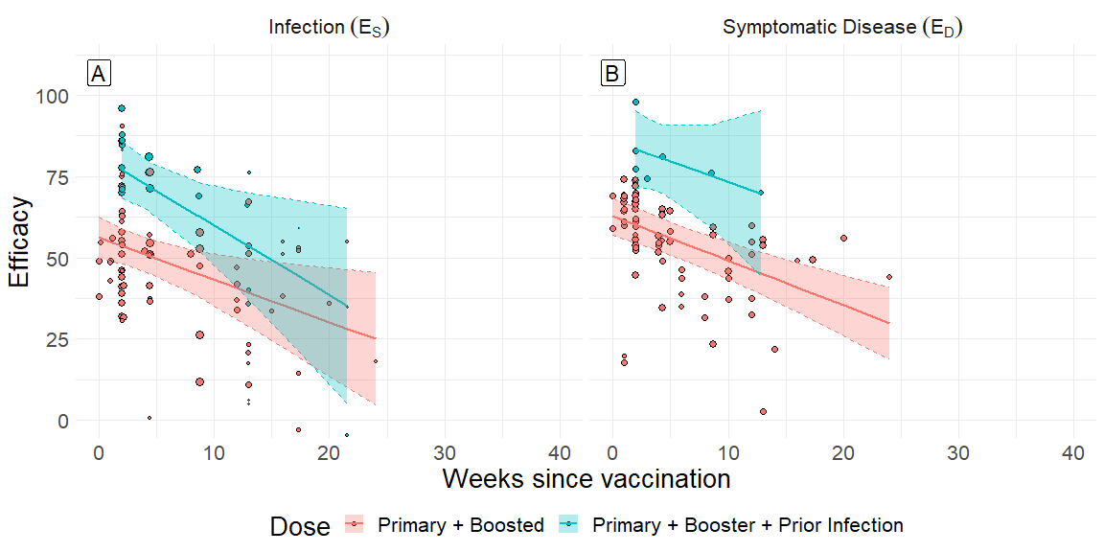

Table 7: Unadjusted estimates of immune efficacy by prior infection at two and thirty weeks since most mRNA booster dose and the change over that time frame with 95% confidence intervals. Primary = Primary series only. Analysis was stratified by infecting strain and clinical outcome. Significance of the impact of strain replacement and of time since vaccination was evaluated with a two-sided t-test. Listed p-values indicate the significance of the strain replacement. Significance of the change over time is indicated by *(p<.05), **(p<.01), and ***(p<.001).

| Outcome | Dose | Initial (Week 2) | Waned (Week 30) | Change |
| --- | --- | --- | --- | --- |
| Any Infection | Primary + Booster | 53.6 (48.1 - 59.1) | 17.2 (-8.8 - 43.2) | 36.4 (9.3 - 63.6)* |
| Primary + Booster + Prior Infection | 77.0 (68.3 - 85.7) | 17.1 (-27.1 - 61.2) | 59.9 (12.3 - 100.0)* |
| p-value | <.001 | 1.00 | 0.32 |
| Symptomatic Disease | Primary + Booster | 60.1 (54.7 - 65.4) | 21.7 (7.6 - 35.7) | 38.4 (23.7 - 53.1)*** |
| Primary + Booster + Prior Infection | 83.4 (71.5 - 95.2) | 48.3 (-21.5 - 100.0) | 35.1 (-39.6 - 100.0) |
| p-value | <.001 | 0.47 | 0.93 |

# Discussion

As SARS-CoV-2 becomes endemic precise estimates of the durability and quality of protection are valuable for guiding ongoing vaccination programs, disease surveillance and other mitigation strategies. In this meta-analysis, we combined data from 123 studies to estimate vaccination-induced and infection-induced protection over time against three outcomes: SARS-2-CoV2 infection, symptomatic COVID-19, and severe COVID-19. We found that 1) all three forms of immunity waned over time, but that protection against severe disease was the most durable, 2) protection against Omicron strains was substantially lower than pre-Omicron strains, 3) booster doses could restore protection against pre-Omicron strains and enhance it against Omicron strains, without improving durability of immunity, 4) prior infection increased the durability of vaccine-induced immunity over time and conferred immunity that was more durable than vaccine-derived, 5) prior infection with a pre-Omicron strain provided similar initial protection as primary vaccination against infection with Omicron strains, but was more durable, and 6) prior infection enhances booster-induced immunity against Omicron strains. These results are consistent with prior meta-analyses, but expand on them due to 1) the inclusion of studies up to January 1st, 2023, 2) a comprehensive analysis of primary and booster-induced immunity, infection-induced immunity, and hybrid immunity, and 3) an analysis of infection-induced immunity following both pre-Omicron and Omicron variants.(Bobrovitz et al. 2023; Stein et al. 2023; Wu et al. 2023; Mohammed et al. 2023; Feikin et al. 2022)

Immunological memory consists of both humoral and cellular responses which may be depleted at different time scales.(Pooley et al. 2023) We have focused upon waning protection over the first 30 weeks after an immune conferring event, due to the availability of data, corresponding roughly to the duration of humoral immunity following vaccination. The maintenance of residual immunity at 30 weeks, especially against severe disease, suggests that long-lived memory CD4+ and CD8+ T cell populations likely continue to provide protection, or that antibody responses in relavent respiratory compartments may differ from those measured in blood. Future study will be necessary to quantify the strength and durability of that protection following primary vaccination, booster doses, and infection.

Our results highlight the importance of booster doses for protecting against new variants. Even though hybrid immunity proved to be more durable than the immunity from vaccination alone, protection against infection and symptomatic disease against Omicron variants still waned significantly over the course of 30 weeks, even among those who got infected by an Omicron variant. It is therefore possible that a new variant could escape from the immunity conferred by Omicron infection, unless that immunity is regularly augmented by booster doses.

As more information on COVID-19 becomes available, estimates of the durability of the immunity will have to be continuously updated. The present study has several limitations. First, all estimates in the meta-analysis were associated with a range of times since the immune conferring event, but many of these ranges were open-ended with a minimum time but no maximum. Therefore, for all estimates, we took the time since immune conferring event to be the minimum time, making our estimates conservative. Second, all estimates in this analysis were relative to previously uninfected and unvaccinated individuals. This sub-population is not randomized, potentially introducing bias. Third, heterogeneity of risk within cohorts can lead to an imbalance between groups, potentially contributing to waning immunity. This can occur if there are unmeasured confounding variables such as differences in exposure or susceptibility to severe disease. Fourth, in this study we assume a linear decline of immunity over time, which we expect to be unlikely to hold beyond thirty weeks. Exponential or bi-exponential decay may be a more appropriate model for the decline of immunity over the course of several years.

A comprehensive understanding of the dynamics of immunity following both vaccination and infection will be critical for future pandemic preparedness. The risk posed by emerging SARS-CoV-2 variants will depend on the population-level protection against infection and severe disease and its robustness to strain replacement. Knowing when and how vaccine protection wanes can help public health officials plan for future vaccination and booster campaigns and offer guidance to individuals about how long protection from vaccination can last. Projecting the impact of inequities distribution of vaccines can (Matrajt et al. 2021) Replenishment of population immunity from ongoing SARS-CoV-2 transmission infections and booster doses must be weighed against the overall waning of immunity over time to assess the potential risk posed by a new emerging variants.

# Bibliography

Antia, Rustom, and M Elizabeth Halloran. 2021. “Transition to endemicity: Understanding COVID-19.” *Immunity* 54 (10): 2172–76.

Basta, Nicole E, M Elizabeth Halloran, Laura Matrajt, and Ira M Longini Jr. 2008. “Estimating Influenza Vaccine Efficacy from Challenge and Community-Based Study Data.” *American Journal of Epidemiology* 168 (12): 1343–52.

Bobrovitz, Niklas, Harriet Ware, Xiaomeng Ma, Zihan Li, Reza Hosseini, Christian Cao, Anabel Selemon, et al. 2023. “Protective Effectiveness of Previous SARS-CoV-2 Infection and Hybrid Immunity Against the Omicron Variant and Severe Disease: A Systematic Review and Meta-Regression.” *The Lancet Infectious Diseases*.

COVIDVaxView. 2024. “COVID-19 Vaccination Coverage and Vaccine Confidence.” <https://www.cdc.gov/vaccines/imz-managers/coverage/covidvaxview/interactive/adults.html>.

Feikin, Daniel R, Melissa M Higdon, Laith J Abu-Raddad, Nick Andrews, Rafael Araos, Yair Goldberg, Michelle J Groome, et al. 2022. “Duration of Effectiveness of Vaccines Against SARS-CoV-2 Infection and COVID-19 Disease: Results of a Systematic Review and Meta-Regression.” *The Lancet*.

Harder, Thomas, Wiebe Külper-Schiek, Sarah Reda, Marina Treskova-Schwarzbach, Judith Koch, Sabine Vygen-Bonnet, and Ole Wichmann. 2021. “Effectiveness of COVID-19 Vaccines Against SARS-CoV-2 Infection with the Delta (b. 1.617. 2) Variant: Second Interim Results of a Living Systematic Review and Meta-Analysis, 1 January to 25 August 2021.” *Eurosurveillance* 26 (41): 2100920.

Higdon, Melissa M, Brian Wahl, Carli B Jones, Joseph G Rosen, Shaun A Truelove, Anurima Baidya, Anjalika A Nande, et al. 2022. “A Systematic Review of Coronavirus Disease 2019 Vaccine Efficacy and Effectiveness Against Severe Acute Respiratory Syndrome Coronavirus 2 Infection and Disease.” In *Open Forum Infectious Diseases*, 9:ofac138. 6. Oxford University Press US.

Matrajt, Laura, Julia Eaton, Tiffany Leung, and Elizabeth R Brown. 2021. “Vaccine Optimization for COVID-19: Who to Vaccinate First?” *Science Advances* 7 (6): eabf1374.

Meggiolaro, Angela, Monica Sane Schepisi, Sara Farina, Carolina Castagna, Alessia Mammone, Andrea Siddu, Paola Stefanelli, Stefania Boccia, and Giovanni Rezza. 2022. “Effectiveness of Vaccination Against SARS-CoV-2 Omicron Variant Infection, Symptomatic Disease, and Hospitalization: A Systematic Review and Meta-Analysis.” *Expert Review of Vaccines* 21 (12): 1831–41.

Meggiolaro, Angela, Monica Sane Schepisi, Georgios F Nikolaidis, Daniele Mipatrini, Andrea Siddu, and Giovanni Rezza. 2022. “Effectiveness of Vaccination Against SARS-CoV-2 Infection in the Pre-Delta Era: A Systematic Review and Meta-Analysis.” *Vaccines* 10 (2): 157.

Mohammed, Hassen, Dan Duy Pham-Tran, Zi Yi Michelle Yeoh, Bing Wang, Mark McMillan, Prabha H Andraweera, and Helen S Marshall. 2023. “A Systematic Review and Meta-Analysis on the Real-World Effectiveness of COVID-19 Vaccines Against Infection, Symptomatic and Severe COVID-19 Disease Caused by the Omicron Variant (b. 1.1. 529).” *Vaccines* 11 (2): 224.

Pooley, Nick, Salim S Abdool Karim, Behazine Combadière, Eng Eong Ooi, Rebecca C Harris, Clotilde El Guerche Seblain, Masoumeh Kisomi, and Nabila Shaikh. 2023. “Durability of Vaccine-Induced and Natural Immunity Against COVID-19: A Narrative Review.” *Infectious Diseases and Therapy* 12 (2): 367–87.

Sabu, Jewel Maria, Izza Zahid, Namitha Jacob, Faith O Alele, and Bunmi S Malau-Aduli. 2022. “Effectiveness of the BNT162b2 (Pfizer-BioNTech) Vaccine in Children and Adolescents: A Systematic Review and Meta-Analysis.” *Vaccines* 10 (11): 1880.

Stein, Caroline, Hasan Nassereldine, Reed JD Sorensen, Joanne O Amlag, Catherine Bisignano, Sam Byrne, Emma Castro, et al. 2023. “Past SARS-CoV-2 Infection Protection Against Re-Infection: A Systematic Review and Meta-Analysis.” *The Lancet* 401 (10379): 833–42.

Swan, David A, Chloe Bracis, Holly Janes, Mia Moore, Laura Matrajt, Daniel B Reeves, Eileen Burns, et al. 2021. “COVID-19 Vaccines That Reduce Symptoms but Do Not Block Infection Need Higher Coverage and Faster Rollout to Achieve Population Impact.” *Scientific Reports* 11 (1): 15531.

Van den Noortgate, Wim, José Antonio López-López, Fulgencio Marı́n-Martı́nez, and Julio Sánchez-Meca. 2015. “Meta-Analysis of Multiple Outcomes: A Multilevel Approach.” *Behavior Research Methods* 47: 1274–94.

Wu, Nana, Keven Joyal-Desmarais, Paula AB Ribeiro, Ariany Marques Vieira, Jovana Stojanovic, Comfort Sanuade, Doro Yip, and Simon L Bacon. 2023. “Long-Term Effectiveness of COVID-19 Vaccines Against Infections, Hospitalisations, and Mortality in Adults: Findings from a Rapid Living Systematic Evidence Synthesis and Meta-Analysis up to December, 2022.” *The Lancet Respiratory Medicine* 11 (5): 439–52.

Zeng, Baoqi, Le Gao, Qingxin Zhou, Kai Yu, and Feng Sun. 2022. “Effectiveness of COVID-19 Vaccines Against SARS-CoV-2 Variants of Concern: A Systematic Review and Meta-Analysis.” *BMC Medicine* 20 (1): 1–15.