Experimental Objective: To determine what percentage of murine small cell lung cancer cells express the target protein CD24 after CRISPR knockout
Background: CD24 is a “Do not eat me signal” that prevents tumor cells from being attacked by immune phagocytes such as macrophages. We have conducted lenti-CRISPR assays using guides specifically targeted to knock out CD24 from our murine small cell lung cancer cell lines as well as a non-targeting guide in the same vector. We have confirmed that the knock-out cell line has negatively enriched levels of RNA expression relative to the control cell line. This experiment describes how we used flow cytometry to compare the level of protein expression of the knockout cell line to the control cell line.
Method: Cultures from each cell line were grown in triplicate for 48 hours. The cells were harvested, washed with PBS, and stained with 100µl fixable aqua live/dead dye (Thermo Fisher, cat# L23105) for 20 minutes at 4°C per the manufacturer instructions. Cells were then washed with PBS and stained with 100µl of anti-CD24 antibody (clone: M1/69) conjugated to PE (Biolegend cat# 101807) for 20 minutes at 4°C. Upon completion of the stain, cells were washed and resuspended in 150µl PBS. Flow cytometry was used to determine the percent of CD24-positive cells from the knock-out and the control line using the BD FACSymphony A3 Cell Analyzer (BD).

Results: Flow cytometry confirmed that the control cell lines were ~95% positive for CD24 while the knockout cell lines each were completely negative.
Conclusion: The knockout cell line and its corresponding control cell line demonstrate differential CD24 protein expression making it a valid model for further interrogating the role of the marke r in tumor biology.

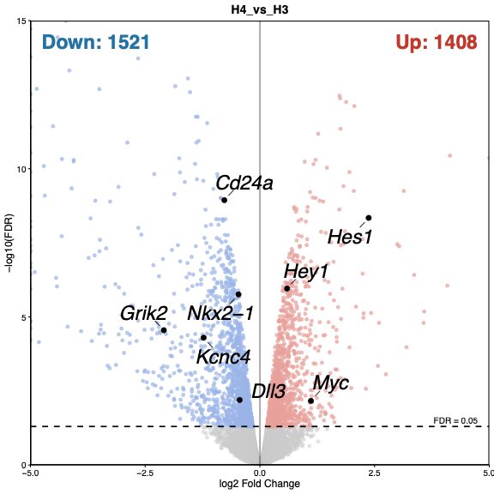

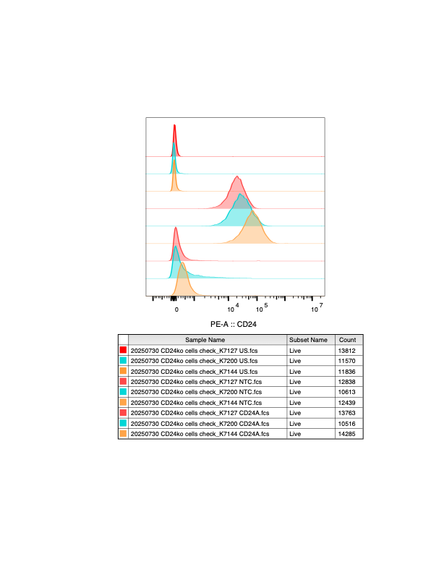
K7127
K7200
K7144
Unstained
Non-Targeting
CD24KO

CD24

