VIROBLAST Help

There are three steps to start VIROBLAST search:

- Copy and paste multiple query sequences in fasta format to text box, or upload a sequence fasta file.
- Choose a database to blast against. The databases include lab local sequence database, public databases or user’s own sequence database.
- Select a proper cutoff criterion to screen the output.

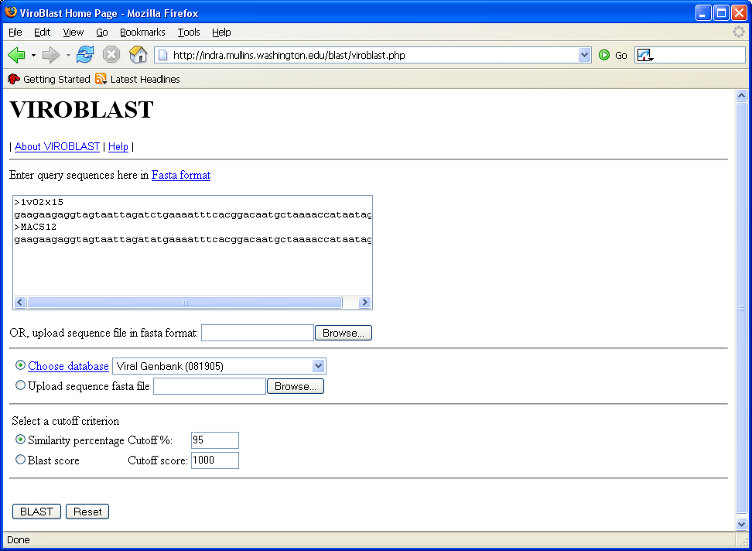

Click “BLAST” button to start search.

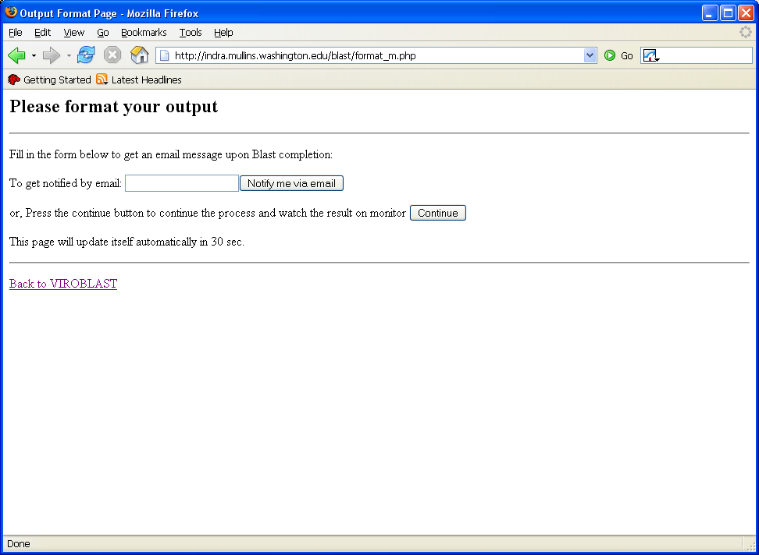
Input email address and click “Notify me via email” button, the VIROBLAST will send user an email with a link to the result upon job done. Or click “Continue” button to continue.

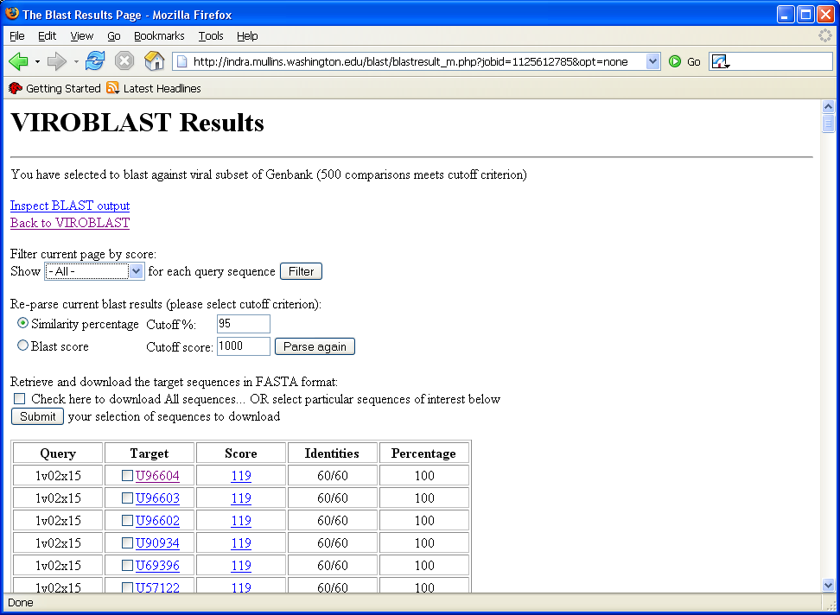

This tabular output lists the blast results that match the query criterion.

- User can reset different parameters to filter and parse again the tabular output.

- Clicking one of links in Target field will link to NCBI web site of the particular sequence if applicable.

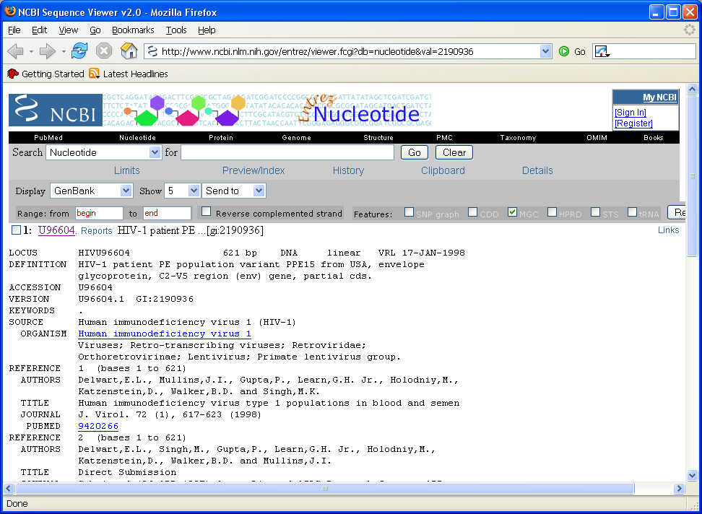

- Clicking one of links in Score field will locate the blast result of particular query sequence in the blast result file.

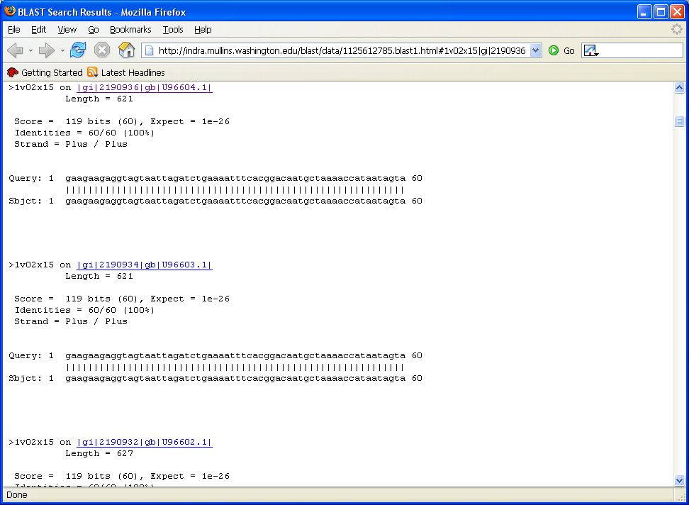

- Clicking “Inspect BLAST output” link will open the blast result file.

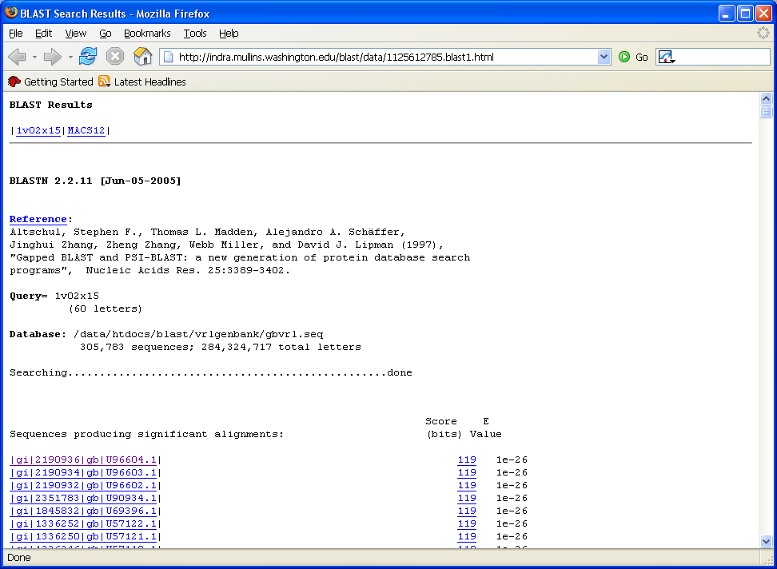

The VIROBLAST automatically divides a big output file into several small files to allow users downloading files quickly and easily. It also provides links to each query sequence blast result for the convenience of analysis of results.

- Check the target sequences to be downloaded or check to download all sequences and click “Submit” button.

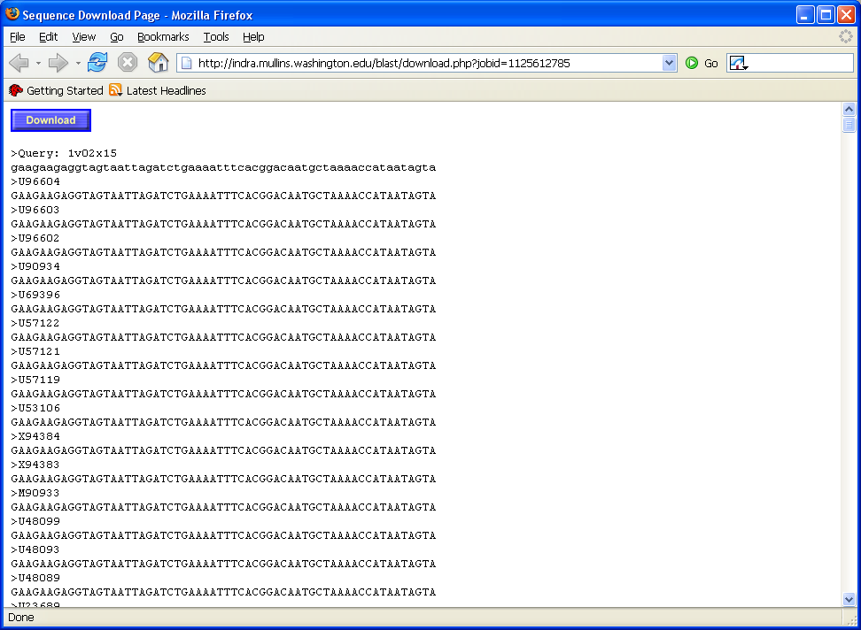

Click “Download” button to download aligned sequences.

