Add elements

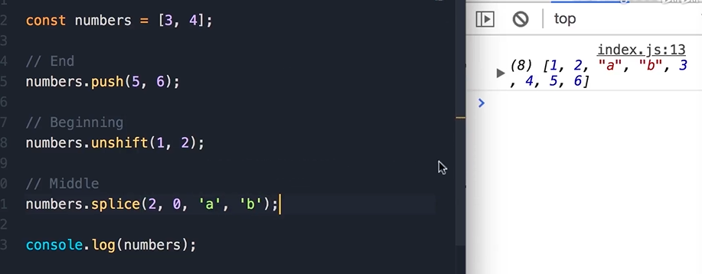

Find elements

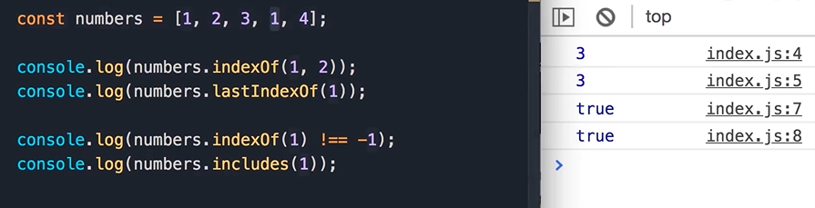

Find element (Object)

find, findIndex

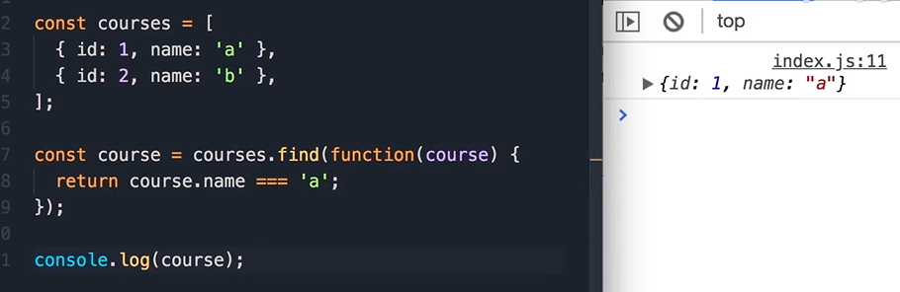

Remove elements

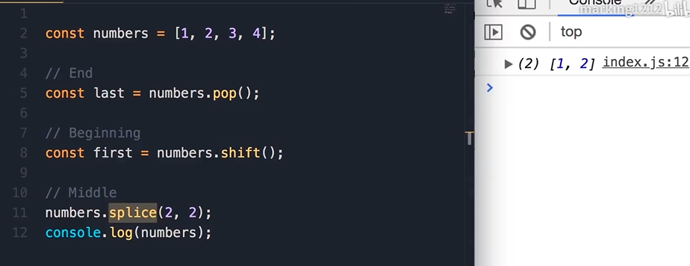

Empty Array

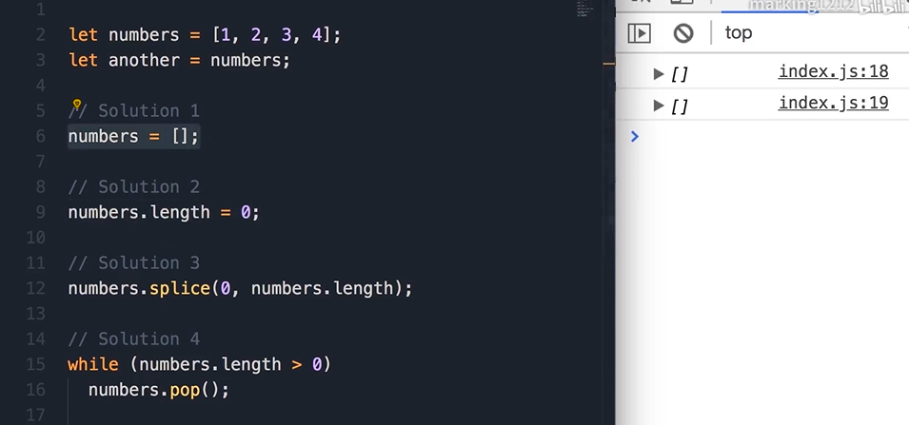

Combining and Slicing Array

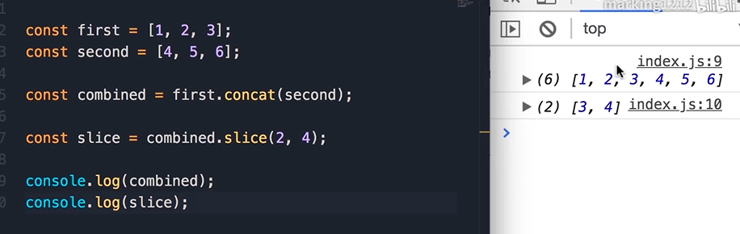

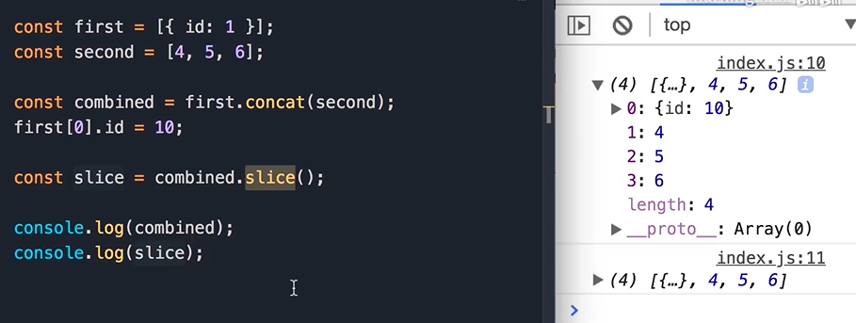

拆分操作符

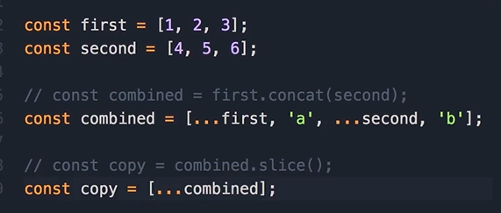

forEach, join, split,

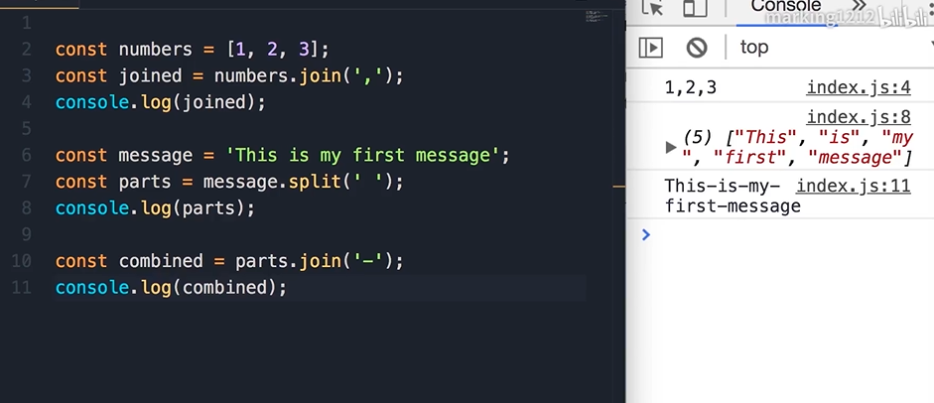

sort, reverse

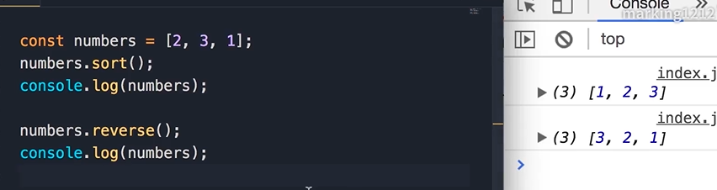

大小写敏感

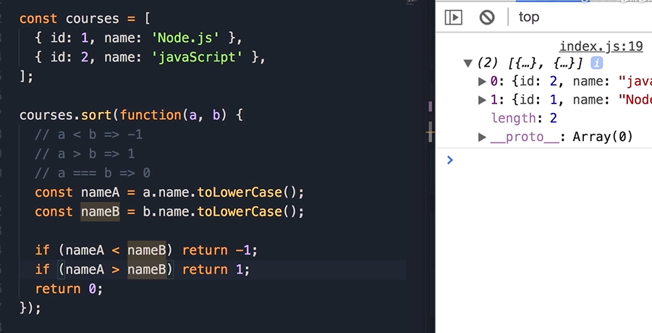

ascii table

<https://www.cs.cmu.edu/~pattis/15-1XX/common/handouts/ascii.html>

every, some

filter, map

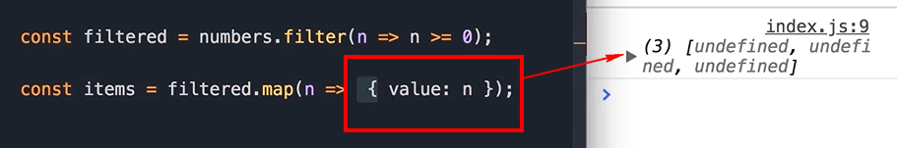

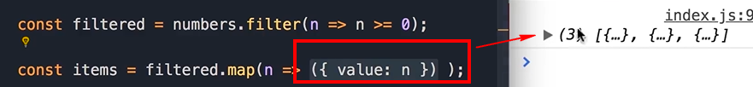

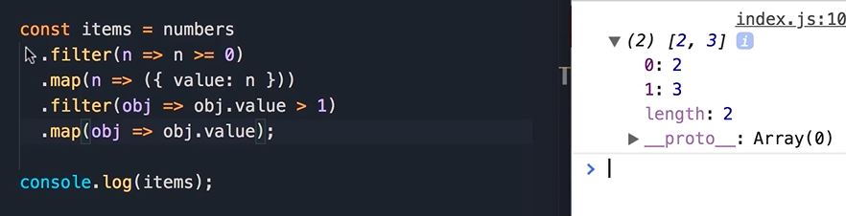

reduce

