

Factory Function

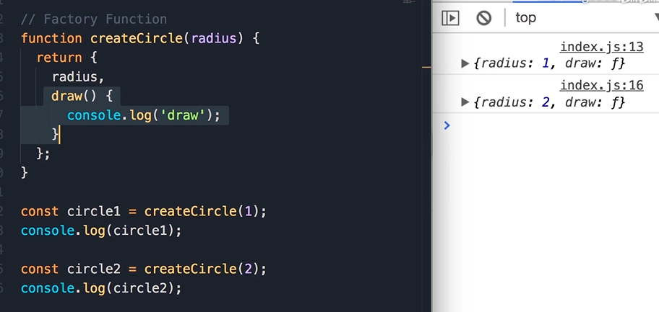

Constructor Function

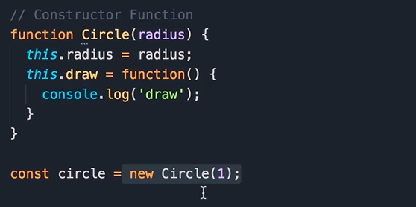

new 做的事情

1. 创建一个empty object
2. 将this 指向 object
3. 将创造好的object 返回

动态改变对象的属性和方法

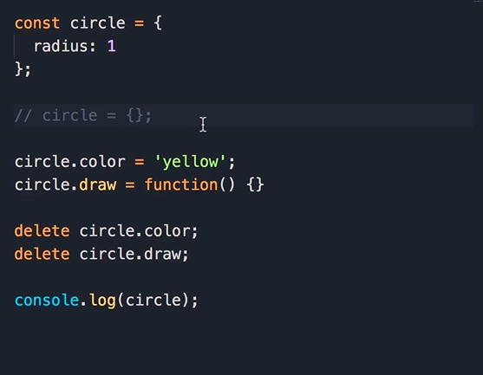

Constructor Property

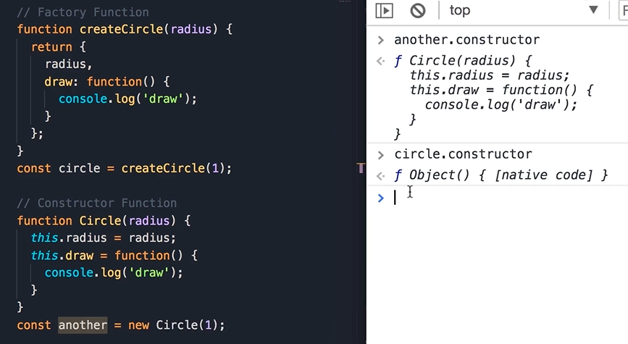

Functions are Objects

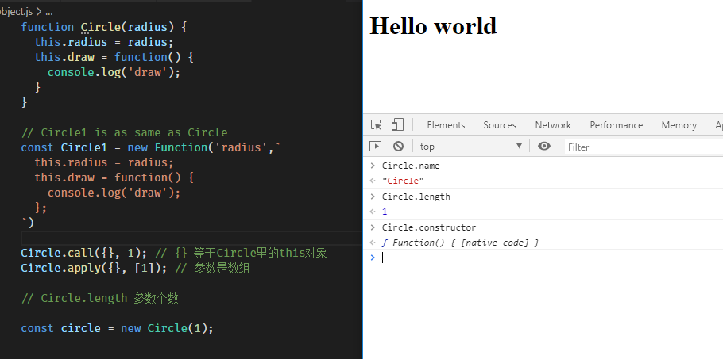

Object Type

Increase 里的number和外面的number完全不一样

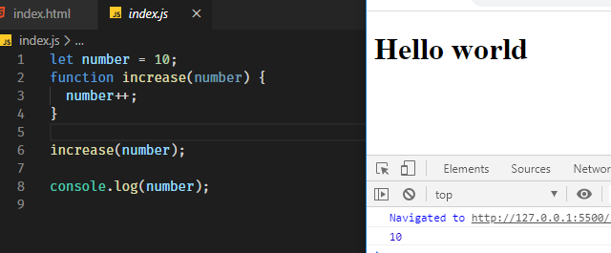

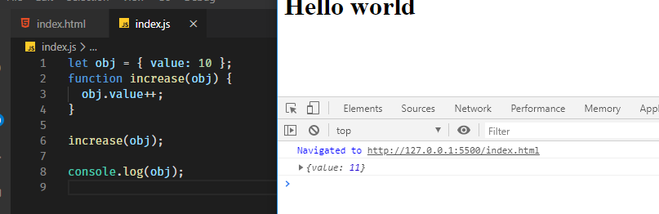

Enumerating Properties of an Object

for … of 只可用于枚举类型，不可用于对象

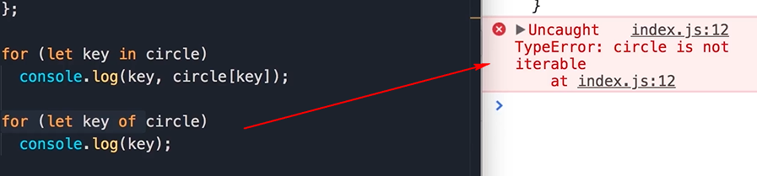

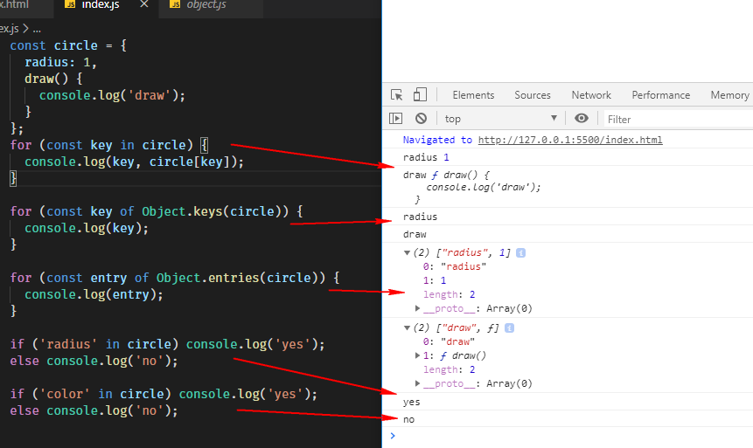

Clone an Object

1. Assign

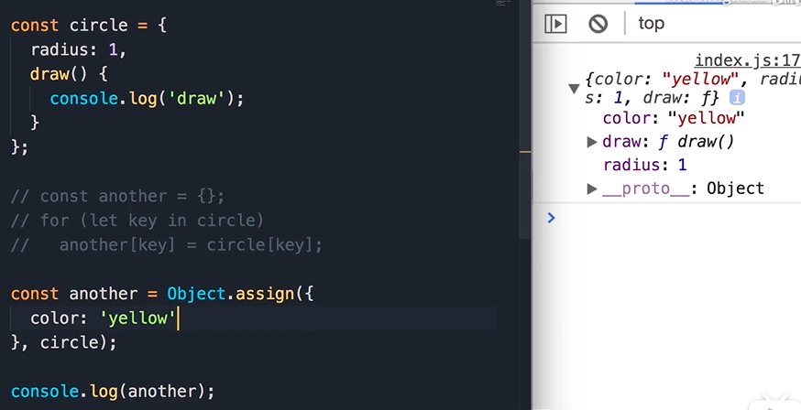

1. 拆分操作符

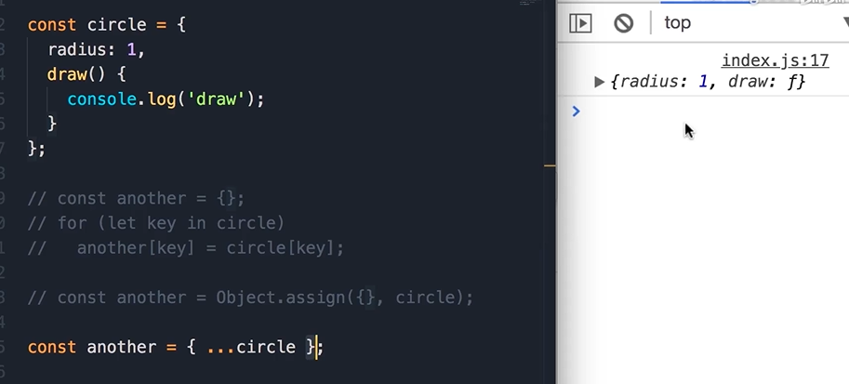

Math

<https://developer.mozilla.org/en-US/docs/Web/JavaScript/Reference/Global_Objects/Math>

两种类型的String

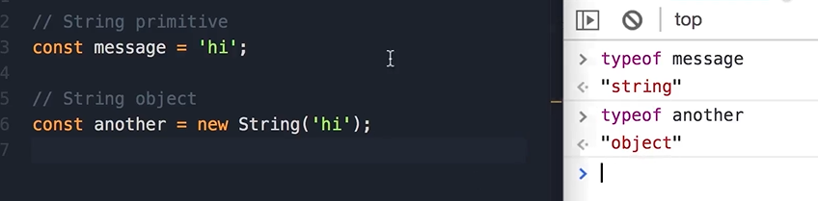

<https://developer.mozilla.org/en-US/docs/Web/JavaScript/Reference/Global_Objects/String>

转义字符

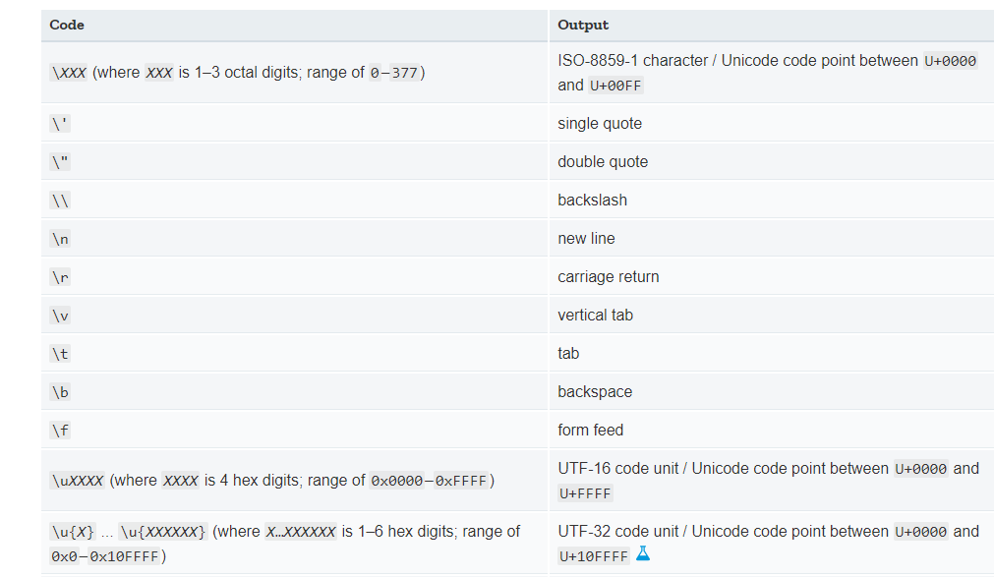

模板语法

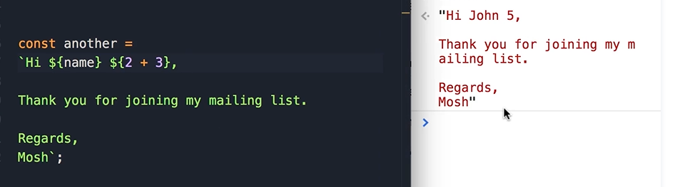

Date

<https://developer.mozilla.org/en-US/docs/Web/JavaScript/Reference/Global_Objects/Date>

月份少1

