**Self-hosting**

代码全面控制NS各个方面

* Configuration
* [Logging](https://docs.particular.net/nservicebus/logging/)
* [Dependency injection](https://docs.particular.net/nservicebus/dependency-injection/)
* [Startup and Shutdown](https://docs.particular.net/samples/startup-shutdown-sequence/)
* [Endpoint Lifecycle](https://docs.particular.net/nservicebus/lifecycle/)
* [Critical Error handling](https://docs.particular.net/nservicebus/hosting/critical-errors)

开启 endpoint

**var** endpointInstance2 = **await** Endpoint.Start(endpointConfiguration) .ConfigureAwait(false);

关闭

**await** endpointInstance.Stop().ConfigureAwait(false);

### Windows Service hosting

### Docker container hosting

### Web hosting

### Service Fabric hosting

### Multi-hosting

hosting multiple NServiceBus endpoints in a single .NET process

### Send-only hosting

**var** endpointConfiguration = **new** EndpointConfiguration("EndpointName"); endpointConfiguration.SendOnly();

### Accessing the bus

不通过NServiceBus APIs 直接访问bus

#### Using dependency injection

#### Static variable

# Endpoints

通过message交互

有一系列message handler 和 sagas

可部署在多个机器和环境

配置 <https://docs.particular.net/samples/endpoint-configuration/>

## Input queue

默认input queue name和endpoint name 一样，可重写

endpointConfiguration.OverrideLocalAddress("MyEndpoint.Messages");

# Selecting a host

NS可以host在多个process

# Startup diagnostics

输出地址 AppDomain.CurrentDomain.BaseDirectory，  web applications例外：App_Data

改变输出地址 endpointConfiguration.SetDiagnosticsPath("myCustomPath");

### Sample content

## Writing to other targets

自己控制日志

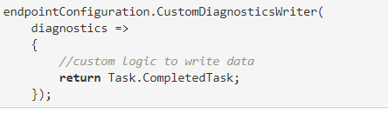

## Adding startup diagnostics sections

需要跑代码理解

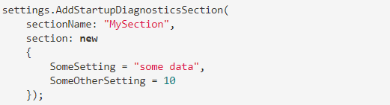

# Transactions and Message Processing

NS根据选择的transport不同提供四级message一致性保证，默认是TransactionScope ，默认timeout limit is 1 minute，可以最大调到10 minute

## Distributed Transaction Coordinator

跨多个资源， e.g. queues and databases

## Message processing loop

1. 看queue里有没有message
2. 如果有，事务启动
3. 连接queue接受message
4. 反序列化message，如果失败message被发送到error queue并且 transaction commits
5. 如果成功触发一系列操作，如果失败重试，超过重试次数，transaction roll back，把message发送到error queue

# Decommissioning Endpoints

关闭永久性的endpoint

# Windows Service Installation

# Overriding the host identifier

## Host identifier

$.diagnostics.hostid and $.diagnostics.hostdisplayname 识别唯一的host

## Overriding the host identifier

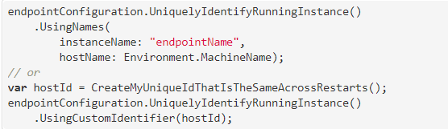

# Overriding app.config settings ?

# Assembly scanning