# Message Headers

## Timestamp format DateTimeExtensions

### NServiceBus.ContentType text/xml or text/json

### NServiceBus.EnclosedMessageTypes

### NServiceBus.MessageId message 唯一Id

### NServiceBus.CorrelationId message 关联Id

### NServiceBus.ConversationId 一系列对话关联的Id

### NServiceBus.RelatedTo

### NServiceBus.MessageIntent

### NServiceBus.MessageIntent

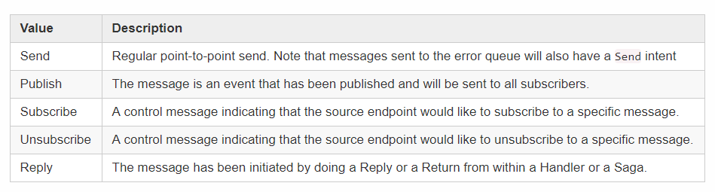

## Send headers

## Reply headers

## Publish headers

## Timeout headers

## Saga-related headers

。。。。。。。。。

# Manipulating message headers

## Reading incoming headers

## Writing outgoing headers

### For all outgoing messages

endpointConfiguration.AddHeaderToAllOutgoingMessages("MyGlobalHeader", "some static value");

# Specify Endpoint Name

## Input queue

# Message routing

logical and physical 两部分组成，logical定义哪个endpoint接受什么message，physical定义哪个endpoint实例接受哪个message

## Command routing

发送到一个endpoint

### Overriding the destination

## Event routing

被多个endpoint接收， 但如果一个endpoint有多个实例，只有一个实例会接收message。Endpoint需要一个message handler

## Reply routing

基于ReplyTo header，与endpoint's routing configuration无关，只有最初的message的发布者可以影响reply routing

# Routing system extensibility points

## Routing APIs 通过API 修改routing

### Command routing

### Event routing

### Physical routing

# Centralized file-based routing

通过文件管理routing

# Scheduling

配置需要重复执行的任务

受[**delayed delivery**](https://docs.particular.net/nservicebus/messaging/delayed-delivery)影响

## When not to use it

任务有if/switch等内部逻辑，用[saga timeouts](https://docs.particular.net/nservicebus/sagas/timeouts)

某一状态发生后要做某些动作，发一个event，不用Scheduler

# Gateway

# NServiceBus Router

## Connecting to the router

## Router configuration

life cycle

## Error handling

# NServiceBus Router two-way bridge topology

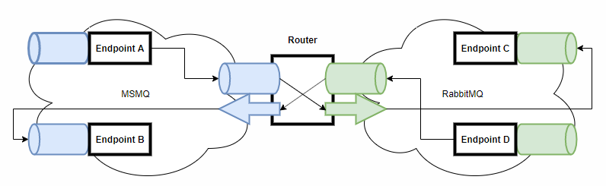

# NServiceBus Router multi-way bridge topology

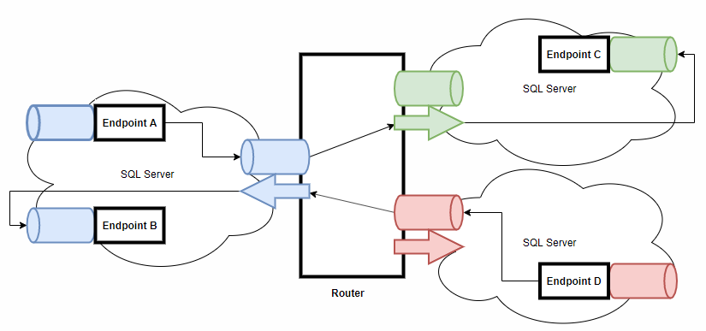

# NServiceBus Router backplane topology

# Transport Bridge

NServiceBus.Bridge is has been deprecated and replaced by NServiceBus.Router.

# Raw messaging using NServiceBus

# It is flexible in terms of message manipulation, therefore it is a good fit for integrations with 3rd party systems, building gateways and bridges.

## Configuration

## Sending

## Receiving

# Audit Filter 是否发送消息到审计队列

### Decorate messages with attributes

### Add to EndpointConfiguration

### Delegate filter fallback

# NServiceBus Mailer

## Enabling

## Usage

# Outbox

# FileShare Attachments store attachments for messages

# SQL Attachments

# Uses a SQL Server [varbinary](https://docs.microsoft.com/en-us/sql/t-sql/data-types/binary-and-varbinary-transact-sql) to store attachments for messages

# DataBus 发送大数据

# FluentValidation message validation

# DataAnnotations message validation

# 