**Recoverability**

* Immediate Retries (previously known as First-Level-Retries)
* Delayed Retries (previously known as Second-Level-Retries)

## Immediate Retries

Can not be use when Transport transactions are disabled.

## Delayed Retries

1. 延迟递增 10、20、30
2. Can not be use when Transport transactions are disabled 并且不支持delayed-delivery.

## Fault handling

当message持续失败，message会被移到error queue

# Custom Recoverability Policy

recoverability.CustomPolicy(AlertableExceptionPolicy);

## Unrecoverable exceptions

由不可恢复的错误导致失败，重试机制被跳过

MessageDeserializationException 是不可恢复的错误

配置不可恢复的错误

recoverability.AddUnrecoverableException<ValidationException>(); recoverability.AddUnrecoverableException(**typeof**(ArgumentException));

## Total number of possible retries

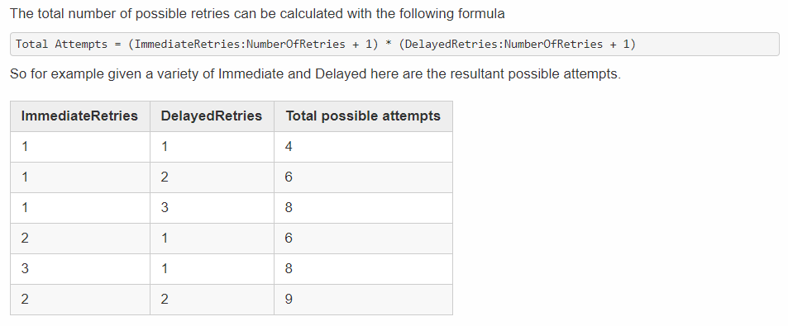

## Retry Logging

## Recoverability memory consumption