# Handlers and Sagas

# Asynchronous Handlers

### 计算密集 和 IO密集

### Thread pool

#### Worker thread pool

#### I/O-thread pool

## Calling short-running, compute-bound code

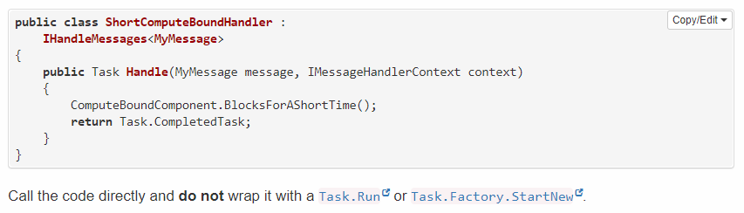

## Calling long-running, compute-bound code

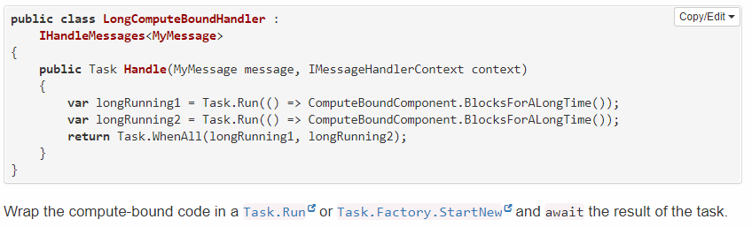

## Return or await

### Await the task

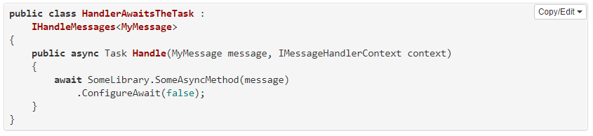

### Return the task 可避免使用async

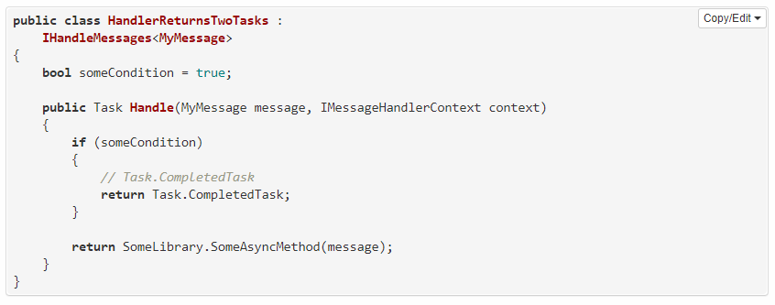

## Concurrency 并发

# 少量并发

#### Batched

  Batching means messages are kept in memory and sent out when the handler is completed.

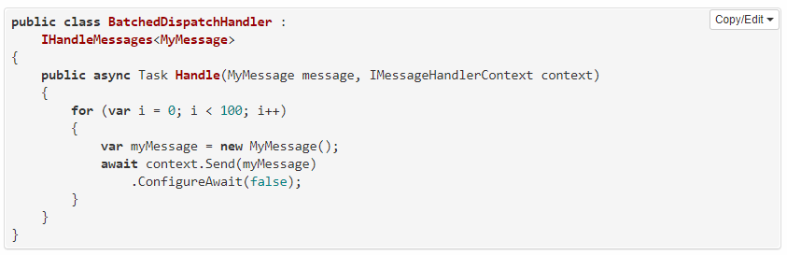

#### Immediate dispatch

# 

# 大量并发

## Integration with non-tasked based APIs

### Events

### Asynchronous programming model (APM) pattern

### Asynchronous RPC calls

# Handlers

# To handle messages of all types

### Mapping to name

**var** fqn = message.GetType().AssemblyQualifiedName;

**var** fallback = message.GetType().FullName;

## Behavior when there is no handler for a message

# Accessing and modifying data

## Without using NServiceBus persistence

### Transport in native transaction mode

当创建订单的Handler被调用多次，导致创建多条订单，怎么处理

### Transport in distributed transaction mode

## Using NServiceBus persistence

分享上下文，保证不会有同样数据被插入多次

SQL Server, MySQL, PostgreSQL, Oracle, and RavenDB

 SynchronizedStorageSession

### Transport in native transaction mode

同一Message可被commit多次，用户保证幂等性

# Handler Ordering

# Sagas

## A simple saga

## Long-running means stateful

**public** **class** **OrderSagaData** : **ContainSagaData** { **public** **string** OrderId { **get**; **set**; } }

## Adding behavior

IHandleMessages<M>

## Starting a saga

IAmStartedByMessages<StartOrder>

# Message Correlation

便于查找已存在的Saga

ConfigureHowToFindSaga/Mapper

**Saga Timeouts**

# SqlSaga base class

### Single Correlation ID

**protected** **override** **string** CorrelationPropertyName => **nameof**(SagaData.CorrelationProperty);

### Correlation and Transitional IDs

### No Correlation ID

# Saga Timeouts

**IHandleTimeouts**<**MyCustomTimeout**>

**public** Task **Timeout**(MyCustomTimeout state, IMessageHandlerContext context)

RequestTimeout<T>

## Timezones and Daylight Saving Time (DST)

# Complex saga finding logic