**Transports**

一个抽象的潜在的队列技术

# Selecting a transport

## Broker versus federated

Broker 模式：大部分transport

Federated 模式： MSMQ

# Different transport types

## Federated transports

## Broker transports

## Unicast-only transports

## Multicast-enabled transports

**Transport Transactions**

## Transactions

四级保证message被发送了，根据选择的transport不同，每级可用性不同

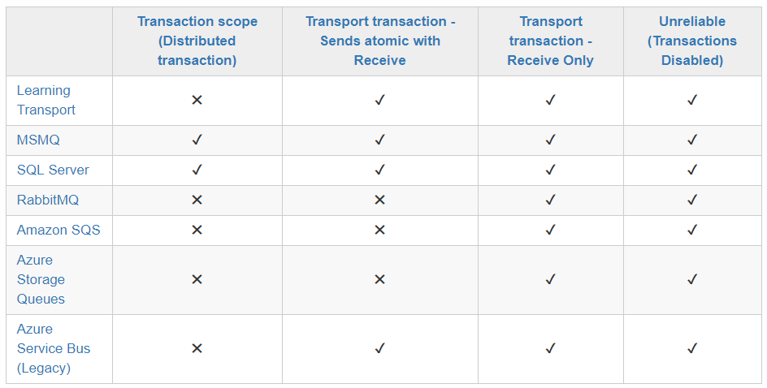

### Transaction scope (Distributed transaction)

