**What is XPath**

**It is a syntax or language for finding any element on the web page using XML path expression**.

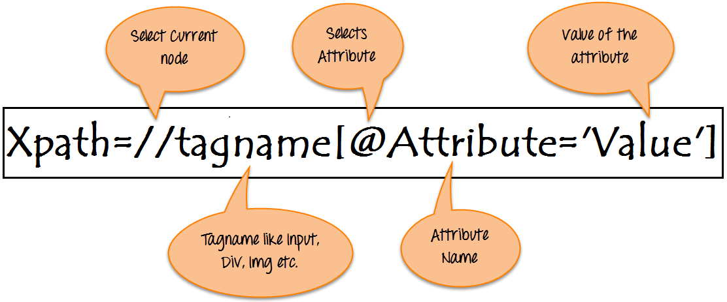

**Syntax for XPath:**

* **// :** Select current node.
* **Tagname:**Tagname of the particular node.
* **@:** Select attribute.
* **Attribute:** Attribute name of the node.
* **Value:** Value of the attribute.

To find the element on web pages accurately there are different types of locators

|  |  |
| --- | --- |
| **XPath Locators** | **Find different elements on web page** |
| **ID** | To find the element by ID of the element |
| **Classname** | To find the element by Classname of the element |
| **Name** | To find the element by name of the element |
| **Link text** | To find the element by text of the link |
| **XPath** | XPath required for finding the dynamic element and traverse between various elements of the web page |
| **CSS path** | CSS path also locates elements having no name, class or ID. |

## Types of X-path

**1) Absolute XPath**

html/body/div[1]/section/div[1]/div/div/div/div[1]/div/div/div/div/div[3]/div[1]/div/h4[1]/b

**2) Relative XPath**

### 1) Basic XPath:

找到属性name是uid的input

Xpath=//input[@name='uid']

### 2) Contains():

找到属性name是包含btn的

Xpath=//*[contains(@name,'btn')]

找到内容是包含here的

Xpath=//*[contains(text(),'here')]

### 3) Using OR & AND:

Xpath=//*[@type='submit' or @name='btnReset']

Xpath=//input[@type='submit' and @name='btnLogin']

### 4) Start-with function:

Xpath=//label[starts-with(@id,'message')]

### 5) Text():

### 6) XPath axes methods:

### a) Following

。。。。

Test: <http://xpather.com/>

<https://www.w3school.com.cn/xpath/xpath_syntax.asp>

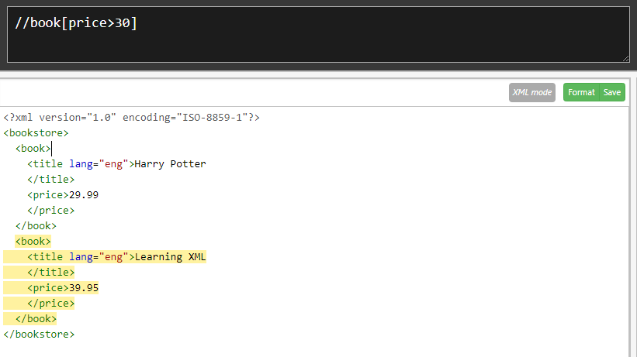

选取同级节点中，title不相等的

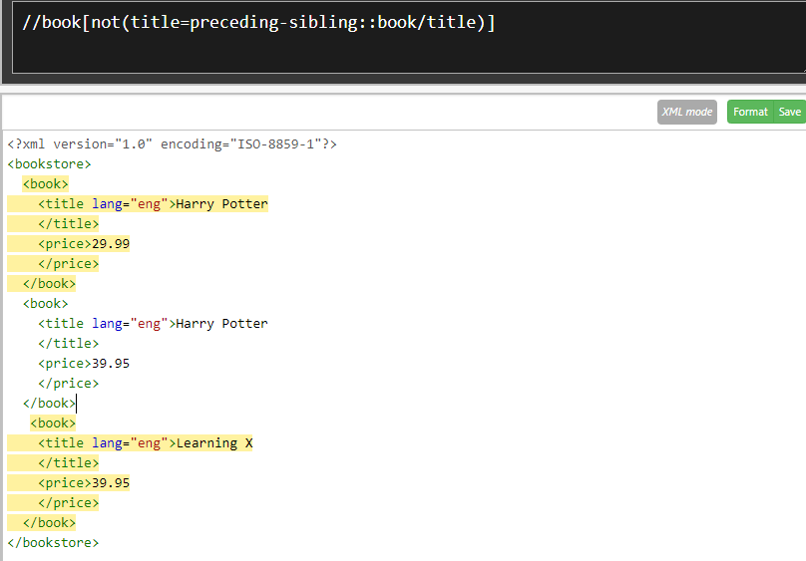

doc(‘xx.xml’)/id(‘A13’)

$book/qty

./price

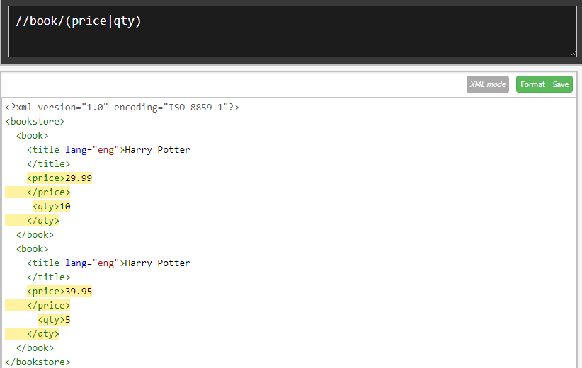

Axis

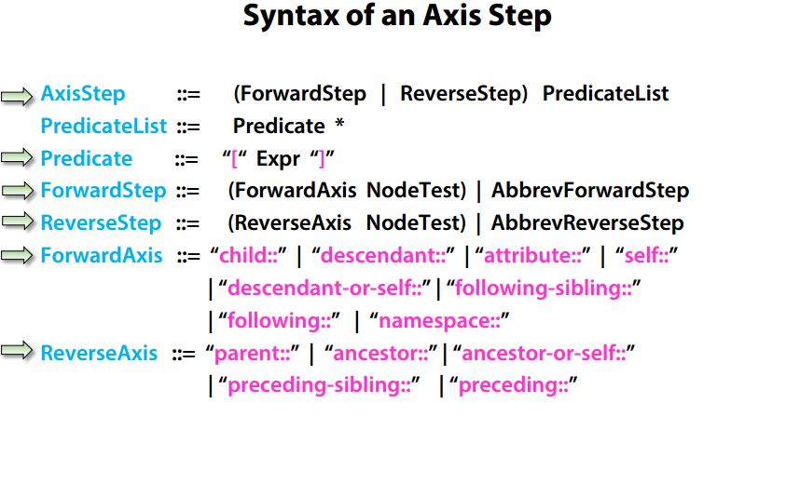

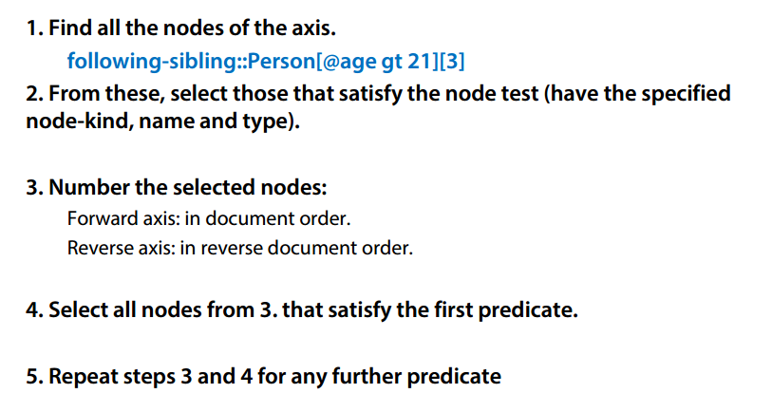

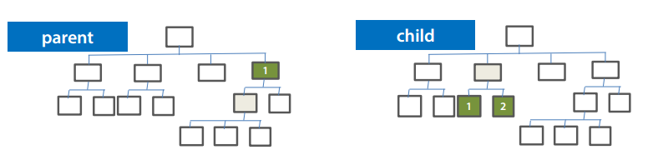 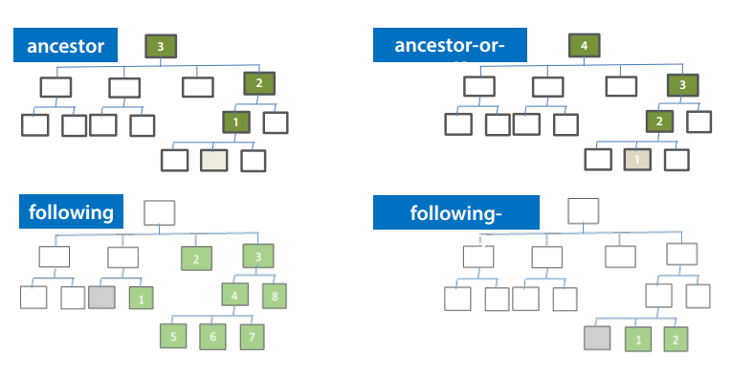 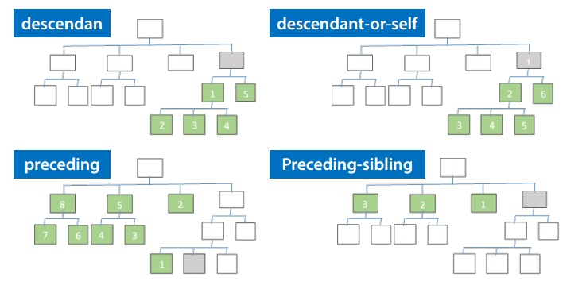 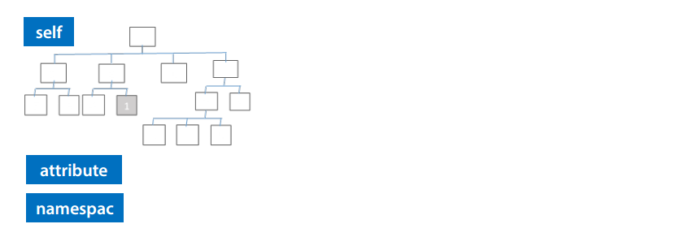

Node Tests