### How to integrate Elyte with Stripe

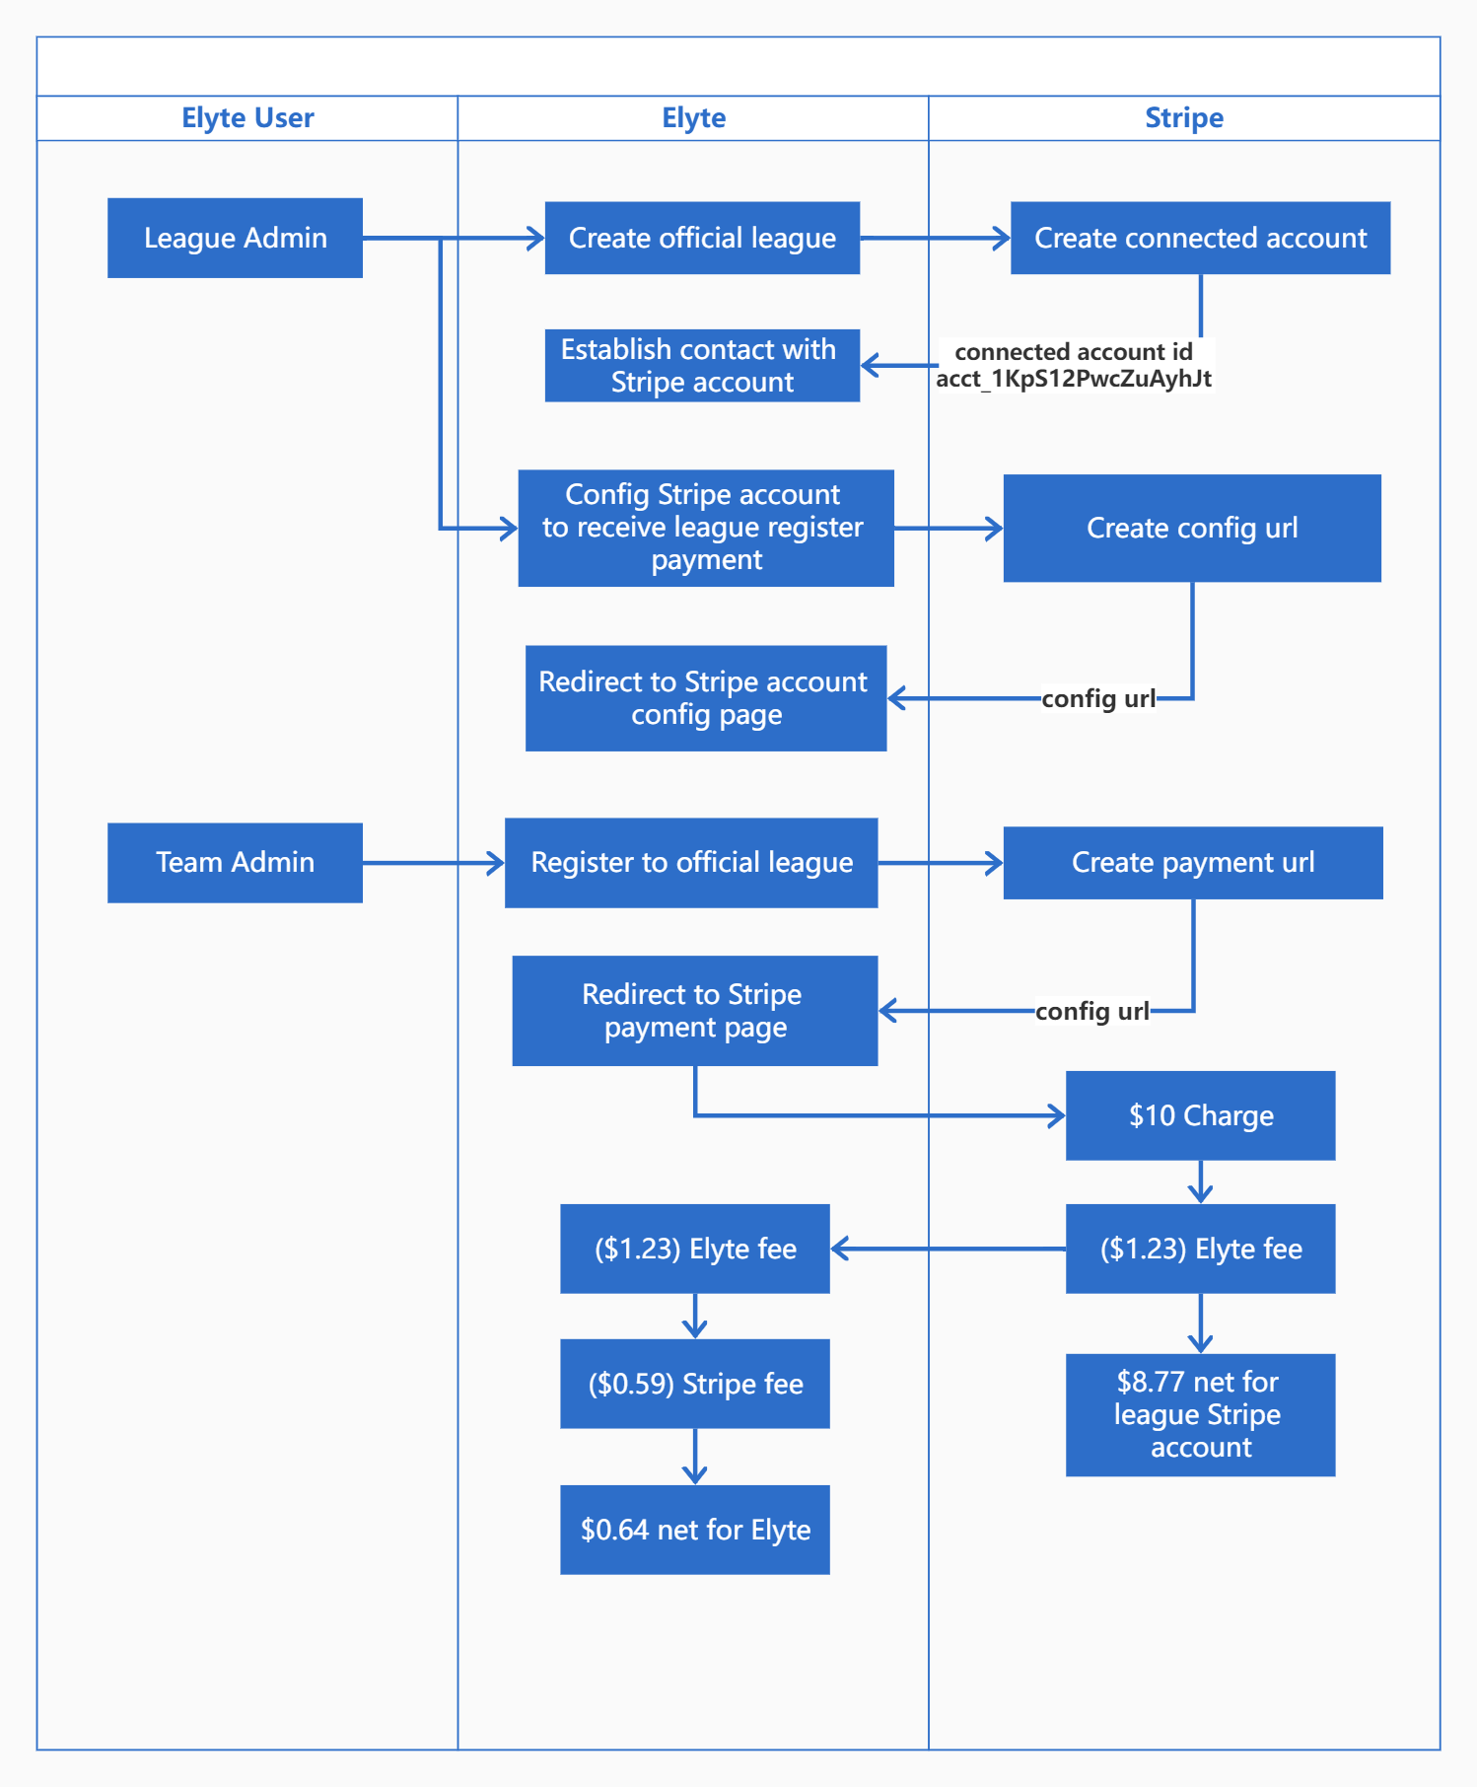

### **Connected Account**

Connect Price

<https://stripe.com/connect/pricing>

Which Stripe Connect account is best for your e-commerce marketplace?

<https://www.cobbleweb.co.uk/which-stripe-connect-account-for-your-marketplace/>

# **Stripe Express Connect**

<https://support.partial.ly/stripe-express-connect/>