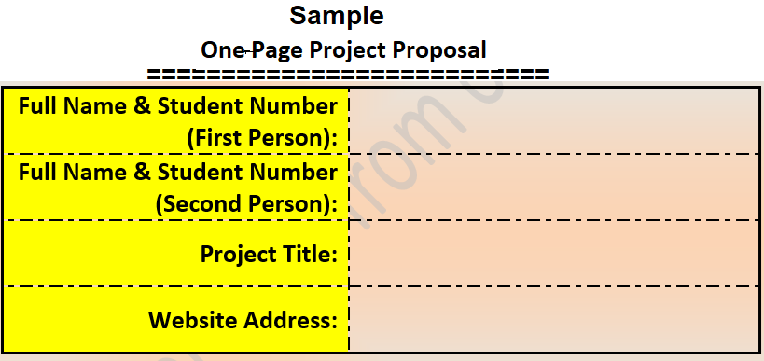

**Frederic Samy Tchedou (813553)**

**Transportation System in India and Togo**

**Karan (812060)**

**Project Description:**

We, Karan (812060) from India and Fred (813553) from Togo, propose an interactive and educational project that explores the transportation modes and practices in our respective countries. This project aims to bridge cultural gaps and foster cross-cultural understanding by showcasing the uniqueness of transportation systems in India and Togo.

**Technical Skills:**

* HTML: Utilize HTML tags for structuring the website, including div, section, ul, li, p, input, form, and more.
* CSS: Apply CSS for styling, layout, animations, and font choices. Utilize features like margin, padding, display: flex, and more.
* JavaScript: Implement JavaScript for DOM manipulation, interactive elements, multimedia integration, and more. Utilize features such as getElementById, querySelector, and loops.