Hello, it is found in docx4j 8.3.0 that after adding the bold configuration (docx4j.fonts.fop.util.FopConfigUtil.simulate-style=true), the color of the Chinese font of word to pdf turns to black. The test result is as follows:

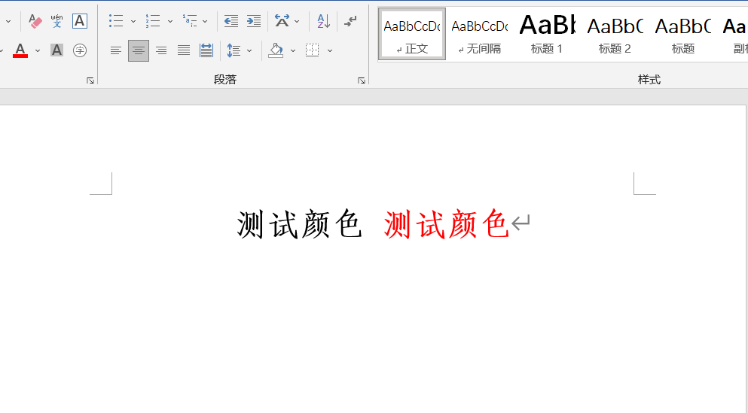

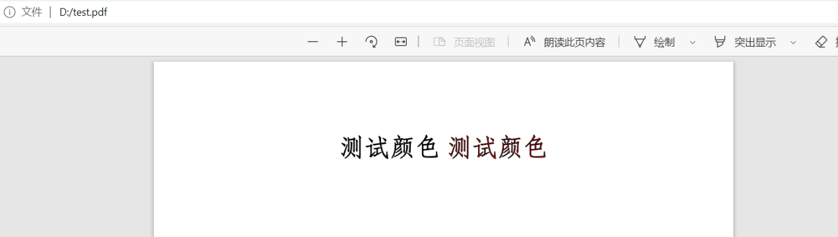

After tracking, it was found that possible problems appeared here org.apache.fop.render.pdf.PDFPainter

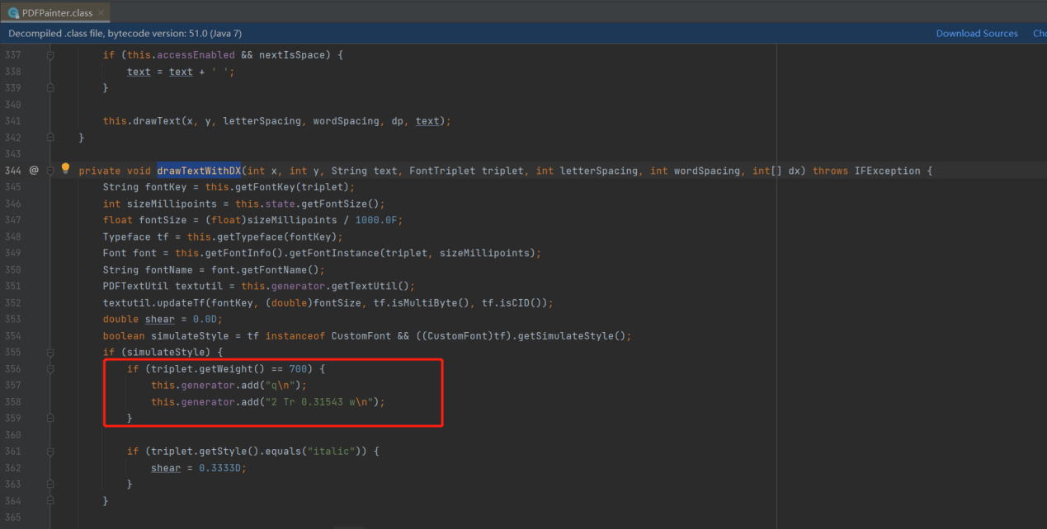

After the change：

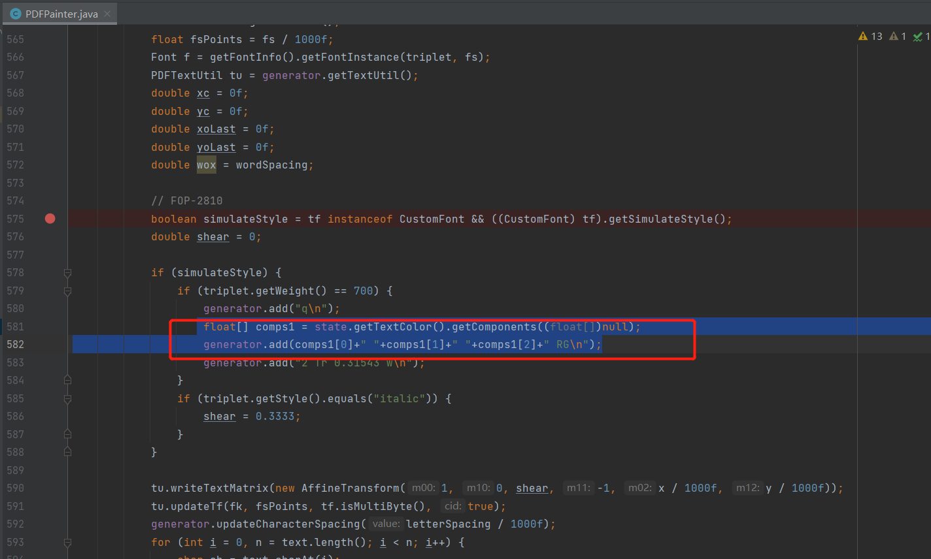

测试结果：

Test Results：

