﻿﻿Guarded Federated Unlearning with Retained-Set Curvature on the FedHDS Backbone

Abstract

Federated unlearning seeks to reduce the influence of a target client without fully retraining the federated model. In language-model federated instruction tuning, this problem is challenging because approximate unlearning must weaken the target-client signal while preserving utility on retained clients. We study a guarded post-training unlearning method built on the FedHDS federated fine-tuning backbone, with the contribution lying in the unlearning stage rather than in a new training algorithm. The method uses the target-client gradient to define the signal to be weakened, estimates curvature from a small retained-client reference set, and constrains the resulting second-order update through global norm clipping, stepped trust-region checking, direction probing, and a forget-loss guard. Experiments on Dolly with Qwen2-0.5B and Qwen2.5-1.5B show that forget-batch Hessian updates can produce stronger target-client loss increases but may incur substantial global-loss degradation. In contrast, retained-set curvature, when combined with direction correction and guard constraints, can improve target-client loss under controlled global loss. Scale and seed checks further indicate that the method is best interpreted as an auditable, utility-preserving approximate unlearning framework rather than a universally strongest forgetting algorithm; the exact forgetting gain remains sensitive to model scale, data scale, and random seed.

Keywords: federated unlearning; retained-set curvature; Hessian-vector product; trust-region guard; language-model fine-tuning

Table of Contents

1. Introduction 4
2. Related Work 7
2.1 Federated Unlearning 7
2.2 Utility-aware Federated Unlearning and Second-order Methods 8
2.3 Position of This Work 8
3. Retained-Set Curvature Based Guarded Federated Unlearning Method 10
3.1 Problem Definition and Optimization Objectives 10
3.2 FedHDS Federated Fine-tuning Backbone 11
3.3 Forget-client Gradient as the Unlearning Signal 12
3.4 Retained-client Reference Set and Curvature Estimation 12
3.5 LiSSA/HVP Approximation for Inverse Curvature Direction 13
3.6 Update Scaling and Global Norm Clipping 14
3.7 Stepped Trust-region Guard for Global Utility Preservation 15
3.8 Direction Probing and Forget-loss Guard for Valid Forgetting 15
4. Experimental Design and Evaluation Protocol 16
4.1 Instruction-tuning Dataset and Base Language Models 16
4.2 Experiment Groups and Robustness Check 17
4.3 Compared Unlearning Settings 18
4.4 Evaluation Metrics and Decision Criteria 19
5. Experimental Results and Mechanism Analysis 19
5.1 Pipeline Feasibility and Training-Backbone Context 20
5.2 Curvature Reference Trade-off 21
5.3 Direction Misalignment and Guard Validation 26
5.4 Generalization across Model Scale and Data Scale 32
Table 6. Model/data scale generalization matrix. 33
5.4.1 Small-model/Large-data Setting 35
5.4.2 Large-model/Small-data Setting 36
5.4.3 Large-model/Large-data Setting 38
5.5 Seed Robustness under the Large-model/Large-data Setting 39
5.6 Integrated Discussion and Method Positioning 42
6. Method Limitations and Applicability Boundaries 43
7. Conclusion and Future Work 44
References 45
Appendix A. Supplementary Figures 47

1. Introduction

Federated learning allows multiple clients to collaboratively train a global model without directly sharing their local data^{[1]}. This training paradigm is useful when data are distributed across users, institutions, or devices, and when centralizing the raw data is undesirable. However, a trained federated model may later face an unlearning request: a client may withdraw consent, request data deletion, or become invalid due to data quality or compliance concerns. In such a case, the system should remove or reduce the influence of that client from the global model.

The most direct solution is to retrain the federated model after excluding the target client^{[2]}. Although retraining provides a clean reference, it is often impractical. Federated training may involve many communication rounds, repeated local fine-tuning, and large model checkpoints. The cost becomes even more pronounced for language-model fine-tuning, where even one full run can already require substantial computing resources and time. Federated unlearning therefore studies how to approximate the effect of removing a client without performing full retraining.

Approximate federated unlearning is difficult because it has two competing requirements. On the one hand, the update should weaken the forgotten client's influence. In this work, that objective is evaluated operationally through forget-client loss: after unlearning, the loss on the forgotten client should not decrease and preferably should increase. On the other hand, the update should preserve the utility of the model on the retained data distribution. If the update increases forget loss but severely damages global performance, the method is not practically useful.

A central challenge in federated unlearning is the trade-off between forgetting and retained utility. An aggressive update may increase the loss on the forget client, but it can also damage performance on the retained clients. Conversely, an overly conservative update may preserve global utility but fail to meaningfully reduce the forgotten client's influence. This trade-off is especially important when second-order approximations are used: Hessian or inverse-Hessian-vector-product based updates can estimate parameter corrections for removing data influence^{[3][4]}, but the choice of curvature reference directly affects both the direction and magnitude of the unlearning update.

Existing second-order unlearning approximations often use a gradient from the target data together with a Hessian or inverse-Hessian-vector product. A natural baseline is to compute both the gradient and curvature reference from the forget-client batch. This forget-batch Hessian approach is directly aligned with the forget objective, but it may move the model in a way that is harmful to retained utility. In a federated setting, where the post-unlearning model should still serve the remaining clients, this is a serious limitation.

This paper adopts FedHDS, the federated data-efficient instruction-tuning backbone introduced by Qin et al.^{[5]}, as the training stage and focuses on controlled post-training unlearning after the federated model has been obtained. The contribution therefore begins after FedHDS training, not in the training backbone itself. Instead of estimating curvature only from the forget-client batch, the study uses retained clients to build a small reference set and approximate the curvature around the retained task distribution. The intuition is that the forget-client gradient defines what should be removed, while the retained-set curvature defines how the model should remain close to the utility-preserving region of the parameter space.

However, retained-set curvature alone is not sufficient. Our experiments show that the retained-set update can preserve global utility but may point in a direction that decreases the forget-client loss. This is an important empirical finding: a method can appear safe under a global utility guard while still failing the forgetting objective. To address this, we introduce a guarded update procedure with four components. First, global update norm clipping limits the magnitude of the second-order correction. Second, a stepped trust-region guard divides the update into smaller steps and rolls back a step if global loss exceeds a threshold. Third, direction probing evaluates positive and negative update signs. Fourth, forget-loss guard rejects a step if it decreases the forget-client loss below a specified tolerance.

The method is evaluated through five connected experiment groups: feasibility validation, the main utility-forgetting trade-off comparison, direction and guard ablation, model/data scale generalization, and seed robustness. Together, these experiments establish the full argument of the paper. The feasibility study confirms that the complete training-and-unlearning procedure can be evaluated coherently in a small setting. The main comparison shows that forget-batch Hessian yields a clearer forgetting signal but incurs substantial global-loss degradation, whereas retained-set guard keeps global loss close to the FedHDS baseline while exposing an update-direction problem. The ablation then explains that failure mode and shows that negative-sign correction with forget-loss guard can recover forgetting effectiveness under controlled global loss. The scale study tests whether this interpretation remains meaningful across a 2 x 2 model/data matrix, and the seed study checks which conclusions remain stable when the random seed changes.

The main contributions are summarized as follows:

1. A complete post-training federated unlearning evaluation framework is built on top of a FedHDS-trained global model, enabling controlled comparison across forgetting, utility, and guard behavior.
2. Retained-set curvature approximation is introduced for federated unlearning, separating the forget-client gradient from the retained-client curvature reference.
3. Second-order unlearning is stabilized with global update norm clipping and a stepped trust-region guard, making updates measurable, reversible, and utility-aware.
4. Retained-set update-direction misalignment is diagnosed, and forget-loss guard with negative-sign correction is shown to increase forget-client loss while keeping global loss controlled.
5. The empirical interpretation remains cautious: retained-set curvature is useful for utility preservation, but it requires direction validation and should not be presented as universally stronger than forget-batch Hessian.
6. A 2 x 2 model/data scale validation is added, showing that the retained-set negative update remains a controllable trade-off across small/large model and small/large data settings.
7. A seed robustness check on the large-model/large-data setting is added, showing stable utility control and meaningful guard behavior while acknowledging that exact forgetting gain is seed-sensitive.

2. Related Work

2.1 Federated Unlearning

Federated unlearning extends machine unlearning to decentralized training, where a removal request must be handled without reconstructing the full centralized dataset. Recent survey work emphasizes that successful unlearning should be judged not only by whether target influence is weakened, but also by whether the remaining model still preserves acceptable utility^{[6]}.

Existing federated-unlearning methods largely follow two directions. The first direction targets client-level removal. FedEraser approximates client removal by calibrating stored historical updates rather than retraining the federated model from scratch^{[7]}. Rapid-retraining methods further reduce the cost of honoring the right to be forgotten by retraining only the affected part of the learning process^{[8]}, while system-oriented formulations treat unlearning as a client right that must be supported by the federated protocol itself^{[9]}. These studies make client removal more practical, but they still leave open how strongly the model can be updated before retained utility deteriorates.

The second direction studies finer forgetting granularity. Class-discriminative pruning removes class-specific influence by pruning parameters associated with the target class^{[10]}. Active-forgetting approaches further use teacher-student memory generation to support class-wise federated unlearning without relying entirely on direct access to forgotten data^{[11]}. Together, these studies broaden federated unlearning from client deletion alone to a design space involving removal granularity, computational efficiency, and post-unlearning utility.

2.2 Utility-aware Federated Unlearning and Second-order Methods

Machine unlearning outside the federated setting provides a useful reference point. Early formulations defined unlearning as removing the influence of selected data without rebuilding the entire system from scratch^{[2]}, while SISA-style training reduced removal cost through structured retraining^{[12]}. In federated settings, recent survey work organizes existing methods into retraining-based, update-correction, historical-update, knowledge-distillation, and second-order approximation families, and emphasizes that evaluation should jointly consider forgetting effectiveness and retained utility^{[13]}. This tension directly motivates the present study.

A complementary line comes from second-order approximation. Influence functions show that data influence can be approximated through inverse-Hessian-vector products^{[3]}. LiSSA-style stochastic second-order optimization offers a practical way to approximate such inverse-HVP directions without explicitly forming the Hessian^{[4]}. Trust-region methods add a related optimization principle: parameter updates should be accepted only within a controlled region so that overly aggressive steps can be rejected^{[14]}. Together, these ideas motivate curvature-informed unlearning updates that are evaluated not only by forgetting strength, but also by their effect on retained utility.

2.3 Position of This Work

Taken together, the literature suggests that federated unlearning for language-model fine-tuning must satisfy three requirements: weakening the target-client influence, preserving retained-client utility, and remaining computationally feasible after training. Prior work provides practical client-removal schemes, finer-grained forgetting mechanisms, and theoretical tools for curvature-aware updates. However, existing formulations rarely distinguish the source of the forgetting signal from the source of the curvature estimate in post-training federated unlearning.

The present study addresses that gap by separating the forgetting signal from the curvature reference: the forget-client gradient specifies what should be weakened, whereas retained-client data define the curvature used to compute the update. Candidate updates are then screened by explicit norm and loss guards before acceptance. The table below positions this design relative to representative federated-unlearning categories. The comparison is qualitative and is intended to clarify the design space rather than to provide a performance ranking.

Table. Qualitative comparison of federated unlearning approaches.

Category | Client-level removal | Post-training | Second-order | Utility guard | Direction validation | Retrain-free
Full or structured retraining [2][12] | Yes | No | No | Implicit | No | No
Update-history calibration [7] | Yes | Yes | No | Partial | No | Yes
Federated rapid retraining [8] | Yes | No | No | Implicit | No | No
Second-order influence-style updates [3][4] | Typically data-level | Yes | Yes | No | No | Yes
Proposed method (guarded retained-set) | Yes | Yes | Yes | Yes | Yes | Yes

Compared with the representative categories summarized above, the proposed method is distinguished by three properties: a post-training update, a second-order direction defined by retained-set curvature, and explicit guards for both utility and forgetting validity. This combination is intended to improve interpretability and auditability, rather than to claim universal superiority across all settings.

3. Retained-Set Curvature Based Guarded Federated Unlearning Method

FedHDS first produces the pre-unlearning model θ*. The proposed method then applies a post-training unlearning update to that same starting point. The procedure has three phases: first, compute the forget-client gradient; second, estimate a second-order direction from retained-client curvature; and third, validate the update through clipping, direction probing, and guards.

3.1 Problem Definition and Optimization Objectives

Consider a federated system with K clients, where client k owns local data Dₖ. After federated training, the server holds a pre-unlearning model θ*. When a target client j requests removal, the algorithm returns an updated model θᵤ. The objective is to reduce the influence of client j while preserving utility on the retained-client distribution.

Formula (1). Forget-client loss change

$${ΔL}_{j}=L_{j}(θ_{u}) −L_{j}(θ∗)$$

In Formula (1), Lⱼ(θ*) and Lⱼ(θᵤ) denote the average loss on forget client j before and after unlearning, respectively, and ΔLⱼ is the resulting loss change. The desired regime is ΔLⱼ > 0, meaning that the post-unlearning model performs worse on the forget client than the pre-unlearning model. If ΔLⱼ < 0, the update has moved in the wrong direction. This quantity is used as an auditable loss-based proxy for forgetting and is interpreted jointly with retained-utility measurements.

Formula (2). Global utility guard

$$L_{G}(θ_{u}) <=γ_{G}$$

In Formula (2), Lᴳ(θᵤ) denotes the global evaluation loss after unlearning, and γᴳ is the maximum acceptable value. This inequality defines the utility constraint: an update is accepted only if the post-unlearning global loss remains within the allowed boundary.

3.2 FedHDS Federated Fine-tuning Backbone

The federated training phase follows the FedHDS fine-tuning backbone introduced by Qin et al.^{[5]}. FedHDS is treated as the fixed training backbone rather than as a contribution of this paper: it produces the common pre-unlearning model θ*, and the proposed method operates only after training has completed. This separation isolates the post-training unlearning question studied here. Accordingly, FL and FedHDS serve as training references, whereas forget-batch Hessian and retained-set Hessian serve as post-training unlearning baselines. The comparison therefore asks which post-training update best reduces the influence of client j while preserving retained utility from the same starting point.

3.3 Forget-client Gradient as the Unlearning Signal

The forget client provides the target signal for unlearning. Rather than retraining the entire model, the server extracts a gradient from that client's data and uses it as the direction that should be weakened.

Formula (3). Forget-client gradient

$$g_{j}= ∇θL_{j}(θ∗)$$

The quantity gⱼ denotes the gradient signal associated with the client to be forgotten, while Lⱼ(θ*) is the loss on that client's data before unlearning. This gradient is not applied directly as a first-order update; instead, it serves as the forgetting signal that is later combined with a curvature estimate.

3.4 Retained-client Reference Set and Curvature Estimation

The main design choice is to estimate curvature from retained clients rather than from the forget-client batch. This keeps the forgetting signal and the utility-preserving geometry anchored to different data sources, which makes the resulting update easier to interpret and control.

Formula (4). Retained reference set

$$D_{ref}=∪_{k≠j}S_{k},S_{k}⊂D_{k}$$

In Formula (4), Dref denotes the retained reference set used for curvature estimation, Sₖ is a sampled subset from retained client k, and Dₖ is that client's local dataset. The reference set is built only from retained clients and is intentionally small. In the main experiments, each retained client contributes one example, so with 20 total clients and one forget client, |Dref| = 19. This keeps the HVP cost feasible while preserving the separation between the forgetting signal and the retained-utility geometry.

Formula (5). Retained curvature direction

$$v ={H_{ref}}^{−1}g_{j}$$

Formula (5) uses Href to denote the approximate Hessian estimated from Dref, gⱼ to denote the forget-client gradient, and v to denote the resulting second-order update direction. The forget-client gradient defines the signal to remove, while the retained-set curvature constrains movement toward a utility-preserving region. Relative to forget-batch Hessian, this choice is more conservative with respect to retained utility, although later experiments show that sign validation is still necessary.

3.5 LiSSA/HVP Approximation for Inverse Curvature Direction

For a language model of this scale, the Hessian is too large to construct or invert explicitly. The method therefore relies on Hessian-vector products together with a lightweight LiSSA-style approximation to obtain a practical inverse-curvature direction.

Formula (6). Approximate inverse-HVP recursion

$$v_{t+1}=g_{j}+ (1 − λ)v_{t}−H_{ref}v_{t}$$

In this recursion, vₜ is the current approximation vector, vₜ₊₁ is the next one, Href vₜ is the Hessian-vector product computed on the retained reference loss, and λ is the damping coefficient. In the reported experiments, the recursion depth is 1 and the damping coefficient is 0.01. This conservative configuration keeps computation feasible and treats the second-order routine as a candidate-direction generator; the later guard mechanisms determine whether the resulting direction is acceptable.

3.6 Update Scaling and Global Norm Clipping

The second-order direction is scaled before application so that its magnitude remains comparable across different retained-client counts and does not immediately violate the utility constraint.

Formula (7). Raw unlearning update

$${Δθ}_{raw}=\frac{η v}{K − 1}$$

In Formula (7), η is the unlearning step size, v is the inverse-HVP direction from Formula (5), and K - 1 is the number of retained clients. The resulting Δθraw is the raw update before clipping and guard checking. Because this update may still be too large to apply safely, the method further clips its global L2 norm.

Formula (8). Global norm clipping

$${Δθ}_{clip}={Δθ}_{raw}· min(1,\frac{τ}{||{Δθ}_{raw}||})$$

The norm ||Δθraw|| is the global L2 norm of the raw update across trainable tensors, τ is the maximum allowed update norm, and Δθclip is the norm-controlled update. If the raw update is already small, it is left unchanged; otherwise it is scaled down to the allowed norm. Reporting both τ and the realized update norm helps separate direction quality from step magnitude.

3.7 Stepped Trust-region Guard for Global Utility Preservation

The clipped update is partitioned into several smaller steps so that utility can be checked incrementally rather than only after the full update is applied.

Formula (9). Step update

$$δ_{s}=\frac{{Δθ}_{clip}}{S}$$

The variable S denotes the number of guarded substeps, and δₛ denotes one substep used during guard checking. Each substep is evaluated separately, which reduces the risk that a single large update will cross the utility boundary without detection.

Formula (10). Step acceptance rule

$$L_{G}(θ_{t}+δ_{s}) <=γ_{G}$$

At guarded step t, θₜ is the current model parameter, δₛ is the candidate substep, and γᴳ is the global-loss acceptance boundary. If the inequality is satisfied, the candidate substep is accepted; otherwise it is rolled back and the procedure stops. The accepted-versus-attempted step count therefore serves as a compact diagnostic of how much of the clipped update remains admissible under the utility constraint.

3.8 Direction Probing and Forget-loss Guard for Valid Forgetting

The preceding trade-off comparison suggests that retained-set curvature can preserve global utility but may weaken forgetting. The subsequent ablation therefore evaluates both update signs along the same clipped direction.

Formula (11). Direction candidates

$$θ^{+}= θ∗ +{Δθ}_{clip}$$

$$θ^{−}= θ∗ −{Δθ}_{clip}$$

The two candidates θ⁺ and θ⁻ are obtained from the same clipped direction Δθclip, with θ* denoting the parameter before unlearning. Direction probing selects the sign that yields the larger increase in forget-client loss while remaining compatible with the global guard as far as possible. The final protection layer is the forget-loss guard.

Formula (12). Forget-loss guard

$$L_{j}(θ_{t}+δ_{s}) >={L_{j}}^{guard}− ε$$

In Formula (12), θₜ is the model parameter before the current guarded step, Lⱼᵍᵘᵃʳᵈ is the baseline forget-client loss used by the guard, and ε is a small numerical tolerance such as 0 or 0.005. A step therefore cannot be accepted merely because global loss is safe; it must also avoid moving the forget-client loss in the wrong direction. Together, direction probing, the global guard, and the forget-loss guard define the final acceptance rule. A rejected substep is therefore interpretable as either utility-damaging or forgetting-invalid.

4. Experimental Design and Evaluation Protocol

4.1 Instruction-tuning Dataset and Base Language Models

We use Dolly as the federated instruction-tuning dataset^{[15]}. Qwen2-0.5B^{[16]} is used for the feasibility validation, main trade-off comparison, and direction ablation because it is large enough to represent a language-model fine-tuning setting while still supporting repeated Hessian-vector product experiments under the available single-device compute budget. Qwen2.5-1.5B^{[17]} is additionally used in the model-scale generalization study.

The federated setting uses 20 clients, a client fraction of 0.2, 2 local steps, batch size 1, maximum sequence length 64, and client 0 as the designated forget client. For all unlearning experiments, the forget-client gradient is computed from eight local training examples of the forget client. Retained-set Hessian experiments use one reference example per retained client, giving 19 retained reference examples when one of the 20 clients is forgotten. The reported second-order updates use LiSSA recursion depth 1, damping 0.01, and unlearning step size 0.01.

4.2 Experiment Groups and Robustness Check

For reproducibility, the archived experiment folders keep their original stage labels, but the paper organizes the evidence by experimental purpose rather than by chronology. The evaluation is divided into five groups, each designed to answer a specific question.

A feasibility group uses a data sampling ratio of 0.2 and 10 rounds. It checks whether FL, the FedHDS baseline, forget-batch Hessian unlearning, and retained-set Hessian with guard can all be evaluated consistently in a small-scale setting. Its purpose is to confirm that the full pipeline is executable and measurable before stronger comparative claims are made.

The main trade-off group increases the data sampling ratio to 0.4 and the number of rounds to 20. It provides the central comparison between forgetting effectiveness and retained utility. In this group, the retained-set method uses automatically calibrated global-guard thresholds relative to the FedHDS baseline pre-unlearning loss.

Direction-and-guard ablation keeps the main trade-off configuration and varies update sign, forget-loss guard, and negative-sign update norm. It diagnoses why retained-set curvature can preserve global utility while still failing the forgetting objective, and it tests whether a corrected direction can satisfy both constraints.

A model/data scale group forms a 2 x 2 matrix over Qwen2-0.5B versus Qwen2.5-1.5B and data sampling ratios of 0.4 versus 0.6. It tests whether the retained-set negative direction and guard behavior remain meaningful as model size and data volume increase.

Finally, the seed-robustness group repeats the large-model/large-data configuration with seeds 43 and 44. It identifies which conclusions are stable across seeds and which remain sensitive to the local training trajectory.

4.3 Compared Unlearning Settings

This study compares five settings: FL, the FedHDS baseline, FedHDS followed by forget-batch Hessian unlearning, FedHDS followed by retained-set Hessian with global guard, and FedHDS followed by retained-set Hessian with negative-sign correction and forget-loss guard. Together, these settings isolate baseline training quality, the effect of the curvature reference, and the impact of sign correction under the same forgetting signal.

The forget-batch Hessian setting serves as the direct unlearning baseline because it uses the forget-client batch as both the gradient source and the Hessian reference. By contrast, the retained-set Hessian setting keeps the same forget-client gradient but replaces the Hessian reference with retained-client data, thereby isolating the curvature effect. The negative-sign setting is introduced only after direction probing shows that the default sign can be misaligned with the forgetting objective.

4.4 Evaluation Metrics and Decision Criteria

Reported metrics include final global loss, forget-client loss before and after unlearning, update L2 norm, numbers of accepted and attempted guard steps, guard outcome, and unlearning time. Utility preservation is assessed by whether the post-unlearning global loss remains close to the FedHDS baseline pre-unlearning loss or stays below the specified global guard. Directional forgetting effectiveness is assessed by whether the forget-client loss is prevented from decreasing and, ideally, is increased.

For the direction-and-guard ablation, interpretation focuses on the interaction among update sign, forget-loss guard, forget-client loss change, and global-guard behavior rather than on another FL-versus-baseline comparison. The scale study then evaluates the same retained-negative configuration under larger model and data settings, while the seed-robustness study separates conclusions that remain stable across seeds from those that are sensitive to the local training trajectory.

5. Experimental Results and Mechanism Analysis

This section presents the experimental evidence in the order of increasing complexity. It begins with a feasibility check of the complete training-and-unlearning pipeline, then examines the utility-forgetting trade-off induced by different curvature references, and finally studies how direction correction, guard design, model/data scale, and random seed affect the observed behavior.

5.1 Pipeline Feasibility and Training-Backbone Context

A small-scale setting is first used to verify that the complete training-and-unlearning pipeline can be executed and evaluated consistently. The goal is not to establish a definitive performance ranking, but to confirm that the proposed post-training unlearning procedure behaves measurably before moving to the main comparison setting.

Table 1. Minimal end-to-end feasibility results.

Source | Setting | Hessian | Forget loss | Final global loss | Update L2 | Steps | Time (s)
FedHDS baseline | step size 1.0000 | none | N/A | 1.6657 | N/A | N/A | N/A
FL baseline | step size 1.0000 | none | N/A | 1.6443 | N/A | N/A | N/A
Forget-batch Hessian | step size 0.0100 | forget-batch | 2.3381 -> 2.3489 | 1.6867 | 0.0872 | 1/1 | 1.44
Retained-set guard | step size 0.0100, maximum norm 0.300, 5 substeps, global guard 1.700 | retained-set | 2.3381 -> 2.3460 | 1.6615 | 0.0427 | 5/5 | 71.13

In this minimal setting, FL reaches final global loss 1.6443, while FedHDS reaches 1.6657. Because the experiment uses only a data sampling ratio of 0.2 and 10 rounds, this small difference should not be overinterpreted. The more relevant observation is that both unlearning paths can be completed end to end under the same pipeline.

The forget-batch Hessian baseline increases forget-client loss from 2.3381 to 2.3489, yielding a gain of +0.0108, but it raises final global loss to 1.6867, above the FedHDS pre-unlearning baseline. The retained-set guard also increases forget-client loss, from 2.3381 to 2.3460, but with a smaller gain of +0.0079. Its update norm is also smaller (0.0427 versus 0.0872), and its final global loss is 1.6615, slightly below the FedHDS result in the same feasibility setting.

These feasibility results suggest two preliminary conclusions. First, second-order unlearning can be integrated into the adopted FedHDS-based training-and-unlearning framework. Second, the retained-set guard behaves more conservatively in update magnitude and more stably in global utility, although its forgetting gain is weaker than that of the forget-batch baseline.

5.2 Curvature Reference Trade-off

The main trade-off setting increases the data sampling ratio from 0.2 to 0.4 and the number of training rounds from 10 to 20, and serves as the primary testbed for the utility-forgetting trade-off.

Table 2. Main utility-forgetting trade-off results with retrain reference.

Source | Setting | Hessian | Forget loss | Final global loss | Update L2 | Steps | Time (s)
FedHDS baseline | step size 1.0000 | none | N/A | 1.5250 | N/A | N/A | N/A
FL baseline | step size 1.0000 | none | N/A | 1.5441 | N/A | N/A | N/A
Retrain baseline | exclude client 0, learning rate 5e-5 | retrain-from-scratch | held-out client-0 loss = 2.2168 | 1.5355 | N/A | N/A | N/A
Forget-batch Hessian | step size 0.0100 | forget-batch | 2.2581 -> 2.2866 | 1.6257 | 0.5077 | 1/1 | 1.64
Retained-set auto guard | step size 0.0100, maximum norm 0.300, 5 substeps, global guard 1.575 | retained-set | 2.2581 -> 2.2329 | 1.5482 | 0.2486 | 5/5 | 131.13

Figure 1 plots the per-round convergence of FL and FedHDS.

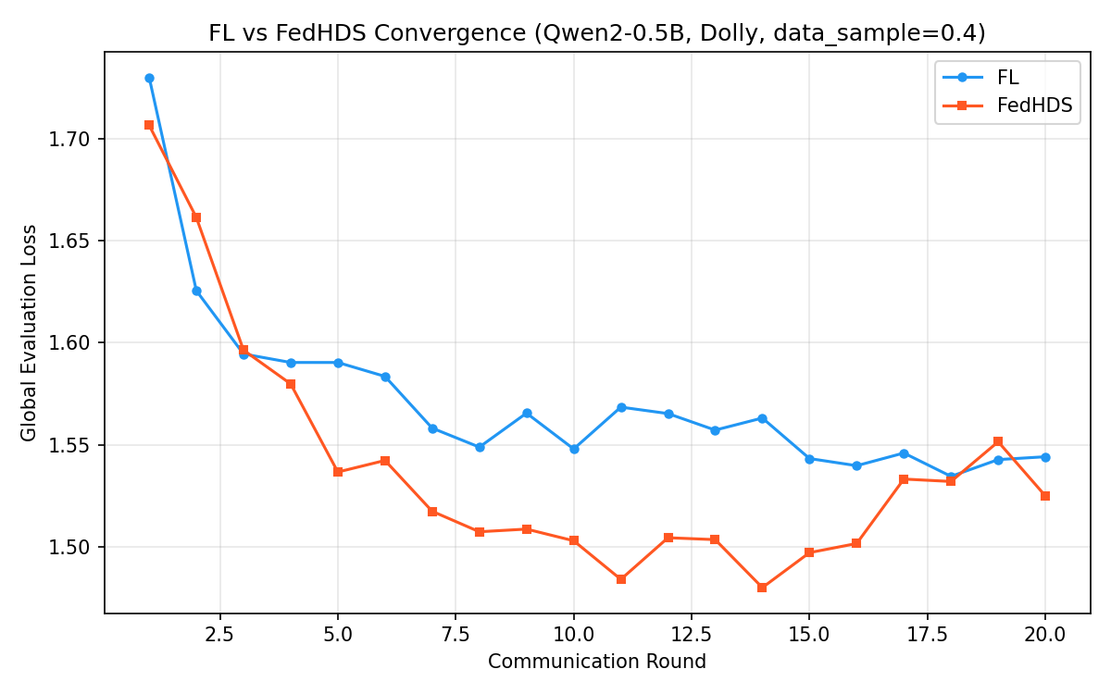
Figure 1. FL vs FedHDS convergence curves.

Figure 1. FL vs FedHDS training convergence (data sampling ratio 0.4, 20 rounds). FedHDS converges to a lower final global loss (1.5250) than FL (1.5441), making it the stronger utility baseline for subsequent unlearning experiments.

Under this stronger training configuration, FedHDS achieves final global loss 1.5250, below FL's 1.5441. This makes FedHDS the more appropriate utility baseline for the subsequent unlearning experiments.

Table 2 also includes a retrain-from-scratch reference. Excluding client 0 and retraining from scratch yields final global loss 1.5355 and held-out client-0 loss 2.2168. Relative to the FedHDS baseline, the global-loss increase is only +0.0105, which is far smaller than the forget-batch increase (+0.1007) and also smaller than the corrected retained-negative result with a maximum norm of 0.10 discussed later in Section 5.3 (+0.0685).

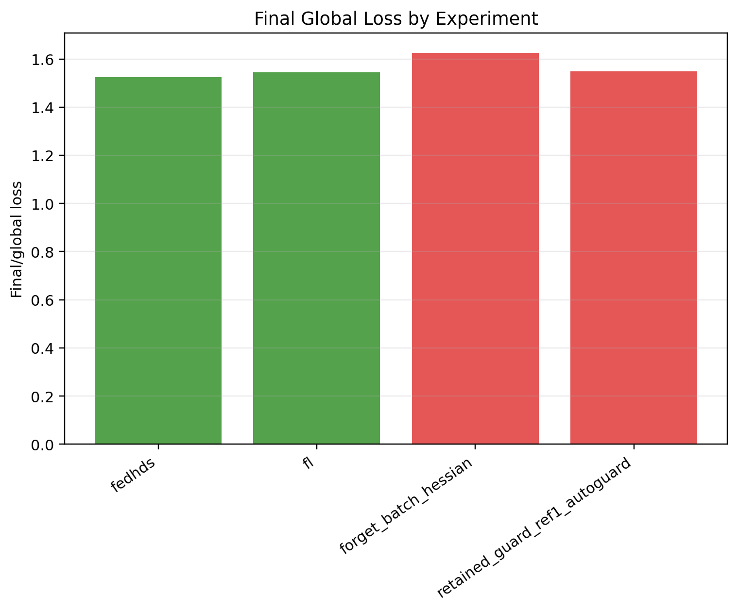
Figure 2. Final global loss comparison in the main trade-off experiment.

Figure 2. Final global loss comparison in the main trade-off experiment.

Unlike the feasibility setting, the larger data sample and longer training schedule make FedHDS the stronger utility baseline here. This supports using FedHDS as the backbone for the unlearning experiments.

The forget-batch Hessian baseline provides the clearest forgetting signal in the main trade-off experiment. It increases forget-client loss from 2.2581 to 2.2866, a gain of +0.0285. However, this comes with a substantial utility cost: global loss rises from 1.5250 to 1.6257, a degradation of +0.1007. The update L2 norm is 0.5077, much larger than that of the retained-set guarded update. This result defines the central trade-off: forget-batch Hessian is more directly aligned with forgetting, but it is much less constrained with respect to retained utility.

Figure 3 shows the same trade-off from the forget-client side: the retained-set auto guard moves in the opposite direction.

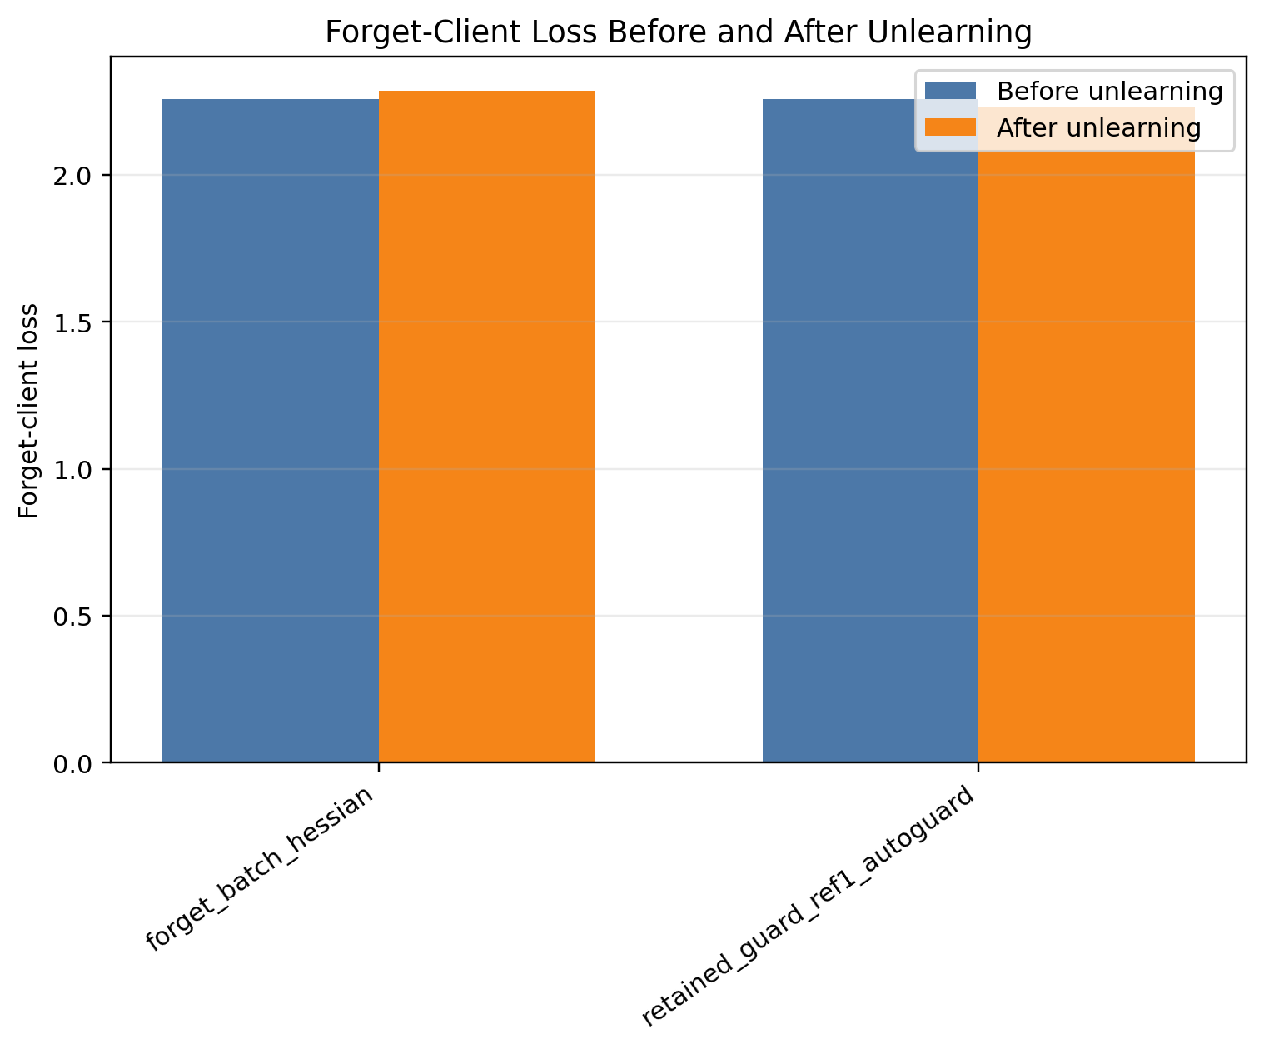
Figure 3. Forget-client loss before and after unlearning in the main trade-off experiment.

Figure 3. Forget-client loss before and after unlearning in the main trade-off experiment.

By contrast, the retained-set auto guard keeps global loss much closer to the FedHDS baseline, changing it from 1.5250 to 1.5482, a degradation of only +0.0232 and still below the global guard threshold 1.575. All 5/5 guard steps are accepted. However, forget-client loss decreases from 2.2581 to 2.2329, a change of -0.0252. In other words, the retained-set guard protects utility successfully, but the resulting update direction is misaligned with the forgetting objective.

An important nuance comes from the retrain reference: the held-out client-0 loss in retraining is 2.2168, slightly lower than the FedHDS pre-unlearning value 2.2581. On this IID Dolly split, exact client exclusion therefore does not translate into a monotonic increase in held-out-client loss. Retraining should therefore be interpreted mainly as an exact-removal and utility-cost reference, whereas forget-loss increase remains a behavioral proxy for post-training unlearning strength.

The main conclusion is therefore a reference-selection trade-off rather than a simple win. Forget-batch Hessian produces stronger forgetting but damages global utility, whereas retained-set Hessian with guard preserves global utility but requires direction correction to become an effective forgetting update.

5.3 Direction Misalignment and Guard Validation

The direction and guard ablation is designed to explain the retained-set failure mode observed in the main trade-off experiment. It keeps the same base configuration and runs a complete nine-setting ablation. The goal is not to claim large-scale generalization, but to determine whether the retained-set update direction is misaligned, whether forget-loss guard can reject invalid forgetting steps, and whether a corrected negative direction can improve forgetting while preserving global utility.

Table 3. Full direction and guard ablation.

Group | Hessian/sign | Forget loss | Final global loss | Update L2 | Steps | Guard outcome | Time (s)
FL baseline | training baseline | N/A | 1.5441 | N/A | N/A | N/A | N/A
FedHDS baseline | training baseline | N/A | 1.5250 | N/A | N/A | N/A | N/A
Forget-batch Hessian | forget-batch, sign=positive | 2.2581 -> 2.2866 (+0.0285) | 1.6257 | 0.5077 | 1/1 | all planned steps accepted | 1.69
Retained-set positive auto direction | retained-set, sign=positive | 2.2581 -> 2.2329 (-0.0252) | 1.5482 | 0.2486 | 5/5 | all planned steps accepted | 189.67
Positive + forget-loss guard (tolerance 0) | retained-set, sign=positive | 2.2581 -> 2.2581 (+0.0000) | 1.5250 | 0.0000 | 0/1 | rejected by forget-loss guard | 88.01
Positive + forget-loss guard (tolerance 0.05) | retained-set, sign=positive | 2.2581 -> 2.2581 (+0.0000) | 1.5250 | 0.0000 | 0/1 | rejected by forget-loss guard | 86.58
Negative sign, maximum norm 0.05 | retained-set, sign=negative | 2.2581 -> 2.4105 (+0.1524) | 1.5561 | 0.0500 | 5/5 | all planned steps accepted | 133.76
Negative sign, maximum norm 0.10 | retained-set, sign=negative | 2.2581 -> 2.6104 (+0.3523) | 1.5935 | 0.1000 | 5/5 | all planned steps accepted | 140.23
Negative sign, maximum norm 0.15 | retained-set, sign=negative | 2.2581 -> 2.6880 (+0.4300) | 1.6094 | 0.1200 | 4/5 | stopped by global-loss guard | 137.92

The first three rows reproduce the main trade-off baseline setting in the same result directory. FedHDS obtains final global loss 1.5250, while FL obtains 1.5441. The forget-batch Hessian baseline increases forget-client loss from 2.2581 to 2.2866, but it also raises global loss to 1.6257. This confirms the trade-off: direct forget-batch curvature is aligned with forgetting, but it is costly for global utility.

The retained-set positive auto-direction row reproduces the retained-set failure mode. The selected positive direction keeps global loss controlled at 1.5482, but decreases forget-client loss from 2.2581 to 2.2329. This failure is not a random fluctuation but a structural sign-sensitivity issue. Table 4 isolates the direction-probing diagnosis.

Table 4. Direction-probing diagnosis: positive versus negative candidate under the same retained-set curvature.

Candidate sign | Forget delta | Global loss after candidate | Passes global guard?
Positive (+Δθ) | -0.0073 | 1.5482 | Yes
Negative (-Δθ) | +0.5014 | 1.7310 | No

The direction-probing records make the mismatch explicit: the positive candidate changes forget loss by -0.0073 and passes the global guard, whereas the negative candidate changes forget loss by +0.5014 but raises global loss to 1.7310 and fails the guard. This is the key diagnostic result of the paper and should be read as a mechanism finding rather than an ordinary ablation. The core problem with retained-set curvature is not that it lacks a forgetting signal, because the negative direction carries a strong one, but that the effective unconstrained direction lies outside the utility-safe region and the default positive sign points in the wrong direction. In other words, retained-set curvature contains useful forgetting signal, but the effective direction is sign-sensitive and must be validated.

When forget-loss guard is enabled, both tolerance settings reject the first candidate step. The model remains at the FedHDS baseline with update L2 0 and 0/1 accepted steps. This is important guard behavior: the system avoids accepting an update that would look safe under global utility but fail the forgetting objective.

Table 5 focuses on the negative-sign norm sweep.

Table 5. Negative-sign update-norm sweep.

Group | Maximum norm | Forget loss | Global loss | Update L2 | Steps | Guard outcome
Negative sign, maximum norm 0.05 | 0.0500 | 2.2581 -> 2.4105 (+0.1524) | 1.5250 -> 1.5561 | 0.0500 | 5/5 | all planned steps accepted
Negative sign, maximum norm 0.10 | 0.1000 | 2.2581 -> 2.6104 (+0.3523) | 1.5250 -> 1.5935 | 0.1000 | 5/5 | all planned steps accepted
Negative sign, maximum norm 0.15 | 0.1500 | 2.2581 -> 2.6880 (+0.4300) | 1.5250 -> 1.6094 | 0.1200 | 4/5 | stopped by global-loss guard

The negative-sign sweep provides the key correction evidence. As shown in Figure 4, increasing the accepted update norm generally increases forget-loss gain while also requiring global-loss guard control.

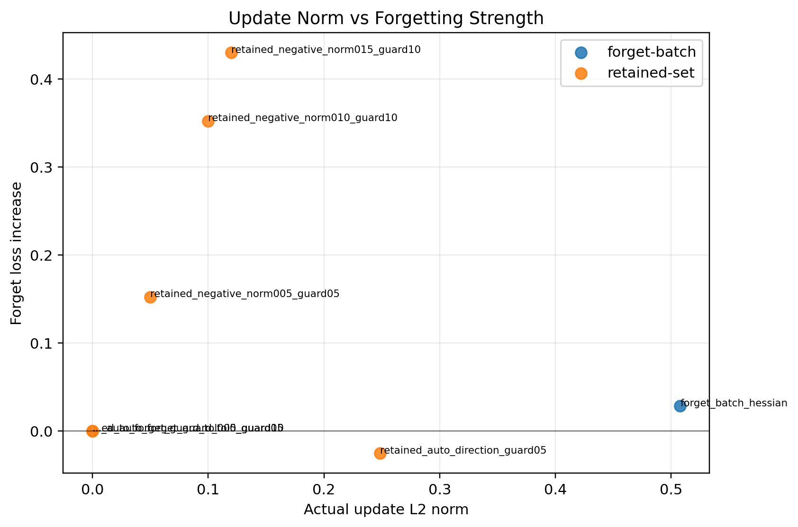
Figure 4. Update norm versus forget-loss gain.

Figure 4. Update norm versus forget-loss gain.

With a maximum norm of 0.05, forget-client loss increases from 2.2581 to 2.4105, while global loss remains 1.5561, below the guard 1.575. With a maximum norm of 0.10, forget-client loss increases further to 2.6104, while global loss remains 1.5935, below the guard 1.625. With a maximum norm of 0.15, forget-client loss increases to 2.6880, but the update is stopped after 4/5 accepted steps by the global loss guard. Figure 5 shows the accepted and attempted guard steps behind this early stop.

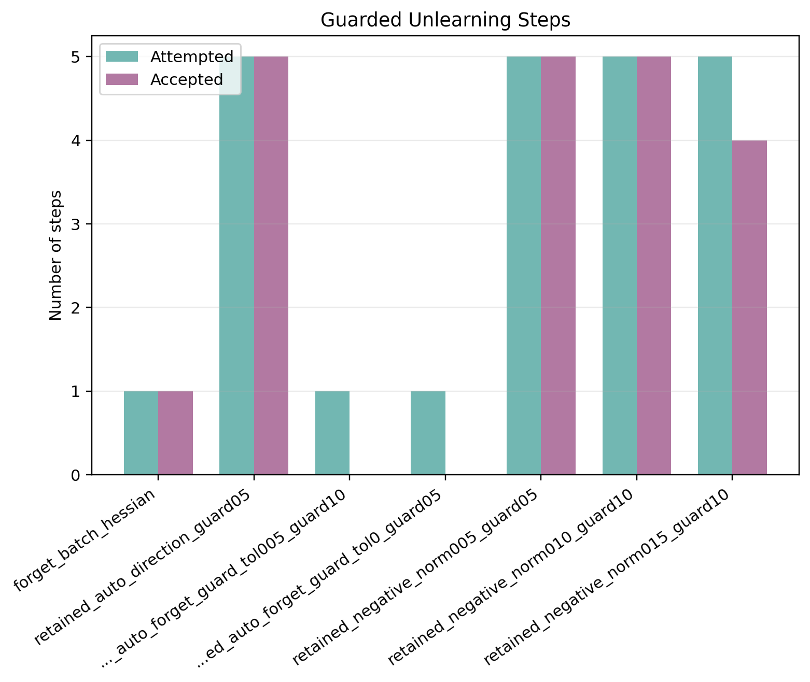
Figure 5. Accepted and attempted guard steps.

Figure 5. Accepted and attempted guard steps.

The final accepted update L2 is 0.1200 rather than the requested 0.1500, showing that the stepped guard actively truncates the update when utility approaches the guard boundary. These guard outcomes are not failure cases in the usual sense. The forget-loss guard prevents a utility-safe but forgetting-invalid step from being accepted, while the global-loss guard truncates a forgetting-strong update when it approaches the utility boundary.

These results show that retained-set curvature is sign-sensitive. The original positive direction is not a reliable forgetting direction under the main trade-off configuration. After switching to the negative direction and enabling forget-loss guard, the retained-set update can substantially increase forget-client loss while keeping global loss controlled. Among the three negative-sign settings, a maximum norm of 0.05 is the most conservative and has the smallest global loss increase, while a maximum norm of 0.10 gives a stronger forgetting gain with still-controlled global loss. The maximum-norm-0.15 case is useful as a guard-stopping example rather than the preferred setting.

Compared with the retrain reference, the negative-sign setting with a maximum norm of 0.10 raises the forget-loss proxy much more strongly (2.6104 versus retrain held-out 2.2168) but at a higher utility cost (1.5935 versus retrain 1.5355). The forget-batch baseline is even costlier in utility at 1.6257. This comparison supports the same interpretation: the proposed retained-negative update is not intended to numerically reproduce retraining. It is an auditable post-training approximation that offers a controllable forgetting/utility trade-off.

5.4 Generalization across Model Scale and Data Scale

The scale study evaluates whether the direction correction and guard design remain meaningful when the data scale, model scale, or both are increased. It does not introduce a new algorithmic component. Instead, it forms a 2 x 2 scale matrix: Qwen2-0.5B versus Qwen2.5-1.5B, and a data sampling ratio of 0.4 versus 0.6.

Figure 6 visualizes the large-model/large-data final global loss comparison, while Table 6 summarizes the scale matrix using three comparable entries from each cell: the FedHDS utility baseline, the forget-batch Hessian baseline, and the retained-set negative update with a maximum norm of 0.10.

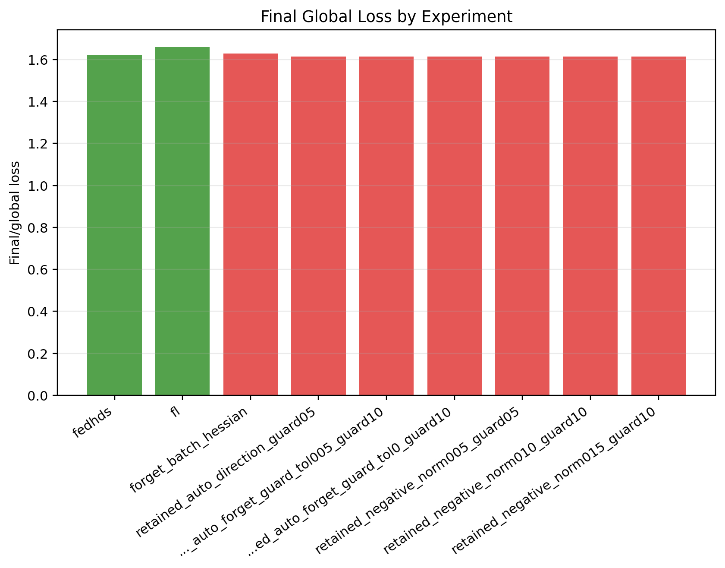
Figure 6. Large-model/large-data final global loss comparison.

Figure 6. Large-model/large-data final global loss comparison.

Table 6. Model/data scale generalization matrix.

Setting | Model | Data sampling ratio | FedHDS baseline global | Forget-batch Hessian | Retained negative update (maximum norm 0.10)
Small model + small data | Qwen2-0.5B | 0.4 | 1.5250 | 2.2581 -> 2.2866 (+0.0285), G=1.6257 | 2.2581 -> 2.6104 (+0.3523), G=1.5935
Small model + large data | Qwen2-0.5B | 0.6 | 1.5423 | 2.4377 -> 2.8059 (+0.3681), G=2.0040 | 2.4377 -> 2.6147 (+0.1770), G=1.5701
Large model + small data | Qwen2.5-1.5B | 0.4 | 1.6438 | 1.8812 -> 1.8702 (-0.0110), G=1.6408 | 1.8812 -> 1.9206 (+0.0395), G=1.6405
Large model + large data | Qwen2.5-1.5B | 0.6 | 1.6201 | 2.0880 -> 2.0828 (-0.0052), G=1.6291 | 2.0880 -> 2.1078 (+0.0198), G=1.6132

The scale matrix supports three observations. First, increasing data while keeping the small model preserves the main retained-set negative behavior: forget loss increases from 2.4377 to 2.6147 under a maximum norm of 0.10, while final global loss remains 1.5701, close to the FedHDS baseline 1.5423. In the same setting, forget-batch Hessian gives a stronger forgetting gain, 2.4377 to 2.8059, but its final global loss rises sharply to 2.0040. This is a clear utility-cost example.

Second, increasing model size while keeping the data sampling ratio at 0.4 changes the forget-batch behavior. Forget-batch Hessian no longer increases forget loss; it changes from 1.8812 to 1.8702. By contrast, the retained negative update with a maximum norm of 0.10 increases forget loss from 1.8812 to 1.9206, with final global loss 1.6405, slightly lower than the FedHDS baseline 1.6438. This suggests that the retained-set negative direction remains useful even when the direct forget-batch curvature becomes weak or misaligned.

Third, increasing both model and data scale keeps the retained-set negative update stable. Forget-batch Hessian changes forget loss from 2.0880 to 2.0828 and final global loss is 1.6291. The retained negative update with a maximum norm of 0.10 increases forget loss from 2.0880 to 2.1078 and obtains final global loss 1.6132, below the FedHDS baseline 1.6201. The forgetting gain is modest, but the utility behavior is favorable.

These results strengthen the direction-ablation interpretation. The key claim is not that retained-set Hessian always maximizes forget-client loss. Instead, the evidence shows that retained-set Hessian with negative direction and guard constraints gives a more controllable forgetting/utility trade-off across model and data scales than the naive forget-batch Hessian baseline.

The complete scale-study result tables are shown in Tables 7-9.
Each regime below isolates a different scale axis and highlights how the same retained-negative mechanism behaves under that change.

5.4.1 Small-model/Large-data Setting

This setting keeps the model small while increasing data volume, so it tests whether the retained-negative update remains utility-safe under a denser retained/forget interaction. Table 7 shows that the negative update at maximum norm 0.10 gives the best balance among the tested norms: it raises forget loss to 2.6147 while keeping global loss at 1.5701, close to the FedHDS baseline 1.5423.

Table 7. Full results for the small-model/large-data setting.

Group | Hessian/sign | Forget loss | Final global loss | Update L2 | Steps
FL baseline | training baseline | N/A | 1.5289 | N/A | N/A
FedHDS baseline | training baseline | N/A | 1.5423 | N/A | N/A
Forget-batch Hessian | forget-batch, sign=positive | 2.4377 -> 2.8059 (+0.3681) | 2.0040 | 1.1020 | 1/1
Retained-set auto direction | retained-set, sign=negative | 2.4377 -> 2.7601 (+0.3224) | 1.5862 | 0.1483 | 5/5
Auto-selected direction + forget-loss guard (tolerance 0) | retained-set, sign=negative | 2.4377 -> 2.7601 (+0.3224) | 1.5862 | 0.1483 | 5/5
Auto-selected direction + forget-loss guard (tolerance 0.05) | retained-set, sign=negative | 2.4377 -> 2.7601 (+0.3224) | 1.5862 | 0.1483 | 5/5
Negative sign, maximum norm 0.05 | retained-set, sign=negative | 2.4377 -> 2.5030 (+0.0652) | 1.5554 | 0.0500 | 5/5
Negative sign, maximum norm 0.10 | retained-set, sign=negative | 2.4377 -> 2.6147 (+0.1770) | 1.5701 | 0.1000 | 5/5
Negative sign, maximum norm 0.15 | retained-set, sign=negative | 2.4377 -> 2.7601 (+0.3224) | 1.5862 | 0.1483 | 5/5

The same pattern is consistent with the section-level trade-off: forget-batch achieves a stronger forgetting gain, but it does so at a much higher utility cost.

5.4.2 Large-model/Small-data Setting

With the data ratio kept lower but the model size increased, this setting tests whether sign correction remains useful once the backbone becomes larger. Table 8 shows that forget-batch Hessian no longer provides a meaningful forgetting gain, while the retained negative update still increases forget loss to 1.9206 and keeps global loss essentially aligned with the FedHDS baseline.

Table 8. Full results for the large-model/small-data setting.

Group | Hessian/sign | Forget loss | Final global loss | Update L2 | Steps
FL baseline | training baseline | N/A | 1.6611 | N/A | N/A
FedHDS baseline | training baseline | N/A | 1.6438 | N/A | N/A
Forget-batch Hessian | forget-batch, sign=positive | 1.8812 -> 1.8702 (-0.0110) | 1.6408 | 0.0519 | 1/1
Retained-set auto direction | retained-set, sign=negative | 1.8812 -> 1.9206 (+0.0395) | 1.6405 | 0.0282 | 5/5
Auto-selected direction + forget-loss guard (tolerance 0) | retained-set, sign=negative | 1.8812 -> 1.9206 (+0.0395) | 1.6405 | 0.0282 | 5/5
Auto-selected direction + forget-loss guard (tolerance 0.05) | retained-set, sign=negative | 1.8812 -> 1.9206 (+0.0395) | 1.6405 | 0.0282 | 5/5
Negative sign, maximum norm 0.05 | retained-set, sign=negative | 1.8812 -> 1.9206 (+0.0395) | 1.6405 | 0.0282 | 5/5
Negative sign, maximum norm 0.10 | retained-set, sign=negative | 1.8812 -> 1.9206 (+0.0395) | 1.6405 | 0.0282 | 5/5
Negative sign, maximum norm 0.15 | retained-set, sign=negative | 1.8812 -> 1.9206 (+0.0395) | 1.6405 | 0.0282 | 5/5

It is the clearest case of scale-dependent sign sensitivity: the curvature reference alone is not enough, but the corrected retained direction remains stable.

5.4.3 Large-model/Large-data Setting

This is the most demanding scale case because both model size and data volume increase. Table 9 shows that the retained negative update remains the most stable option: it raises forget loss to 2.1078 and keeps final global loss at 1.6132, below the FedHDS baseline 1.6201.

Table 9. Full results for the large-model/large-data setting.

Group | Hessian/sign | Forget loss | Final global loss | Update L2 | Steps
FL baseline | training baseline | N/A | 1.6587 | N/A | N/A
FedHDS baseline | training baseline | N/A | 1.6201 | N/A | N/A
Forget-batch Hessian | forget-batch, sign=positive | 2.0880 -> 2.0828 (-0.0052) | 1.6291 | 0.2335 | 1/1
Retained-set auto direction | retained-set, sign=negative | 2.0880 -> 2.1078 (+0.0198) | 1.6132 | 0.0305 | 5/5
Auto-selected direction + forget-loss guard (tolerance 0) | retained-set, sign=negative | 2.0880 -> 2.1078 (+0.0198) | 1.6132 | 0.0305 | 5/5
Auto-selected direction + forget-loss guard (tolerance 0.05) | retained-set, sign=negative | 2.0880 -> 2.1078 (+0.0198) | 1.6132 | 0.0305 | 5/5
Negative sign, maximum norm 0.05 | retained-set, sign=negative | 2.0880 -> 2.1078 (+0.0198) | 1.6132 | 0.0305 | 5/5
Negative sign, maximum norm 0.10 | retained-set, sign=negative | 2.0880 -> 2.1078 (+0.0198) | 1.6132 | 0.0305 | 5/5
Negative sign, maximum norm 0.15 | retained-set, sign=negative | 2.0880 -> 2.1078 (+0.0198) | 1.6132 | 0.0305 | 5/5

Although the forgetting gain is modest, the update remains utility-safe, which is the key requirement for the scale study.

5.5 Seed Robustness under the Large-model/Large-data Setting

Robustness is then checked on the most demanding large-model/large-data setting: Qwen2.5-1.5B with a data sampling ratio of 0.6 and 20 rounds. Rather than introducing a new experimental category, this test asks whether the seed-42 observation is isolated or representative. The federated and unlearning configuration is kept fixed, and only the five core settings are rerun for seed 43 and seed 44.

Figure 7 shows the seed-level forget-client loss changes, while Table 10 compares seed 42, seed 43, and seed 44. Seed 42 is the original large-model/large-data result, while seed 43 and seed 44 come from the robustness run.

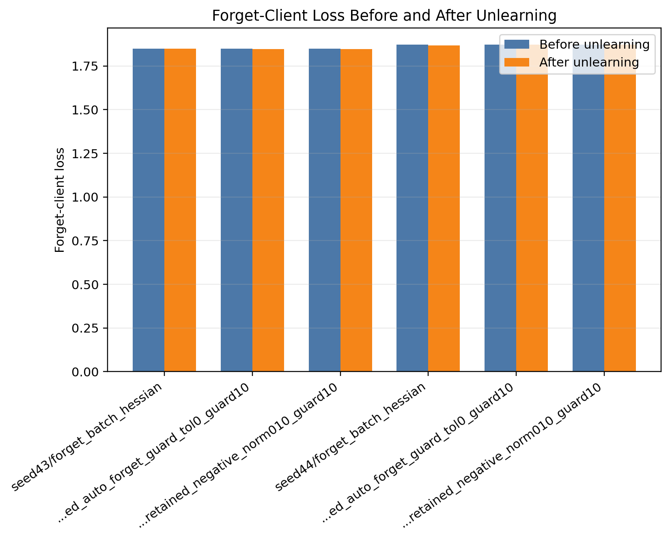
Figure 7. Seed robustness forget-client loss comparison.

Figure 7. Seed robustness forget-client loss comparison.

Table 10. Seed robustness check on the large-model/large-data setting.

Seed | FedHDS baseline global | Forget-batch Hessian | Retained auto guard | Retained negative update (maximum norm 0.10)
42 | 1.6201 | 2.0880 -> 2.0828 (-0.0052), G=1.6291 | 2.0880 -> 2.1078 (+0.0198), G=1.6132, steps=5/5 | 2.0880 -> 2.1078 (+0.0198), G=1.6132, steps=5/5
43 | 1.6377 | 1.8483 -> 1.8490 (+0.0007), G=1.6368 | 1.8483 -> 1.8472 (-0.0011), G=1.6380, steps=5/5 | 1.8483 -> 1.8472 (-0.0011), G=1.6380, steps=5/5
44 | 2.0818 | 1.8732 -> 1.8677 (-0.0056), G=2.0871 | 1.8732 -> 1.8725 (-0.0008), G=2.0826, steps=5/5 | 1.8732 -> 1.8732 (+0.0000), G=2.0818, steps=0/1

The robustness check refines the conclusion rather than reducing it to success or failure. In seed 42, the retained negative update with a maximum norm of 0.10 increases forget loss from 2.0880 to 2.1078 and obtains final global loss 1.6132, below the FedHDS baseline 1.6201. In seed 43, the same retained negative setting preserves utility, with final global loss 1.6380 close to the FedHDS baseline 1.6377, but the forget loss changes from 1.8483 to 1.8472, a very small decrease. In seed 44, the forget-loss guard rejects the retained negative update at 0/1 accepted steps, leaving the model at the FedHDS baseline state with forget loss 1.8732 and global loss 2.0818.

These results support two claims and one boundary. The first claim is that retained-set negative updates remain utility-safe in the large-model/large-data setting: even when forgetting gain is absent, global loss stays close to the FedHDS baseline. The second claim is that the forget-loss guard is functionally important: in seed 44 it prevents an invalid update from being accepted. The boundary is that the exact forgetting gain is seed-sensitive. A more accurate conclusion is therefore that retained-set Hessian with negative direction and guard constraints provides an auditable and utility-safe update path, while the strength of forgetting depends on the local training trajectory and random seed.

5.6 Integrated Discussion and Method Positioning

Across the five experiment groups, a consistent picture emerges. As the training setting becomes stronger, FedHDS becomes the more appropriate utility baseline, which supports its use as the backbone for the post-training unlearning module. Against that backbone, forget-batch Hessian serves as a useful but costly reference: it often produces a clearer forgetting signal, but it also induces the largest global-loss degradation. Retained-set curvature changes the nature of the update by shifting emphasis toward utility preservation, although the main trade-off experiment shows that the default direction can be misaligned with the forgetting objective.

The ablation and scale studies clarify that this limitation is not a failure of the guard mechanism itself, but a sign-sensitive update-direction problem. Once the negative direction is selected and guarded, retained-set curvature yields a more controllable forgetting/utility trade-off than the naive forget-batch baseline across the tested model and data scales. In the small-model settings, this mainly appears as lower utility cost for a given forgetting gain; in the larger-model settings, it appears as a more stable update path even when forget-batch curvature no longer produces a reliable improvement in forget loss. The scale results therefore position retained-set curvature not as a universal maximizer of forgetting strength, but as a utility-aware approximation strategy whose behavior remains interpretable under changing experimental regimes.

The seed-robustness results further constrain the claim. What remains stable across seeds is not a guaranteed increase in forget-client loss, but the availability of an auditable and utility-safe update path. This is where the guard mechanisms matter most: update norm, clipping, accepted steps, stopping reasons, and post-step losses make the unlearning decision traceable rather than opaque. The overall experimental message is therefore that retained-set curvature with trust-region style guards is best understood as a controllable post-training federated unlearning framework. With direction validation and forget-loss guard, it can improve forgetting behavior while keeping global loss under control, but the exact magnitude of the forgetting gain should still be treated as scale- and seed-dependent.

6. Method Limitations and Applicability Boundaries

The present results should be interpreted within a controlled experimental scope rather than as universal validation. All experiments use a single dataset family, a fixed federated setup, and the Qwen/Qwen2.5 model family, with only one designated forget client in each run. The scale study broadens this scope along model and data dimensions, but it does not yet establish behavior across multiple datasets, multiple model families, more diverse client distributions, or broader forget-client choices. The reported evidence therefore supports controlled generalization within the current FedHDS/Dolly/Qwen setting, not a claim of architecture- or dataset-independent validity.

The evaluation protocol also has important boundaries. Although the manuscript includes a retrain-from-scratch baseline, that comparison reveals that forget-client loss should be treated as a practical operational proxy rather than as a perfect gold-standard forgetting score. On the current IID Dolly split, retraining without client 0 yields a held-out client loss slightly below the pre-unlearning FedHDS value, which shows that exact client exclusion does not necessarily imply a monotonic increase in held-out loss. The current study also remains limited in robustness coverage: the seed analysis is intentionally small and confirms stable utility control and meaningful guard behavior, but it also shows that exact forget-loss improvement is seed-sensitive. Stronger claims would require more seeds, more forget clients, and broader privacy-oriented evaluation.

Practical deployment would face additional efficiency and tuning constraints. Retained-set Hessian computation is substantially more expensive than the forget-batch Hessian baseline because it requires retained-data HVPs together with repeated guard evaluations during stepped updates. The method is also sensitive to reference-set size, maximum update norm, and global-guard calibration; values that work in one regime may be too permissive or too restrictive in another. These sensitivities do not invalidate the approach, but they define its present applicability boundary: the method is best viewed as a controllable and auditable post-training unlearning framework whose behavior still depends on careful calibration. Future work should extend the evaluation to additional datasets, model families, seeds, forget clients, and privacy-oriented attacks, while also improving retained-set HVP efficiency for larger-scale deployments.

7. Conclusion and Future Work

This paper studies post-training federated unlearning on top of the FedHDS backbone through retained-set curvature approximation and guarded trust-region style updates. The objective is to weaken the target-client contribution while preserving global utility for retained clients through a procedure whose update direction, magnitude, and stopping behavior remain auditable.

The experimental results support three main conclusions. First, the overall training-and-unlearning pipeline is feasible under the current Dolly/Qwen setting. Second, the main trade-off comparison and follow-up ablation show that forget-batch Hessian offers a clearer forgetting signal but at a higher utility cost, whereas retained-set curvature provides a more utility-preserving update path whose effectiveness depends on direction validation and guard design. Third, the scale and seed studies show that this retained-negative guarded interpretation remains meaningful beyond the original small-model setting, although the exact forgetting gain remains sensitive to scale and random seed.

Overall, retained-set curvature should not be viewed as a universal replacement for forget-batch Hessian. Its value lies instead in providing a more controllable and interpretable framework for approximate federated unlearning, in which accepted steps, stopping reasons, update magnitude, forgetting behavior, and utility impact are all explicitly tracked. Future work should extend the evaluation to more seeds, more forget clients, additional datasets and model families, and stronger privacy-oriented assessments such as membership inference or canary extraction, while also improving retained-set HVP efficiency for larger-scale deployment.

References
[1] H. B. McMahan, E. Moore, D. Ramage, S. Hampson, and B. Aguera y Arcas, "Communication-Efficient Learning of Deep Networks from Decentralized Data," Proceedings of AISTATS, 2017. https://arxiv.org/abs/1602.05629

[2] Y. Cao and J. Yang, "Towards Making Systems Forget with Machine Unlearning," IEEE Symposium on Security and Privacy, pp. 463-480, 2015. https://doi.org/10.1109/SP.2015.35

[3] P. W. Koh and P. Liang, "Understanding Black-box Predictions via Influence Functions," Proceedings of ICML, PMLR 70:1885-1894, 2017. https://proceedings.mlr.press/v70/koh17a.html

[4] N. Agarwal, B. Bullins, and E. Hazan, "Second-order Stochastic Optimization for Machine Learning in Linear Time," Journal of Machine Learning Research, vol. 18, pp. 1-40, 2017. https://www.jmlr.org/papers/v18/16-491.html

[5] Z. Qin, Z. Wu, B. He, and S. Deng, "Federated Data-Efficient Instruction Tuning for Large Language Models," arXiv:2410.10926, 2024. https://arxiv.org/abs/2410.10926

[6] Z. Li, X. Meng, L. Wang, and X. Hao, "Survey on Machine Unlearning," Journal of Software, vol. 36, no. 4, pp. 1637-1664, 2025. https://doi.org/10.13328/j.cnki.jos.007237

[7] G. Liu, Y. Yang, X. Ma, C. Wang, and J. Liu, "Federated Unlearning," CoRR abs/2012.13891, 2020. https://arxiv.org/abs/2012.13891

[8] Y. Liu, L. Xu, X. Yuan, C. Wang, and B. Li, "The Right to be Forgotten in Federated Learning: An Efficient Realization with Rapid Retraining," IEEE INFOCOM, pp. 1749-1758, 2022. https://doi.org/10.1109/INFOCOM48880.2022.9796721

[9] L. Wu, S. Guo, J. Wang, Z. Hong, J. Zhang, and Y. Ding, "Federated Unlearning: Guarantee the Right of Clients to Forget," IEEE Network, vol. 36, no. 5, pp. 129-135, 2022. https://doi.org/10.1109/MNET.001.2200198

[10] J. Wang, S. Guo, X. Xie, and H. Qi, "Federated Unlearning via Class-Discriminative Pruning," Proceedings of the ACM Web Conference 2022, pp. 622-632, 2022. https://doi.org/10.1145/3485447.3512222

[11] Y. Li, J. Zhang, Y. Liu, and C. Chen, "Class-wise Federated Unlearning: Harnessing Active Forgetting with Teacher-Student Memory Generation," Knowledge-Based Systems, vol. 316, article 113353, 2025. https://doi.org/10.1016/j.knosys.2025.113353

[12] L. Bourtoule, V. Chandrasekaran, C. A. Choquette-Choo, H. Jia, A. Travers, B. Zhang, D. Lie, and N. Papernot, "Machine Unlearning," IEEE Symposium on Security and Privacy, pp. 141-159, 2021. https://doi.org/10.1109/SP40001.2021.00019

[13] N. Romandini, A. Mora, C. Mazzocca, R. Montanari, and P. Bellavista, "Federated Unlearning: A Survey on Methods, Design Guidelines, and Evaluation Metrics," IEEE Transactions on Neural Networks and Learning Systems, 2025. https://doi.org/10.1109/TNNLS.2024.3478334

[14] A. R. Conn, N. I. M. Gould, and P. L. Toint, Trust Region Methods. SIAM, 2000. https://doi.org/10.1137/1.9780898719857

[15] M. Conover, M. Hayes, A. Mathur, J. Xie, J. Wan, S. Shah, A. Ghodsi, P. Wendell, M. Zaharia, and R. Xin, "Free Dolly: Introducing the World's First Truly Open Instruction-Tuned LLM," Databricks Blog, 2023. https://www.databricks.com/blog/2023/04/12/dolly-first-open-commercially-viable-instruction-tuned-llm

[16] A. Yang et al., "Qwen2 Technical Report," arXiv:2407.10671, 2024. https://arxiv.org/abs/2407.10671

[17] Qwen Team et al., "Qwen2.5 Technical Report," arXiv:2412.15115, 2024. https://arxiv.org/abs/2412.15115

Appendix A. Supplementary Figures
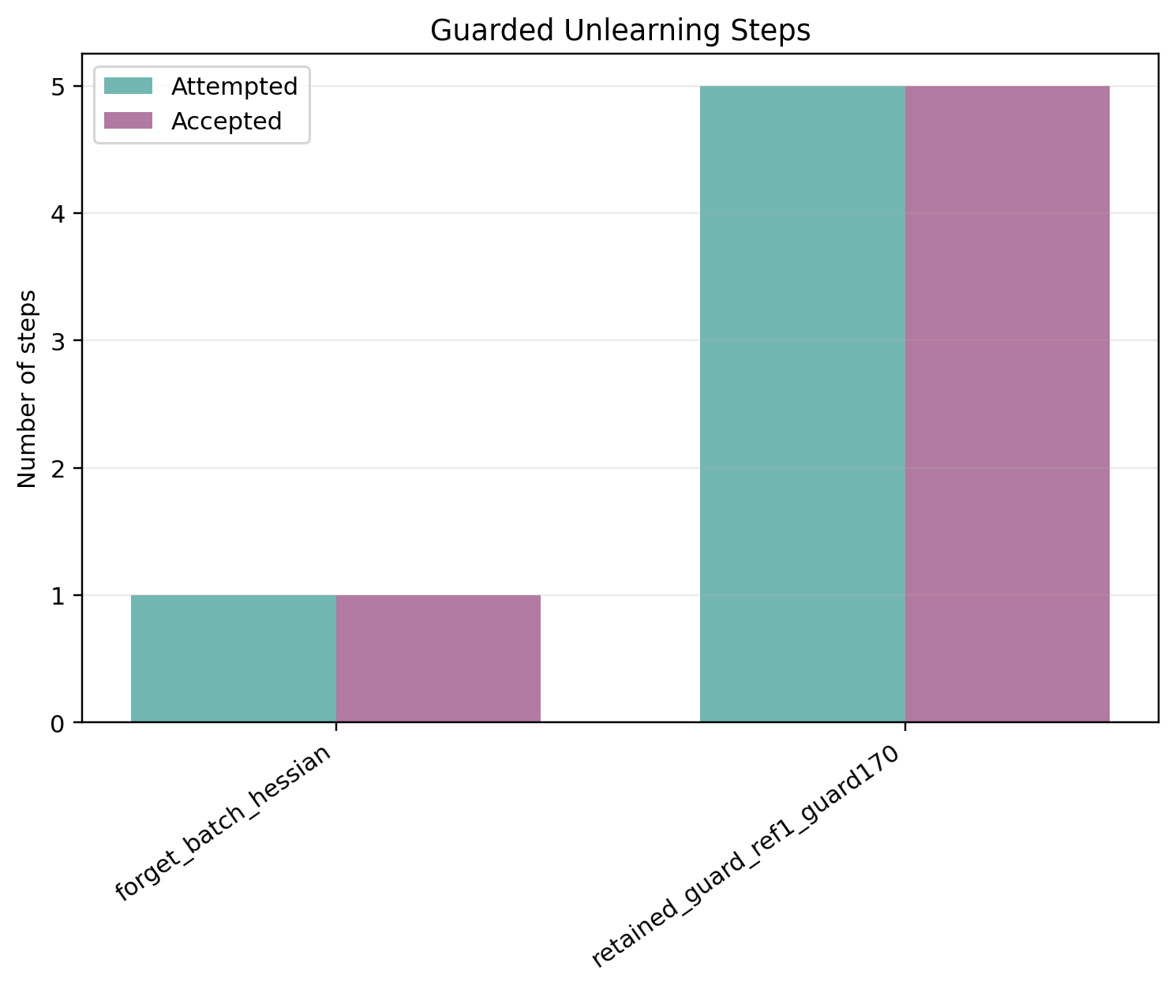
Figure A1. Stage 1: accepted and attempted guard steps.
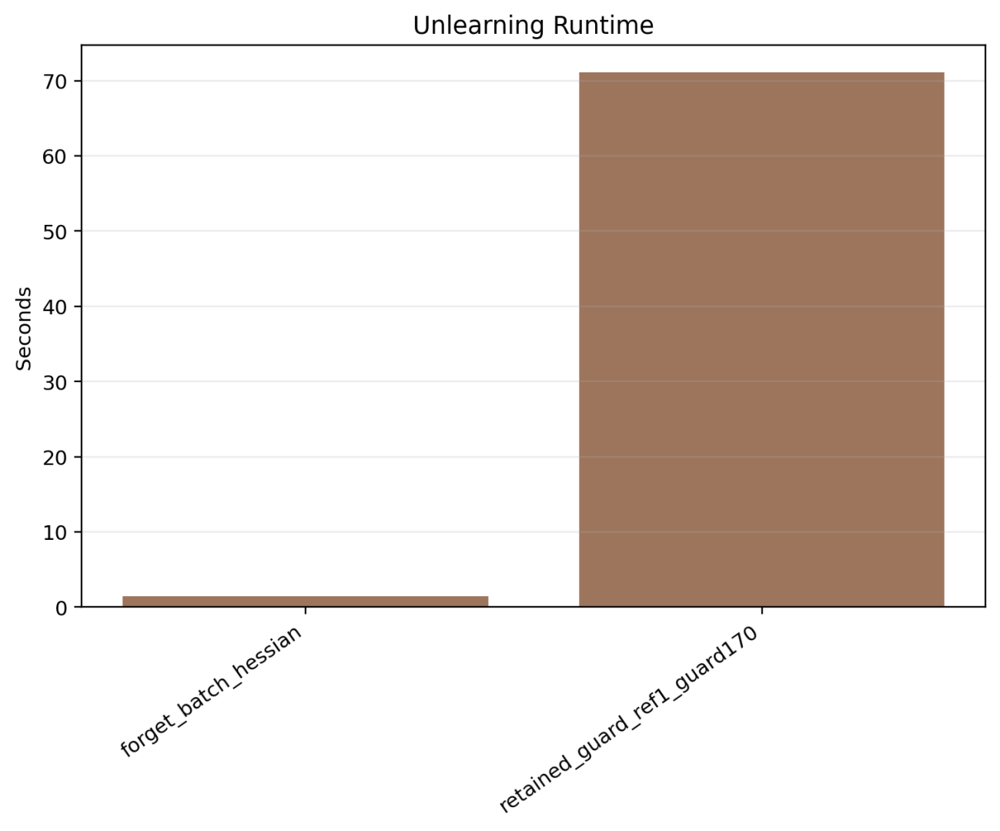
Figure A2. Stage 1: unlearning time comparison.
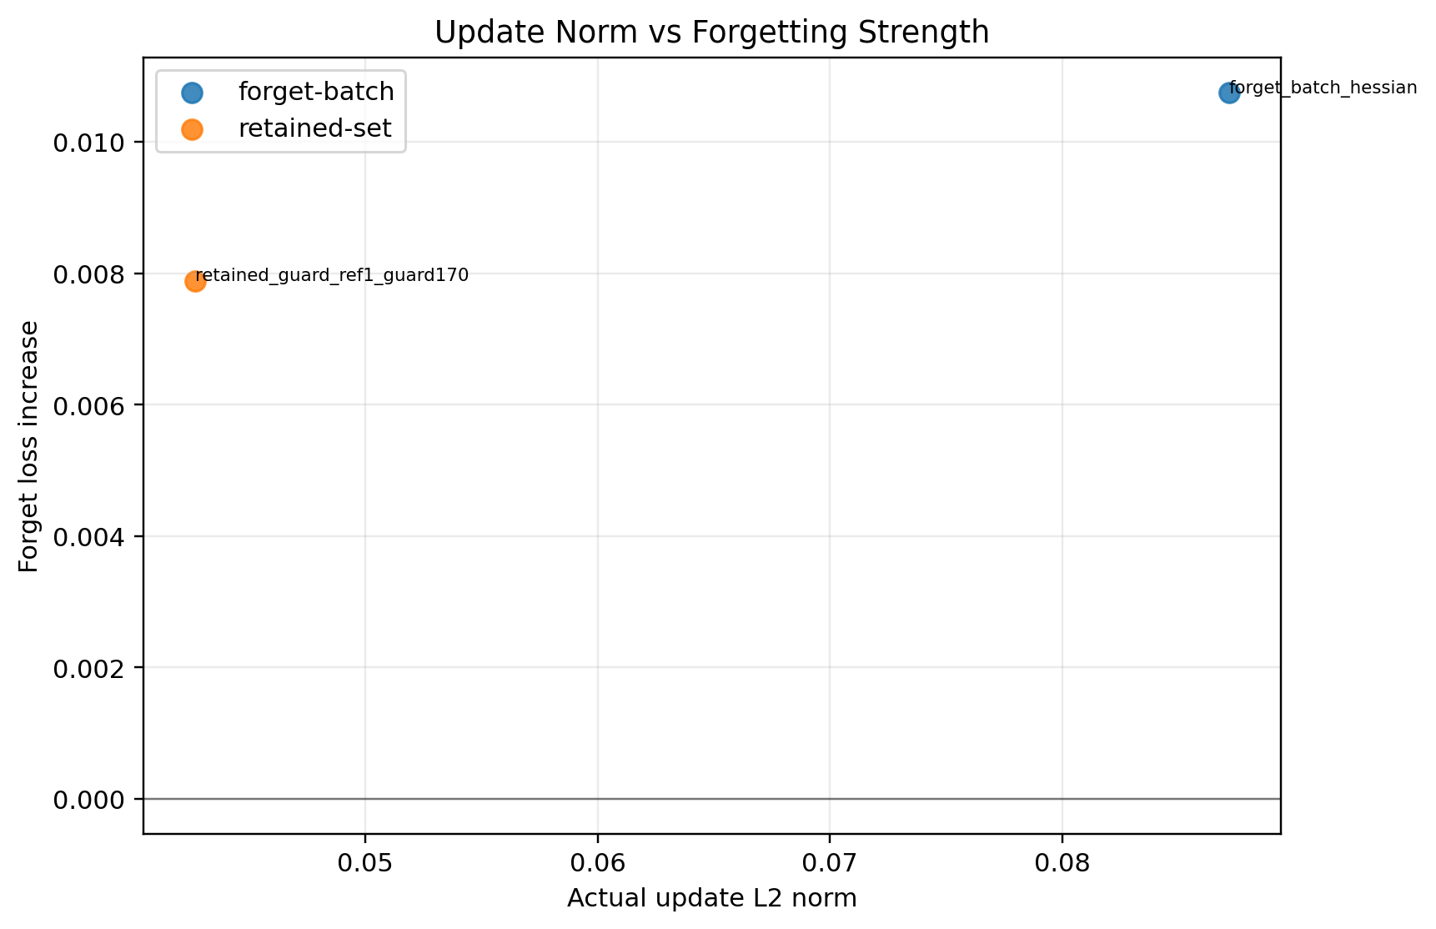
Figure A3. Stage 1: update norm versus forget-loss gain.
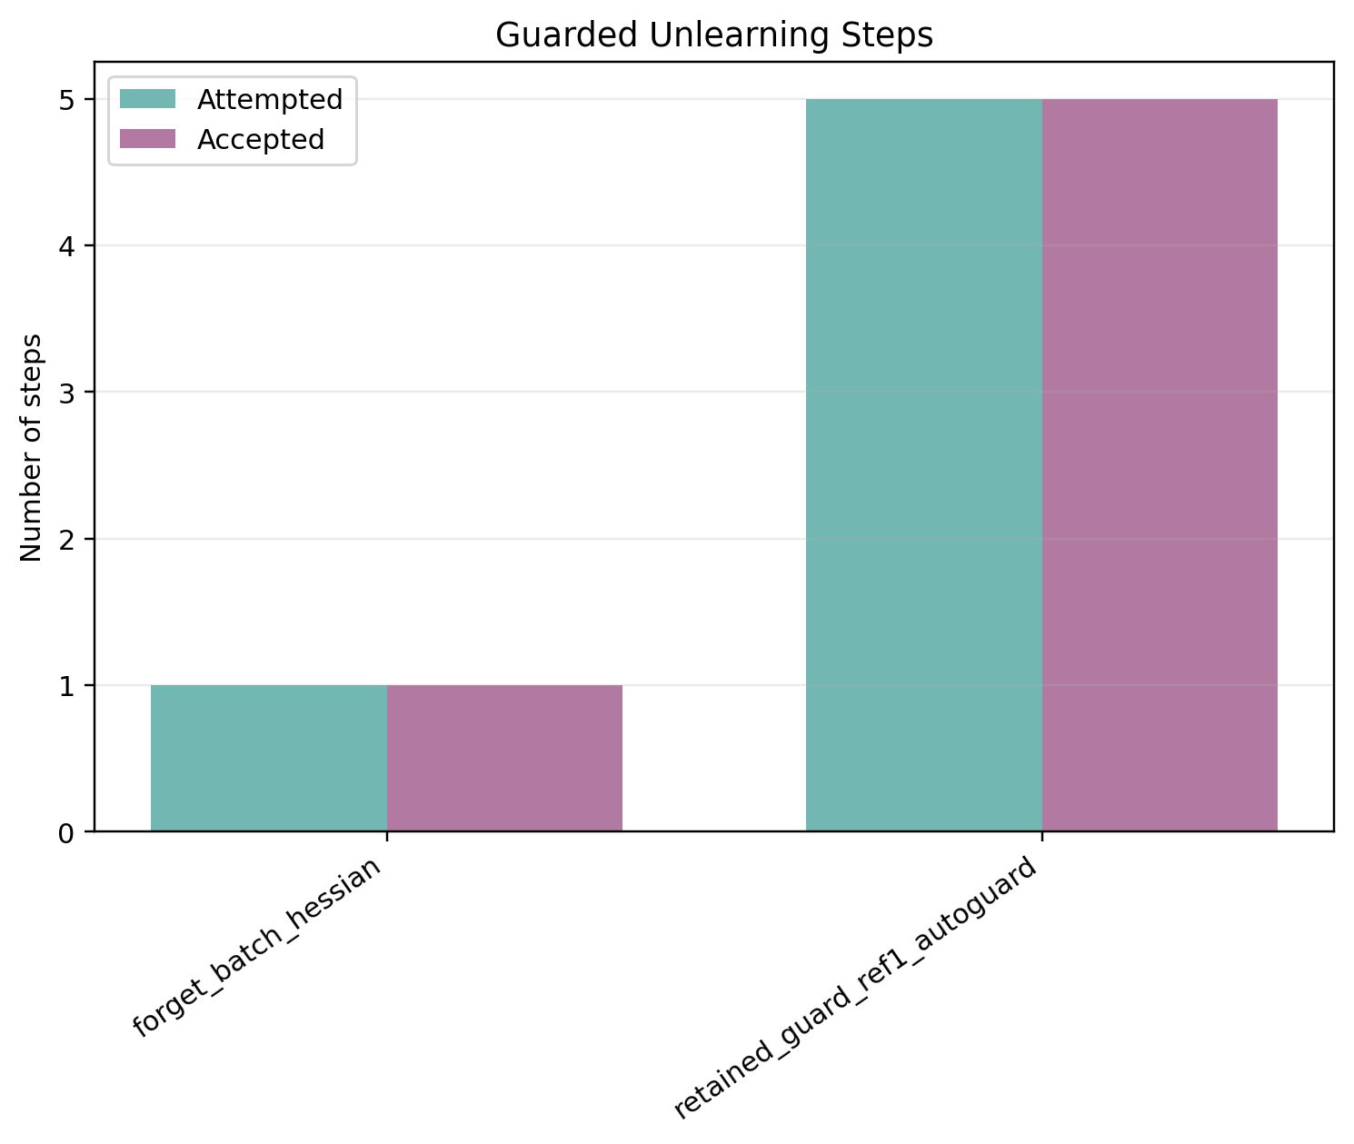
Figure A4. Stage 2: accepted and attempted guard steps.
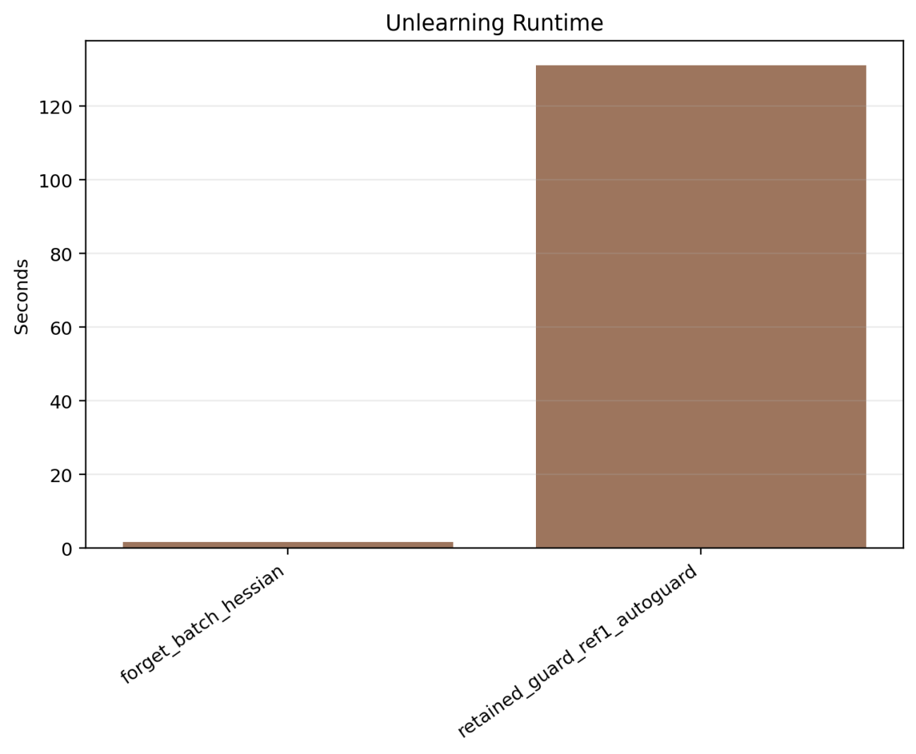
Figure A5. Stage 2: unlearning time comparison.
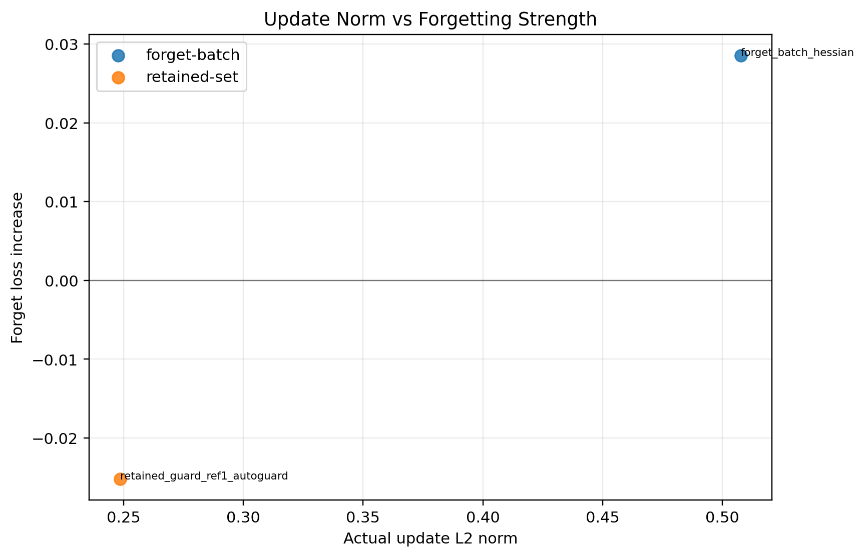
Figure A6. Stage 2: update norm versus forget-loss gain.
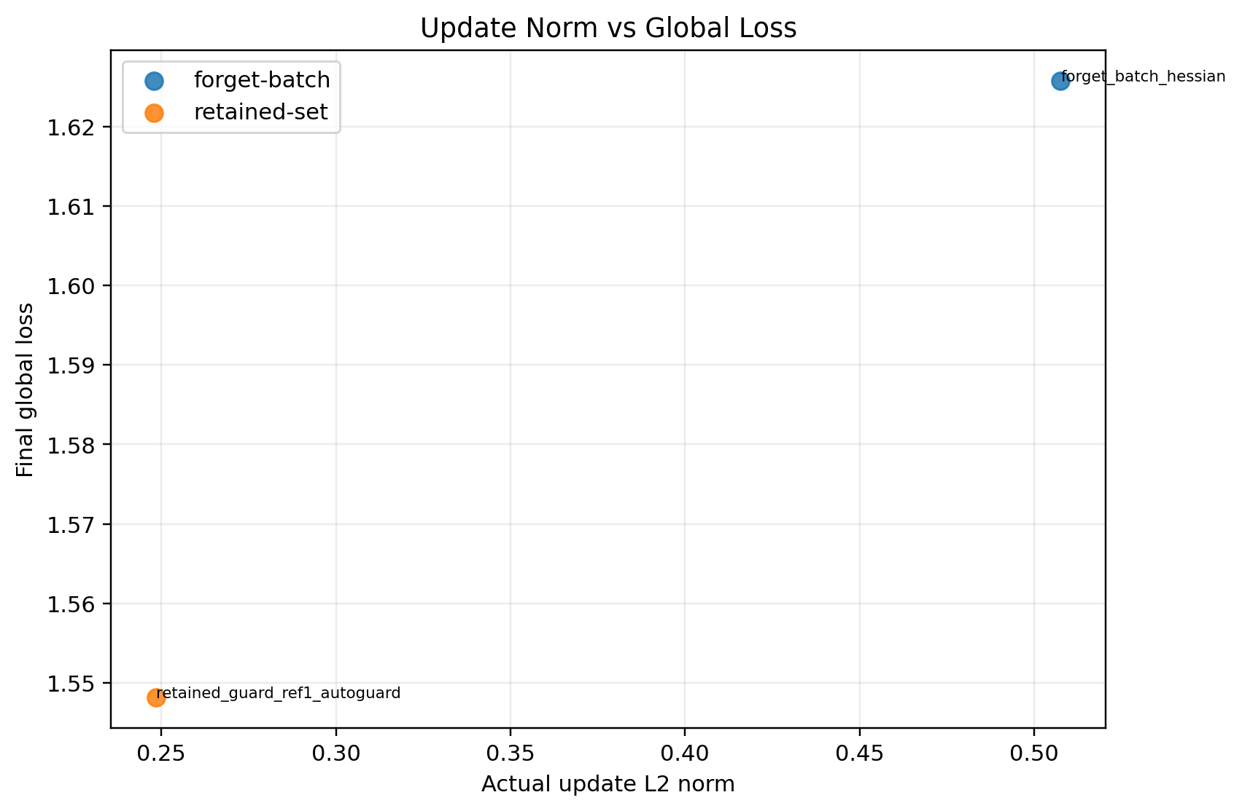
Figure A7. Stage 2: update norm versus final global loss.
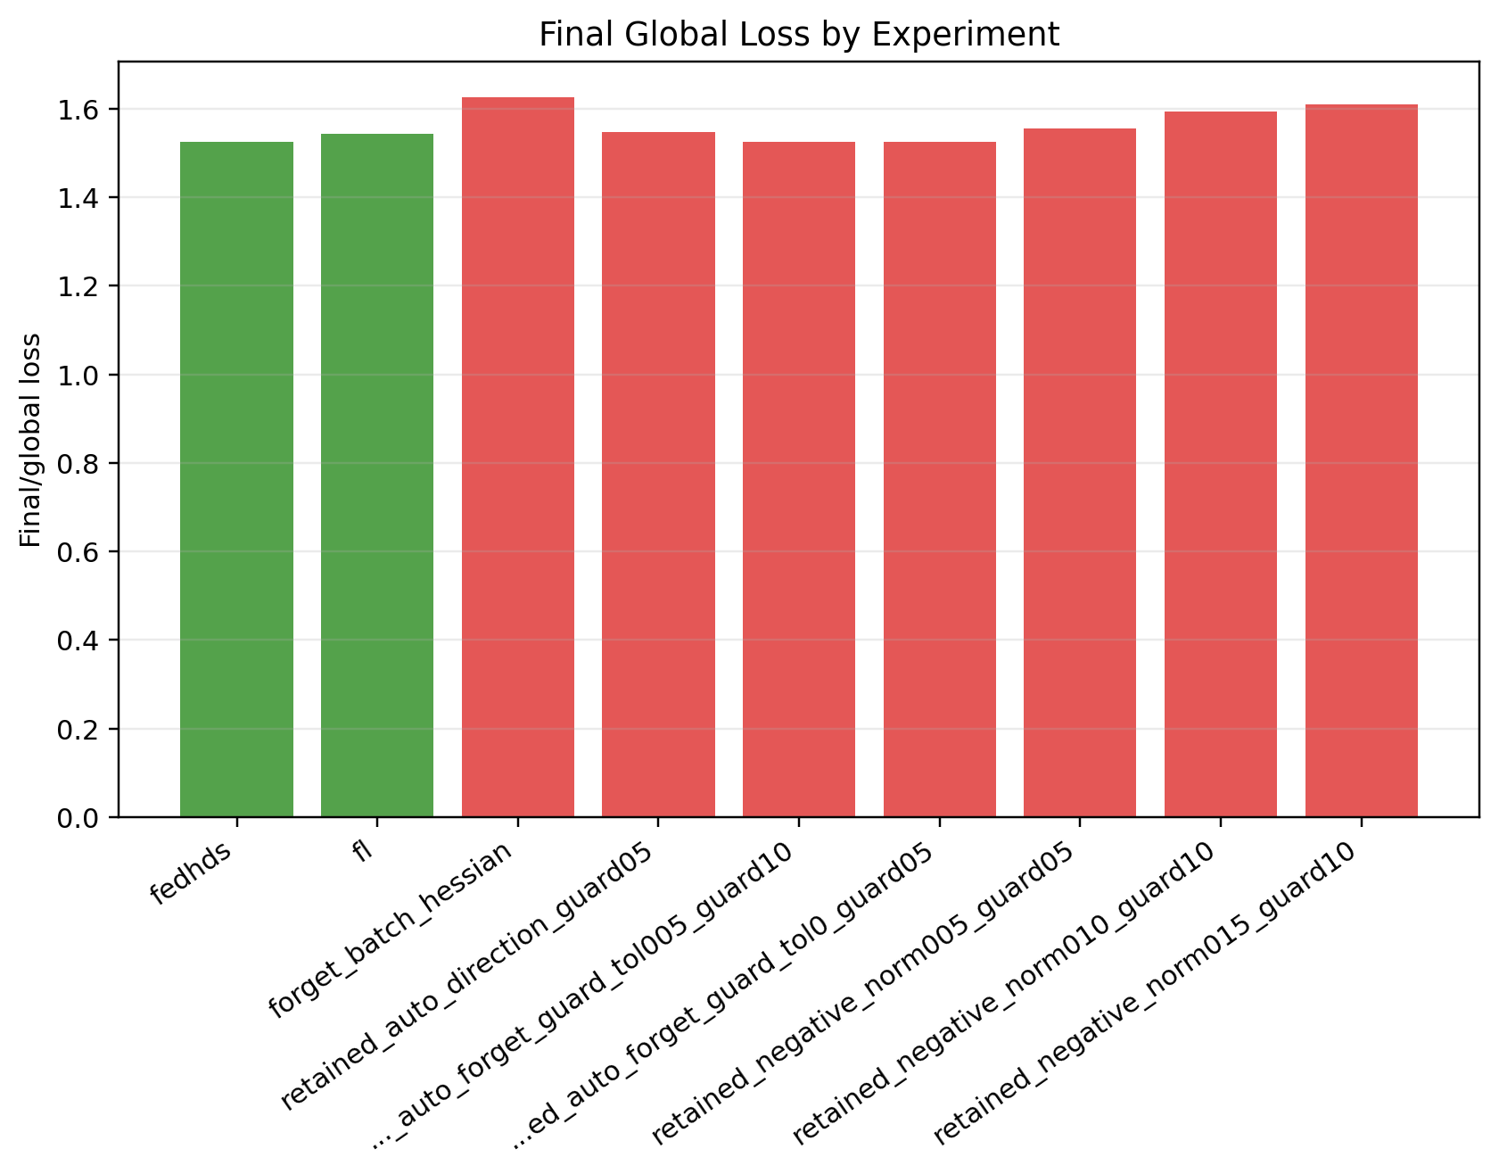
Figure A8. Stage 3: final global loss comparison.
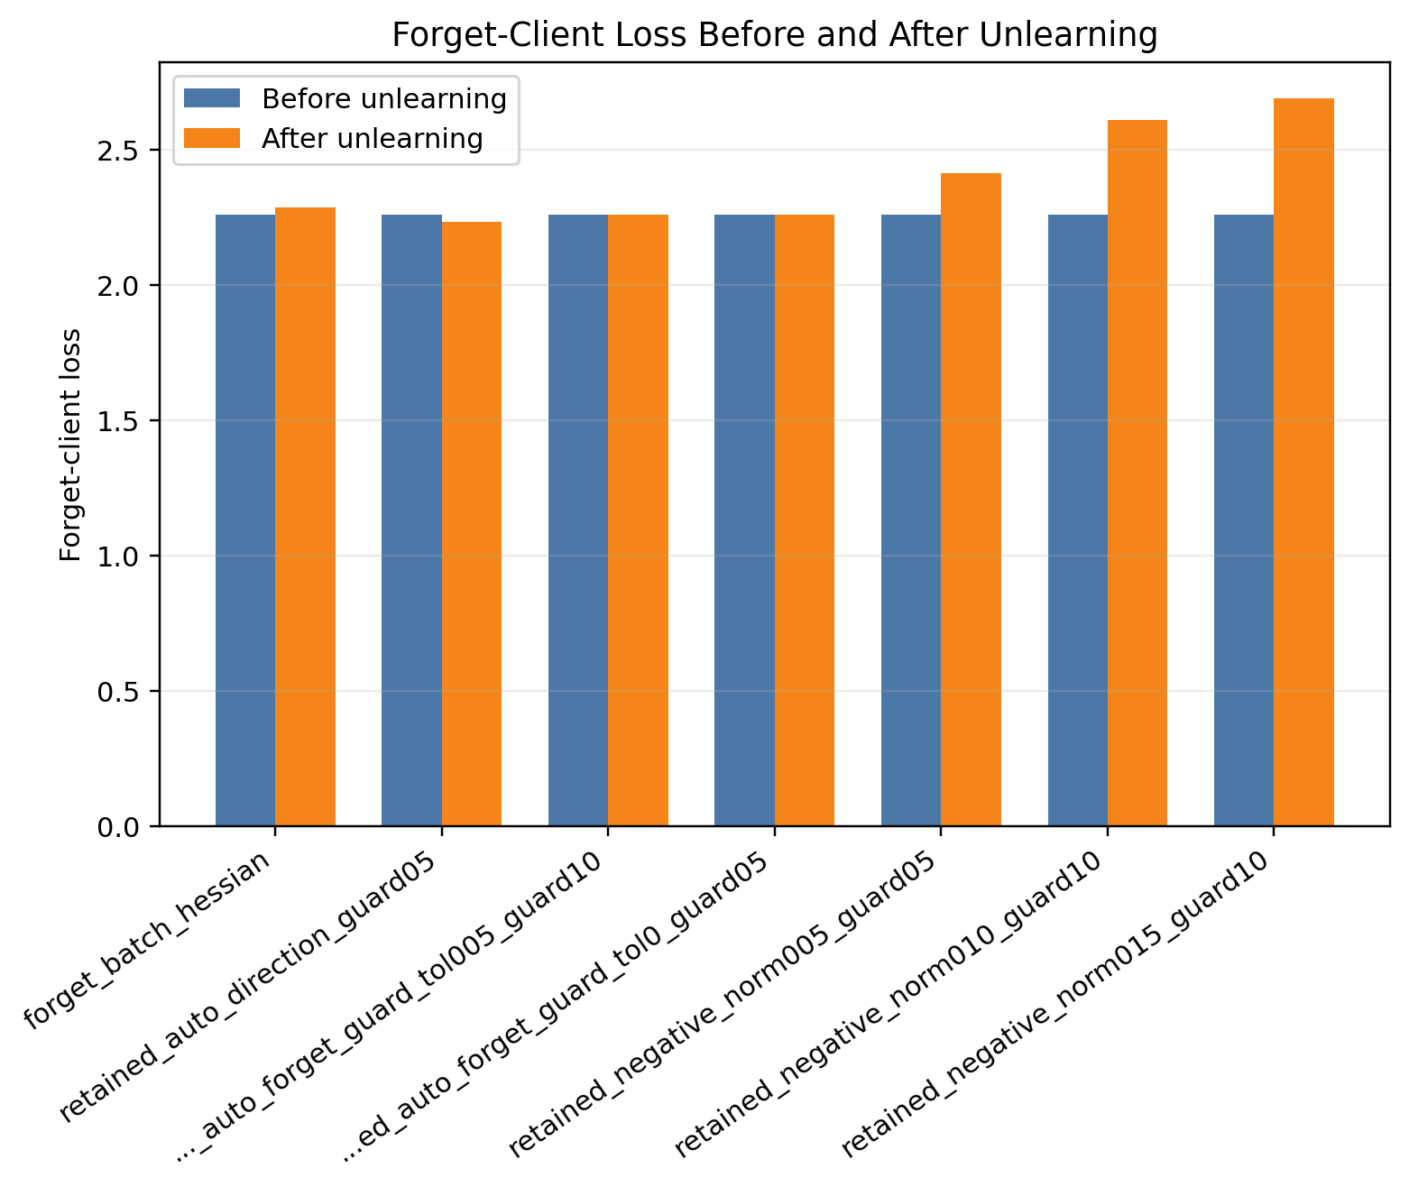
Figure A9. Stage 3: forget-client loss before and after unlearning.
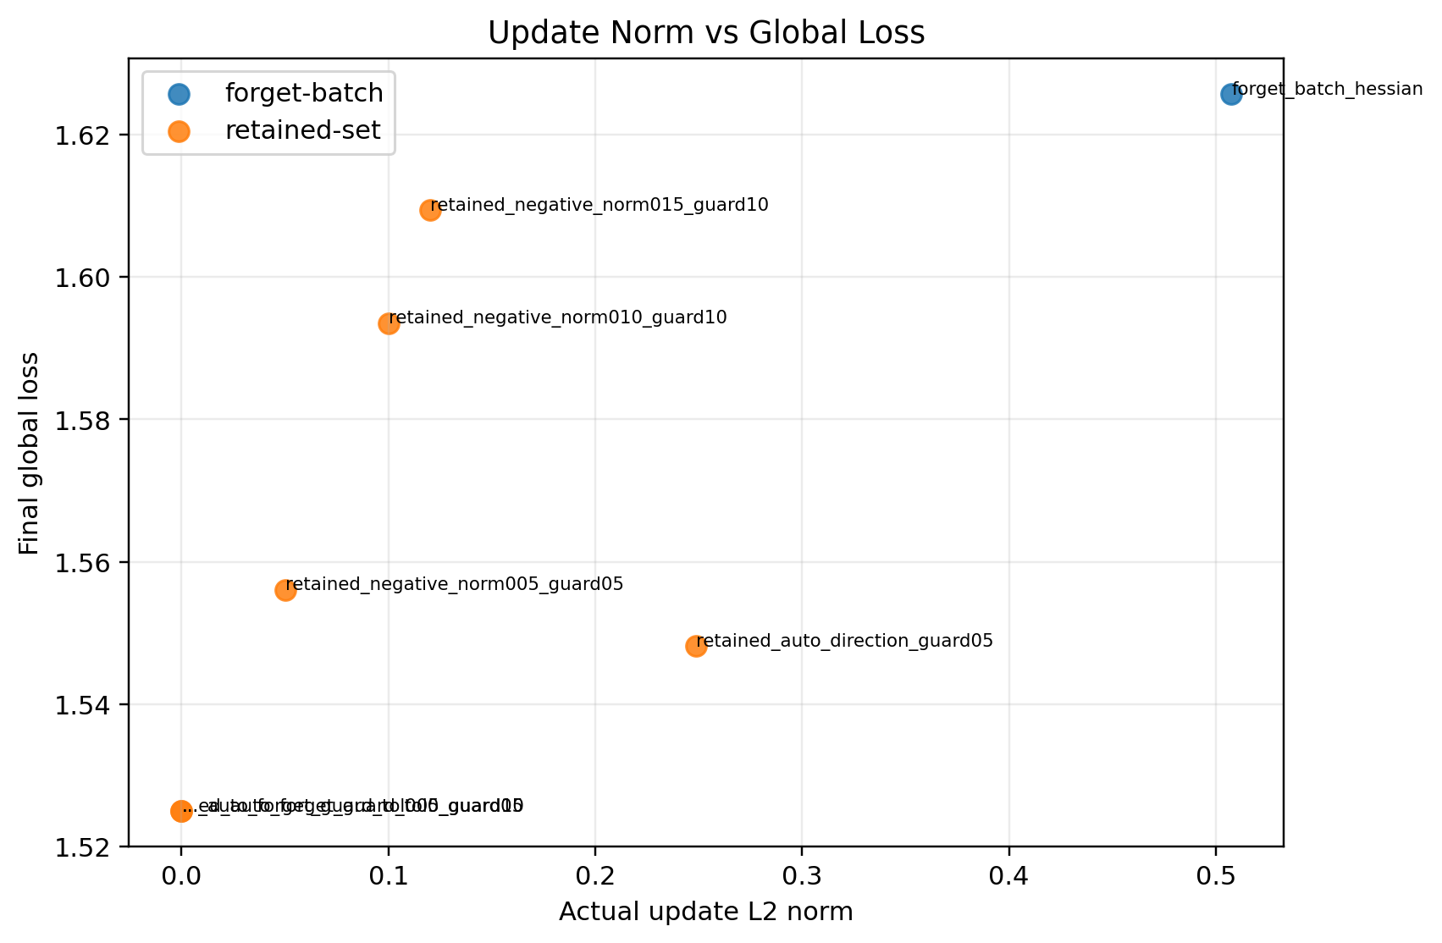
Figure A10. Stage 3: update norm versus final global loss.
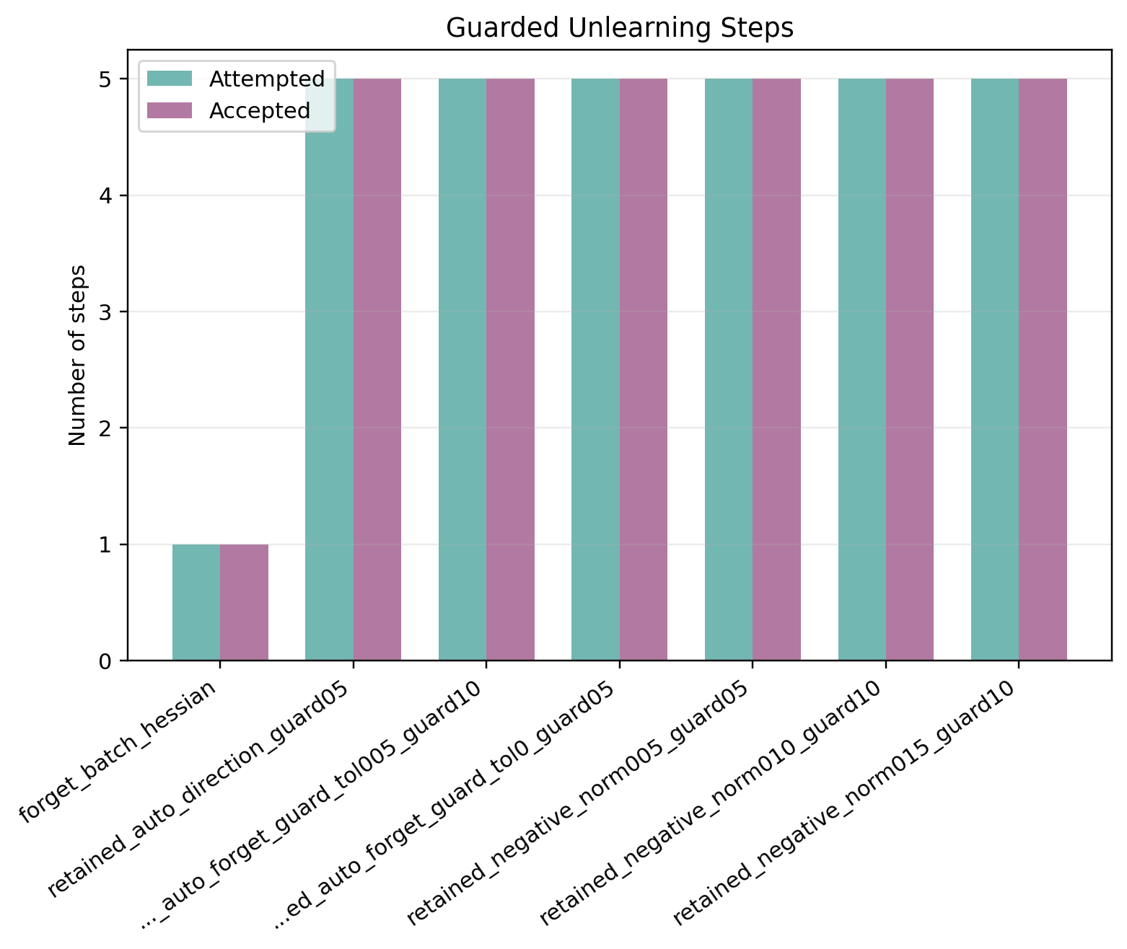
Figure A11. Stage 4A: accepted and attempted guard steps.
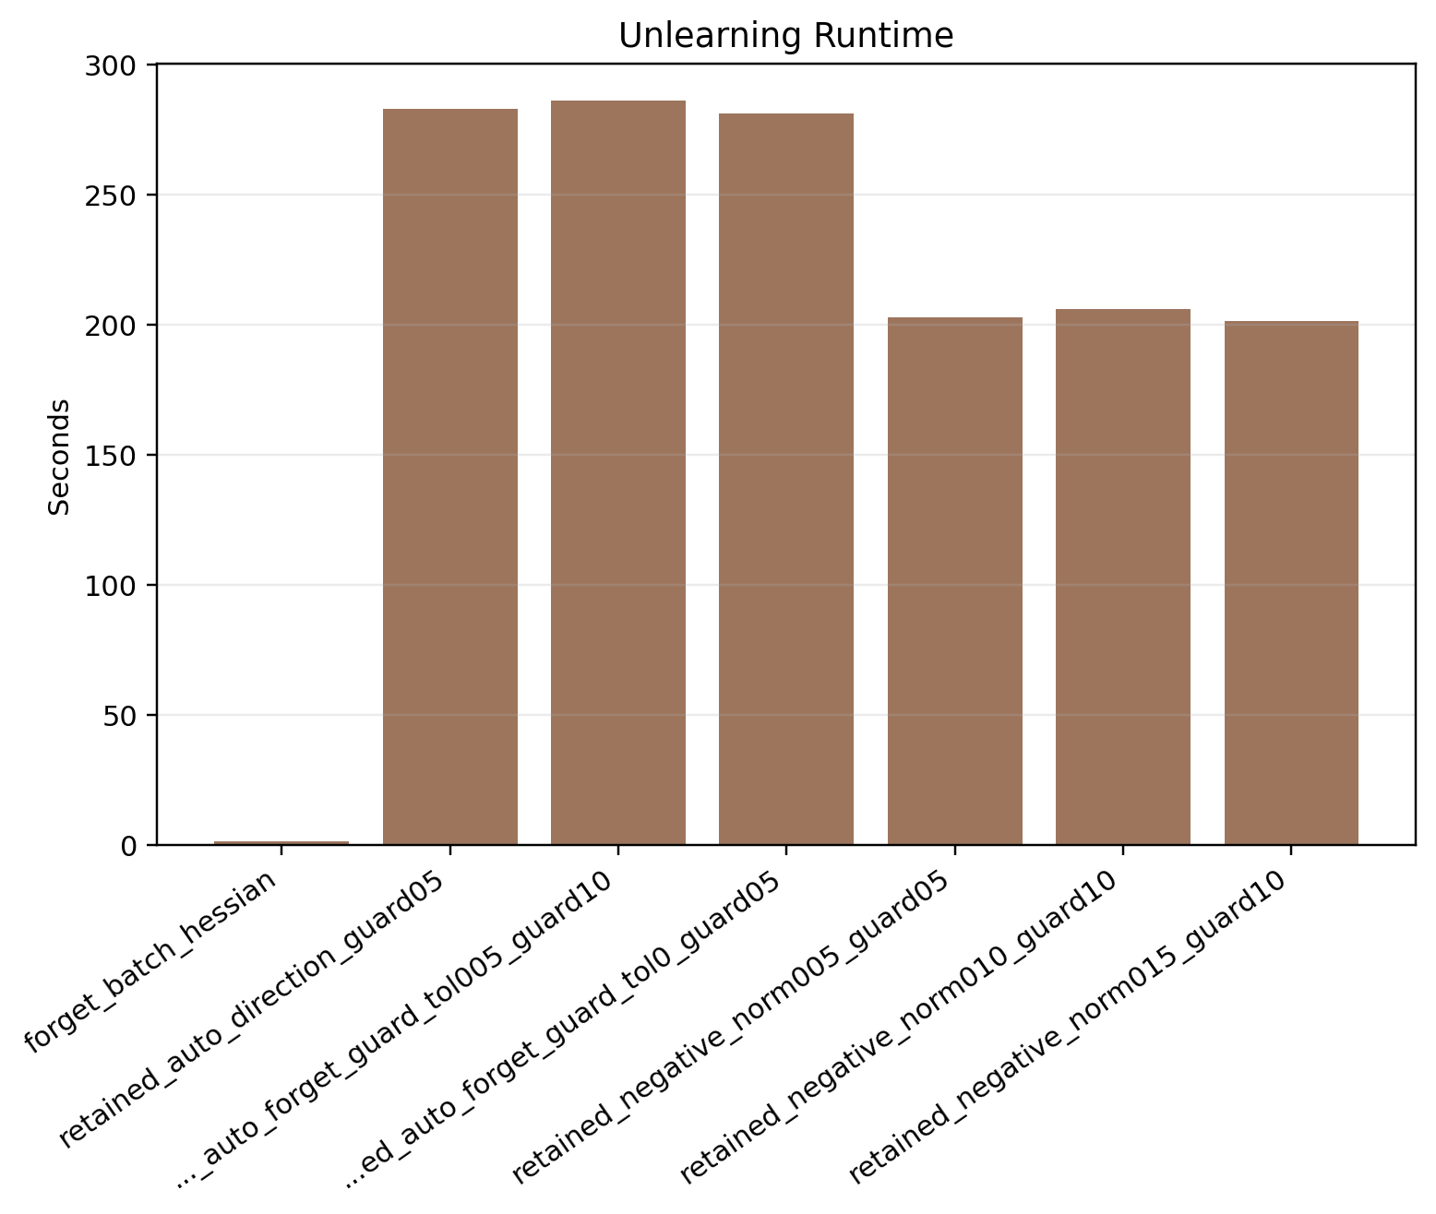
Figure A12. Stage 4A: unlearning time comparison.
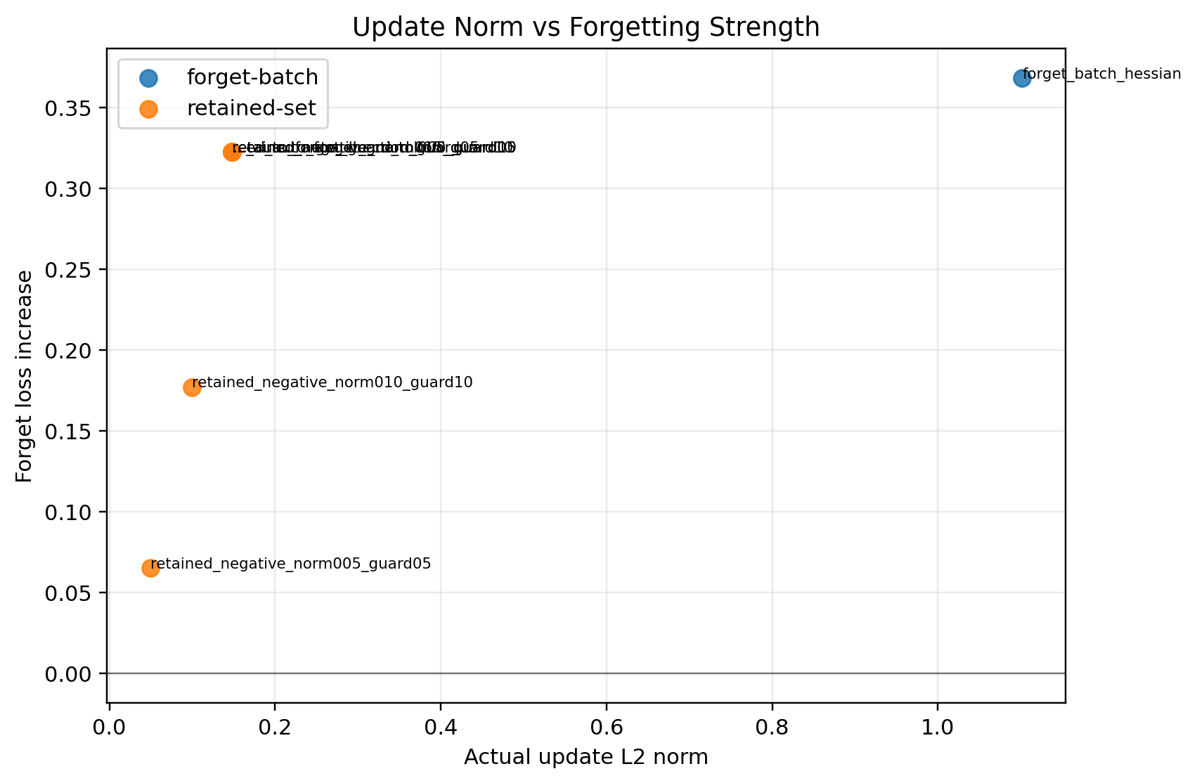
Figure A13. Stage 4A: update norm versus forget-loss gain.
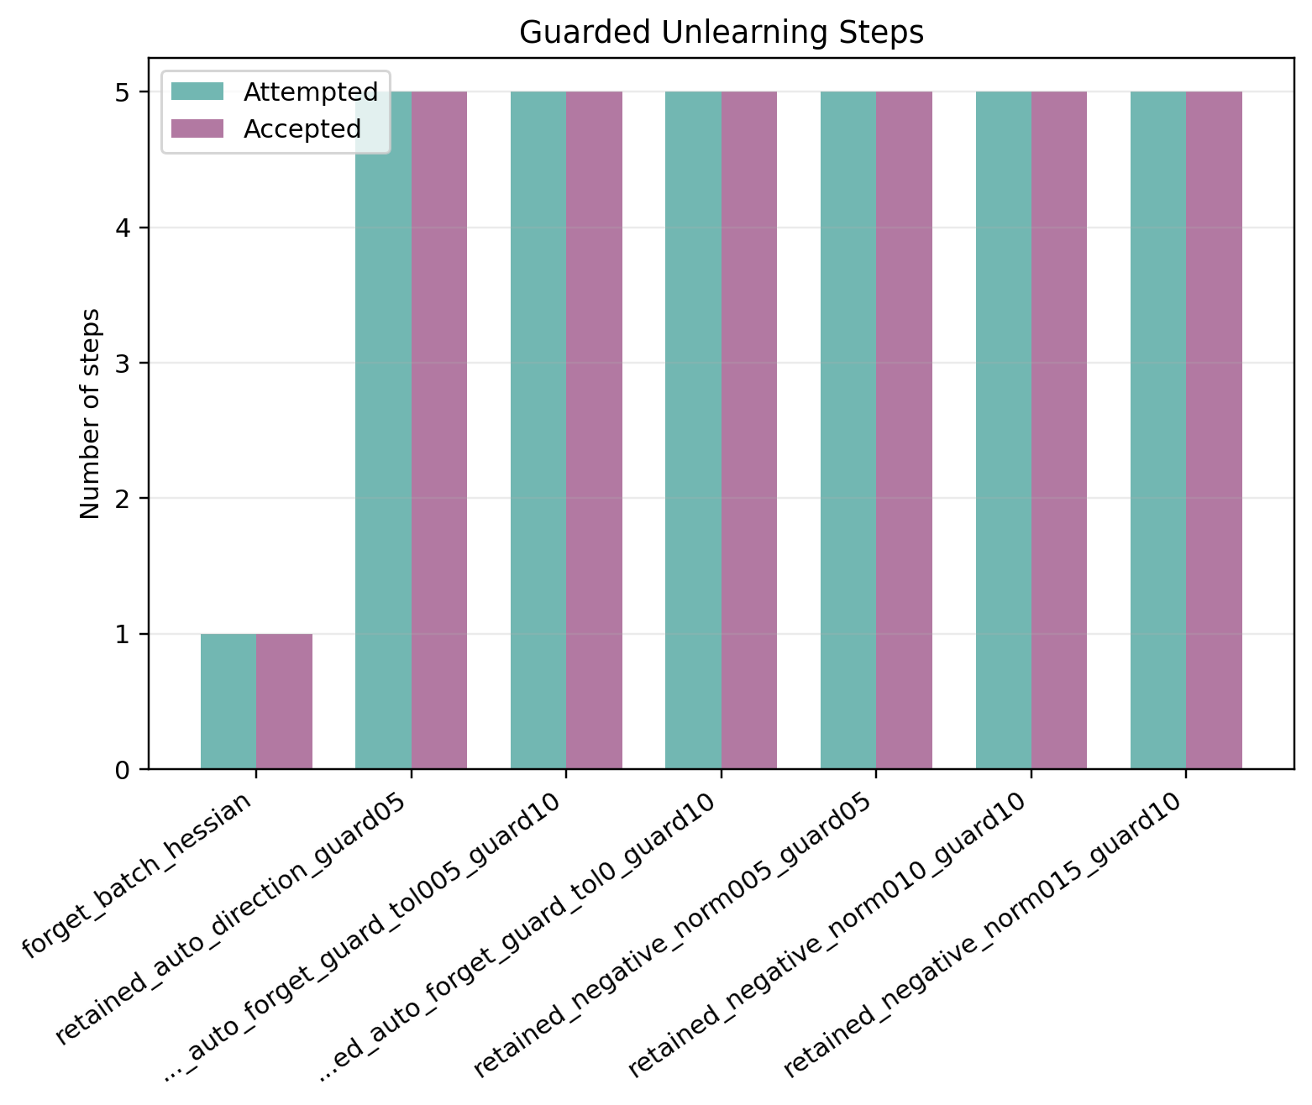
Figure A14. Stage 4B: accepted and attempted guard steps.
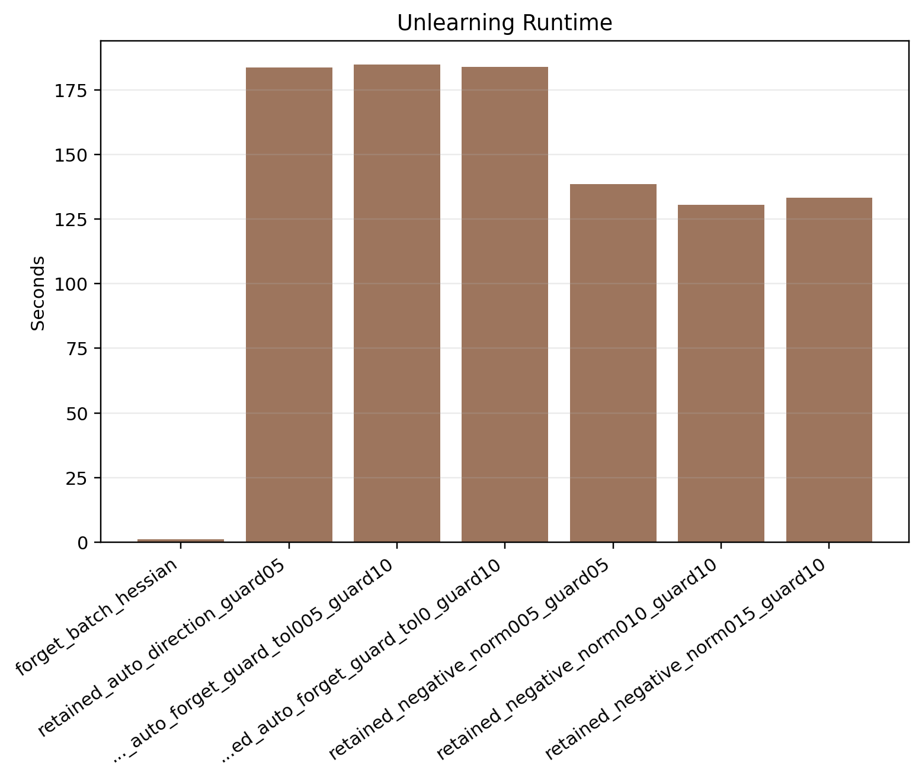
Figure A15. Stage 4B: unlearning time comparison.
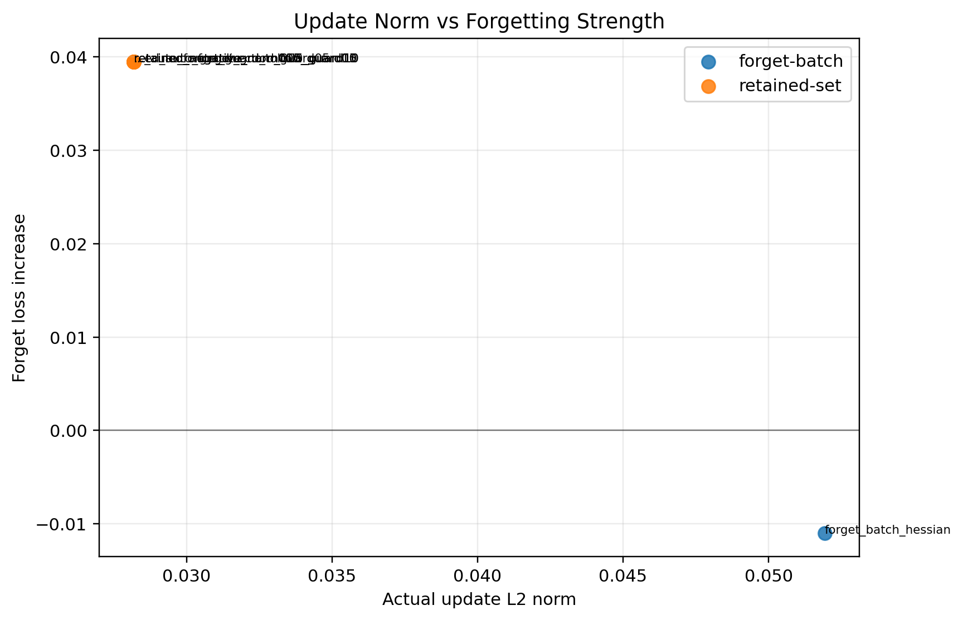
Figure A16. Stage 4B: update norm versus forget-loss gain.

Figure A17. Stage 4C: accepted and attempted guard steps.
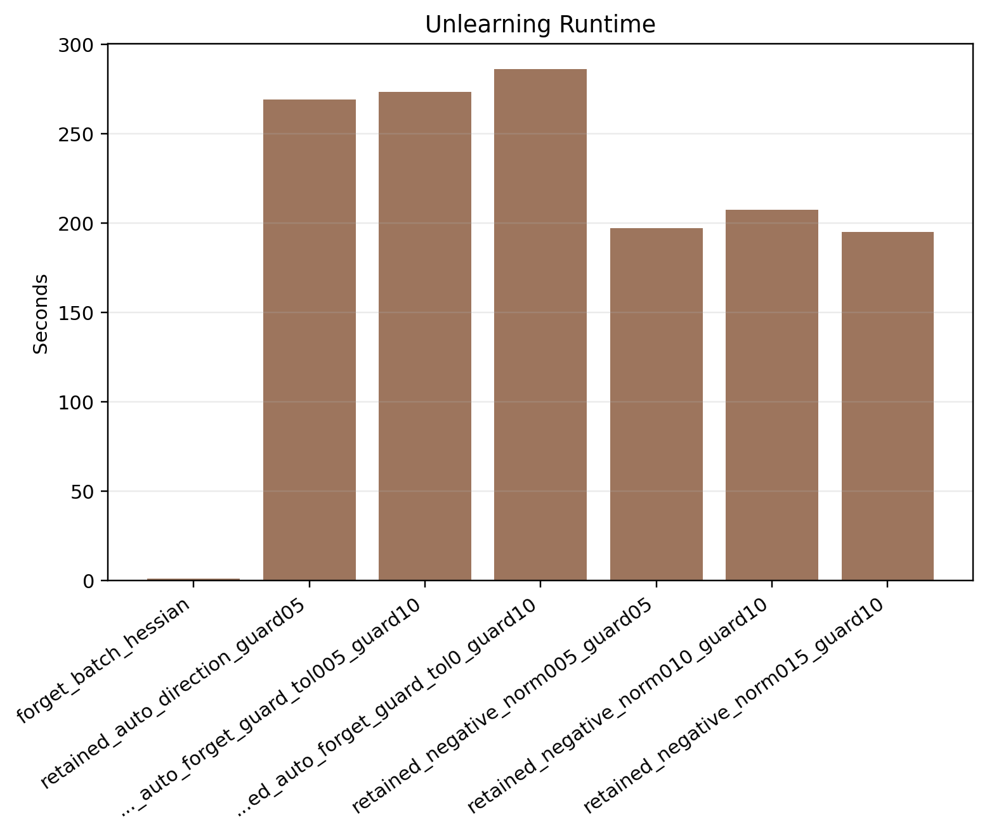
Figure A18. Stage 4C: unlearning time comparison.
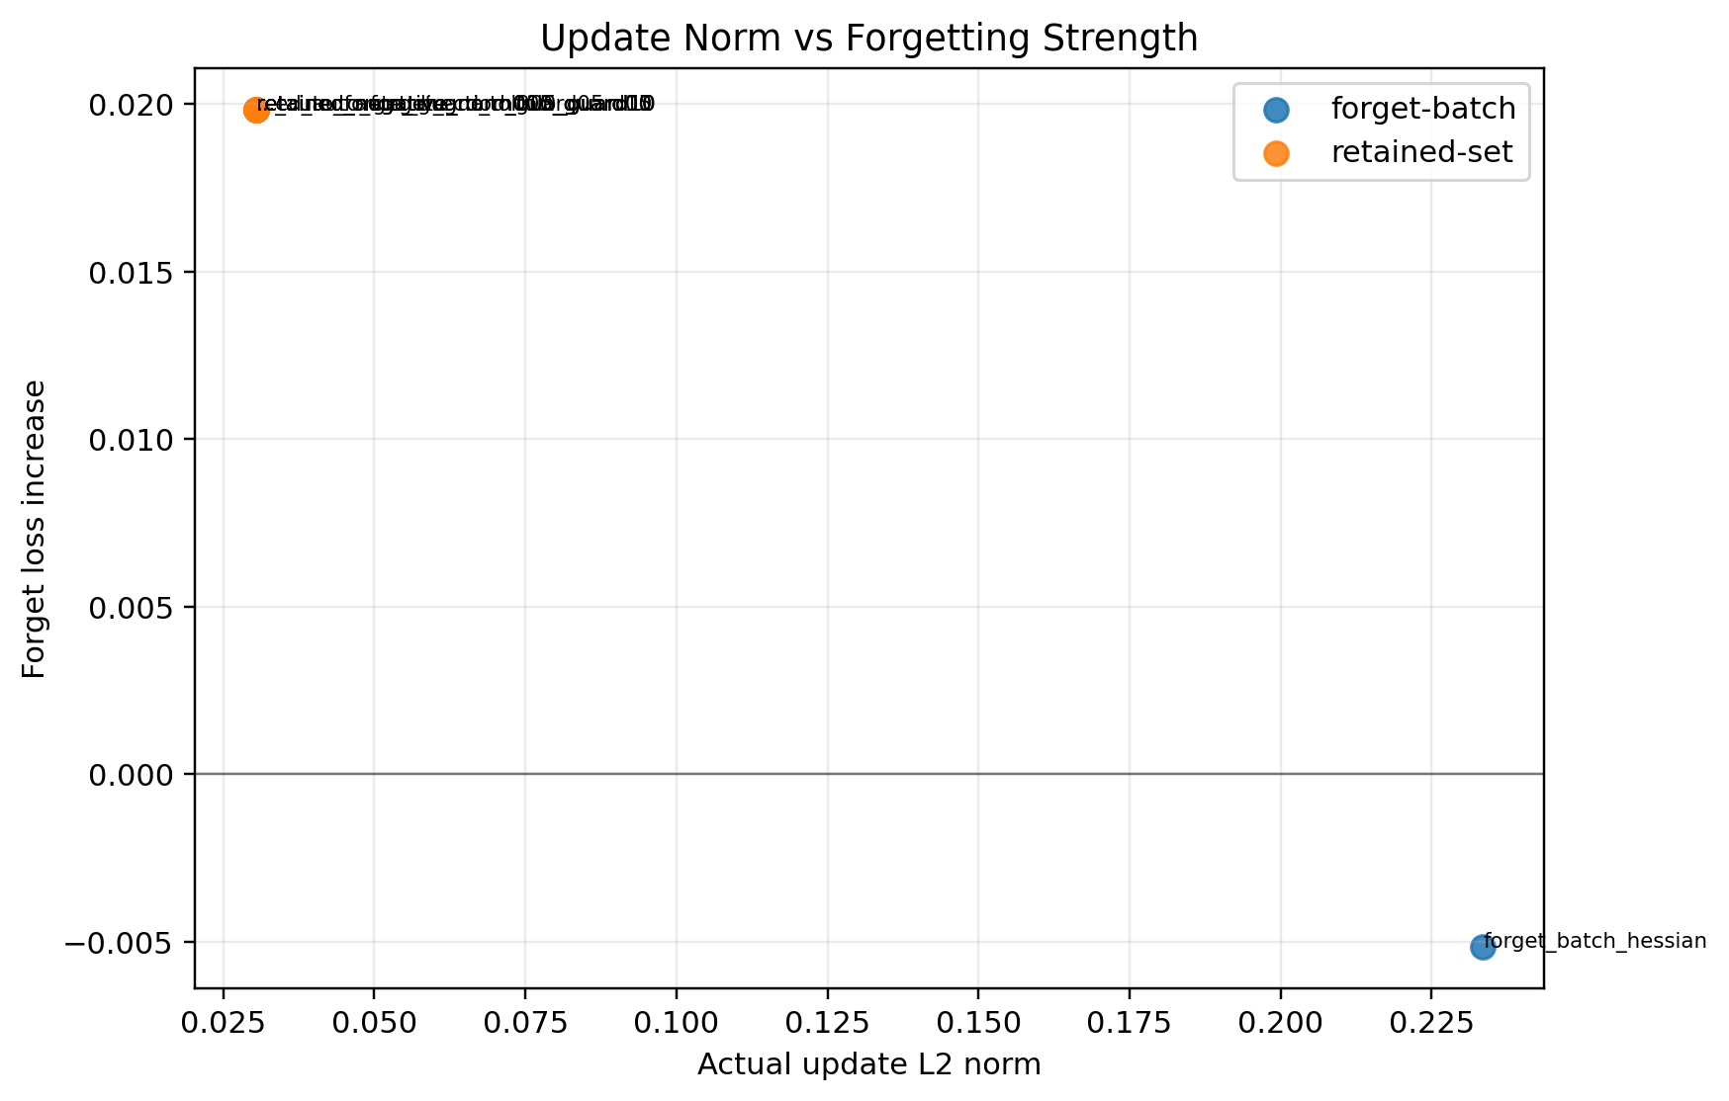
Figure A19. Stage 4C: update norm versus forget-loss gain.
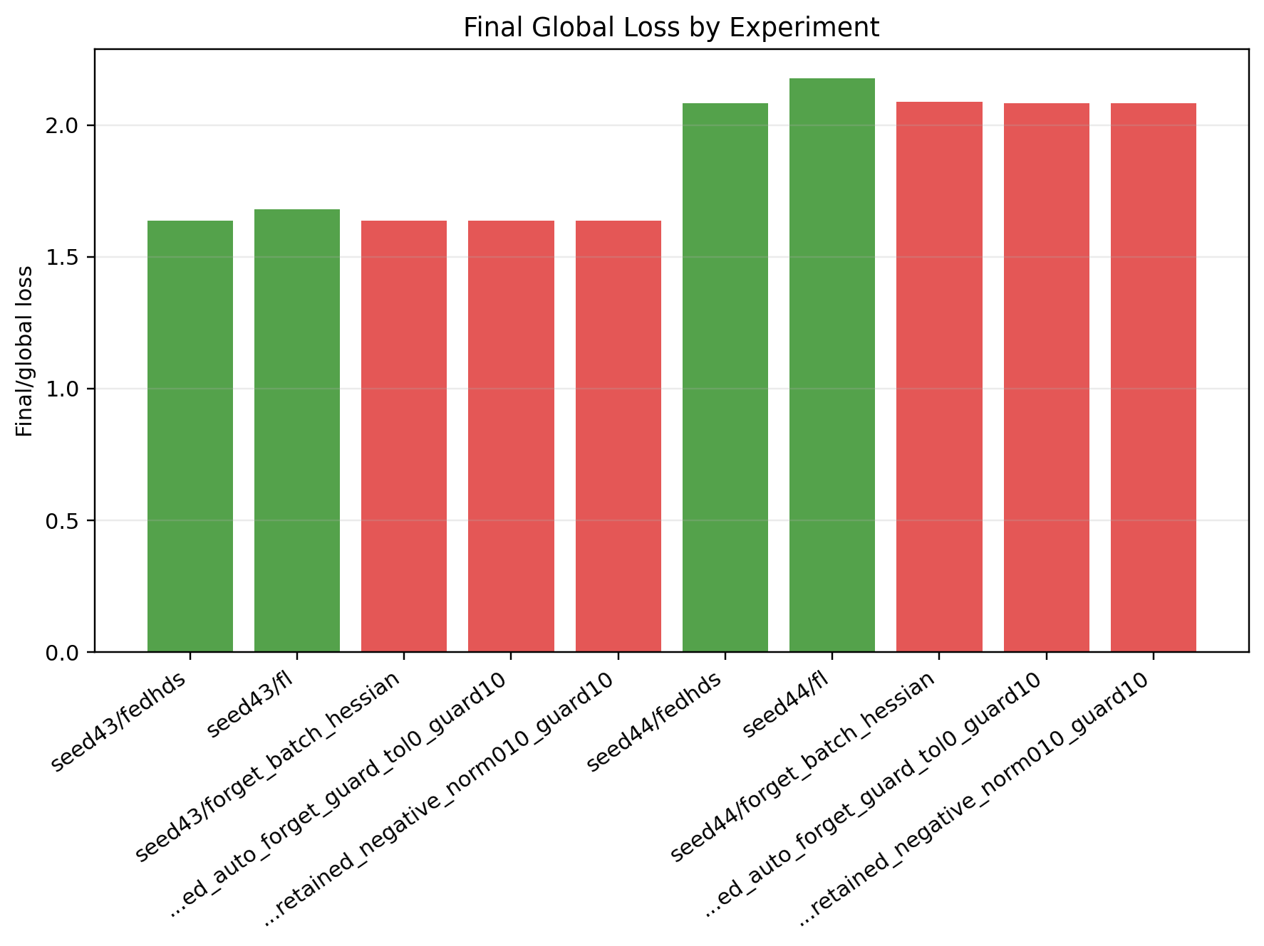
Figure A20. Stage 4 seed summary: final global loss comparison.
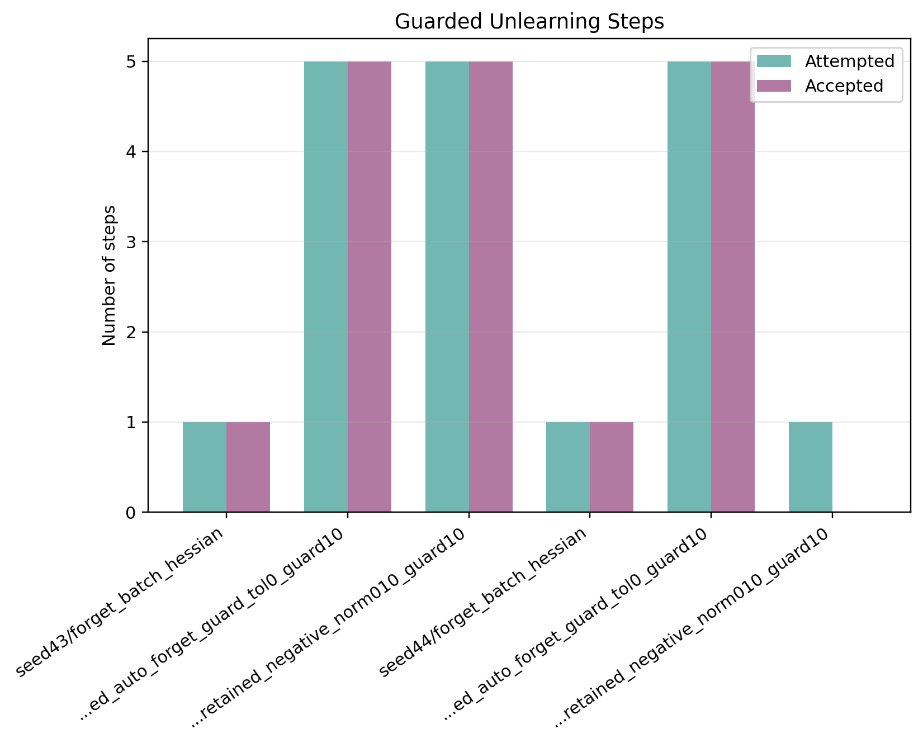
Figure A21. Stage 4 seed summary: accepted and attempted guard steps.
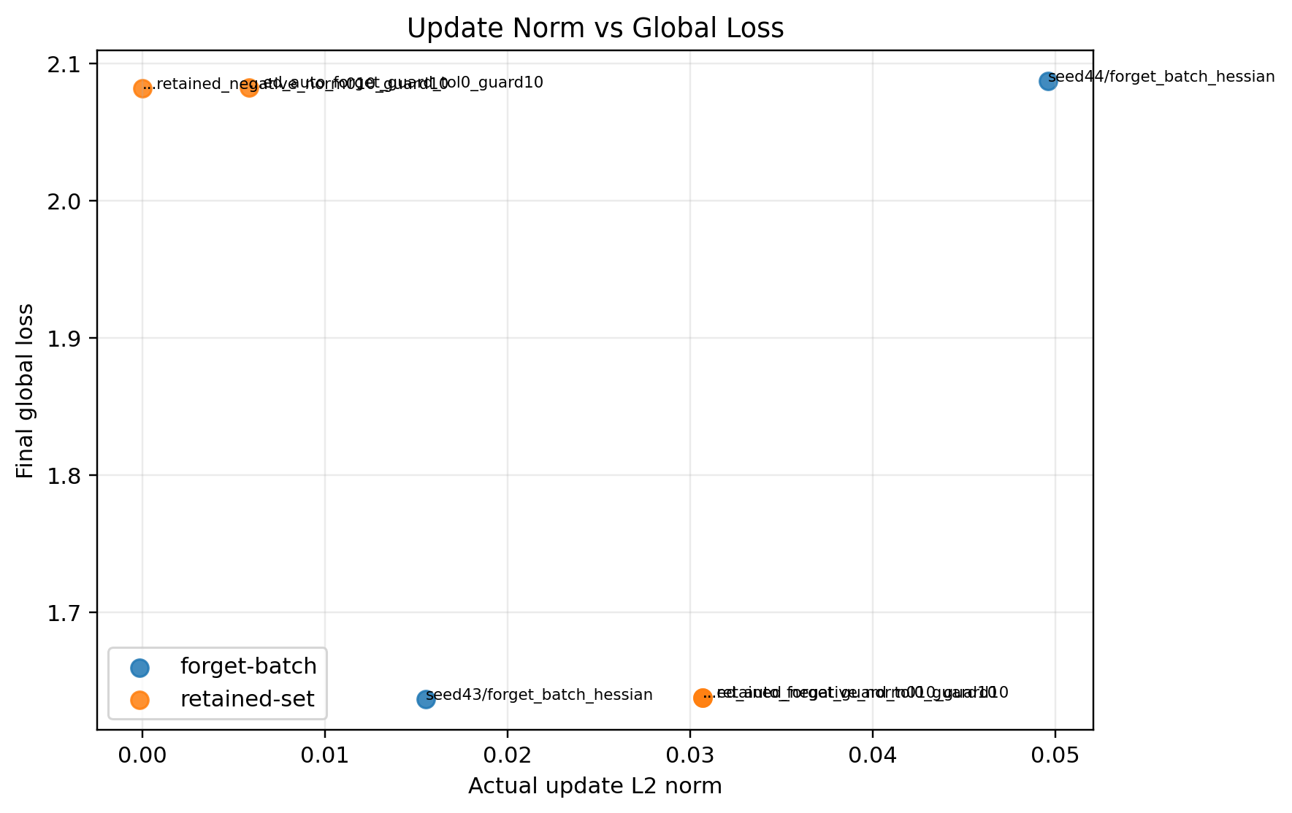
Figure A22. Stage 4 seed summary: update norm versus final global loss.
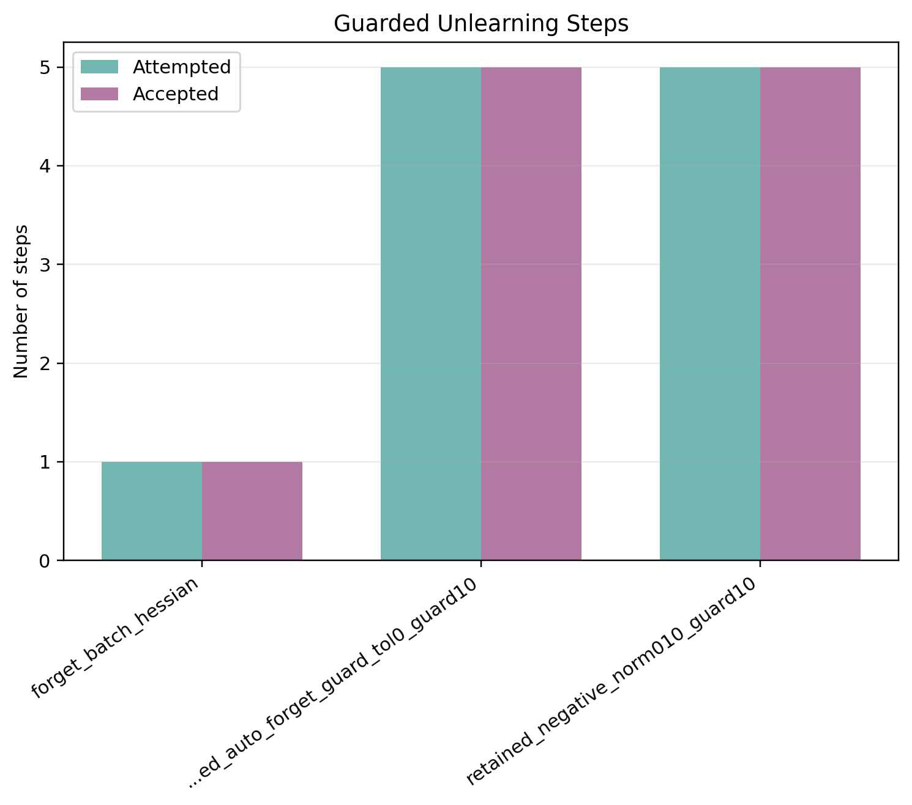
Figure A23. Stage 4 seed43: accepted and attempted guard steps.
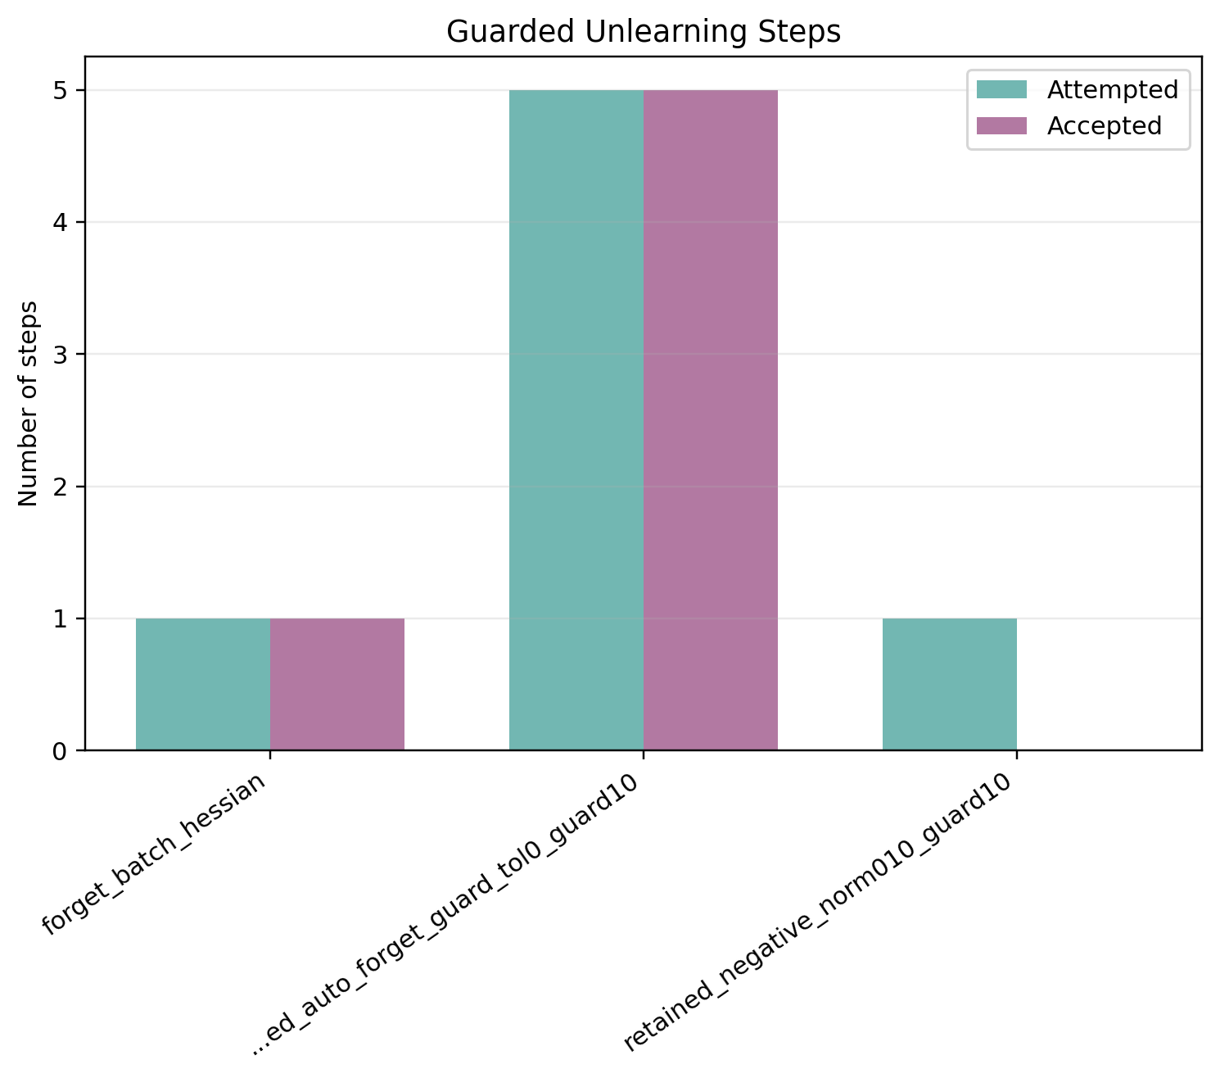
Figure A24. Stage 4 seed44: accepted and attempted guard steps.

