30 Oct

Ubuntu

https://blog.zenggyu.com/posts/en/2018-01-29-installing-r-r-packages-e-g-tidyverse-and-rstudio-on-ubuntu-linux/

It’s like I have installed tidyverse now, since the outprints are the same as in Dr. Pawar’s course notes

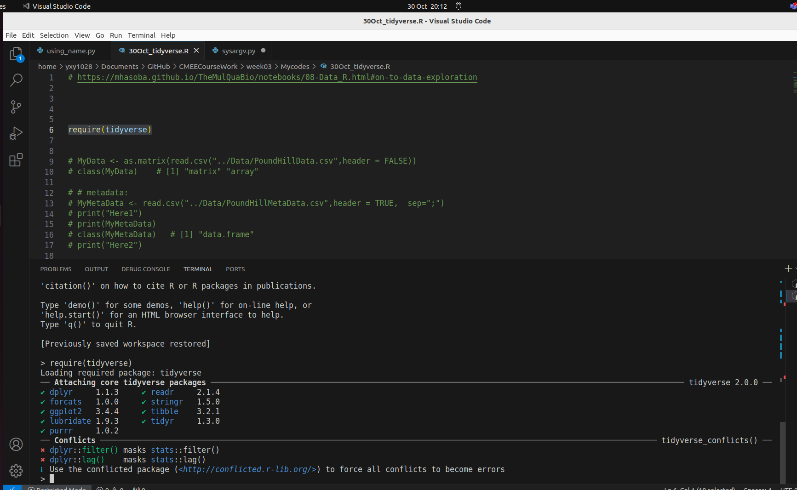
Q:

How to check whether a package has been installed or not?

