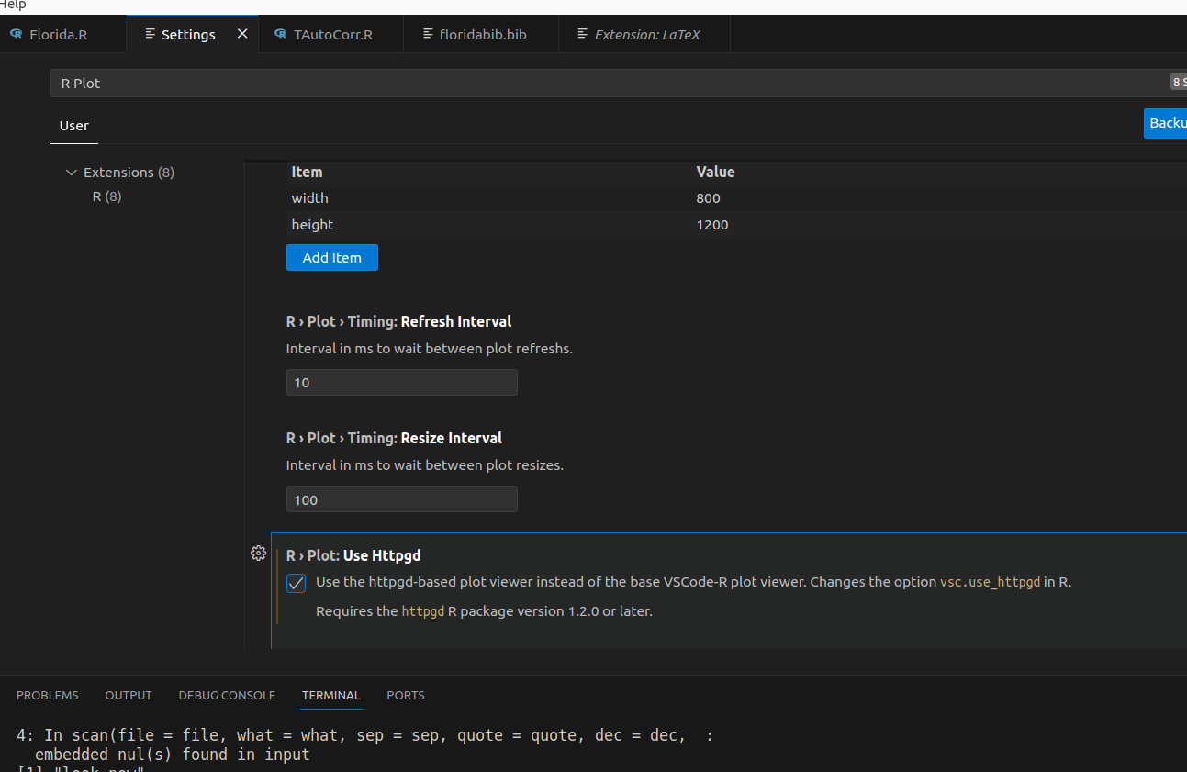
Sdf

Ctrl + , search: settings.json open the default settings json

