Q and A

Orme, David
Hang on, let me just paste this.

Orme, David
So the outcome of that should be that you see a whole bunch of files, so something is deleted your files somehow. Not quite sure how, but I think try start again and see see how you get on.

Orme, David
Any other questions?

Orme, David
OK, let me just have a look.

Orme, David
OK, let me just find where we're looking at. So I'll go to Article 2.

Orme, David
Kappa of Naughty Point. Naughty two. I'm not quite sure what you mean though. I'm just looking for Naughty point. Naughty 2.

Orme, David
So I mean it depends which model you're looking at. So the examples online the capper is is greater than nought point nought 2 depending on which model you look at.

Orme, David
So certainly they're not great models, but they're they're not a capra of nought, point nought 2.

Orme, David
So I'm not quite sure which example you're referring to there she Han.

Orme, David
OK.

Orme, David
I'm just whilst I whilst if she hand can you if you can, you can give some points to what section you mean. I can come back to in a bit more detail. So GG plots.

Orme, David
Ggplot is really good.

Orme, David
And there are lots of really neat aesthetics to make. Nice Gigi plot plots, but it's, I mean, it's been around now for quite a long time. I guess when I learned to when I started making plots in RI got very used to using the base graphics, so that if I want to create base graphic, if I want to create plots in RI will use typically base graphics and I've got pretty good at tinkering with them so that I get exactly the results I want. So if I'm trying to create a graphic to present.

Orme, David
In a figure in a paper I will use base graphics. Nearly all of the time because I find that all of the kind of canned neat things and I include GG plot in that.

Orme, David
Do something that it turns out to be incredibly finicky to try and change so they they enforce a bunch of stuff that then leads to.

Orme, David
You. So they do make changes that they they because it's very high level making very fine changes is quite difficult.

Orme, David
so i generally find it easier to use base base graphics and i don't tend to use gg plots so the reason i haven't put a lot of stuff about gg plot in this practical is because i don't personally use it now there are some really useful routines in there so if you if you're used to using gg plot and you end up

奥姆，大卫
等一下，我把这个贴出来。

奥姆，大卫
因此，结果应该是您看到一大堆文件，因此某些内容以某种方式删除了您的文件。 不太确定如何，但我想尝试重新开始，看看你进展如何。

奥姆，大卫
还有其他问题吗？

奥姆，大卫
好吧，让我看看。

奥姆，大卫
好的，让我找到我们正在看的地方。 那么我将转到第 2 条。

奥姆，大卫
淘气点的河童。 顽皮的二号。 我不太确定你的意思。 我只是在寻找淘气点。 顽皮 2.

奥姆，大卫
所以我的意思是这取决于您正在寻找哪种型号。 因此，网上的示例封盖器大于零点零 2，具体取决于您查看的型号。

奥姆，大卫
所以他们当然不是伟大的模特，但他们也不是无用之人，毫无意义2。

奥姆，大卫
所以我不太确定你指的是哪个例子，她是韩。

奥姆，大卫
好的。

奥姆，大卫
我只是在我的同时，如果她可以给你，如果可以的话，你可以对你的意思的部分给出一些要点。 我可以再详细讨论一下。 所以GG情节。

奥姆，大卫
ggplot确实不错。

奥姆，大卫
还有很多非常简洁的美学需要制作。 不错的吉吉情节，但我的意思是，它已经存在了很长一段时间了。 我想当我开始在 RI 中制作绘图时，我已经非常习惯使用基本图形，因此，如果我想创建基本图形，如果我想在 RI 中创建绘图，通常会使用基本图形，我已经 非常擅长修改它们，这样我就能得到我想要的结果。 因此，如果我想创建一个图形来展示。

奥姆，大卫
在论文的图中，我将使用基础图形。 几乎所有的时间都是这样，因为我发现所有那些罐装的简洁的东西我都在其中加入了 GG 情节。

奥姆，大卫
做一些事情，结果证明尝试和改变是非常挑剔的，所以他们强制执行了一堆随后导致的事情。

奥姆，大卫
你。 所以他们确实做出了改变，因为这是非常高的水平，做出非常精细的改变是相当困难的。

奥姆，大卫
所以我通常发现使用基本图形更容易，而且我不倾向于使用 gg 图，所以我没有在这个实践中放置很多关于 gg 图的内容的原因是因为我个人现在不使用它 那里有一些非常有用的例程，所以如果你习惯使用 ggplot 并且最终会得到

Change p value

go to nought .5, then you're only selecting a single point, which is the median, so it'll be one point in green.

Orme, David

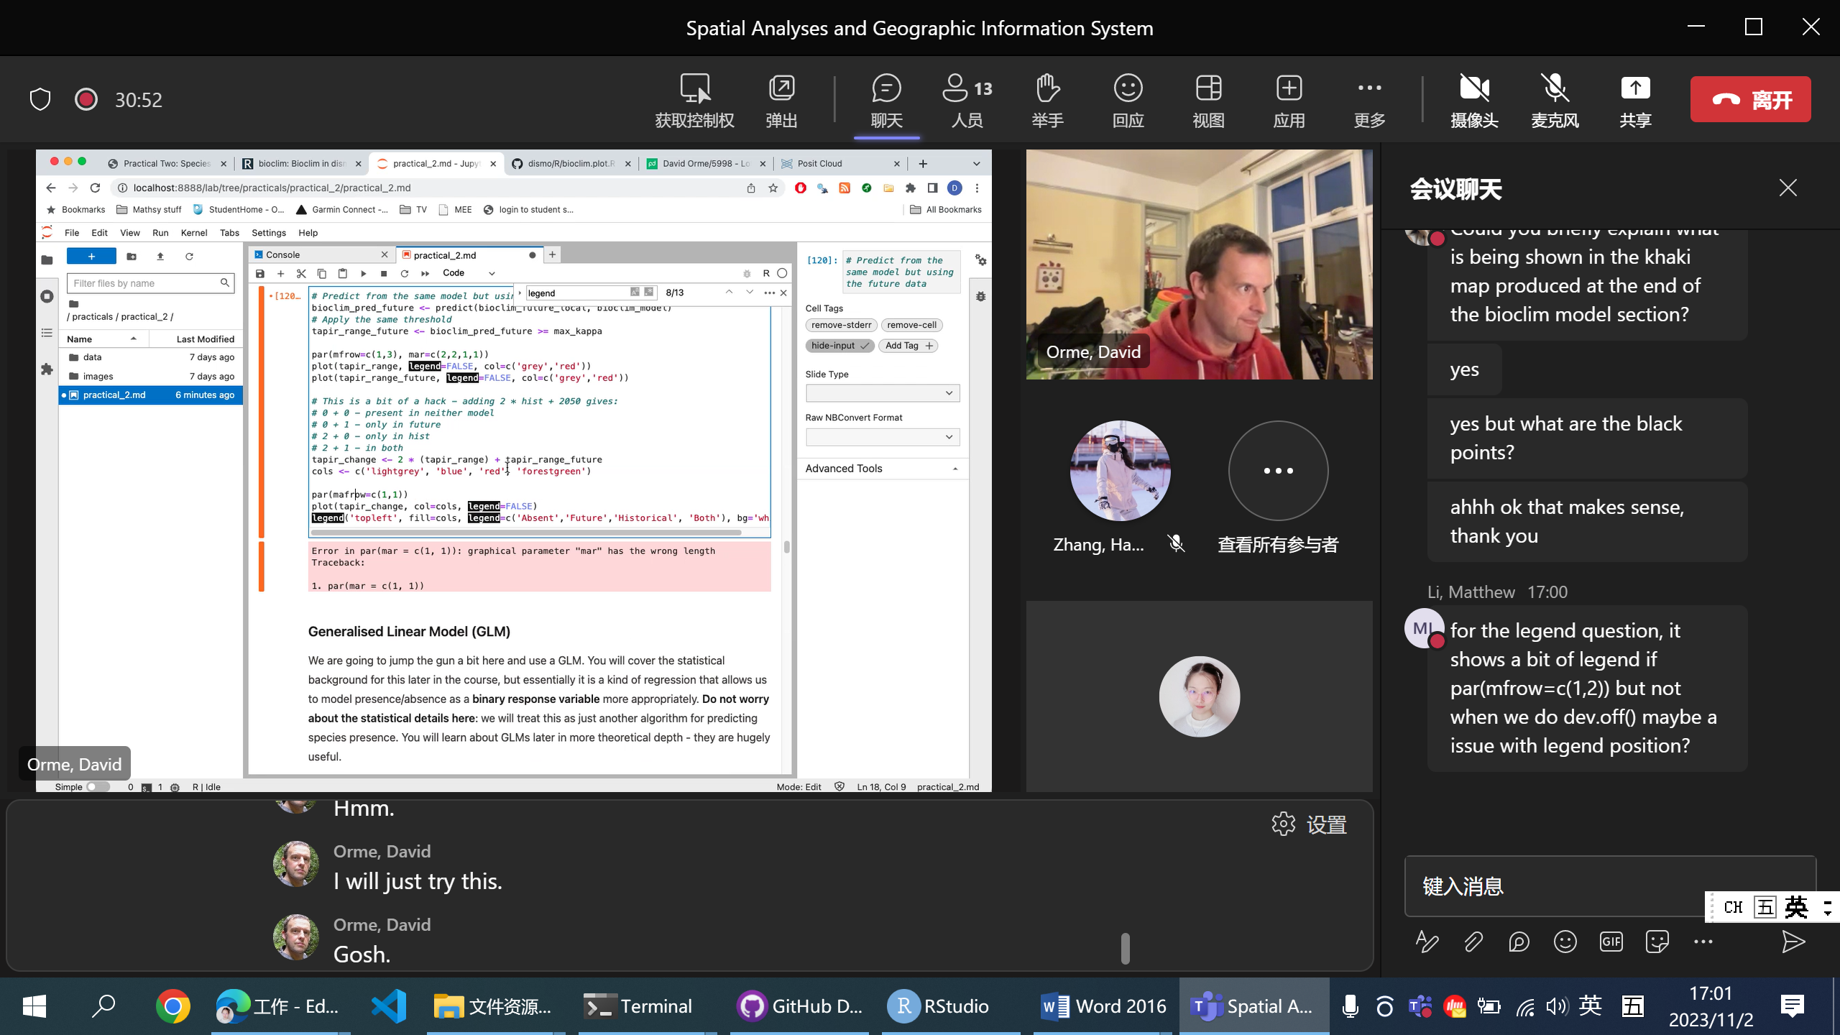

Legend, seems not working:

It seems to be a problem with using topleft - normally that positions the legend neatly, but here that seems to have broken. If you set the x and y directly, it seems to work:
legend(-6e5, 1.14e7, fill=cols,
legend=c('Absent','Future','Historical', 'Both'),
bg='white')

