Rstudio in Windows app, can run GIS and show the plot
Select codes, and click ‘run’. Posit Cloud can also run.

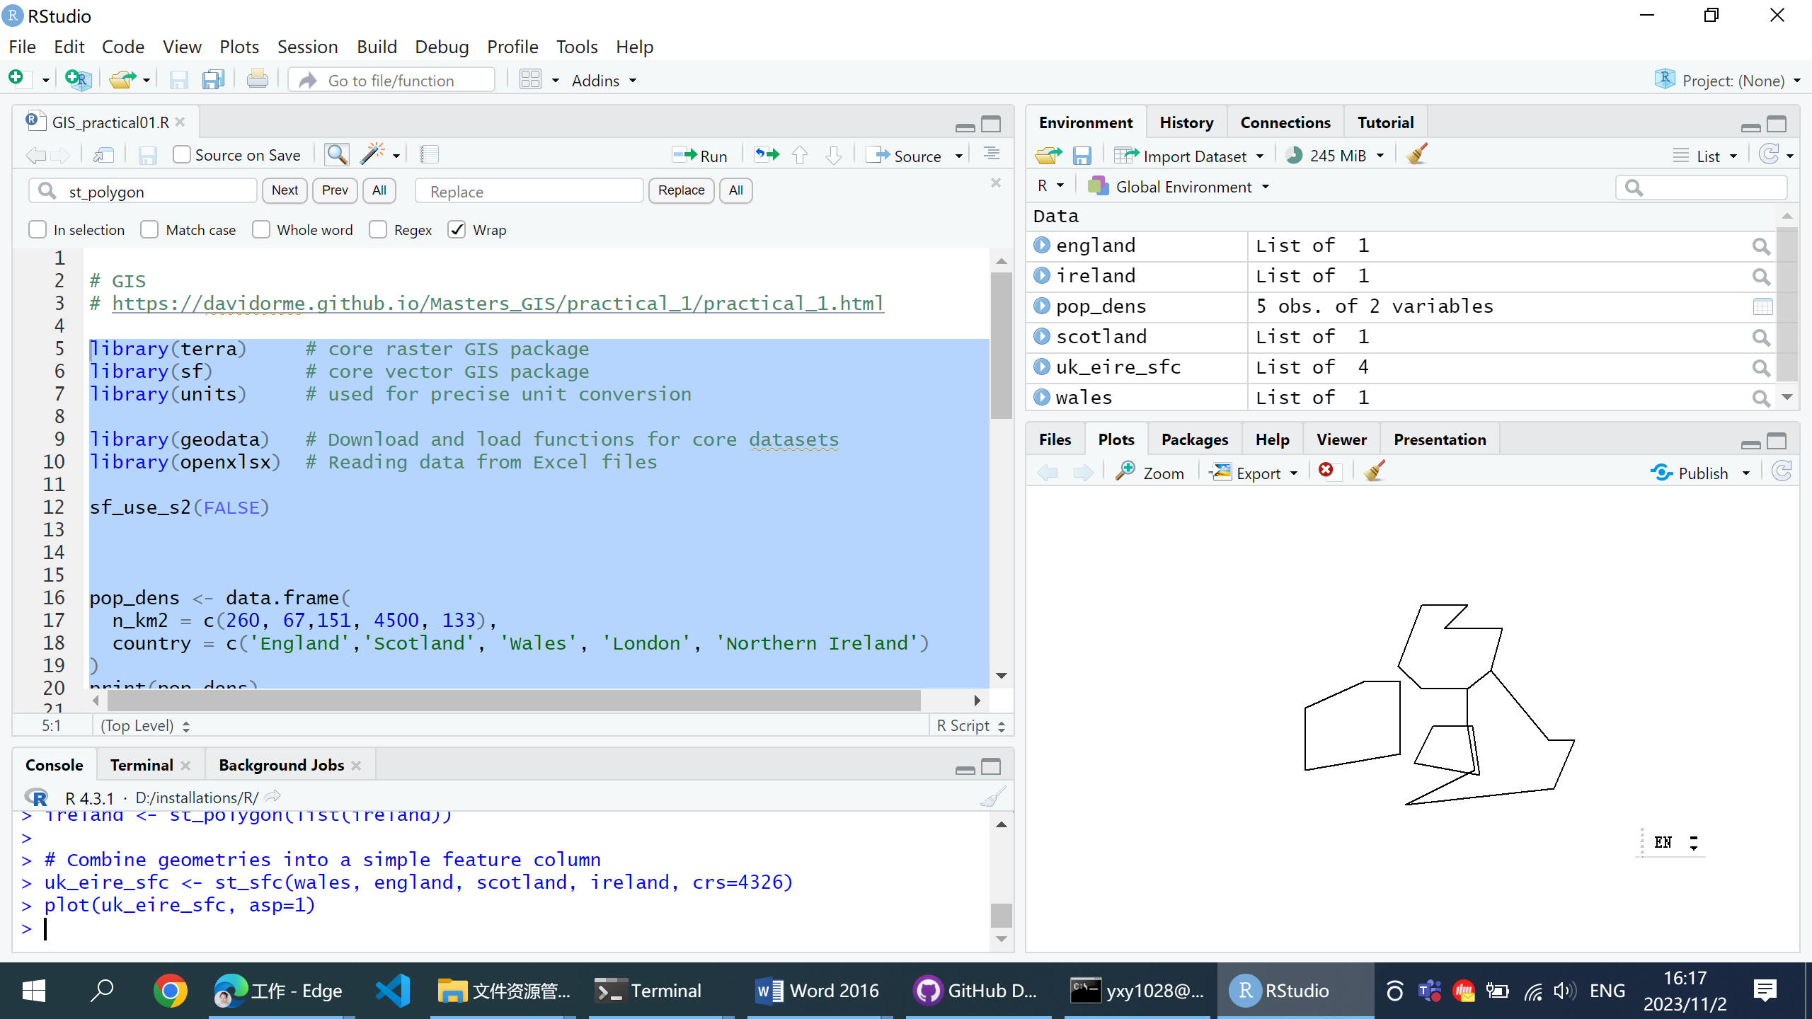

Legend, seems not working:

It seems to be a problem with using topleft - normally that positions the legend neatly, but here that seems to have broken. If you set the x and y directly, it seems to work:
legend(-6e5, 1.14e7, fill=cols,
legend=c('Absent','Future','Historical', 'Both'),
bg='white')

