UNIX course note

forward slash /
~ Home directory path

You can also combine commands using &&. For example,
cd CMEECourseWork && cd CMEECourseWork

数文件夹中的文件数
ls / | wc -l

mv 是非常危险的命令，因为背后把文件挪走了，导致原来的位置没有文件 (cr: https://blog.csdn.net/qq_60271706/article/details/126807960?ops_request_misc=&request_id=&biz_id=102&utm_term=%7C%20linux&utm_medium=distribute.pc_search_result.none-task-blog-2~all~sobaiduweb~default-4-126807960.142^v95^insert_down28v1&spm=1018.2226.3001.4187)

Question:
ls / >> ListRootDir.txt
cat ListRootDir.txt

The meaning of |

https://blog.csdn.net/s1429583654/article/details/127299571?ops_request_misc=&request_id=&biz_id=102&utm_term=%7C%20linux&utm_medium=distribute.pc_search_result.none-task-blog-2~all~sobaiduweb~default-2-127299571.142^v95^insert_down28v1&spm=1018.2226.3001.41872、语法
命令：command1 | command2 | command3
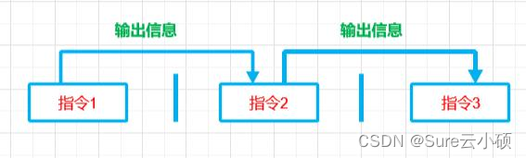

Review later:
https://mhasoba.github.io/TheMulQuaBio/notebooks/01-Unix.html#redirection-and-pipes
ls *
ls File*
ls *.txt
ls File?.txt
ls File[1-2].txt
ls File[!3].*

https://mhasoba.github.io/TheMulQuaBio/notebooks/01-Unix.html#redirection-and-pipes
Installing from downloaded *.deb files
You can also install software from third-party sources by downloading an installable package archive. Such archives come with a *.deb extension.

sudo dpkg -i code_1.71.2-1663191218_amd64.deb # install, including dependencies

grep: Find patterns in directory and file names, as well as file contents;

Question:
Rsync: Sync folders on your computer, including on any atatched devices (like an external hard drive)

