AWD-LSTM
Feb 03

https://github.com/salesforce/awd-lstm-lm

PS F:\yxyUoL\FP\awd-lstm-lm-master\awd-lstm-lm-master> python main.py
Producing dataset...
F:\yxyUoL\FP\awd-lstm-lm-master\awd-lstm-lm-master\wikitext-103\train.txt
Traceback (most recent call last):
File "main.py", line 100, in <module>
corpus = data.Corpus(args.data)
File "F:\yxyUoL\FP\awd-lstm-lm-master\awd-lstm-lm-master\data.py", line 33, in __init__
self.train = self.tokenize(os.path.join(path, 'wikitext-103', 'train.txt')) # yxy has changed this on Feb 03! Added 'wikitext-103'
File "F:\yxyUoL\FP\awd-lstm-lm-master\awd-lstm-lm-master\data.py", line 44, in tokenize
for line in f:
UnicodeDecodeError: 'gbk' codec can't decode byte 0xae in position 96: illegal multibyte sequence
PS F:\yxyUoL\FP\awd-lstm-lm-master\awd-lstm-lm-master>

改了路径，解码

PS F:\yxyUoL\FP\awd-lstm-lm-master\awd-lstm-lm-master> python main.py
Producing dataset...
F:\yxyUoL\FP\awd-lstm-lm-master\awd-lstm-lm-master\wikitext-103\train.txt
Traceback (most recent call last):
File "main.py", line 105, in <module>
train_data = batchify(corpus.train, args.batch_size, args)
File "F:\yxyUoL\FP\awd-lstm-lm-master\awd-lstm-lm-master\utils.py", line 21, in batchify
data = data.cuda()
File "C:\Python\Python38\lib\site-packages\torch\cuda\__init__.py", line 221, in _lazy_init
raise AssertionError("Torch not compiled with CUDA enabled")
AssertionError: Torch not compiled with CUDA enabled
PS F:\yxyUoL\FP\awd-lstm-lm-master\awd-lstm-lm-master>

PS F:\yxyUoL\FP\awd-lstm-lm-master\awd-lstm-lm-master> python
Python 3.8.8 (tags/v3.8.8:024d805, Feb 19 2021, 13:18:16) [MSC v.1928 64 bit (AMD64)] on win32
Type "help", "copyright", "credits" or "license" for more information.
>>> import torch
>>> print(torch.__version__)
1.13.1+cpu
>>> print(torch.cuda.is_available())
False
>>>

Feb 04

C:\Users\ADMINI~1\AppData\Local\Temp\cuda

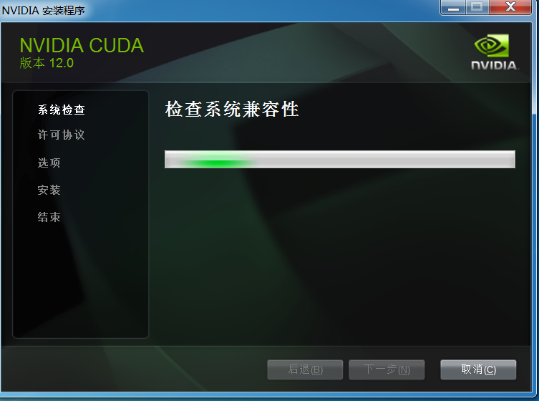

换了一个数据库，wikitext-2
PS F:\yxyUoL\FP\awd-lstm-lm-master\awd-lstm-lm-master> python main.py --epochs 750 --data data/wikitext-2 --save WT2.pt --dropouth 0.2 --seed 1882
Producing dataset...
F:\yxyUoL\FP\awd-lstm-lm-master\awd-lstm-lm-master\wikitext-2\train.txt
Applying weight drop of 0.5 to weight_hh_l0
Applying weight drop of 0.5 to weight_hh_l0
Applying weight drop of 0.5 to weight_hh_l0
[WeightDrop(
(module): LSTM(400, 1150)
), WeightDrop(
(module): LSTM(1150, 1150)
), WeightDrop(
(module): LSTM(1150, 400)
)]
Using []
Args: Namespace(alpha=2, batch_size=80, beta=1, bptt=70, clip=0.25, cuda=True, data='data/wikitext-2', dropout=0.4, dropoute=0.1, dropou
=400, epochs=750, log_interval=200, lr=30, model='LSTM', nhid=1150, nlayers=3, nonmono=5, optimizer='sgd', resume='', save='WT2.pt', see
e-06, wdrop=0.5, when=[-1])
Model total parameters: 33543246
Traceback (most recent call last):
File "main.py", line 242, in <module>
train()
File "main.py", line 199, in train
raw_loss = criterion(model.decoder.weight, model.decoder.bias, output, targets)
File "C:\Python\Python38\lib\site-packages\torch\nn\modules\module.py", line 1194, in _call_impl
return forward_call(*input, **kwargs)
File "F:\yxyUoL\FP\awd-lstm-lm-master\awd-lstm-lm-master\splitcross.py", line 132, in forward
softmaxed_all_head_res = torch.nn.functional.log_softmax(all_head_res, dim=-1)
File "C:\Python\Python38\lib\site-packages\torch\nn\functional.py", line 1930, in log_softmax
ret = input.log_softmax(dim)
RuntimeError: [enforce fail at C:\actions-runner\_work\pytorch\pytorch\builder\windows\pytorch\c10\core\impl\alloc_cpu.cpp:72] data. Def
memory: you tried to allocate 765987840 bytes.
PS F:\yxyUoL\FP\awd-lstm-lm-master\awd-lstm-lm-master>

可能是因为我把.cuda()给禁用了，它不能用GPU.

alpha=2, batch_size=80, beta=1, bptt=70, clip=0.25, cuda=True, data='data/wikitext-2', dropout=0.4, dropoute=0.1, dropouth=0.2, dropouti=0.65, emsize=400, epochs=750, log_interval=200,
lr=30, model='LSTM', nhid=1150, nlayers=3, nonmono=5, optimizer='sgd', resume='', save='WT2.pt', seed=1882, tied=True, wdecay=1.2e-06, wdrop=0.5, when=[-1]

