Comparative Analysis
of Neural Networks and General NLP Methods
on An Academic Journal Article Database

- BSc Computer Science (Data Science) degree
Final Project, Final Report

(Freda) Xiaoyun Yu
Feb. 2023

Table of Contents
Table of Contents 2
List of Figures 5
List of Tables 5
1 Introduction 7
1.1 Template 7
1.2 Background 7
1.3 How I Extend From Template 8
1.3.1 Meet the Requirements of Machine Learning Template 8
1.3.2 Extend from the Machine Learning Template 8
1.3.3 Extend from My Previous Course Modules 8
1.4 Selection of Data 8
2 Literature Review 9
2.1 Historical Formation 9
2.2 Classification in Librarianship 10
2.3 The Importance of Classification 10
2.4 BERT-based Ensembling Models on Academic Articles 11
2.5 Multiple NLP Methods for Binary Classification on Academic Articles 11
2.6 DANN, FastText, LSTM, GloVe, Attn 12
2.7 DNN on Smaller Chunks of Discourses 12
2.8 ULMFiT 13
2.9 AWD-LSTM and Dropout Techniques 13
2.10 Philosophical Reflections 14
3 Design 14
3.1 Justify Features Based on Domain and Users 14
3.2 Timetable 15
3.3 Database (Continue with Section 1.4) 15
3.3.1 For My Models 15
3.3.2 For Pre-Trained Models in Literature 15
3.4 Key Technologies and Methods 16
3.4.1 Text Classification Overview 16
3.4.2 Machine Learning Workflow Mentioned by Chollet 16
3.4.3 Controlled Experiment 16
3.4.4 Neural Network 16
3.4.4.1 Feed-Forward Neural Networks (FNN) 17
3.4.4.2 CNN (Convolutionary Neural Networks) 17
3.4.4.1 RNN (Recurrent Neural Networks) 17
3.4.4.2 LSTM, AWD-LSTM 17
3.4.5 Grid Search 17
3.4.6 One-Hot Encoding vs. Word Embedding 17
3.4.7 Bayesian Classification 18
3.4.8 Support Vector Machine (SVM) 18
3.4.9 Topic Modelling: Latent Dirichlet Allocation 18
3.5 Evaluation Methods 18
3.5.1 Underfitting or overfitting? 18
3.5.2 Accuracy, Precision, Recall, F1 19
3.5.3 Confusion Matrix 19
3.5.4 ROC, AUC 20
4 Implementation 20
4.1 Collect Data 20
4.2 Data Cleansing 20
4.3 Train-Test Splitting, Encoding 21
4.4 A Small Neural Netwok (Chollet Step5) 21
4.5 An Overfitting Neural Network (Chollet Step6) 22
4.6 Controlled Experiments for Hyperparameters 22
4.7 Use GridSearchCV to Bruteforce Search 23
4.8 General NLP Methods with Vectorizers and Classifiers 24
4.9 1D-Convolutionary Neural Network (CNN) 25
4.10 Recurrent Neural Network (RNN), LSTM Layer 25
5 Evaluation 25
5.1 Evaluation of Models 25
5.1.1 Feed-Forward Neural Networks 25
5.1.2 Classical NLP Methods 26
5.1.3 CNN 26
5.1.4 RNN and LSTM 26
5.1.5 Latent Dirchlet Allocation 27
5.2 The Best Model(s) 27
5.3 Evaluation of This Project 27
5.3.1 Successes 27
5.3.2 Limitations and Future Extensions 28
6 Conclusion 28
6.1 Summary of This Project 28
6.2 Discussions 29
7 Appendix 31
7.1 Source Codes & Files Repository 31
7.1.1 Repository 31
7.1.2 Sources on Sections 31
7.2 References 31
7.3 Additional Tables & Pictures 35

List of Figures
[???will add page numbers]
Fig 1.4-1 Output Data in JSON and XLSX Format | 9
Fig 1.4-2 The Excel File for Each Category with the Annotated Category Column | 9
Fig 1.4-3 Snapshot of the 'combined.xlsx' Data File | 9
Fig 2.6-1 Micro-F1's of the Best DANN Models that Classify Abstracts into 81 SCs, Compared with Baseline by Kandimalla et al. | [???]
Fig 2.8-1 The Repeating Module in an LSTM Contains Four Interacting Layers by Olah
Fig 3.2-1 Milestones and Key Dates
Fig 3.2-2 Timetable Snapshot
Fig 3.3.1-1 Convert Cleansed Data into Keras Recognised Format
Fig 3.4.7-1 Bayes' Theorem
Fig 3.4.7-2 Bayesian Classifier
Fig 3.4.9-1 Polygon for Latent Dirichlet Allocation
Fig 3.5.3-1 Confusion Matrix for 6-Classes Classification
Fig 3.5.4-1 My ROC Curves for a CNN Model
Fig 4.2-1 The Final Cleansed Form of One of the Article Data
Fig 4.3-1 Encoding, Feed to Keras
Fig 4.4-1 Loss Curve During Epochs for a Small FNN
Fig 4.4-2 Accuracy Curve During Epochs for a Small FNN
Fig 4.4-3 Performance Summary of Each Category for a Small FNN
Fig 4.5-1 Loss Curve During Epochs for an Overfitting FNN
Fig 4.5-2 Accuracy Curve During Epochs for an Overfitting FNN
Fig 4.5-3 Performance Summary of Each Category for an Overfitting FNN
Fig 4.8-1 Using make_pipeline to Construct a TFIDF-SVC Model
Fig 5.1.5-1 LDA Result

List of Tables
[???will add page numbers]
Table 2.5-1 Performances of Weeding Classifiers by Wagstaff and Liu
Table 2.7-1 The Accuracies of the Baselines with Different Input Texts Units and Composition Methods on the Test Set by Lee & Han
Table 4.6-1 Experiments Records - Activation Functions
Table 5.1.1-1 Summary of High Accuracy Feed-Forward Neural Network Models
Table 5.1.2-1 Performances of My NLP Models

1 Introduction

1.1 Template
CM3015-Machine Learning and Neural Networks template.

1.2 Background
Nowadays, great progress has been made in the text classification field, from traditional NLP vectorizers and classifiers to Deep Neural Network (DNN) models such as AWD-LSTM, ULMFiT, and other Transfer Learnings which adopt Computer Vision (CV) models into the text field. Considerable research efforts have been devoted to gaining high performing scores on some of the widely applied public databases, such as DBpedia, IMDB, Penn Treebank[20], WikiText-2[20], but seldom have researchers run experiments on topic-targeted databases such as academic journal article databases[22, 23, 24, 25, 26, 27]. It is well-known in neural network field that, depending on the dataset, there is not one single universal model that can perform always the best, and therefore we need to tune hyperparameters, or use pre-trained models to fine-tune. The lack of previous research on this type of database prompts me toward this project.
Furthermore, I am interested in exploring text classification on journal articles database since the number of publications in core academic journals is becoming more and more vital for anyone growing within academia[2, 4], whether it be a college student, a postgraduate doctor, a professor, or a university on the whole. Importantly, academic journal platforms generally have a crucial faultiness – most of the articles do not contain the subject categories in their metadata section[37], which makes searching for specific fields of papers in academic search engine more difficult for users who have specific requests, and it prohibits data scientists from implementing a more systematic and intelligent database on these article data. What is more, the limited research on academic articles databases generally only use the abstracts as the data source (even many journal editors only use the abstract to categorise[25]), which is objected by the famous librarian Melvil Dewey[3].
Therefore, I plan to investigate text classification models for the subject-classification of academic journal articles, with my own collected dataset, and I will use full article body as the data.
Classification aims to get a discrete value, which is a categorical variable. Many cutting-edge technologies are developed based on classification algorithms, such as exception detection, semantic recognition, image processing, and voice processing, etc. From the perspective of realisation principle, classificaiton models can be linear model, tree model, or neural network (NN) model. For the text classification task, it can actually use Transfer Learning with pre-trained models widely used in Computer Vision (CV) field or others, which is the basic idea of ULMFiT[13]. There are many other pre-trained models and methods including textCNN, Bi-LSTM, RCNN, BERT, C-LSTM[30], AWD-LSTM[20], etc.[21]. There are also NLP methods which combine vectorizers and classifiers, whose rules are settled by human and thus are more targeted, which is different from pure NN.
I will try to use multiple Machine Learning (ML) methods: build some Feed-Forward Neural networks (FNN) and tune hyperparameters; try to compare different vectorizers and classifiers; try to use DNN such as CNN, RNN, LSTM, etc. I aim to compare the performances of these models, and bring to you the best-performing model(s) that I can find. Such models will be the foundation for an intelligent article search engine, and the information retrieval and management processes. It may also help in showing the trend of research focus, the scientists’ choices, the change of the focus, and even some social problems underlying in research field, or the trend and difficulties in interdisciplinary fields.

1.3 How I Extend From Template

1.3.1 Meet the Requirements of Machine Learning Template
1. Develop a deep learning classification model using Tensorflow and more Python libraries; 2. Aims to find the best-performing model by tuning hyperparameters and using different models; 3. My model achives at least a common-sense prediction; 4. Gather a dataset of a moderate size (mine is 600 items); 5. Replication of high-quality published models (ULMFiT, RNN); 6. Significantly improves the common-sense baseline (my accuracy is 0.73~0.85; baseline is 1/6=0.167); 7. Pre-trained models are adopted (FastAI ULMFiT, AWD-LSTM[20], Bert-for-Task, etc.);

1.3.2 Extend from the Machine Learning Template
1. Have collected dataset on my own with a relatively large size (600 items); 2. A novel idea for the dataset (journal articles, which has limited literature review papers); 3. Have used NLP methods (vectorizers: TF-IDF, Count Vectorizer, Bigram; classifiers: Multinomial Naïve Bayes, SVM, ); 4. Have constructed a feasible CNN model with an accuracy score of 0.57; 5. Have implemented LSTM layers inside my neural network; 6. Have tried to use others’ settings as a reference (CNN, RNN, etc.); 7. Have drawn neural networks [???]

1.3.3 Extend from My Previous Course Modules
1. CM3060-Natural Language Processing, midterm: Have fixed errors in data cleansing; have used Machine Learning procedure; used Feed-Forward Neural Networks and tune hyperparameters; used Deep Neural Networks (CNN, RNN, etc.); compared all results; adopted pre-trained models.
2. CM3015-Machine Learning and Neural Networks, final-term: Have used NLP machine learning models and compared them; have tuned hyperparameters based on more controlled settings; have used DNN; have proposed the best model; have tried pre-trained models.

1.4 Selection of Data
The main reason why I do not use only the abstract of each article, but instead using the full article is that, my main purpose here is to train and get a best performance model as far as I can, and I secondly care about the reality issues, such as the restriction of accessing to the full articles. Besides, the words use in the abstracts are somewhat misleading for some categories[3]. For example, in the abstract of a standard biology paper, it may mention some statistical words such as ‘p value’, ‘hypothesis’, etc. that may mislead the machine to classify it as statistics - however the statistics here is only the method, not the focus of field. In fact, most of the papers would contain some of the society descriptions in their abstract, just as an introduction. Thus, it would be misleading only using the abstract. To pursue the accuracy, I would use the full article as the source of data.
I have collected 6 subjects of articles, 100 for each, from the EventRegistry.org, using their API https://www.newsapi.ai/documentation/sandbox?tab=searchArticles and sandbox. Since each class has the same amount of data, we do not need to bother with class weighting, and this is a balanced dataset. The commonsense baseline is thus 1/6=0.167. Using their API, we can get 20+ features about the article, but we only use the full content feature here which follows the pattern of most text classification problems, so we do not have an issue with feature scaling.
After configuring the proper conditions in the sandbox and checking the output articles are correct, I copied their serialisation codes into my Jupyter Notebook and output the desired datasets into JSON files (Fig 1.4-1).
I then slightly tidied up their format, and used an online tool to validate these JSON files (Fig 1.4-1). After that, I upload each file into an online tool to convert these JSON files into EXCEL files (Fig 1.4-1). | 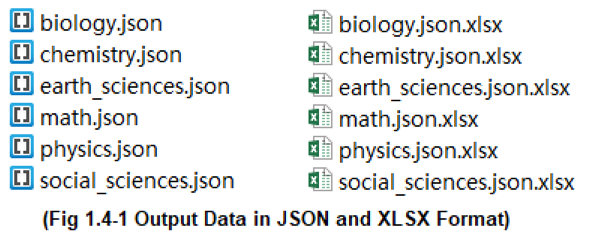
The converted into EXCEL files contain 27 columns in each. After that, I added a ‘category’ column for each (Fig 1.4-2), and combined all files into one big EXCEL file named ‘combined.xlsx’ (Fig 1.4-3) using python codes, which would be the data source file that I would use later. For text classification task, I can only use the article ‘body’ column in the ‘combined.xlsx’ as my feature X, and the ‘category’ column as my target Y.
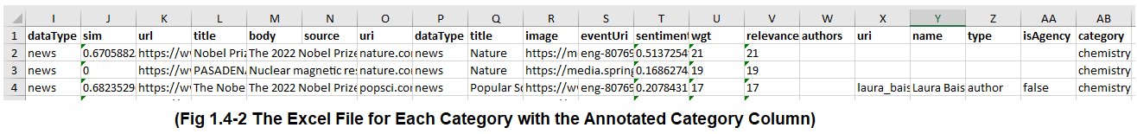
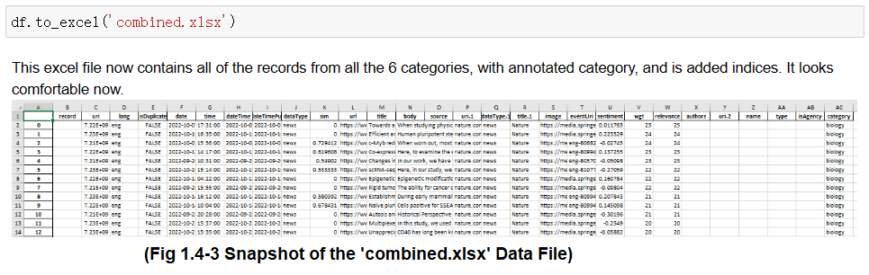

2 Literature Review

2.1 Historical Formation
Classification is not a recently raised issue, but a long existing topic in history. Broadly speaking, classification is to put elements into usually limited sets, in order to simplify the world.
According to Daniel Parrochia (a French philosopher), ancient classification from Plato and Aristotle through the eighteenth century, is ‘hierarchical’[14], with limited sets, and is often ‘based on a single criterion’. Ingetraut Dahlberg[10], a German philosopher who has founded the journal International Classification has told us that it was in the 16th century that an Italian philosopher named Mario Nizolio (1498–1556) voiced his annoyance that various disciplines may be found under multiple dimensions if shown in a broad plan of the science(Dahlberg pp.85). In Nizolio’s paper ‘Antibarbarus philosophicus’, he mentioned several classes to divide science into fields. Even the phylogenetic tree idea proposed by Darwin was inspired by the popular philosophical idea of classification at his time, declared by Parrochia[14].

2.2 Classification in Librarianship
Subject categorization has been a long-time discussed topic in the librarianship field[1, 15, 16]. In the early years, librarians needed to classify books manually, and this procedure is very similar to the subject categorization for academic journals.
In Melvil Dewey’s book[3] A Classification and Subject Index, for Cataloguing and Arranging the Books and Pamphlets of a Library which was written in 1876, he says that ‘the library is first divided into nine special libraries which are called Classes. These Classes are Philosophy, Theology, etc., and are numbered with the nine digits . . . and each one is separated again . . . 513 is the 3d Section (Geometry) of the 1st Division (Mathematics) of the 5th Class (Natural Science)’ (Dewey, Preface). He has classified books into trees, and the classes under the branch of ‘Natural Science’ are just what we want to categorize all our articles into. Specifically, they are: mathematics, astronomy, physics, chemistry, geology, paleontology, biology, botany, zoology. I somehow don’t agree with his classes, since paleontology, botany and zoology obviously belong to biology. However, the detailed subclasses are the keywords which I should notify in my classification models. What’s more, he mentions that the headings for the books are not reliable enough to classify books, since ‘brevity has been secured in many cases at the sacrifice of exactness’[3](Dewey, Preface). Thus, if we want to classify our articles, it is sometimes not reliable enough only based on their headings. He even mentions that if the content and the form are in different subjects, such as Mathematical History, then we should classify it into Maths, instead of History, since the content is the crucial one. Thus, I am considering not to list ‘history’ as one of the subjects that I want to classify, or, each article may have multiple tags, which is also a further step from what I want to build.
Mentioned by Parrochia[14], an Indian librarian called Ranganathan led the trend in classification during 20th century. His ‘faceted classification’ (also called “Colon classification” or CC) could permit taxonomists to promptly mix classes into a subject and form a combined version of its class flag, and thus could solve the ‘Mathematical History’ problem proposed above.

2.3 The Importance of Classification
I have found many books which guide readers in writing articles of the academic field. Svensson[6] has taught us a lot of skills and rules in his book Academic Journals and Academic Publishing which emphasises the importance of writing outstanding academic articles. This can demonstrate that my project would be helpful for people who work or study in academia, since the topic of investigating an academic article is strongly focused by these professional people.
Leckie and Buschman[1] have mentioned in their book ‘Information Technology in Librarianship’ that several researchers actually have had observations among children that these young kids can classify given websites into categories (Bar-Ilan & Belous, 2007; Bilal & Wang, 2005; Large, Beheshti, Nesset, & Bowler, 2007a) (Buschman pp.192). Their research may inspire neuroscientists and AI scientists to look for new algorithms in classifications.

2.4 BERT-based Ensembling Models on Academic Articles
Ambalavanan et al.[17] have stated that text classification of academic articles can assist us in finding a targeting article in a huge database with big amount of articles, although their classification is based on article quality, rather than the subjects. They have decided to focus on text classification using BERT-based ensemble models. They have developed a unique cascading ensemble that was comparable to the step-by-step screening method used to create the gold standard. With a single integrated model, which they refer to as the individual task learner, they have compared the performance of the ensembles (ITL). They have performed trials using a manually annotated dataset of about 49 K MEDLINE abstracts, and utilised SciBERT, a variation of BERT pre-trained on scientific literature. They have only used the title and summary for each article, which was less advance than mine I assume, according to Dewey’s addresses[3]. However their dataset is huge, with 49,028 unique articles. They overall got high recalls (about 0.86+, which means collected fully) but low precisions (about 0.6, which means wrong classification). Their conclusion is: ‘while the cascading ensemble achieved the highest precision and the highest F-measure, the single integrated model achieved the highest recall’.

2.5 Multiple NLP Methods for Binary Classification on Academic Articles
Wagstaff and Liu[15] have taught us in their paper ‘Automated Classification to Improve the Efficiency of Weeding Library Collections’ about the five classifiers in machine learning especially for weeding process (remove outdated items) in library management, which is a binary classification. For each classifier, they have filtered the best parameter group. Although their topic is different from mine, I can take consideration of the different performances of these classifiers. From Wagstaff and Liu’s paper, we know that there are significant difference between human weeding and AI weeding procedure for library management. Therefore we know that there are indeed certain tasks in managing books or articles that must be done by human beings. Perhaps we can finally find a way to use AI to classify articles, but AI certainly cannot replace the complete job of a librarian, or an editor. Their results are listed in Table 2.5-1. They have even considered Chi Square evaluation metric, which is what I should learn from.
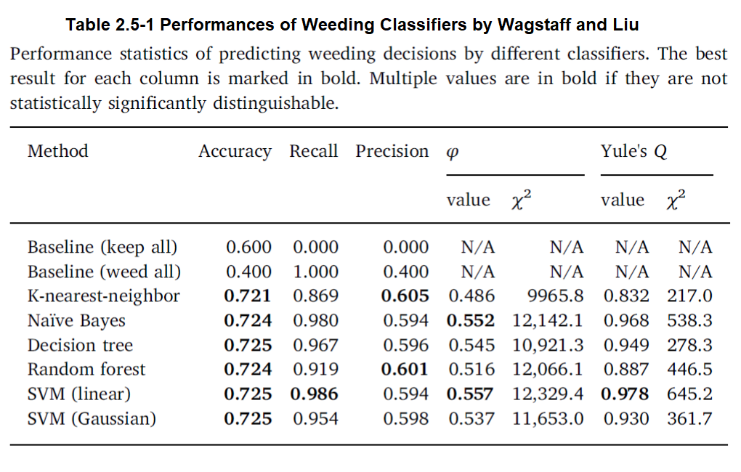

2.6 DANN, FastText, LSTM, GloVe, Attn
Kandimalla, Rohatg et al. have written a crucial paper[18] called ‘Large Scale Subject Category Classification of Scholarly Papers with Deep Attentive Neural Networks’ which has just the same focus as mine. However, they only use the abstracts instead of the whole paper. The data size is 9,000,000, and the source of data is Web of Science (WoS) in the year 2015. They have used over 100 categories which is a huge number, and therefore, they have proposed a deep attentive neural network (DANN) to classify papers in two layers (‘Two-Level Classifier’). The proposed network consists of two bidirectional recurrent neural networks followed by an attention layer. They have just used unigram, not n-grams. Their best model ‘achieves micro-F1 measure of 0.76 with F1 of individual subject categories ranging from 0.50 to 0.95’. Notice that the 0.76 of F1 is not very high. Their core findings are: (1) FastText + BiGRU + Attn and FastText+BiLSTM + Attn achieve the highest micro-F1 of 0.76; GloVe + BiLSTM + Attn (micro-F1 = 0.75); GloVe + BiGRU + Attn (micro-F1 = 0.74); FastText + LSTM + Attn (micro-F1 = 0.75); FastText + GRU + Attn (micro-F1 = 0.74); (2) Retraining FastText and GloVe improves the performance; (3) Character-level embedding models often perform worse than word-level embedding models; (4) The best machine learning model (LR) is outperformed by the best DANN model by roughly 10%. They have also acknowledged that the document representation is a restriction - the sequential information is ignored by the BoW model. The Fig 2.6-1 shows their results.
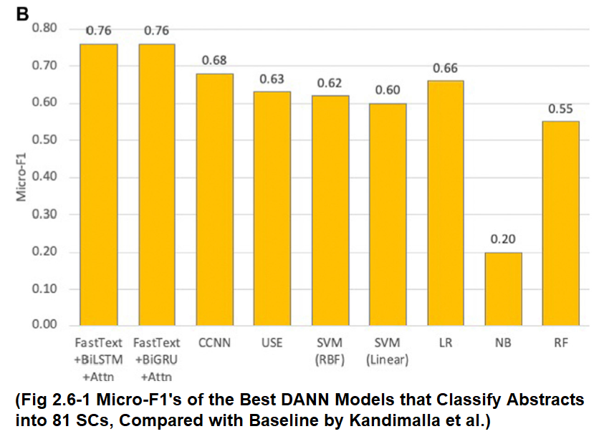

2.7 DNN on Smaller Chunks of Discourses
Technically speaking, Lee & Han et al.[19] have explored some of the DNN (Deep Neural Networks) methods on smaller chunks of discourses. Their evaluation scores which are around 0.86 for accuracies of course cannot be compared with my research interest on long passages, but their adjustments on hyperparameters and the choice of other models can inspire me for my task. They have proposed a brilliant way based on Rhetorical Structure Theory (RST) to identify Elementary Discourse Units (EDUs) and their discourse connections. The output is input into a neural network with a tree-like layout that represents the language information, such as the document's organization, discourse roles, and relational types. This model is called ‘discourse-aware tree-structured neural networks’ by them. They have found that: (1) words are not as good a unit as sentences in modelling a document; (2) It is advantageous to compute document embeddings by carefully composing embeddings of smaller text units rather than adopting an overview of the document all at once; (3) It is intriguing to see that LSTMEDUVec performs terribly even though it looks to be the perfect fusion of LSTM and EDU; (4) Since sentences in the training data are more distinctive than words, a normal LSTM is anticipated to perform badly with sentences. They have also discussed about the gradient-dissappearing problem in the End-to-EndTreeLSTM, as well as its space storage issue. Their results:
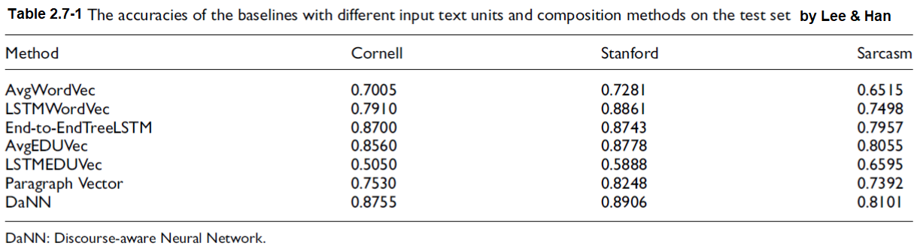

2.8 ULMFiT
Howard and Ruder[13] have used the state-of-the-art language model AWD-LSTM[20](Merity et al., 2017) and they bring to us a universal LSTM model fine-tuning for classification (ULMFiT), which is a transfer learning model. They have used 6 datasets: TREC-6; IMDb; Yelp-bi; Yelp-full; AG; Dbpedia. The whole paper includes three phases, where they introduce several skills to improve the performance. Phase 1: General-domain LM pretraining; Phase 2: Target task LM fine-tuning – skills: (1) Discrivinative fine-tuning, (2) Slanted triangular learning rate; Phase 3: Target task classifier fine-tuning – skills: (1) Concat pooling, (2) Gradual unfreezing, (3) BPT3C, (4) Bidirectional language model. In the end, the performance of their ULMFiT on 6 text classification tasks is significantly better than the existing text classification methods, and the error rate is reduced by 18-24% when tested on most data sets. Also, training with only 100 labeled samples yields pretty good results. I can borrow some of their hyperparameter settings from their result.
An LSTM is a type of RNN (different from a feed-forward network), which uses previous knowledge in decision, but LSTM is a Long-Short-Time model that can uses texts long before the current text. The below graph shows an LSTM[32].
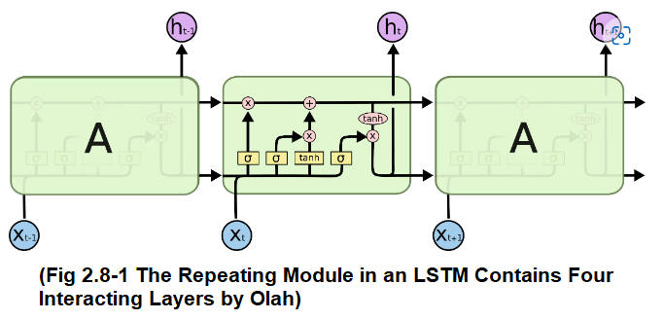

2.9 AWD-LSTM and DropConnect Techniques
Though the performance of RNN in language model tasks is outstaning, the cyclic connection of RNN is prone to overfitting. The paper named ‘Regularizing and optimizing LSTM language models’ proposed by Merity et al.[20] is a well-known research centerd on this point, and it mentions many technologies to solve RNN overfitting generally. The thesis is to introduce various regularization techniques in LSTM to improve the generalization ability of the model and improve the performance of the language model. They use 2 datasets: Penn Treebank; WikiText-2. The authors point out that using a fixed-length time-based backpropagation algorithm (BPTT) is inefficient, so 'Variable length backpropagation sequences' are proposed. Merity et al. also uses a method called ‘DropConnect’ to subtitute the Dropout neurons in regularization, since Dropouts will weaken the long-distance ability. Other than dropouts, Merity et al. do not use SGD here, but investigate ASGD (averaged SGD) and find that ASGD has a better effect. They have also investigated other regularization strategies, such as variable BPTT length. They finally study the use of a ‘neural cache’ in their model, and find that it can further improve the model performance.

2.10 Philosophical Reflections
Back to philosophy again, if we want to refine the classification methods, we need to know the limitations of the idea ‘classification’. Parrochia[14] in the ‘Internet Encyclopedia of Philosophy’ mentions two instabilities for classifications. (1) ‘Intrinsic instability’ is related to the majority of strategies (separations, calculations and so forward) that are utilized to classify objects; (2) ‘Extrinsic instability’ is associated to the truth that our information is constantly changing, so the definitions of objects (or properties of the objects) are advancing. In my project, I will mainly deal with ‘intrinsic instability’ technically, and will discuss broadly about some of the ‘extrinsic instabilities’.

3 Design

3.1 Justify Features Based on Domain and Users
My project can be dedicated to the following fields:
(1) real journal platforms in academia (e.g. Nature, Science, etc.) to classify newly received articles and therefore simplify the procedure before posting new articles, and will make the news being published more timely without manual work; may stimulate an interdisciplinary collaboration between these platforms and data science platforms to add comprehensive metadata for information retrieval;
(2) librarianship field[15, 16], by boosting the development of computer-based technologies to do part of the librarian jobs, and to stimulate the debate of human work vs. computer work;
(3) real journal platforms if I can find any obstacles or difficulties when developing my project, and will contribute furthermore if I could possibly propose methods to solve them;
(4) philosophical field, by exploring potential difficulties and proposing possible solutions, since classification is a very basic concept in philosophy[14];
(5) students studying in academia (e.g. postgraduate applicants, doctoral students) who have a strong pressure or focus on publishing papers, by receiving stimulation and inspirations found from my project. For instance, the top list of keywords shown in each academic subject can be a hint to expand the students’ academic vocabulary set;
(6) teachers working in academia who need a timely update for the recent research trend, to stimulate their own research and to give their students a prospective working direction;
(7) data scientists and computer scientists who are also interested in text classification methods. If my models are well-tuned, they may be applied more widely as a transfer learning example, not only in my own dataset, but also in other label-classifications in NLP field, such as sentiment classification, or even image classification. Data scientists may find new inspirations on labelling articles.

3.2 Timetable
The file for the timetable: https://drive.google.com/file/d/13k0SemUWFsap0NRNjtA1iPflu7cThafr/view?usp=sharing A snapshot is in the Fig 3.2-2 in the Appendix.
For milestones, cucial tasks and dates, please see the Appendix Fig 3.2-1.

3.3 Database (Continue with Section 1.4)

3.3.1 For My Models
After having that raw EXCEL file, I need to select the core features, and store them in proper data types. After data cleansing and preprocessing, I have got diversified forms of the same source X_feature and Y_target, prepared for any further processing. Then, I converted them into Keras-recognised data type, and splitted them into training set and test set (Chollet[12] Step 4, Ch. 4.5). I have prepared both the original version and the cleansed version for X and Y (see Fig 3.3.1-1), for later to compare their performances.
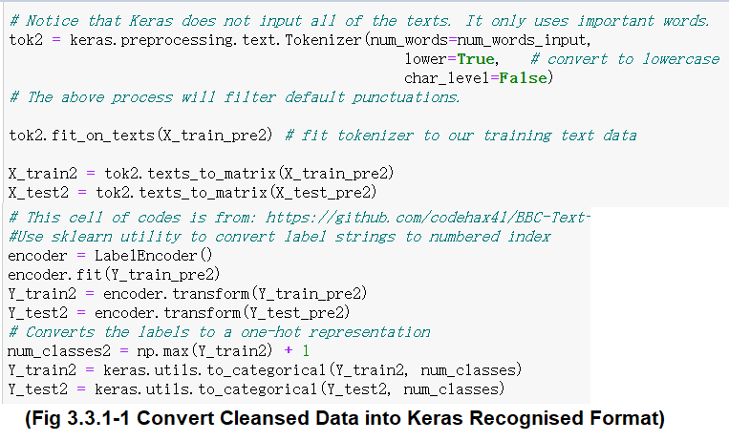
For easier retrieval later, I output my data into 600 .txt files from the name ‘000.txt’ to ‘599.txt’ structured into folders named with numbers ‘0’ to ‘5’, representing 6 categories, with 100 files in each.

3.3.2 For Pre-Trained Models in Literature
To use any pre-trained models that predecessors have developed, I have to adjust my data structure to their accepted input data format. To use the ‘Bert for Task’ pre-trained model which was developed by jiangxinyang227 in Github, I firstly added the target label with the separation sign ‘/<SEP>’ in the end of each file; then splitted each of the six categories into train-validation-test sets, with the file numbers of 60, 20, 20, respectively. Then I combine the training files in all categories into one train.txt file (the same for validation and test file). In the end I have three files, which contain all the training, validation, and test files respectively. This step ensures that inside each set, either it be train, validation, or test, there are the same ratio of files in each category. This dataset is very balanced and complete. [??Add utf-8 reform??]

3.4 Key Technologies and Methods

3.4.1 Text Classification Overview
Text Classification needs some small number of classes, a large set of example documents with document content and class tag, and the input documents data that we care about; the output should be a model that can label a document to an accurate class (Algorithm 3.4.1-1).
Algorithm 3.4.1-1: Text Classification General Idea
Inputs: A document d; a set of classes C = {c1, c2, …ci}; a set of example documents, each with document d
d and class c: (d1, c1), (d2, c2), …(dj, cj)
Output: A classifier Υ: d→c

3.4.2 Machine Learning Workflow Mentioned by Chollet
1. Defining the problem and assembling a dataset: The input data? What will I predict? What type of problem is it? Balanced dataset or not? 2. Choosing a measure of success: accuracy? Precision? Recall? (I will use them all); ROC? 3. Deciding on an evaluation protocol (see the ‘Evaluation’ section below); 4. Preparing data; 5. Developing a model that does better than a baseline; 6. Scaling up: developing a model that overfits; 7. Regularizing the model and tuning hyperparameters. [12]

3.4.3 Controlled Experiment
I will use the controlled experiment method when tuning the hyperparameters in feed-forward neural network especially. A controlled experiment contains 3 types of variables: indepenedent variable (the hypermarameter I am studying); dependent variable (the performance, the scores); controlled variables (all of the other hyperparameters , and other conditions which are not the hypermarameter I am studying right now).

3.4.4 Neural Network
A neural network is a computational model consisting of a large number of nodes (or neurons) directly connected to each other; each node (except the input node) represents a specific output function (or considered as an operation), called the activation function ; The connection of each two nodes represents the proportion of the signal in the transmission (that is, the proportion that the "memory value" of the node is considered to be transmitted), which is called weight; the output of the network is different due to the diversification of the activation function and the weight. Note: In some networks, there is a bias item, that is, the correction of the weight summation result, described as 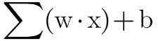.
There are many hyperparameters that usually should be tuned to get a suitable neural network: batch size, activation function in each layer, number of layers, number of neurons in each layer, loss function, regularisation and learning rate, epoch number, etc.
Batch size is how many data to be processed each time; bigger batch size makes tiny oscillations for the direction of descending and thus more concise, smaller batch size is harder to converge. The activation function determins how neurons are determined as ‘active’ and generally is a jumping function; for single-label multi-class classification, we should use softmax[12]. The number of layers will determine the depth of our model. A good NN often needs neuron numbers to increase at first, and to decrease at last, otherwise it meets ‘bottleneck’ effect. Loss Function is used for optimisation, where it represents the distance between predicted data and real data and thus should be minimized; Chollet says we should use categorical crossentropy for single-label multi-class classification[12]. Reglarisation is to improve the performance on test set by penalizing large influences on the model and thus avoid overfitting; there are L1, L2, Dropout regularisations; L1 and L2 are adding an item into the loss function; dropout is to stop some neurons’ activation. Learning rate determins how long the model will take for each step and thus it influences whether it can find the global minimum point on the loss function. Epoch number is how many iterations we will train on the whole training set; too small will encounter underfitting, while too big will risk for overfitting.
Pros: does not need feature engineering; better performance with bigger sample size. Cons: the procedure cannot be expained; the performance under small sample size may be worse than machine learning; model tends to be too complicated.

3.4.4.1 Feed-Forward Neural Networks (FNN)
In FNN, information always goes from previous layer to the later layers and never goes back, and it does not contain any loops. There is a Backpropagation algorithm to evaluate the current loss function stage comaring with the final output, and to adjust the gradient. My controlled experiments are largely on FNN.

3.4.4.2 Convolutionary Neural Networks (CNN)
Convolution is widely used in image processing. In entity identification, we set a small rule in each convolution matrix, and use it as a filter to examine through the whole image; combining many small rules can achieve a very abstract identification task. Generally, we set Convolution layer and Pooling layer in turn. This method can be transferred to text classification field, by using word vectors to replace the pixels in the image. The convolutional kernal scans for 2~5 words each time[29], which is similar to N-grams language model.
Pros: shared convolutionary core is strong enough to deal with high-dimension data; the classification would be better if we manually select features well and train the weight. Cons: needs tuning; needs big sample size, and may need GPU to train; the physical meaning is blurred.

3.4.4.1 Recurrent Neural Networks (RNN)
In many tasks, the output of the network not only depends on the current input, but also depends on the outputs in some past stages, for example, videos, articles, voices. In RNN, there are loops that can reference past information, so that it is more sensible for us to process article data. This is a mechanism that allows more operations among neurons, though the whole procedure still can hardly be conveyed by plain language.

3.4.4.2 LSTM, AWD-LSTM
When an input series of data is too long, there may exist the problems of Gradient Vanishing and Gradient Exploding, and thus people have explored variant of methods to improve RNN, including LSTM (Long Short Term Memory). LSTM[32] adds a ‘forgetting gate’ to RNN. AWD-LSTM[20] is a model which has sharpened LSTM, by using DropConnect instead of Dropout, and many regularisation methods.

3.4.5 Grid Search
Grid search is a method to brutforcely search for every possible combinations settled down by us, and it returns the best combination. Sci-kit Learn has a GridSearchCV functionality.

3.4.6 One-Hot Encoding vs. Word Embedding
These are the two main vector representations of texts. One-Hot Encoding uses 0 or 1 to represent the features. In contrast, Word Embedding will bring closer of two similar words. The idea is that, the similar words will appear in the same text context. Word2Vec is a word embedding method.

3.4.7 Bayesian Classification
Bayes Theorem states: the new probability of a hypothesis after a new evidence coming in, should depends on both the prior knowledge, and the new evidence (Fig 3.4.7-1). It is often used to determine the probability when a hypothesis is true. | 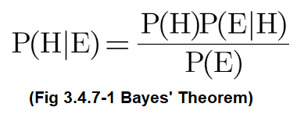

It can be extended to be a Bayesian Classifier: we just replace the ‘hypothesis’ with ‘label’ which is what we postulate, and we replace ‘evidence’ with ‘feature’ which is the thing we’ve required from the data. Therefore we have Fig 3.4.7-2, which means that, to choose between labels, we compare their posterior probabilities. | 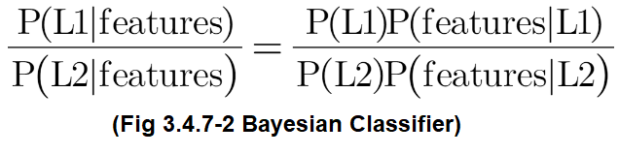

3.4.8 Support Vector Machine (SVM)
Support Vector Machine (SVM) classifies groups by constructing a line with margins, which is the distance between one group to the other, usually the closest dots. The idea to search for the best-fit line is to maximize the margin. Sci-kit Learn has SVM algorithm in sklearn.svm package. For sklearn.svc.LinearSVC, they have hyperparameters of: penalty, loss, dual, tol, C, multi_class, class_weight, verbose, etc.[36].

3.4.9 Topic Modelling: Latent Dirichlet Allocation
Latent Dirichlet Allocation (LDA) is a type of unsupervised learning method. It can give us a settled number of possible aggregations based on some similar features inside of each. Two assumptions of LDA: Each topic is a mixture of an underlying set of words; Each document is a mixture of a set of topics.
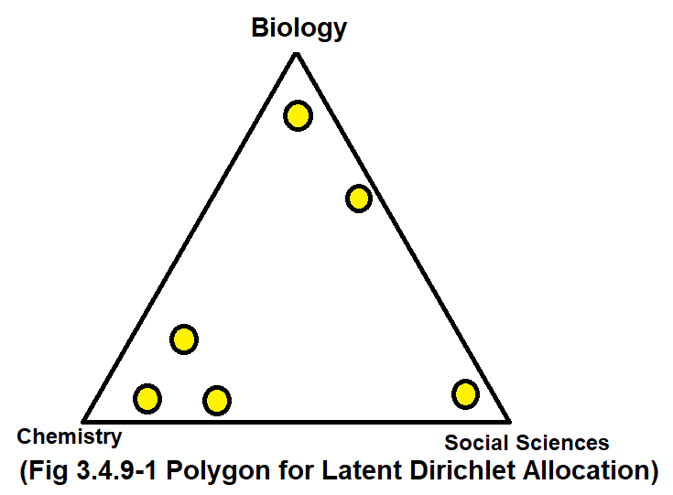 | For a given number N, LDA draws a polygon with N edges. It decides which data point belongs to which group by observing which angle the data point is the nearest to (Fig 3.4.9-1).

3.5 Evaluation Methods

3.5.1 Underfitting or overfitting?
The key in machine learning models is the ‘generalization’, which is to convey a widely suitable model on unseen data, based on our known training data. If we have a too-simple model, the model cannot learn comprehensively on the training set, and thus its description ability is weak. This is underfitting. If we have a strongly written neural network, but train it overly, the training accuracy will be very high, but it describes too much details about this training set but ignores the needs on unseen test set. This is overfitting. To deal with underfitting, we can: (1) add new features; (2) decrease the regularization parameters; (3) use more complex non-linear models such as SVM, Decision Tree, Deep Learning; (4) use ensembling methods to combine low-capacity models. To prevent overfitting, we can: (1) gather more real data; (2) use simulations to generate more data; (3) split dataset into train-validate-test datasets; (4) data augmentation; (5) use regularization; (6) use dropouts to stop neurons from ‘colluding with’ each other.
To find the optimal epoch number, we usually use two plots: the Epoch-Loss plot, and the Epoch-Accuracy plot, showing both training set and validation set in each. The loss should be decreasing as training goes on, but if we observe an uprising curve on the validation set, that is the ‘overfitting moment’ and we should just record the epoch number; then find that epoch number on the Accuracy plot, we should usually find a decreasing trend. That epoch number is what we should settle. We have reasons to try for any ‘overfitting moment’ until we find the proper epoch number.
[??Bias-Variance Curve. How to avoid them? ]

3.5.2 Accuracy, Precision, Recall, F1
Accuracy = (Correct Predictions)/(Total Predictions). It considers all the categories. As our dataset is balanced, we can use accuracy, because it will not be overweighted for larger categories. By so, my dataset avoids Simpson’s Paradox[10].
Precision = (The positive predictions which are correct)/(All the positive predictions) = TP/(TP+FP). High precision is the lack of False Positives (mis-report), which means that among the collected predictions, each prediction is accurate enough.
Recall = (The positive predictions which are correct)/(All the true positive cases) = TP/(TP+FN). High recall is the lack of False Negatives (omission), which means that from the collected predictions, the correct predictions are comprehensive.
In multi-category classification, precision and recall should be appied to each category, and are relative to the others. These two metrics helps us to form an understanding of our model when it is good at classifying some certain categories while is weak at classifying some others. It inspires us to retrospect on text cleansing, or even further discussions about the category topics in application perspective; it avoid the appearance of Simpson’s Paradox in some extent[10]. Precision and recall both have averages, as a summary for all the categories in their metric.
F1 = (2*Precision*Recall)/(Precision+Recall). As it combines precision and recall and gives them the same weight, we can use it as an overall metric to evaluate the performance on each category.

3.5.3 Confusion Matrix
Confusion Matrix is a visualised method to show all the True Positives, True Negatives, False Positives, and False Negatives. As these concepts are relative to each category, in the end we have a square matrix with the row (or column) number equals to the category number. Implemented in Heatmap codes, we can clearly see the overall performance – if the diagonal line is visually obvious, then the performance is good; if all the colours are similar, then that model is bad. Fig 3.5.3-1 shows a strong model’s confusion matrix, with 6 categories. | 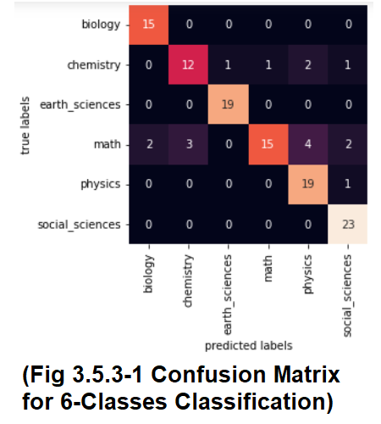

3.5.4 ROC, AUC
ROC (Receiver Operating Characteristic) curve is an overall metric, with each point representing different thresholds, showing the relationship of FPR (False Positive Rate) and TPR (True Positive Rate). FPR = FP/(FP+TN), TPR = TP/(TP+FN) which is the recall. It can be seen as an upgraded version of the confusion matrix. As we set the range to be different classes or Micro- or Macro-average, there can be different ROC curves (Fig 3.5.4-1). AUC (Area Under Curve) is a rate to represent the ratio the ROC curve encloses, compared with the whole area. The bigger the AUC is, the better the model. AUC means ‘the probability that the prediction outcome of positive samples is bigger than the prediction outcome of negative samples’. AUC=1 is perfect; AUC=[0.85, 0.95] is outstanding; AUC=[0.7, 0.85] is general; AUC=[0.5, 0.7] is just acceptable; AUC=0.5 is like random guessing; AUC<0.5 is worse than random guessing. | 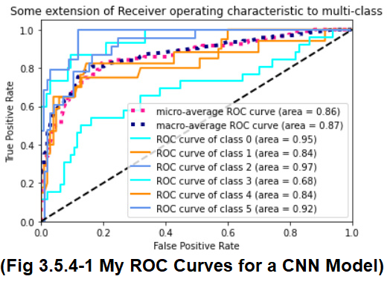

4 Implementation

4.1 Collect Data
See the full file of retrieving data here: https://drive.google.com/file/d/17ztt_VkZ0MOn7pQ-x7YcIDwyks2pxahC/view?usp=sharing After installing EventRegistry, I write the Algorithm 4.1-1 to retrieve articles and related information for each category into JSON files:
Algorithm 4.1-1: Information Retrieval from EventRegistry.org Using Their API
1: er ← EventRegistry object, with my unique API key
2: q, qStr ← The detailed query generated by their sandbox and functions
3: for each_article in the_query(inputs: er, maxItems=100):
4: with open(created_empty_json_file):

5: write to that file with the retrieved each_article
Then I convert format into EXCEL files, and summarise them into one file. After that, I read the ‘body’ (article) column data into x variable, and the category column data into y variable (with integers from 0 to 5 to represent each category).

4.2 Data Cleansing

Steps: Remove unwanted characters; Lowercase and expand contractions; Remove stopwords & lemmatisation. Key algorithms are listed in Algorithm 4.2-1 and 4.2-2:
Algorithm 4.2-1: Remove Unwanted Characters
Input: a text string text
1: set rules using RegularExpression library, examples: enter, URLs, special chars, html tags, …
2: for each mentioned above, substitue and replace the old text with the updated version
3: repeat 1~2
Output: the characters-removed version of that string of text

Algorithm 4.2-2: Expand Contractions & Lowercase
Input: a text string text
1: contractions ← set rules for contractions; new_text ←an empty list to store future list of word strings
2: for each character char in text:

3: if char is not space:
4: read the char, and append it into a temporary variable
5: else if char is space:
6: join each character to form the word, and lowercase the word
7: if that word is in the contractions:
8: append the full version to new_text
9: else:
10: just append this word to new_text
11: text ← use space to join these words, then delete spaces at beginning and the end
Output: the new version of that string of text
The final cleansed form of one of the article data is shown in Fig 4.2-1:
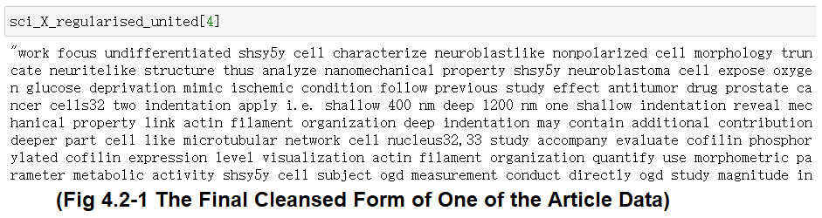

4.3 Train-Test Splitting, Encoding
Tensorflow only takes in number data, but we have text data, so we must transform our data, which is known as ‘encoding’ process, after train-test dataset splitting. (I leave for the splitting of train-validation in writing real models later.) Please see the Fig 4.3-1 in the Appendix for the whole codes of encoding.

4.4 A Small Neural Netwok (Chollet Step5)
Although an underfitting NN is not helpful for developing the most strong model, it is a necessary step described by Chollet[12]. In the Epochs-Loss plot on the validation set (Fig 4.4-1 curve), we see the loss is decreasing without a fluctuation, so it is not yet overfitting. The Epoch-Accuracy curve (Fig 4.4-2) shows an increasing trend, which also means it is still underfitting. We see the total accuracy is 0.50 on test set, which is higher enough than the baseline 0.167 (Fig 4.4-3).
Settings 4.4-1: Small Neural Network which Underfits
All layers are Dense. 3 layers in total. Neuron numbers: 16-16-6
activation function: all are relu, output layer is softmax; optimizer: rmsprop;
loss func: categorical_crossentropy; batch size=64; epochs=8

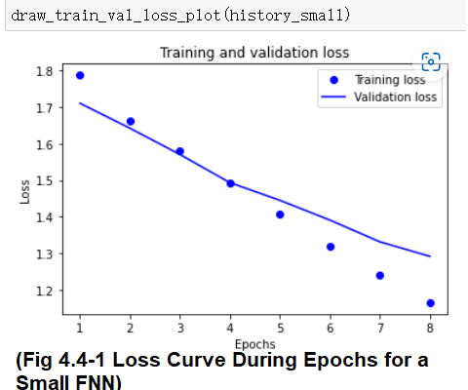 | 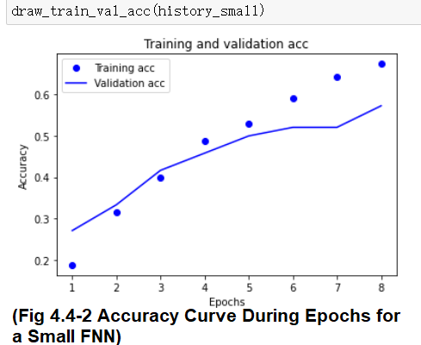 | 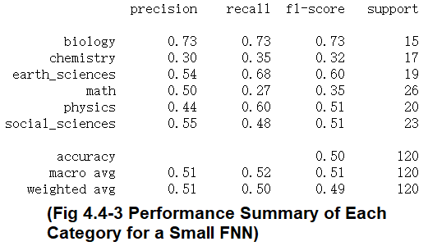

4.5 An Overfitting Neural Network (Chollet Step6)
The Settings 4.5-1 shows my overfitting neural network hyperparameters. From Fig 4.5-1 the Epoch-Loss plot, the loss is even increasing, so it must be overfitting. From Fig 4.5-2 we see the accuracy is fluctuating, so it must be overfitting. Although the total accuracy is 0.61>baseline 0.167 which is satisfying, we need to use a smaller epoch number to prevent overfitting.
Settings 4.5-1: Bigger Neural Network which Overfits
All layers are Dense. 6 layers in total. Neuron numbers: 16-128-256-256-16-6
activation function: all are relu, output layer is softmax; optimizer: rmsprop;
loss func: categorical_crossentropy; batch size=64; epochs=200
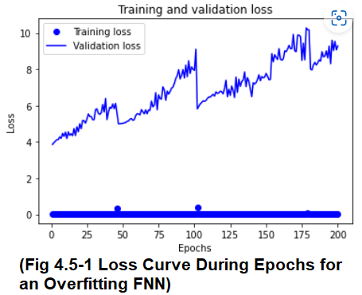 | 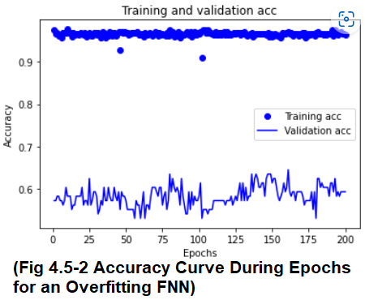 | 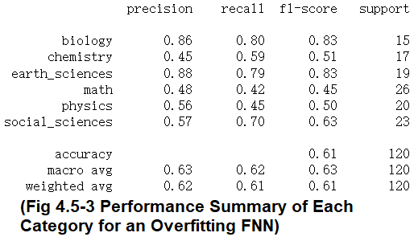

4.6 Controlled Experiments for Hyperparameters
Much effort has been put on the experiment on each hyperparameter. Till now, I have collected hundreds of experiment records on hyperparameters: batch size, number of layers, activation functions, neuron numbers, optimizers, regularisation. See my complete experiment records here: [?????]
To demonstrate my designed functions for controlled experiments, I list in Algorithm 4.6-1 a function which experiments on the activation functions as an example. That function can be implemented also for other hyperparameters, since the input parameters contain many variables which are available to be tuned. The real controlling part is when calling this function, where I have ensured that only the act_list is the changing part, while other parameters are fixed.
Algorithm 4.6-1: Controlled Experiment for Activation Functions
Inputs: activation function list act_list, Number of inner layers num_layers_inner, batch_size,
neuron number neuron, number of words words, random_state
1: | if length(act_list) does not equal to (num_layers_inner + 2):
2: | print(“You should enter two matching lengths. ”)
3: | else if length(act_list) < 2:
4: | print(“Must have at least 2 activation functions. ”)
5: | else:
6: | model ←create a keras Sequential model
 | model.add Dense layer(64 neurons, activation←act_list[0], input_shape ← (words,))
 | i ← 0
 | while i < num_layers_inner:
 | model.add Dense layer(neuron neurons, activation←act_list[i+1])
 | i ← i+1
 | model.add Dense layer(6 neurons, activation←the last element in act_list)
 | compile model, with optimizer←’rmsprop’, loss←‘categorical_crossentropy’, metrics←’accuracy’
 | split data into training and validation data with ratio 8:2, random state←random_state
 | history ←model.fit(training and validation data, batch size←batch_size, epochs←20, )
 | results ←model.evaluate(the cleansed X test data, the cleansed Y test data)
 | combine ← [results, history]
Output: combine, which contains both the test loss & accuracy values, and the history
The experiment results for activtion function as an example is listed in the Table 4.6-1. We see when there is only one hidden layer, when other hyperparameters are fixed, hard_sigmoid performs the best with the best test accuracy and a relative low loss.
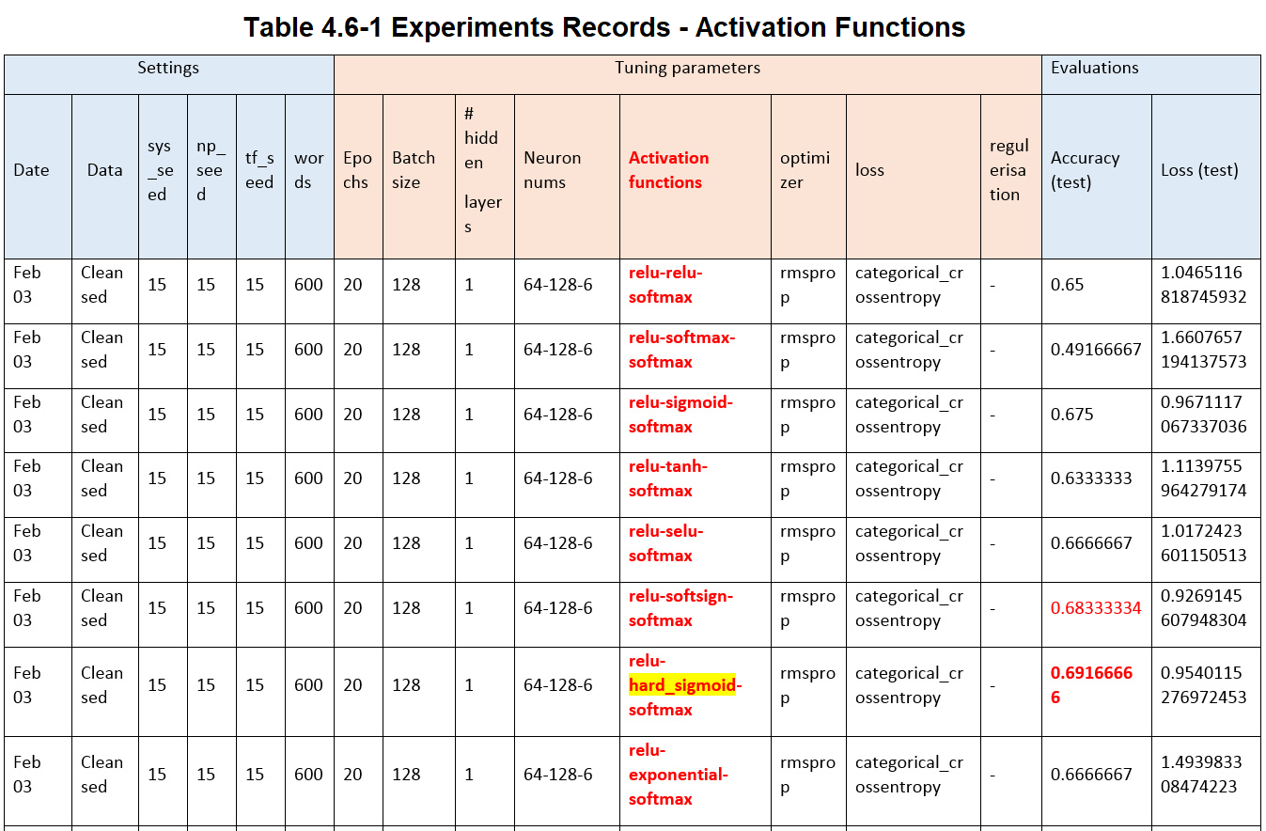

4.7 Use GridSearchCV to Bruteforce Search

Sci-kit Learn provides for us with GridSearchCV to conveniently set searching scopes. After setting the searching scope as in Settings 4.7-1, I have got the best hyperparameters: {'act_func': 'tanh', 'batch_size': 256, 'epochs': 20, 'loss_f': 'mean_absolute_error', 'neuron_num1': 64, 'neuron_num2': 128, 'optimizer': 'rmsprop'} with the best accuracy of 0.5521.
Settings 4.7-1: GridSearchCV_01
the input layer neuron number: [32, 64],
the neuron number in each inner layer (identical): [128, 256, 512],
the activation function in each layer (identical): ['relu', 'tanh', 'sigmoid', 'selu'],
batch size: [64, 128, 256, 512],
epoch number: [20, 40, 70],
loss function: ['categorical_crossentropy', 'mean_absolute_error'],
optimizer: ['adam', 'rmsprop', 'sgd', 'adagrad']
Using the hyperparameters shown in Settings 4.7-2, I have got the best settings of: {'act_func': 'relu', 'batch_size': 256, 'epochs': 60, 'loss_f': 'mean_absolute_error', 'neuron_num1': 64, 'neuron_num2': 256, 'num_layers': 0, 'optimizer': 'adam'} with the accuracy of 0.5625.
Settings 4.7-2: GridSearchCV_02
the input layer neuron number: [32, 64],
the neuron number in each inner layer (identical): [128, 256, 512],
number of inner layers: [0, 1, 2, 3],
the activation function in each layer (identical): ['relu', 'tanh', 'selu'],
batch size: [128, 256, 512],
epoch number: [20, 40, 60],
loss function: ['categorical_crossentropy', 'mean_absolute_error'],
optimizer: ['adam', 'rmsprop', ‘adamax’]

4.8 General NLP Methods with Vectorizers and Classifiers
Here, I combine various pairs of vectorizers and classifiers to examine each model’s performance. For each model, I can import the vectorizer and classifier objects from Sci-kit Learn, then use make_pipline function to make my model. Then, simply use the ‘fit’ method for the pipeline model to fit the cleansed training data, and use it to predict the test data, see an example in Fig 4.8-1. I have investigated the following vectorizers: TF-IDF, Count Vectorizer, Bigram; and these classifiers: Support Vector Classifier (SVC), Multinomial Naïve Bayes (MNB), Random Forest, K-Nearest Neighbors; 12 models in total. After building each model, I have evaluated it with heatmap, classification report, ROC curves and AUC.
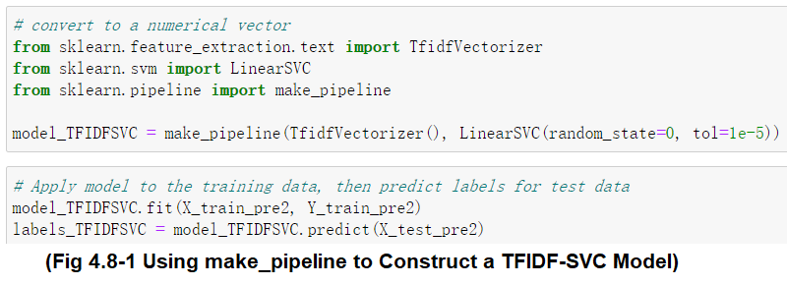

4.9 1D-Convolutionary Neural Network (CNN)
I have used convolutionary neural network to get rather good results, with accuracy of 0.633 on the test set (Feb 08), fine-tuned a set of settings mentioned by person ‘Alialili AIhub’ in Bilibili video website. My settings for the best CNN model are shown in Settings 4.9-1.
Settings 4.9-1: 1D CNN
Layer types: (1) Embedding(2000, 128, 600); (2) Conv1D(256, 3); (3) MaxPooling1D(3, 3);
(4) Conv1D(32, 3, ‘relu’); (5) Flatten; (6) Dropout(0.3); (7) BatchNormalization;
(8) Dense(256, ‘relu’); (9) Dropout(0.2); (10) Dense(6, ‘softmax’).
np_seed: 15; tf_seed: 15; words: 600; batch size: 64; epoch: 31

4.10 Recurrent Neural Network (RNN), LSTM Layer
Using Chollet’s settings[12] in his book Ch.6.4, I only get a passed accuracy score of 0.267 which is not significantly higher than the baseline 0.167. This model uses two LSTM layers and two Dropout layers.

5 Evaluation

5.1 Evaluation of Models

5.1.1 Feed-Forward Neural Networks
In the controlled experiments, the best accuracy score which achieves 0.73 on the test set, is given by a very simple model when I develop a set of experiemts for the number of layers. It has 0 hidden layers, with neuron numbers of 256 and 6 in the input and output layers, with relu and softmax activation functions for these two layers, rmsprop optimizer, categorical crossentropy loss function, no regularisation, on 20 epochs with input of 600 keywords on the cleansed data, on all random seeds (system, numpy, tensorflow) of 15.
All the models with high accuracy on the test set are given in Table 5.1.1-1 (see Appendix).
Findings for each hyperparameter:
Batch size – based on my controlled settings, the best performing batch size is 64 when operated on Dec 09, with accuracy=0.675. I have found an increasing-then-decreasing pattern of the accuracies when the batch size goes down.
Number of layers – I have found that the best number of layers is unpredictable, varying from different controlled settings (I use 3 groups), and different operating date (two days). The best layer number covers all from 0 to 4. Therefore, this hyperparameter depends on the real settings of our model.
Activation functions – from the two groups of experiment, I find that putting hard sigmoid inside the inner layer achieves the best accuracy, and softsign and sigmoid perform the second and third best; if using two same activation functions inside the inner layers, then use tanh. Never try to put softmax inside inner layers, since it has got 0.49 and 0.29 when using once and twice. Others are just viable as well.
Neuron numbers – in the same settings, two neuron number groups win with 0.68 accuracy: 128-128-256-6; 512-256-128-6.
Optimizers – Adam stands out with accuracy of 0.708, followed by AdaMax of 0.692. Rmsprop is the third best. Never try to use SGD or AdaGrad! They only have accuracy of 0.425 and 0.358 respectively. AdaDelta is even more unacceptable, with only 0.175 accuracy.
Regularisation – For L1 and L2 regularizers, if I set the same regularisation for every layer, I can get a high accuracy when L1 or L2 is very small, at around 0.00001 or 0.0001; but L1 cannot be set as big, because l1(0.1) only gets 0.208 accuracy. On the contrary, when l2 is large, l2(0.01) can get the highest accuracy of 0.692. If use l1_l2 combined, we should not set either one as big.
Using GridSearchCV from Sci-kit Learn, I have found out some of the generally good performing models. The accuracy for the two best models I have found, are 0.55 and 0.56.

5.1.2 Classical NLP Methods
Surprisingly, some of the models achieve very high accuracy score, much higher than any general neural network model (Table 5.1.2-1). We can see the highest accuracies can be 0.86, both using SVM Classifier. Multinomial Naïve Bayes Classifier follows up, with an accuracy of under 0.80. K-Nearest Neighbors Classifier with TF-IDF is also brilliant. Bigram with SVM Classifier or MNB performs rather ordinary, with the score similar to the best accuracy score I can achieve using feed-forward neural networks. Here I use cleansed data for all models including Bigram, is not ungrounded, if someone argues that the cleansed data is not a complete sentence – since in some way, the cleansed data reserves the order of the crucial words as that in the original data. Never try to use Bigram with K-Nearest Neighbors, because in the heatmap, I find the model classifies almost all the samples as the math category, which is what I cannot explain. Bigram with Random Forest also should be avoided.
Overall, to choose classifiers: Support Vector Classifier is our No.1 choice; MNB Classifier is also within our consideration; if we want to use K-Nearest Neighbors, then we must carefully choose the vectorizer (should be TF-IDF); Random Forest Classifier is only acceptable. To choose vectorizers: TF-IDF is our No.1 choice, which performs always very well; Count Vectorizer is almost as good as TF-IDF, but don’t combine it with K-Nearest Neighbors Classifier; Bigram performs the worst among these three vectorizers, in all 4 classifiers, perhaps this is why Kandimalla et al. do not use N-grams[18].
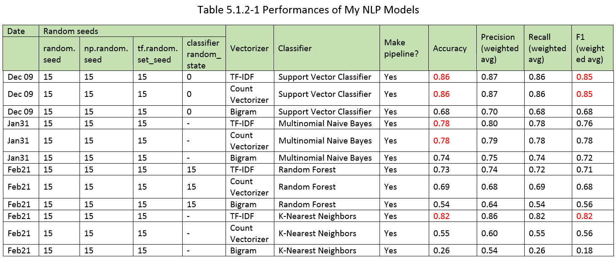

5.1.3 CNN
The highest accuracy I have got so far using CNN, is 0.633 on the test set, where I have adopted a pre-trained model showed by ‘Alialili AIhub’ in Bilibili video website. This model uses many dropout layers, and one BatchNormalization layer. Although this model cannot beat the feature engineering models at all, it is quite a progress where I can significantly win the baseline 0.167.
Compared with my initial CNN model which only gets accuracy of 0.125, Alialili AIhub’s model uses Batch Normalization, some Dropout layers, and the proper size of input and output size in each MaxPooling and Conv1D layer, and thus his model can get a better result. Dropout and Batch Normalization aim to prevent overfitting and have improved the performance of test set.

5.1.4 RNN and LSTM
These models I have developed perform not as well as the CNN models. Generally, I get an accuracy score of around 0.267, not exceeding too much from the baseline 0.167.
I have added an LSTM layer to an RNN, fine-tuning the settings given by Chollet[12] in his book Ch.6. However his model does not perform well in my case.
Using the fine-tuned AWD-LSTM settings given by Merity in his Github, I only get accuracy=0.167 on the test set (Feb 04), which is just the baseline.

5.1.5 Latent Dirchlet Allocation
In the Fig 5.1.5-1 (see Appendix), it is not surprise that our LDA has classified the whole dataset based on a completely different mechanism from the scientific-subject-based rubric which we use, just because LDA takes into account for all of the words and it aggregates them based on general essay classification mechanism. LDA has combined both the subject classification and research method classification together. The result groups generated on Oct 25 seem like: Topic 0 – general administrative issue; Topic 1 – Cell Biology; Topic 2 – Physics; Topic 3 – Cell Biology experiment; Topic 4 – Geography; Topic 5 – Physics experiment.

5.2 The Best Model(s)
The best models are the ones using SVC and TF-IDF or SVC and Count Vectorizer. They achieve accuracy=0.86. K-Nearest Neighbors Classifier with TF-IDF follows up with accuracy=0.82. Multinomial Naïve Bayes with TF-IDF or Count Vectorizer also stand out, with accuracy=0.78. See Table 5.1.2-1 for details.
The best FNN is the one which achieves accuracy=0.733 on test set, with Settings 5.2-1.
Settings 5.2-1: The Best Feed-Forward Neural Network
For
All layers are Dense. 2 layers in total. Neuron numbers: 256-6; random seeds 15;
activation function: relu-softmax; optimizer: rmsprop; batch size=64; epochs=20;
loss func: categorical_crossentropy. Operated on Feb 03.
The best Deep Neural Network I find, is a CNN model, with Settings 5.2-2. It achieves the accuracy of 0.633 on the test set.
Settings 5.2-2: The Best Deep Neural Network
For
There are 10 layers in total. batch size=64; epochs=31; random seeds 15. Operated on Feb 08.
1: layers.Embedding(input_dim=2000, output_dim=128, input_length=600)
2: layers.Conv1D(256, 3, padding='same', activation='relu')
3: layers.MaxPooling1D(3, 3, padding='same')
4: layers.Conv1D(32, 3, padding='same', activation='relu')
5: layers.Flatten()
6: layers.Dropout(0.3)
7: layers.BatchNormalization()
8: layers.Dense(256, activation='relu')
9: layers.Dropout(0.2)
10: layers.Dense(6, activation='softmax') optimizer='rmsprop', loss='categorical_crossentropy', metrics=['accuracy']
loss='categorical_crossentropy', metrics=['accuracy']

5.3 Evaluation of This Project

5.3.1 Successes
- The collected database is very balanced.
- Have controlled random seeds, which helps other people to repeat my steps, and random seed is actually one parameter that I should control in my experiments.
- Have adapted codes to draw the ROC curves for each category and Micro- and Macro-avg, can show the AUC for each.
- Have splitted the training set and test set which have consistent data (the number of features – only the article body; and the numerical value distribution of each feature), and are complete in each category.
- Have presented all-correct data cleansing procedures, including using the correct order of expanding contractions, lemmatisation, etc. This is a crucial step to eliminate noises that may lead to model overfitting by misguiding it to ignore the core.
- Have compared the performances of many FNN after hyperparameter tuning, many DNN including CNN, RNN and others, and general NLP models.
- Have tried to use pre-trained models or settings given by other people.
- Have attempted to repeat the original codes given by prestigious papers, including ULMFiT (FastAI), AWD-LSTM, Wikipedia2Vec, etc.

5.3.2 Limitations and Future Extensions
- 600 samples are not enough to demonstrate firmly for any conclusion. For general ML, we need at least thousands of samples to train and test. For my project, I should have used K-Folded Cross Validation to avoid any bias caused by small sample size.
- I can repeat the NLP models, but cannot repeat the same result using the same Neural Network models. It is perhaps because of the randomness of embedding layer, the randomness of the model weight; the randomness of Dropout layer; etc.
- I have tried to use NNI[28] to search for the best hyperparameters on another small model, but I have not yet figured out how to implement it in my models.
- FastAI or ULMFiT: Although I have tried to run FastAI pre-training on their datasets, I find their algorithm runs extremely slowly on two of my devices. After learning the data, the calling to use the learning data stuck.
- AWD-LSTM: From their github code repository[20], I stuck when running codes and got the CUDA error. After deleting all the .cuda() and .cpu() codes, there still are errors.
- Many of the pre-trained models require a specific format of data input, for which I can hardly find an example in them. There are UTF-8 decoding errors.
- It would be better if I can adopt an NLP-combined layer inside my neural network, since many of the vectorizers would allocate different weights to different words, and classifiers are normally targeted and effective since they are the lessons taught by human to the machine.
- I should extend my database in order to include all kinds of academic journal articles, to let my data to be more representative.
- Should connect the article data with different journal platforms, different publishing websites, and other metadata which I have collected using the EventRegistry API, to get more interesting discoveries.

6 Conclusion

6.1 Summary of This Project
During these months, I have explored a classification dataset which is collected by me, by using different Machine Learning methods and models, with comprehensive evaluation metrics, implementing experiments, and finally filtered out the best models and have made rather comprehensive discussions.
Although great effort has been put into the hyperparameter-adjusting stage in my feed-forward neural network, till now, general NLP methods outperform feed-forward neural networks. The best accuracy I can get by tuning hyperparameters, is approximately 0.733; while NLP methods with the vectoriser which either puts attention to the importance of words (TF-IDF) or uses one-hot encoding (Count Vectorizer), and the classifier either considers previous knowledge (Naïve Bayes) or draws lines among samples in hyperspaces (SVC), all perform quite impressive – they all can get an accuracy score of over 0.70 (the exception is Bigram vectorizer), and they can even get 0.85 of F1 just using the built-in pipeline of sklearn. For Deep Neural Networks, it is better to have a pre-trained settings for either CNN or RNN and then fine-tune some of the hyperparameters and values. I have gained benefits from previously existing models, since my best DNN model is a CNN with accuracy=0.633 for which I have adopted a pre-trained model used by a video in Bilibili.
Though I have not discovered why Neural Networks cannot beat some NLP models, I guess it is because neural networks are without language-targeted teaching from humans, and thus the tuning is completely technical and rather blind; while NLP models are written by language experts so they have taught the machine how to learn in a better way, and the machine has a rough direction. This postulation should be examined by further efforts.
For the whole academic journal platforms, editors can adopt my models to classify their articles based on subjects, but I suggest them to add a step to manually review, since my models cannot guarantee a 90% accuracy, and we don’t want any mis-classified papers to be put into wrong sub-journals.

6.2 Discussions
What about multi-class classification? Consider an exmaple: a biology paper containing experimental words and some discriptions about the research society. Should it be classified as ‘Research Society’ or ‘Biological Experiment’ or just general ‘Biology’? Should it depend on the ratio of the contents? How many labels should we give each article – can the number vary from one to another?
Now the articles are all in English, but it would be more comprehensive if we consider other languages. There are some adaptives for the text classification on those languages. The differences can be in word-detection, encoding type, (without) lemmatization, etc. for example in character-based Chinese language. The training would then depends totally on the word-separated form, and there would be more problems in Part-of-The-Speech tagging.
‘The NFL (No Free Lunch Theorem) stated that within certain constraints, over the space of all possible problems, every optimization technique will perform as well as every other one on average (including Random Search)’ [38]. The consequence is that our preferred algorithm may perform just like a totally unsophisticated algorithm.
In the aspect of article classification, we can classify them based on subjects, and we can also classify them into theoretical, experimental, descriptive, or designed papers, based on research methods (though they are not applicable for social sciences). We may have layers of classifications for natural sciences. In my model, I may further purify the feature words used in my NLP models or purify the cleansed data in order to eliminate the impact of research-methods-based classification towards my subject-based classification.
Having a broader view, we may have some doubts for the entire Machine Learning realm.
Neural Network is like a parrot speaking humans’ words, but it cannot achieve the self-reflection and auto-adjustment state as a crow does when it can put stones in the bottle in order to drink the water (a Chinese allegory). The crow here understands clearly about the causality of ‘putting stones’ → ‘water surface rises’, but the parrot cannot know the reasons why he speaks such a sentence, just like our NN model cannot understand the detailed reasons embedded. NN can answer ‘What’ questions, but cannot answer ‘How’ and ‘Why’ questions. Even feature engineering cannot answer ‘Why’ questions. Thus, Machine Learning apparently does not have the ‘super-evolutionary speedup’, which is a fast development based on the intelligent creature itself instead of the outside, as mentioned by Pearl and Mackenzie[10]. ML algorithms also will fall into Berkson's Paradox[10], since ML models can only get conclusions based on limited data and features, hence they tend to draw false causality conclusions between two unrelated things just based on strong connection.
Sawyer in his BBC documentary has discussed about the moral issues of AI. Some of the strong candidates are weeded out by an AI algorithm in an interview for a famous cosmetics company[33]. Thus, I should prohibit my models from being used by anyone who wants to do a weeding process for the academic articles, as there are people who are investigating the weeding process[15].
Is classification really a crucial task in our life? Cramer in his book Chaos and Order Chapter 1 has stated that ‘Mother Nature doea not create categories’ but she ‘creates individuals’, and we humans are ‘shortsighted to seek for similarities’ so that we may ‘notice each item’[6]. Therefore, the ‘classification’ idea might have been exaggerated at all when it was born in Darwin’s era. We must be aware of the core content and main task – the classification is just a convenient way for us to read information; it is not the goal itself, if it is too complex and needs to include more details. For article classification, the worst case and the safest case is that we have human editors to filter for categories to give tags, and to ensure that each unique article would not be buried. AI surely can develop deeply in classification field using evolving algorithms, but the wise work of human is what can never be totally replaced.

7 Appendix

7.1 Source Codes & Files Repository

7.1.1 Repository
- Github: https://github.com/FredaXYu/FinalProject
- (Alternative) Google Drive: [???]

7.1.2 Sources on Sections
- Data
Collected data: [???]
Reformed data: [???]
- Codes: https://github.com/FredaXYu/FinalProject/tree/main/%5BCODES%5Dipynb_files
- Files: [???]
- Pitch Video, Video link: [???] The slides I use in the video: [???]

7.2 References
[??Needed to be adjusted to ACM style! ]
[1] Buschman, John, and Gloria J. Leckie. Information Technology in Librarianship: New Critical Approaches. Libraries Unlimited Incorporated, 2009.
[2] Cope, Bill, and Angus Phillips. The Future of the Academic Journal. Chandos Publishing, 2014.
[3] Dewey, Melvil. A Classification and Subject Index, for Cataloguing and Arranging the Books and Pamphlets of a Library. Brick Row Book Shop, 1876, Project Gutenberg.
[4] Gross, Alan G., et al. Communicating Science: The Scientific Article from the 17th Century to the Present. Parlor Press, 2011.
[5] Svensson, Goran. Academic Journals and Academic Publishing. Emerald Group Publishing, 2006.
[6] Cramer, Friedrich. Chaos and Order: The Complex Structure of Living Systems. VCH, 1993.
[7] Abrizah, A., et al. “LIS Journals Scientific Impact and Subject Categorization: A Comparison between Web of Science and Scopus.” Scientometrics, vol. 94, no. 2, 13 July 2012, pp. 721–740., https://doi.org/10.1007/s11192-012-0813-7.
[8] Boyack, Kevin W., and Richard Klavans. “Accurately Identifying Topics Using Text: Mapping PubMed1.” STI 2018 Conference Proceedings, 2022, pp. 107–115., https://hdl.handle.net/1887/65319. Accessed 7 Nov. 2022.
[9] Cortes-Rodriguez, Patricio, et al. “Methodology to Categorize the Research Output of Academic Institutions, through the Sustainable Development Goals (Sdgs).” Emerald Open Research, vol. 3, 10 Sept. 2021, p. 21., https://doi.org/10.35241/emeraldopenres.14355.1.
[10] Dahlberg, Ingetraut. “Classification Theory, Yesterday and Today.” International Classification, vol. 3, no. 2, 12 Sept. 1976, pp. 85–90., https://doi.org/10.5771/0943-7444-1976-2-85.
[11] Pearl, Judea, and Dana Mackenzie. The Book of Why: The New Science of Cause and Effect. Basic Books, 2020.
[12] Chollet, Francois. Deep Learning with Python. O'REILLY, 2021.
[13] Howard, Jeremy, and Sebastian Ruder. “Universal Language Model Fine-Tuning for Text Classification.” Proceedings of the 56th Annual Meeting of the Association for Computational Linguistics (Volume 1: Long Papers), 2018, https://doi.org/10.18653/v1/p18-1031.
[14] Parrochia, Daniel. “Classification.” Internet Encyclopedia of Philosophy (IEP), https://iep.utm.edu/classification-in-science/.
[15] Wagstaff, Kiri L., and Geoffrey Z. Liu. “Automated Classification to Improve the Efficiency of Weeding Library Collections.” The Journal of Academic Librarianship, vol. 44, no. 2, 2018, pp. 238–247., https://doi.org/10.1016/j.acalib.2018.02.001.
[16] Unknown. “Introduction to Library Classification.” National Institute of Open Schooling, https://nios.ac.in/media/documents/vocational/CLS/Certificate_Course_in_Library_Science_english/M2_PDF/M2L2.pdf.
[17] Ambalavanan, Ashwin Karthik, and Murthy V. Devarakonda. “Using the Contextual Language Model Bert for Multi-Criteria Classification of Scientific Articles.” Journal of Biomedical Informatics, vol. 112, 2020, p. 103578., https://doi.org/10.1016/j.jbi.2020.103578.
[18] Kandimalla, Bharath, et al. “Large Scale Subject Category Classification of Scholarly Papers with Deep Attentive Neural Networks.” Frontiers in Research Metrics and Analytics, vol. 5, 10 Feb. 2021, https://doi.org/10.3389/frma.2020.600382.
[19] Lee, Kangwook, et al. “A Discourse-Aware Neural Network-Based Text Model for Document-Level Text Classification.” Journal of Information Science, vol. 44, no. 6, 4 Dec. 2017, pp. 715–735., https://doi.org/10.1177/0165551517743644.
[20] Merity, Stephen, Nitish Shirish Keskar, and Richard Socher. "Regularizing and optimizing LSTM language models." arXiv preprint arXiv:1708.02182 (2017). https://github.com/salesforce/awd-lstm-lm
[21] Feng, Xiang, et al. “Academic Emotion Classification and Recognition Method for Large-Scale Online Learning Environment—Based on A-Cnn and LSTM-Att Deep Learning Pipeline Method.” International Journal of Environmental Research and Public Health, vol. 17, no. 6, 16 Mar. 2020, p. 1941., https://doi.org/10.3390/ijerph17061941.
[22] Garcia-Gorrostieta, Jesús Miguel, and Aurelio López-López. “Argument Component Classification in Academic Writings.” Journal of Intelligent &amp; Fuzzy Systems, vol. 34, no. 5, 24 May 2018, pp. 3037–3047., https://doi.org/10.3233/jifs-169488.
[23] Glänzel, W., et al. “An Item-by-Item Subject Classification of Papers Published in Journals Covered by the SSCI Database Using Reference Analysis.” Scientometrics, vol. 46, no. 3, 1999, pp. 431–441., https://doi.org/10.1007/bf02459602. https://akjournals.com/view/journals/11192/46/3/article-p431.xml
[24] Gómez-Núñez, Antonio J., et al. “Improving SCImago Journal & Country Rank (SJR) Subject Classification through Reference Analysis.” Scientometrics, vol. 89, no. 3, 14 Aug. 2011, pp. 741–758., https://doi.org/10.1007/s11192-011-0485-8.
[25] Milojević, Staša. “Practical Method to Reclassify Web of Science Articles into Unique Subject Categories and Broad Disciplines.” Quantitative Science Studies, vol. 1, no. 1, 2020, pp. 183–206., https://doi.org/10.1162/qss_a_00014.
[26] Osborne, Francesco, et al. “Automatic Classification of Springer Nature Proceedings with Smart Topic Miner.” Lecture Notes in Computer Science, International Semantic Web Conference, 2016, pp. 383–399., https://doi.org/10.1007/978-3-319-46547-0_33. https://link.springer.com/chapter/10.1007/978-3-319-46547-0_33
[27] Zins, Chaim. “Classification Schemes of Information Science: Twenty-Eight Scholars Map the Field.” Journal of the American Society for Information Science and Technology, vol. 58, no. 5, 2007, pp. 645–672., https://doi.org/10.1002/asi.20506.
[28] Microsoft. Neural Network Intelligence (version v2.10). https://github.com/microsoft/nni
[29] Rie Johnson and Tong Zhang. 2015a. “Effective use of word order for text categorization with convolutional neural networks.” In NAACL HLT 2015, The 2015 Conference of the North American Chapter of the Association for Computational Linguistics: Human Language Technologies, pages 103–112.
[30] Zhou, Chunting, et al. “A C-LSTM Neural Network for Text Classification.” International Journal of Emerging Trends in Engineering Research, vol. 2, 30 Nov. 2015, https://arxiv.org/abs/1511.08630.
[31] jcblaisecruz02. 6 Dec. 2020. AWD-LSTM: AWD-LSTM and Ulmfit Reproduction from Scratch. GitHub - JCBLAISECRUZ02. https://github.com/jcblaisecruz02/awd-lstm.
[32] Olah, Christopher. “Understanding LSTM Networks.” Colah's Blog, Github, 27 Aug. 2015, http://colah.github.io/posts/2015-08-Understanding-LSTMs/.
[33] Sawyer, Georgia. Computer Says No. Performance by Daniel Henry, BBC Three, BBC, 5 June 2022, https://www.bbc.co.uk/programmes/m0015gvw. Accessed 19 Nov. 2022.
[34] Lunqing Hou, Fei Wang, Xin Deng, and Zhouan Shi. 2020. Tensorflow 从零开始学 (Tensorflow Learning From Zero). Publishing House of Electronics Industry, Beijing.
[35] Fig 3.4.8-1. Bing Pic Search. Source: shorturl.at/jlY16.
[36] DataTechNotes. 2020. Classification Example with Linear SVC in Python. https://www.datatechnotes.com/2020/07/classification-example-with-linearsvm-in-python.html
[37] PublicKnowdgeProject. Unknown Year. Issue and Article Metadata - Better Practices in Journal Metadata. https://docs.pkp.sfu.ca/metadata-practices/en/issue-article-metadata
[38] Luke, Sean. Essentials of Metaheuristics. 2013. pp.203

7.3 Additional Tables & Pictures
