IXD Midterm
Xiaoyun Yu Jun, 2022
Q6
When performing usability evaluations it is common to give users some time to familiarise themselves with the system.

i. Why is this important? Please provide three examples. [3]
(1) When using low-fidelity prototypes, users may feel unfamiliar with the system, but that’s not very considerable in our usability test, because later on we will improve the fidelity level. So by giving users more time, they can get more familiar with this low-fidelity model. For example,
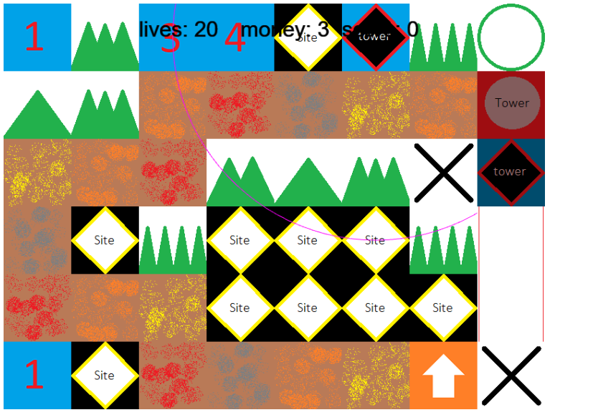 | 
The above pictures are low-fidelity prototype and high-fidelity prototype of our game project when doing Agile. There are not much real differences in functionality between the two, it’s just the difference of picture source layout and design of single elements. When users are asking about usabililty, they are not only asked about the design, but also functionalities and arrangements. By giving them more time, they can figure out how to start our game, and give us feedbacks on the functionalities.
(2) We should observe users’ behaviours – what they find out first, and then what they do next, then where they hesitate on, etc. When giving them a period of time to get familiar with our system, we should always find out user behaviour clues, and do some notes. It is because sometimes asking users about where they stuck is less effective than just observing them directly. For example,
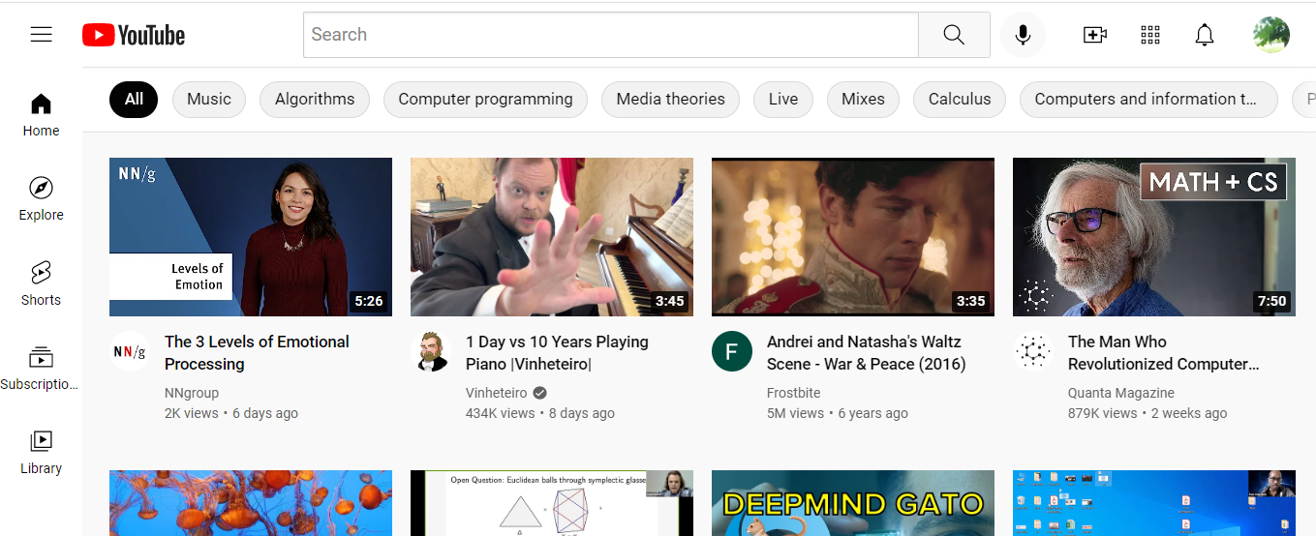 | I have designed the Youtube website. Now I give users some time to get familiar with Youtube. First, I observe that user A is browsing through the page to look for ‘my account’, and soon he finds it out at the top right corner - so this place is effective. Then user A is observing seriously about the videos below – so the customizable feature is good. And so on.
(3) In testing, to mimic a real-world senario, users should be given some space to use the system and to explore all the features individually. Otherwise if we only follow the testing pipeline of asking and filling in the form, users would not have a chance to experience the real-world usage senario. And, users would have a chance to do things creatively, perhaps will find out some new functionaities or bugs. For example,
 | In Microsoft Paint, by giving users some time, they would very likely discover by themselves that erasers can have different colours just by selecting ‘Colour 2’. Is ‘Colour 2’ meaningful and clear? Will users accept such a concept? We should give them some space to figure out.

ii. Describe two advantages and two disadvantages of utilising quantitative data in research. [4]
Advantages:
(1) Quantitative data is paired with experiment design and some evaluations that make the results can be replicable. So research using quantitative data is often replicable, checkable.
(2) Quantitative data can be continuous, which means that it can get wide range of data. It can discover some intermediate states that are not observable by qualitative data.

Disadvantages:
(1) Many times, quantitative data cannot explain questions raised by sociology or other humanities, because it has ignored the opinions from individuals, their backgrounds, their emotions, personalised settings, etc. Quantitative data assumes all the samples are taken in a ‘fair’ way, a non-personalised way.
(2) Quantitative data often ignores outliers. However, it is those ourliers that may implicate some deep social phenomenon. For example, a research that cares about stay-at-home children should just focus on outliers of the age when entering into school.

iii. Describe two advantages and two disadvantages of utilising qualitative data in research. [4]
Advantages:
(1) The data-collection methods can be varified and flexible. Unlike quantitative data that requires strict data-collection methods, qualitative data can be collected through many times, whenever the users are available, or after our research focus is shifted a little bit. We can even just ask people a very simple question and record their personalised responses.
(2) The complexity of data (outliers etc. ) can be included into the conclusion of our research. In fact, quanlitative data is just for researchers to discover about the complexities of their research interest. How deep and how inspiring the data would be, depends on how researchers interpret the data. They are all accepted. Whilst quantitative data can be only interpreted based on statistical rules.

Disadvantages:
(1) Qualitative data is less persuasive in statistical view, and thus it lacks of logical support from mathematical or statistical theories. The interpretation is too flexible that there may exist biases. For example, a feminist only collects comments from feminists and interpret deeply about their opinions, but is still biased.
(2) Qualitative data requires researchers must be equipped with special knowledge in that field. Otherwise, they would not have the ability to interpret any data and do some extensions. While quantitative data only requires researchers to have solid statistical knowledge, just like using a template.

(750 words)

References:

- https://greengarageblog.org/15-advantages-and-disadvantages-of-quantitative-research
- https://vittana.org/23-advantages-and-disadvantages-of-qualitative-research

