IXD Midterm
Xiaoyun Yu Jun, 2022
Q6
You have been tasked with designing an interface for a self-driving car.
i) Describe an appropriate model for exploring interaction design possibilities with cars that are driven by human beings. [2]
ii) Describe your model and potential limitations of the model in relation to the five dimensions of interaction design: Language, visuals, space and proximity, time and behaviour. [5]
iii) Identify a goal [1] scenario [1] and a story [1] for the context of riding in a self-driving car
iv) Describe an uncomfortable interaction in driven cars that can be solved by moving to a self-driving model [1]

i. I investigate the U.S. type of car (not the U.K. type).
From the human’s side:
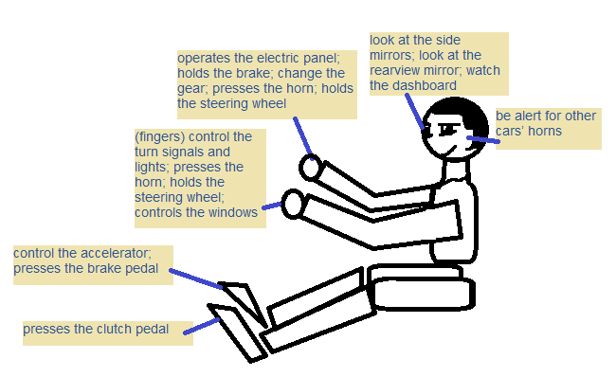
Body part of a human | Functionalities when driving a car
right hand | operates the electric panel; holds the brake; change the gear; presses the horn; holds the steering wheel;
left hand | (fingers) control the turn signals and lights; presses the horn; holds the steering wheel; controls the windows;
eyes | look at the side mirrors; look at the rearview mirror; watch the dashboard; be alert for other cars/pedestrians;
left foot | presses the clutch pedal;
right foot | control the accelerator; presses the brake pedal;
neck | be put in a comfortable position at the seat;
ears | be alert for other cars’ horns;

From the car’s side:

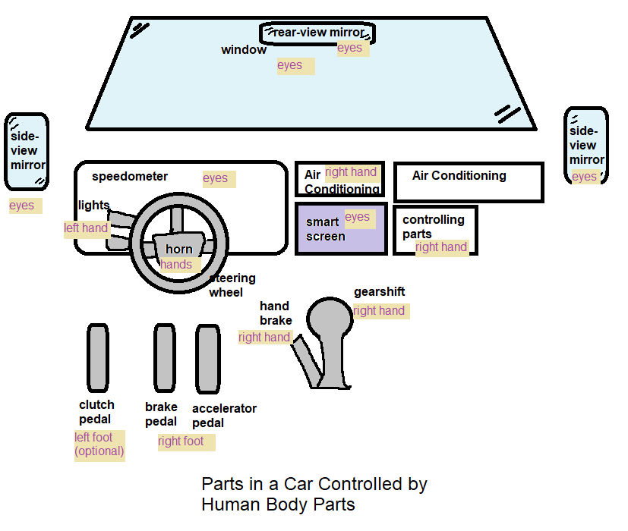
Car’s part | Controlled by which human body part
window | eyes
rear-view mirror | eyes
side-view mirror | eyes
speedometer | eyes
steering wheel | left hand and right hand
horn | left hand and right hand
lights | left hand
smart screen | eyes, right hand
hand brake | right hand
gearshift | right hand
(clutch pedal) | (left foot)
brake pedal | right foot
accelerator pedal | right foot
controlling parts | right hand
air conditioning | right hand

Self-driving car model:
Key functionality of a car based on scenarios | How to realise | Corresponding self-driving car parts
detect the distance of all the key objects in front, rear, both sides of the car | feature extraction from videos/images; tracking of one thing
detect all living things | 360 degree thermo-cameras; feature extraction from videos/images; tracking of one thing
(detect the age of any human, whether he/she has disabilities or not) | feature extraction from videos/images; tracking of one thing
detect all cars surrounding it | feature extraction from videos/images; tracking of one thing
detect a human from only parts of him/her | identification of a feature; inference ability; tracking ability
control the front lights and rear lights to other cars and pedestrians
can turn left or right | controlling the directions of tyres
can horn whenever: (1) the pedestrians have not noticed us; (2) the car in front is stuck or moving slowly | controlling the sound system; tracking of one thing
provide obvious hint for driver if he wants to control the car and has shifted the driving mode to ‘manual’ | sound hint, visual hint; full human manual driving mode functionalities, similar to common cars
can brake when: in the moving direction, a thing will be too near in very short amount of time | controlling the tyres (brake); detection of distance; tracking of one thing; monitoring
can accelerate when: (1) start off the car; (2) there is no dangerous things in front; (3) on a highway | controlling the tyres

ii. Language:
My model has simple words that can be easily understood by end users, so I think my model has done quite well in Language. There are indeed some jargons, like ‘feature’, ‘inference’, etc. that may prevent users from full acceptance of my model. Also, language has tones that influence people. My tone is perhaps too plain that users will find less involvement.
Visuals:
I have included several graphs which show the relationships between functionalities of a car and the human body parts. Graphs make my model more straightforward to users. My graphs are indeed in intermediate level, not too overwhelmed. But if the user is unacquainted with automobile terms and how to drive a car, then I should improve my model.
I can still explore more types of visuals: icons, statistical plots, typography, etc. Also, I should improve the colour usage.
Space and proximity:
I do not have a concrete physical model for users, so users may find my models somewhat hard to interpret comparing to directly interacting with a physical model. I should consider to involve: game sticks, touchscreen, etc.
However, I have some entities in my models which are similar to things in real life (driver, equipments), which will make my model more acceptable.
Time:
Users will quickly understand what I am conveying from both the words and graphs in my model. But there are considerations: (1) If the user is unacquainted with automobile terms and how to drive a car, then he will spend more time on my model; (2) There are some technical jargons that may cost long time to understand; (3) They cannot touch a physical model, so users may spend longer in my model. But overall, users will not spend very long time.
I should also consider to make a model that uses: sound, films, animations, etc.
Behaviour:
I do have considered how human behaviours should influence the car design. There is a human sitting in the first picture, and all human body parts listed in the second picture. However, I didn’t consider user bahaviours – I cannot collect user feedbacks on how they feel and think. E.g. I should consider involving vibration in notifications.
iii. Goal: The driver should intervene whenever there is a personalised want to prevent some dangerous accidents.
Scenario: At sunset, there is a very short child playing just in front of the self-driving car, and he is in the blind zone of all the cameras, so the car has not identified such a person. The driver has noticed the child and wants to control the car to brake and to turn the steering wheel by just turning the steering wheel.
Story: As a user, based on the above scenario, the driver wants to control the car and to brake it by just turning the steering wheel so that the car can prevent from hitting the child.
Solution: (1) Set different levels for self-driving cars. For level 0 cars, they shoud allow a simple operation to pass the driving right to the driver. (2) There should be a very big button near the turning wheel so that when the driver presses it, the car suddenly brakes. (3) For level 0 cars, if the driver is handling the turning wheel, the car should slow down, and stop self-driving immediately.
iv. Uncomfortable interaction:
(1) When a driver wants to brake, he/she mistakenly presses the accelerator pedal (since both the brake and accelerator are controlled by the right foot), so the person in front of the car is hurt.
(2) It is very difficult to control the turning angle manually when reversing the car, especially in rain.

(1034 words)

References:
- https://www.interaction-design.org/literature/article/the-five-languages-or-dimensions-of-interaction-design

