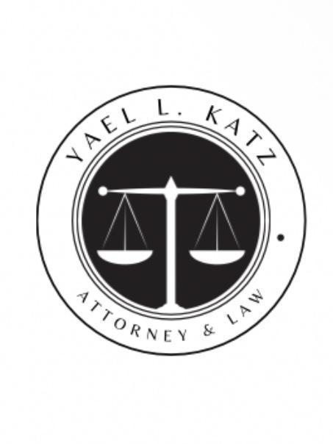
YL Katz, Law Offices,
New York, NY
9172732211 • ylk@katz-lawyers.com

10/16/2025

VIA EMAIL & MAIL
By Email & Certified Mail
Edwin Mason
Chairman, Stratagem Global Corporation
e.mason@stratagemcorp.com
Johnathan O’Brien
Vice Chairman & CEO, Stratagem Global Corporation
jobrien@stratagemcorp.com
Stratagem Global Corporation
1717 K Street NW, Suite 700
Washington, DC 20006

Re: Final Demand / Notice of Enforcement, Investigation & Criminal Referral (Corporate & Personal Liability)
Gentlemen,
This letter is the final demand — and formal notice — that your continued refusal to respond to prior demands compels us to escalate this matter in every available forum: civil, regulatory, and criminal.
Your silence and inaction can no longer be viewed as inadvertent or defensible. Rather, they constitute willful evasion, obstruction, and likely fraud.
You are hereby placed on notice of the following:

I. Corporate & Personal Liability — No More Shielding
- Joint and Several Liability
You, Stratagem Global Corporation (“Stratagem”), Edwin Mason, and Johnathan O’Brien are jointly and severally liable for all obligations arising from the Secured Promissory Note and the Pledge & Security Agreement dated August 10, 2023 (the “Agreement”).
- Veil Piercing / Personal Exposure
We will move to pierce the corporate veil, hold all corporate formalities disregarded, and seek recovery against your personal assets, guarantees, and other controlled entities.
- Corporate Dissolution / Receivership / Liquidation
Without further notice, we will seek judicial dissolution, appointment of a receiver, and forced liquidation of all corporate assets, including pledged equity interests in Meade Transportation, Inc. and Virginia Freight Holdings, LLC.
- Attachment / Garnishment / Foreclosure
We will seek pre-judgment attachment and garnishment of bank accounts, receivables, contracts, and property held in your individual or corporate name; pursue foreclosure of pledged collateral; and seek UCC and judicial liens on all assets.

II. Investigation, Subpoenas & Discovery
We have already conducted our due diligence, including:
- Verifying that Edwin Mason is listed on Stratagem’s website as Chairman / Founding Partner
- Confirming that Johnathan O’Brien is likewise described as Vice Chairman & CEO / Founding Partner
- Reviewing Stratagem’s site’s public “About / Team” page (listing Mason, O’Brien, CFO Ben Posner)
- Noting that Stratagem has filed litigation in the U.S. District Court for the Western District of Virginia in “Stratagem Global Corporation et al v. Meade et al”, under 15 U.S.C. § 78m(a), confirming they engage in securities or investment-related claims.
Given that, we will serve subpoenas and compulsory process (federal Rule 45 and state/county subpoenas) upon Stratagem, its officers, shareholders, transfer agents, banks, accountants, consultants, and other third parties, demanding:
- Full stock / membership / share ledgers, capital tables, option/warrant schedules, subscription agreements, transfer records
- All pledge / security / collateral assignments and UCC schedules
- Operating agreements, bylaws, amendments, minute books, board resolutions
- Bank account opening / KYC / signature cards, statements, wire / ACH logs
- Financial statements, general ledgers, audit work papers, internal valuations
- Communications, presentations, marketing or investor materials concerning collateral, equity, or fundraising
- All documents reflecting transfers, concealing or dissipation of assets.
We will seek immediate motions to enforce, compel deposition, and impose sanctions for noncompliance or document destruction.

III. SEC / State Securities / Regulatory Referral
Because Stratagem presents itself as an investment / growth / infrastructure / logistics / energy investment group (per its website) , and because your obligations are tied to pledged equity interests and financing, we will refer this matter to:
U.S. Securities and Exchange Commission (Division of Enforcement), for possible violations of Section 10(b), Rule 10b-5, and other securities statutes;
- State securities regulators (in jurisdictions where you operate);
- State attorneys general and consumer protection agencies if misrepresentations or deceptive practices are found.
We will include this correspondence, demand letters, agreement documents, and subpoena responses in the referral.

IV. Criminal Referrals & Allegations
Be advised that your conduct may also be the subject of criminal investigation. Among other potential violations:
- Wire Fraud / Mail Fraud (18 U.S.C. §§ 1341, 1343) — if you used interstate mail, email, or wire transfers to misrepresent or conceal obligations, collateral, or equity;
- Bank Fraud (18 U.S.C. § 1344) if banking relationships were used to mask transfers;
- Securities Fraud or False Filings under federal securities laws;
- Concealment, Misapplication, or Fraudulent Transfer of Collateral - e.g., under Va. Code § 18.2-185 or D.C. analogous statutes;
- Obtaining Money by False Pretenses or Embezzlement under applicable state law (Virginia, D.C.)
We will prepare and file sworn complaints and affidavits with:
- The FBI / U.S. Attorney’s Office (White Collar Division)
- The SEC Criminal Enforcement wing
- The Commonwealth’s Attorney, City/County of Roanoke (or appropriate VA locality)
- The District of Columbia Office of the Attorney General, Public Integrity Division.
Once filed, we will request asset freezes, restraining orders, forfeiture of proceeds, and law enforcement cooperation with civil discovery.

V. Demand for Payment / Cure - Final Opportunity
In light of the foregoing, you have no further excuse or safe haven. This is your final and non-negotiable opportunity to avoid full-blown enforcement, liquidation, regulatory and criminal exposure.
You must within three (3) business days of receipt:
- Contact our office with a detailed, binding payment proposal that cures all amounts in full and provides security;
- Provide irrevocable written acknowledgment that you waive any defenses related to statute of limitations, laches, or any delays;
- Authorize us to inspect, audit, and confirm collateral holdings;
- Cease any further transfers, concealments, or destruction of documents or assets.
- Notify any third party holding your assets or documents (banks, custodians, accountants) that they are preserved for legal process.
If you fail to satisfy these within the three-day window, we will proceed immediately and simultaneously with:
- Civil enforcement: judgment, attachment, receivership, dissolution, veil piercing
- Investigative subpoenas, motion to compel, sanctions
- SEC and regulatory referrals
- Criminal complaints and law enforcement referrals.
We will also seek recovery of all attorneys’ fees, costs, investigation expenses, and pre-judgment and post-judgment interest.

VI. Reservation of Rights & No Waiver
All rights and remedies (at law, in equity, and under statute) are hereby expressly reserved. No failure or delay in exercising any right or remedy will operate as a waiver. You have been sufficiently warned.

Yael Katz, Esq.
Member, New York Bar
YL Katz, Esq.
YL Katz, Law Offices
ylk@katz-lawyers.com | 917-273-2211

