Chapter One
The Landscape Before the Leap

Quarters, Boyz II Men, The League Bowler, and Amusement Parks

Growing up in the eighties and nineties, my brothers and I had a limited range of family entertainment options throughout elementary, middle, and high school. We’d hit the arcade at the local mall, go skating, or bowl. When we ran out of money, we’d get creative — and by creative, I mean riding our bikes around the neighborhood or constructing a WWF ring in my parents’ bedroom and beating the crap out of each other. Once a year, our parents would take us to Disney or an amusement park like Kings Island or Six Flags, and nothing else came close to topping it. It always felt special — “This is different, let’s go!”

But those trips were once a year. The rest of the time, we worked with what we had. The arcade at the local mall was the place to be. Anyone who was anyone was there, playing Donkey Kong, Mortal Kombat, or, in my case, running away from ghosts in Pac-Man — never quite making it past level four in that game. We saved every quarter we could find and made it a weekly ritual. At one point, we even discovered a hack — Drachmas worked in the arcade machines! Thankfully, we had plenty from our annual trips to Greece, which made the gaming sessions last longer. But eventually, it all became stagnant — same games, same kids, nothing new. When the original NES went mainstream, arcades became a dying breed, and so did our interest in them. Time to find the next thing.
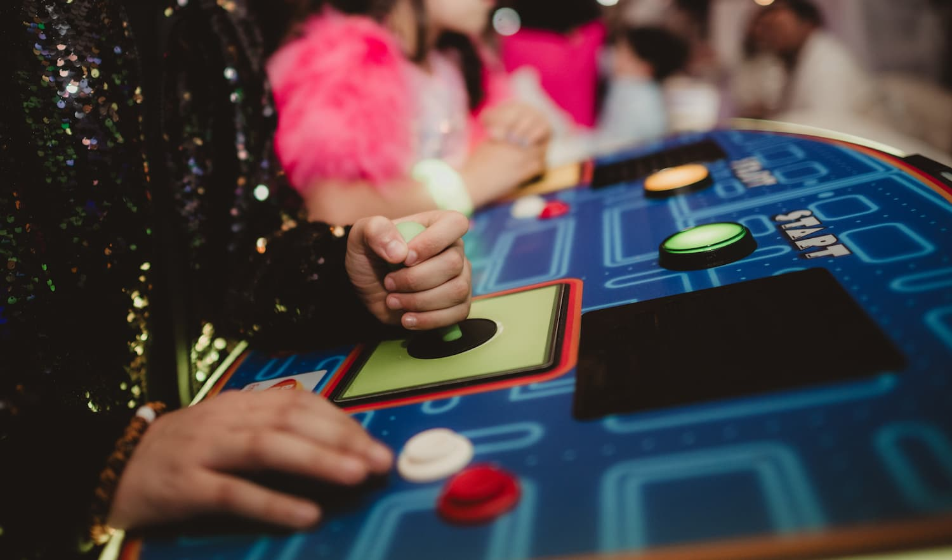The arcade: Where friendships were tested, fingers flew, and the only goal was staying alive past level four.
[VISUAL STRATEGY — KEEP] Arcade_Interior_Retro.jpg stays as-is. Well anchored to the paragraph above it.

Then, of course, there was the skating rink — the quintessential high school field trip in my day. I remember gliding to the soothing sounds of Boyz II Men while attempting to backward skate without falling and embarrassing myself in front of cute boys. And who could forget that tacky, wall-to-wall carpet? What a time to be young and alive. I jumped at any chance to go, rounding up my friends outside of school and making it a full, fun day. But as we got older, even that lost its charm — it just wasn’t the same. The venues started to run down, the food leaving a lot to be desired.

￼
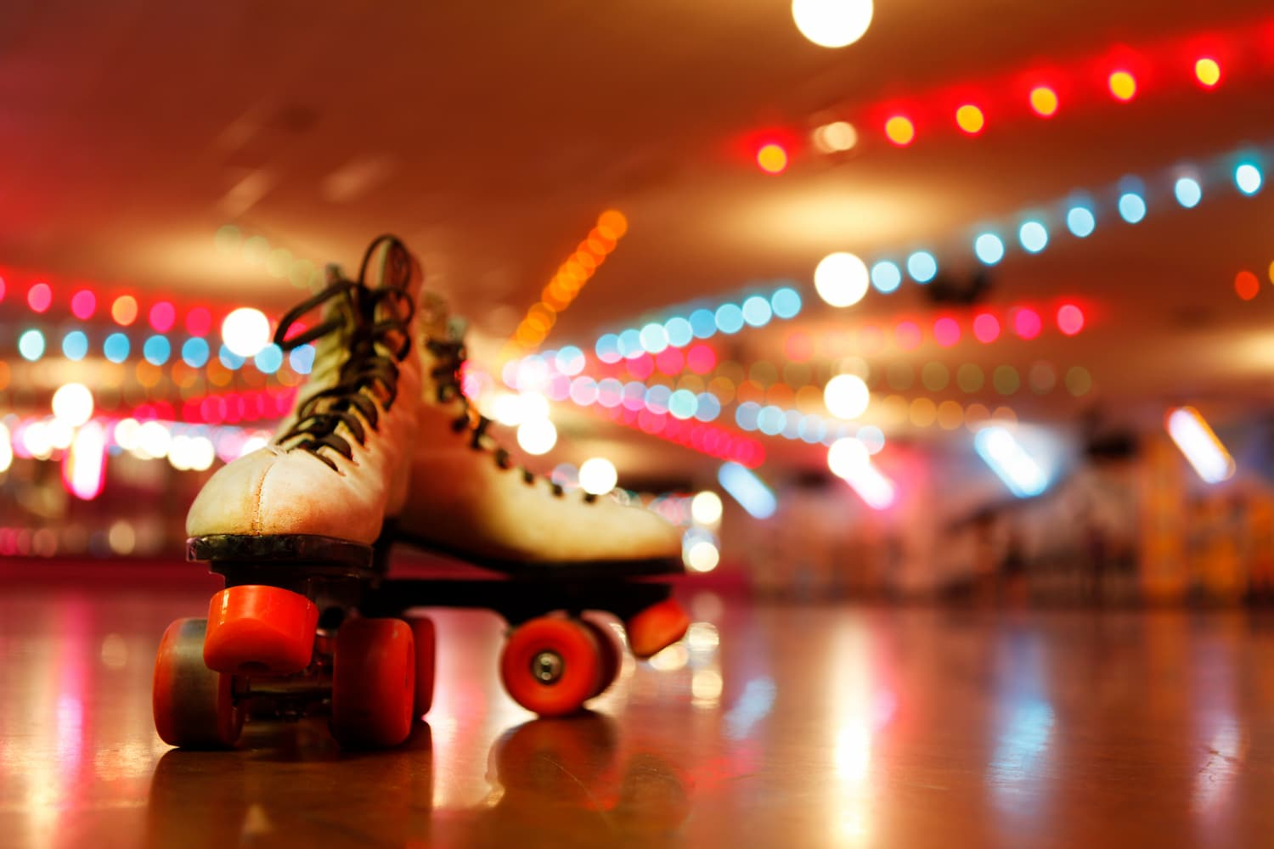
The skating rink: Where the lights were low, the music slow, and falling in front of your crush was a death sentence.
[VISUAL STRATEGY — KEEP] Roller_Skates_Vintage.jpg stays as-is. Well anchored to the paragraph above it.

Bowling, by comparison, actually grew with us, following us out of high school and into our adult lives. After I graduated from high school, bowling alleys became the go-to spot to unwind after work. Not necessarily to bowl but to hang out, have a cocktail, and maybe play a game or two if we were in the mood. Amaretto Sours never tasted as sweet as they did inside that bowling alley, and they probably never will. Then somewhere along the way, the flashing lights and cosmic bowling crept in. Bowling alleys were modernizing and becoming more popular, and we could barely find a lane to bowl, let alone a place to hang out.

￼
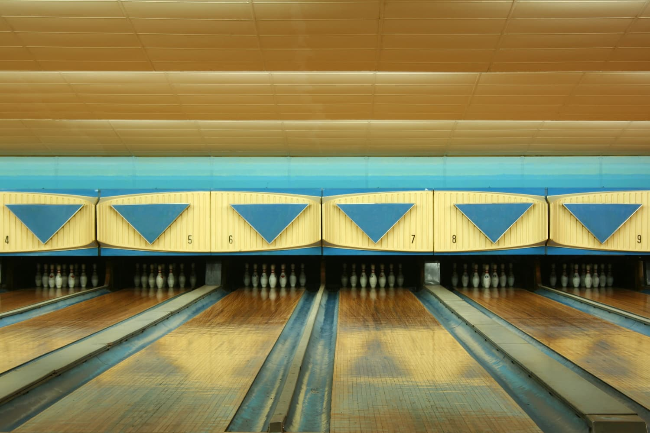
Bowling alleys: Part competition, part cocktail lounge, always iconic.
[VISUAL STRATEGY — CUT] Recommend removing Vintage_Bowling_Alley.jpg. It's the least specific memory in the chapter (no named venue, shortest paragraph) and a generic lanes photo does less work than the arcade and skating images nearby. Removing it also makes room for the two additions below without overloading the chapter.
Through all of it, amusement parks remained the gold standard of family entertainment. If you’re going to Disney, the magic sells itself — what more needs to be said? Days filled with thrilling rides, charming characters, delicious food, sweet exhaustion, and at least one sibling meltdown before the trip was over. It was the highlight of the year — months of planning and anticipation, and it never disappointed. Disney wasn’t something we did every year, but Kings Island and Six Flags were annual adventures. I still remember the first time I set foot in Six Flags Ohio. Let me tell you, my mind was blown! What is this? Where has it been hiding, and why didn’t my parents tell us about it? Everyone knows about Disney, but do they know about this? They had huge roller coasters, funnel cakes, SeaWorld, and a nearby water park. The only problem was that these parks weren’t close by — they cost a small fortune when you convert the regular dollar into a teenage dollar, and we couldn’t always get all our friends to go at the same time.

￼
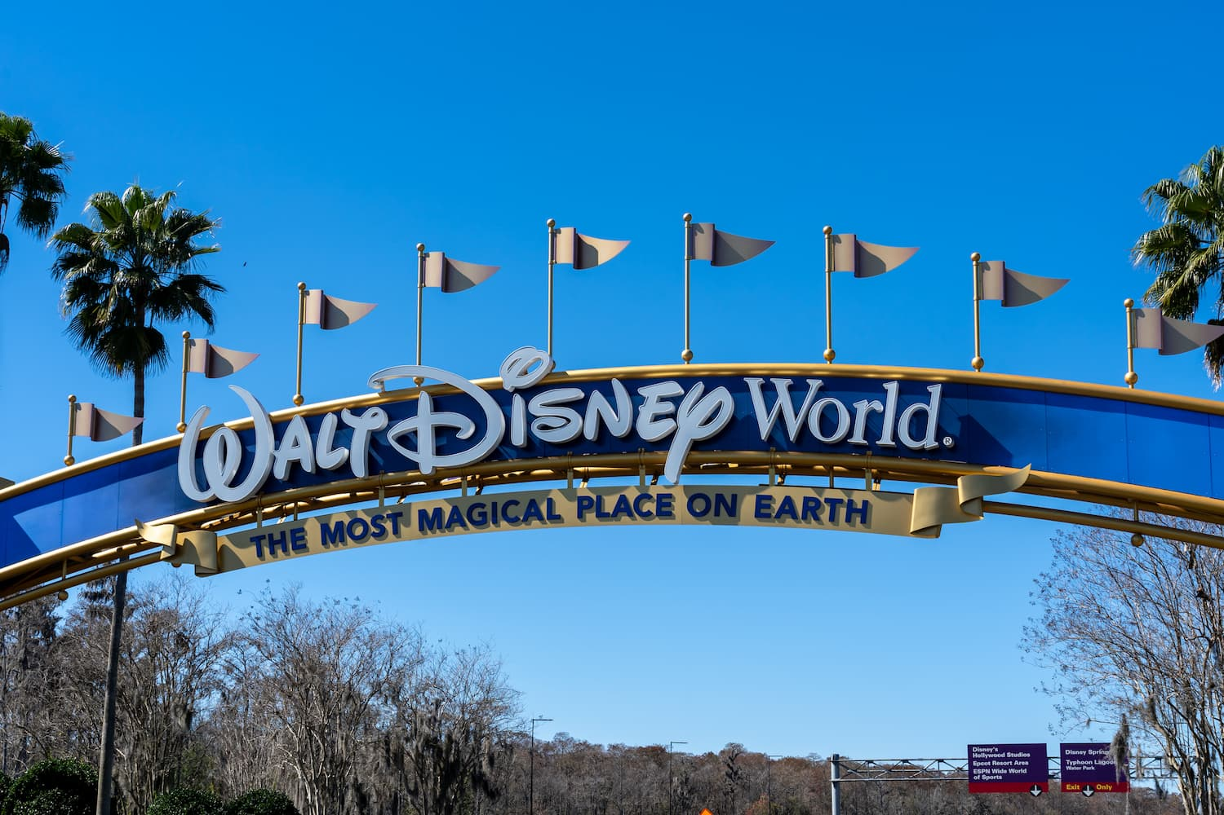
Walt Disney World: The mecca of family entertainment, where the magic (and meltdowns) began.
[VISUAL STRATEGY — ADD] Add Six_Flags.jpg here. The text gives Six Flags Ohio its own vivid, distinct beat (“my mind was blown,” coasters, funnel cakes, the water park next door), separate from Disney, but only the Disney sign currently represents that whole passage. This keeps the two parks visually distinct instead of Disney standing in for both. Note: this file isn't in the tracker yet, needs sourcing info confirmed.
[VISUAL STRATEGY — KEEP] Disney_World_Entrance.jpg stays as-is.

Adulting, Existential Dread, and Outgrowing Chuck E. Cheese

I began transitioning into adulthood: a job, a house, bills, and all the existential questions about life and what I should do with it. Adulting is honestly overrated - you gain the freedom to do whatever you want, but have less time to enjoy it At that point, fun meant going to bars, hanging out with friends, traveling abroad, and all the other things adults do.

Then in 2006, everything changed. I was blessed to become a stepmom. I wanted my stepdaughter to experience everything I had during my childhood. One of the first things we did was take her to Kings Island. The problem? She was only three, which meant she was too small to ride most of the attractions and quick to tire. She also had little patience for the heat, and there weren’t many places to get out of the sun. Like any three-year-old, she had a meltdown after a while, and I wasn’t far behind. It turned out to be more exhausting than fun.

That’s when I remembered Chuck E. Cheese. I’d been a couple of times as a kid, but I could barely recall the experience other than knowing it had games, shows, and pizza. The Chuck E. Cheese mouse wasn’t quite as famous as Mickey Mouse, but still pretty well known. It offered an immersive family entertainment experience where families could enjoy arcade games, ball pits, kiddie rides, live performances, food, and beyond.

I decided to take my daughter there to see how it had evolved, but it was always crowded and eventually she aged out. After all, the target demographic was younger kids. It was time to move on to the next thing.

￼
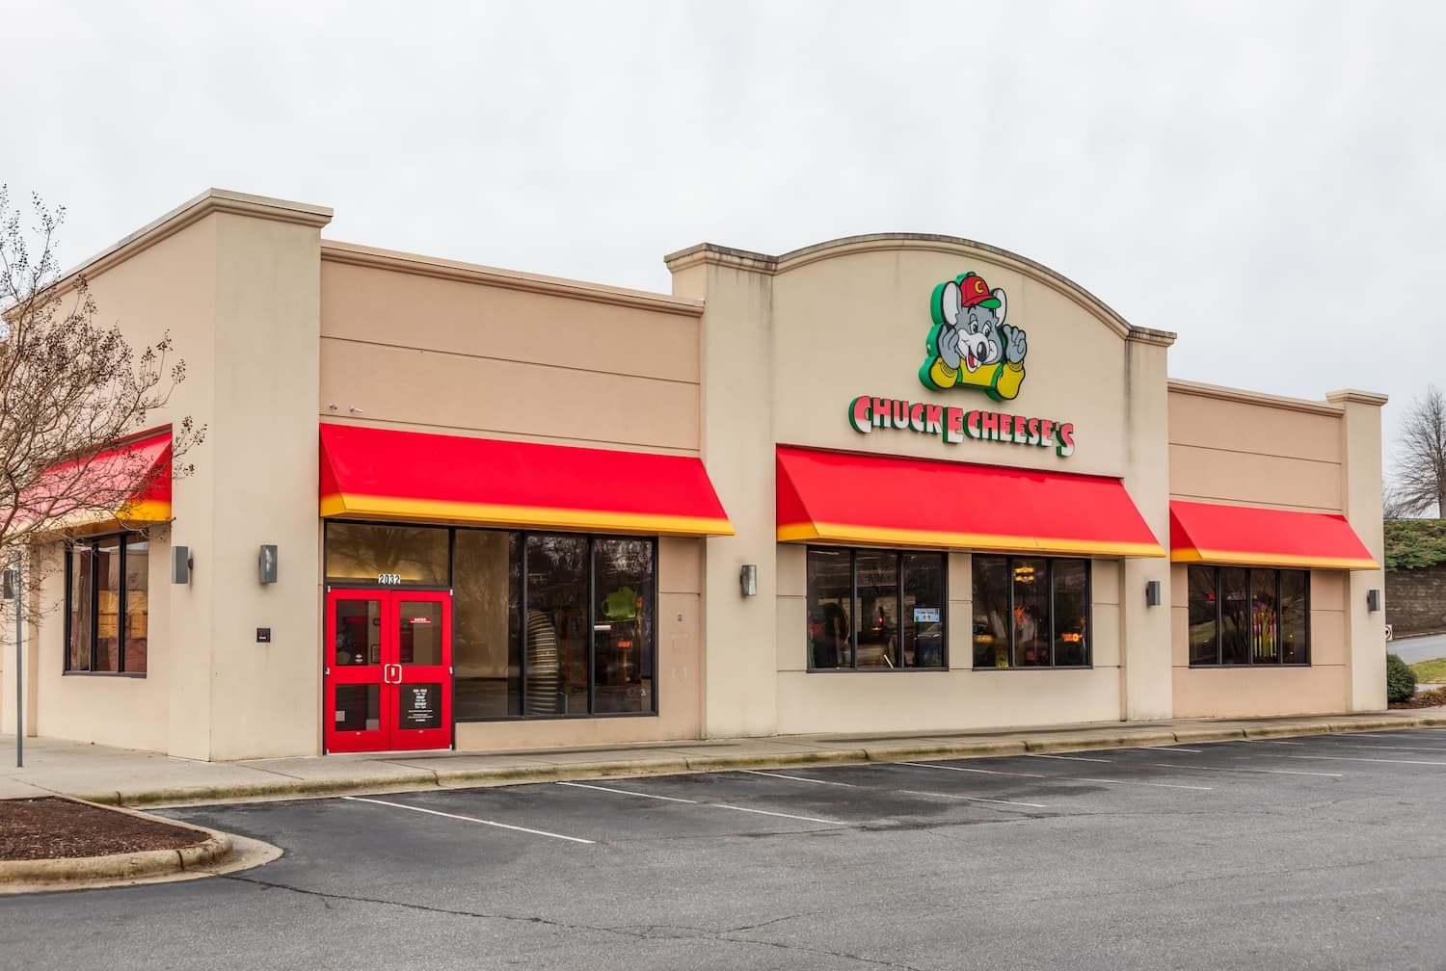
Chuck E. Cheese: The original one-stop chaos shop for every parent in the early 2000s.
[VISUAL STRATEGY — KEEP] Chuck_e_Cheese_Animatronic.jpg stays as-is.

As she got older, we tried all the activities I loved as a kid — skating, bowling, and video games — but by middle school, the novelty had worn off. Even planning birthday parties became a challenge. How many times can you recycle the same entertainment ideas?

Our old house never had the backyard for it, but in 2014 when we moved somewhere with more space, the answer seemed obvious: a big backyard trampoline. I always remembered trampolines as small, just big enough for one person to jump on. But when I started shopping around, I realized there were many sizes and options available.

I decided to give the trampoline a shot. Setting it up was a logistical nightmare — nets, springs, bolts, pads, and countless other components I didn’t recognize. It felt like I needed an engineering degree to put it together. Eventually, we got it done. I’ll never forget the look of sheer joy on my daughter’s face when she jumped on it for the first time. She could use it whenever she wanted and it was big enough for all her friends to join her. She even camped out on it a few times.

￼
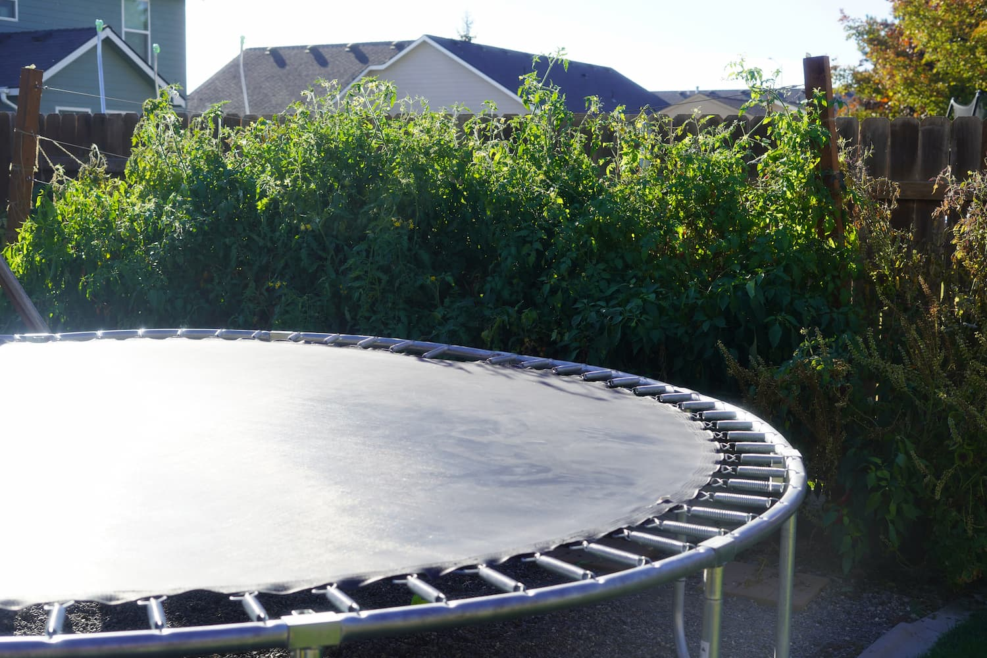
Backyard trampolines of the 2000s: the gateway drug to full-blown trampoline parks.
[VISUAL STRATEGY — KEEP] Backyard_Trampoline_2000s.jpg stays as-is.

Backyard Discoveries and the Next Big Thing

Around the time I bought the trampoline, I started noticing “trampoline centers” popping up around town. Everything we encountered when she was younger was indoor bounce houses — just a bunch of inflatables in a building. These new centers, however, were different. They brought outdoor trampolines indoors, which seemed exciting because it gave us another option during inclement weather. One had just opened nearby and we decided to give it a shot.

I honestly didn’t know what to expect. Maybe just a bunch of round trampolines in a room, like those inflatable parks. But it was nothing like I imagined. The trampoline beds were joined together to create one large surface, separated by pads. You could navigate obstacle courses or practice flipping on tumble tracks. I couldn’t help but join in — it was so much fun!

I quickly realized that trampoline parks are something parents can enjoy with their kids, rather than watch from the sidelines. It didn’t hurt that it was a great form of exercise, too. We bounced for hours and kept coming back for more.
[VISUAL STRATEGY — ADD] Add Trampoline_Park.jpg here. This is the strongest visual in the whole batch and it isn't in the tracker or manuscript yet. The first trampoline park visit (“I honestly didn’t know what to expect... it was nothing like I imagined”) is the turning point of the chapter, and that beat currently has no image. Kids mid-jump in a padded arena is the natural fit here. Needs sourcing info confirmed before it's locked in.

Setting the Stage: Evolve or Get Left Behind

That visit stayed with me longer than I expected. What I hadn’t realized until then was that I’d been living through the evolution of family entertainment, and the industry was about to evolve again in a big way.

Without evolution, brands risk being left behind. It’s inevitable. While I was living the corporate life in the restaurant world, trampoline parks were expanding into something bigger: family entertainment centers. Think Chuck E. Cheese but a level above, geared towards older kids. The trampoline was the core theme, of course, but surrounding it was every other activity I’d grown up enjoying. Arcade games, obstacle courses, dodgeball, birthday parties — all under one roof.

￼
From mall arcades to backyard bounce: the cultural breadcrumb trail that led to trampoline parks.
[VISUAL STRATEGY — KEEP] Chapter1_timeline_graphic stays as-is. Strong recap visual for the closing section.

That curiosity took me somewhere I didn’t expect: out of the restaurant industry and into the corporate office of one of the largest trampoline park brands in the country. I searched high and low for information about its origins, but all I found were the same recycled articles. As I settled into the brand, I realized the people I was connecting with every day were experts in the industry. But the information always felt disjointed. There was no documented formal history, just stories passed around from person to person. So I began to wonder: How did it all start? What is the actual timeline of events? Who helped shape it? What does the future hold for this industry?

The trampoline park industry is poised for another round of explosive growth, with new parks opening globally and constant innovations reshaping the experience. Smart wristbands and other technologies provide a more gamified experience, allowing kids to earn points for play, while the addition of dry launch slides and mixed-reality games offer immersive, full-body options for fun. But you can’t understand where it’s going without understanding where it’s been, and that’s a story that hasn’t been told yet.

The people who lived through it have stories worth telling. This is their story.

