Chapter One
The Origins of Trampoline Parks

The History Behind the Trampoline

To understand this industry and the history of the modern trampoline, you have to go back much further than you might expect — a few thousand years, in fact. While the story of the modern trampoline’s creation is well-documented and firmly established in history, there’s an earlier tale that sets the stage.
The origins of what we now know as the modern trampoline can be traced back to ancient civilizations in Asia and the Middle East. Even the Inuit people of Alaska are part of the lore surrounding its mysterious beginnings. Historical accounts describe the use of stretched animal hides to launch people into the air for tumbling and acrobatics. Later, Europeans joined in, replacing the animal skins with blankets and tossing people into the air for entertainment — a practice known as “blanketing,’’ because nothing says fun like being tossed around by random people.

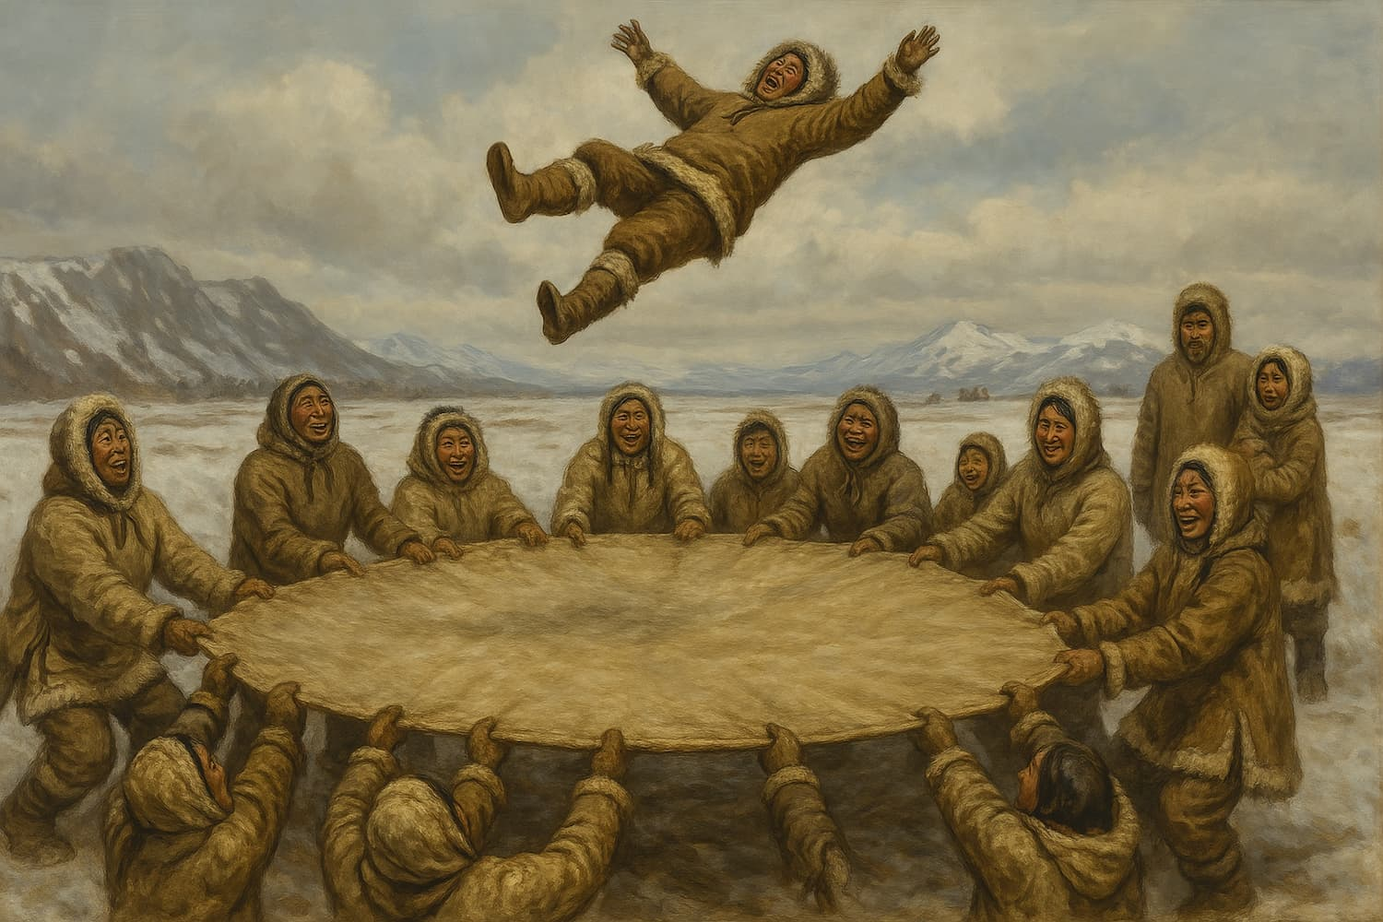
Inuit Tradition: Jumping on stretched animal hides, an ancient practice that inspired the modern trampoline.
[VISUAL STRATEGY — KEEP] Intuit_Stretched_Hide.jpg stays as-is. Note the filename has a typo (should read “Inuit”) -- worth correcting before it's finalized in the tracker.

By the nineteenth century, this tradition made its way into the circus world, evolving into a springboard-like apparatus (complete with safety netting) for acrobatics and stunts. The complete history of what came before trampolines may never be known, but something about it caught the attention of two men from Iowa.

From Concept to Creation (1934-1936)

Enter George Nissen and Larry Griswold — two innovators from Iowa who were laying the groundwork for an entire industry. It was the early 1930s, and George was a championship-level gymnast with three NCAA titles under his belt. As a teenager, he’d sit in awe at the circus, watching aerialists fly through the air, drop into nets, and somehow launch back up into more flips and tricks.

Larry, another accomplished gymnast, had spent time in New York studying acrobatics before returning to the University of Iowa as a coach, working directly with George. Together, they began experimenting with what they called a “tumbling rig” — a simple but effective device made of a steel frame and a tightly stretched canvas bed. It allowed gymnasts to practice aerial skills repeatedly without the same risk of injury as the training methods from days of old.

At the time, this was revolutionary. Up until then, there was no efficient, reusable tool for repetitive aerial training. Crash mats existed, sure, but nothing that allowed you to launch, land, and try again in one continuous flow. What they created introduced an entirely new kind of controlled airtime, opening the door to possibilities far beyond competitive gymnastics.

By 1936, they were ready to show it off. George took the invention on tour, including to Mexico, where they began performing public demonstrations to generate buzz. They’d pop up at circuses, acrobatic shows, gyms — any venue where they could showcase what this rig could do. Their goal was straightforward: prove that the tumbling rig could be both a serious training tool and a new kind of physical experience, one that made people feel like they were flying, flipping, and fearlessly pushing limits.

Decades later, the trampoline industry would tap into the same feelings.

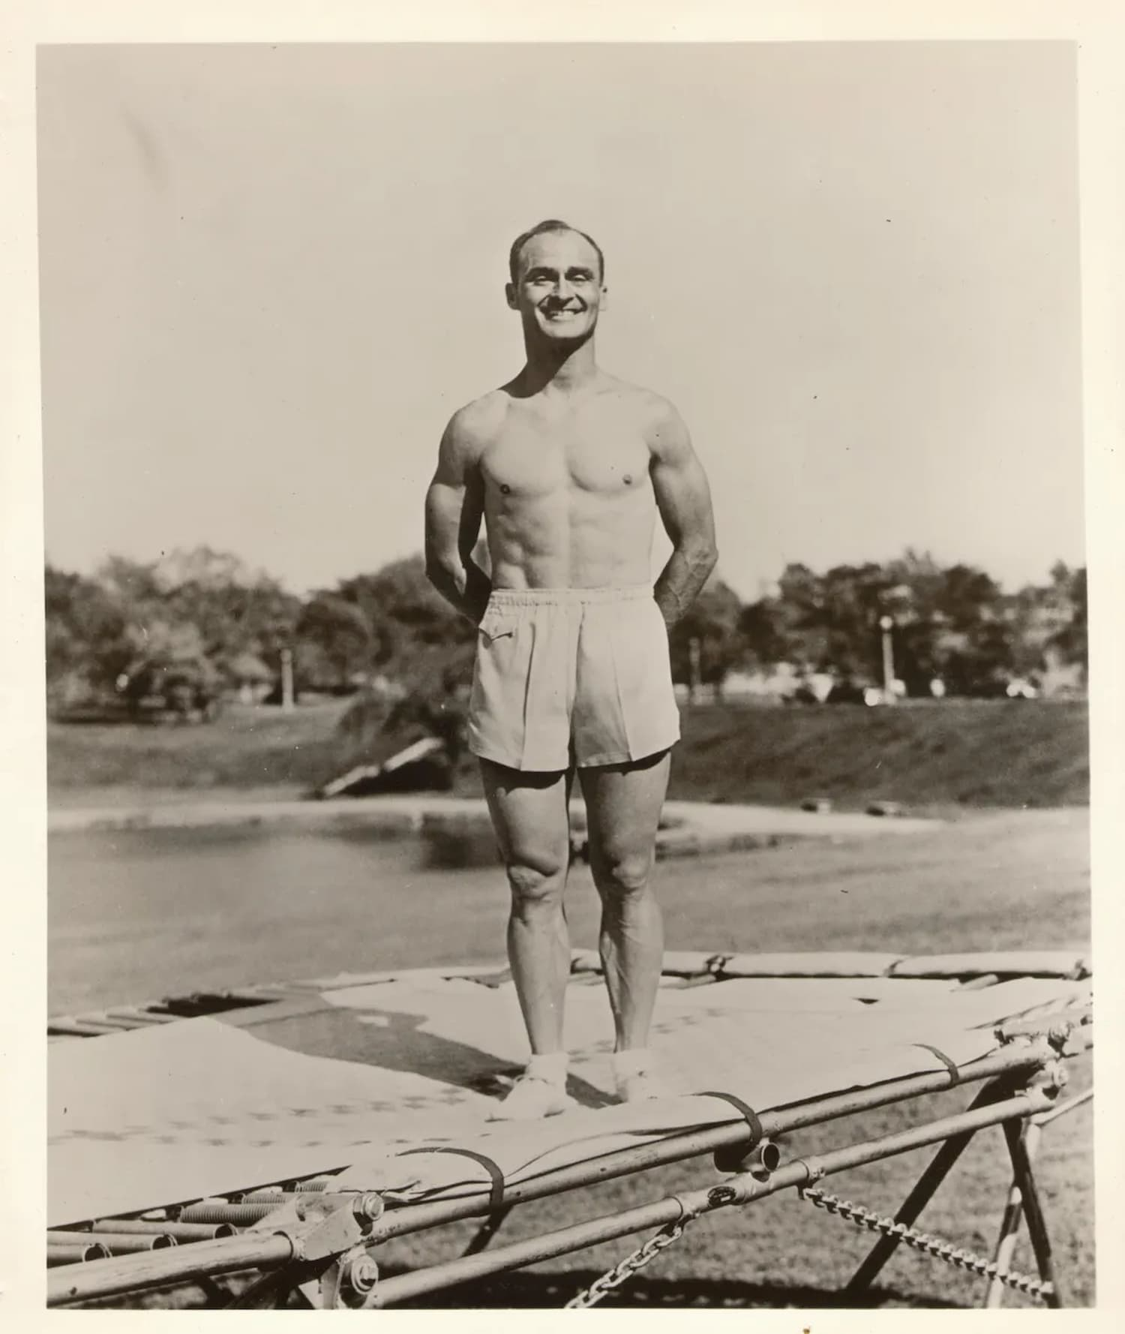
Nissen and his invention. Courtesy of Dian Nissen.
[VISUAL STRATEGY — NOTE] Tracker marks this “Needs Permission” from Dian Nissen directly. Not yet cleared. Confirm status before treating as locked in.
[VISUAL STRATEGY — KEEP] Nissen_with_Invention.jpg stays as-is.

Gymnastics Training Came First (Late 1930s)

After returning from their 1936 promotional tour, George and Larry got down to business. The applause from curious onlookers had been nice, sure, but they knew it had more potential than simply wowing a crowd. It had real value for athletes, especially gymnasts who needed a safer, smarter way to practice their aerial skills.

George and Larry weren’t shy about getting the word out. They actively pitched their tumbling rigs to coaches, training facilities, and universities across the country. The rig was a safe platform for athletes to develop spatial awareness, timing, and full-body control, all of which are critical for succeeding in competitive gymnastics. And it worked.
By the late 1930s, the tumbling rig had become essential training equipment. Gymnasts began using them to practice flips, somersaults, and twists — skills that were notoriously hard (and risky) to attempt on solid ground or with rudimentary equipment. It gave them a new level of freedom: more height, more airtime, and far less impact on the body. That meant athletes could push their limits without pushing their luck.

The tumbling rig earned a permanent place in gymnastics programs, becoming a major turning point in how gymnastics is taught and performed.

Griswold-Nissen Trampoline & Tumbling Co. (1941)

By 1941, the tumbling rig had proven its value in gymnastics training. George and Larry knew the business had legs, so they made their next big move: co-founding the Griswold-Nissen Trampoline & Tumbling Company.

With their company in place, they had the means to scale production and bring their invention to a much wider audience. This tool for elite gymnasts was now making its way into schools, training centers, and eventually, backyards. More importantly, George and Larry standardized the design, improving the product’s safety, consistency, and durability.

As demand for the tumbling rig grew, it became clear it wasn’t just for gymnasts anymore. Coaches, physical education teachers, and athletic trainers saw it as a legitimate way to build balance and coordination. It was showing up in programs everywhere — from competitive sports to basic physical education.

Naturally, the military took notice. The tumbling rig was about to enter a new arena entirely: national defense training. Its evolution suddenly had very little to do with sports, and everything to do with strategy.

Military Training Came Later (1940s–WWII Era)

As World War II ramped up, so did the demand for innovative training tools. The United States military, always on the lookout for ways to sharpen reflexes and improve physical conditioning, saw potential in this strange new bouncing apparatus.

In the early 1940s, military trainers began integrating trampolines into their programs to help soldiers develop skills like balance and agility, which were a matter of life or death on the battlefield. The beauty of the trampoline was in its versatility: it offered a high-intensity, low-impact workout that built strength and reflexes without overloading joints or muscles. In short, it delivered results without breaking someone’s body.

Even more important? It allowed soldiers to practice movements they’d need in the field — jumping, rolling, landing, and recovering — repeatedly. The spring-loaded surface created a safe environment to simulate dynamic motion without the risk of injury associated with concrete, gravel, or uneven terrain.

George and Larry, never ones to miss an opportunity to demonstrate the value of their inventions, worked directly with military trainers to show just how far the tool could go. By the mid-1940s, it became a widely used tool in military training camps, giving soldiers an edge that traditional drills couldn’t offer. The trampoline’s leap into military use validated its role far beyond sports or entertainment. It was officially a tool for serious training.

The timing couldn’t have been better. As the war came to an end and the world shifted into the 1950s, it carried with it a new kind of credibility. It had been tested under pressure and proven its worth. Tumbling rigs — be they recreational, competitive, or military — were here to stay.
[VISUAL STRATEGY — ADD] Consider a visual for the military training section above (soldiers using trampolines for conditioning). It's a strong narrative beat with zero visual support right now. A period photo, if sourceable, would add real authority here. Optional if nothing suitable can be found or licensed.

The Official Birth of the Trampoline (1945)

On March 6, 1945, George and Larry were granted a patent. Later, they changed the name and secured a registered trademark for “Trampoline,” derived from the Spanish word trampolín, meaning diving board. Their invention had become so popular it was now everywhere, from the Olympics to the military, but at this stage it was still seen primarily as a tool for professionals rather than a recreational product for the general public. But just like a limited-edition sneaker drop, it didn’t stay that way for long.

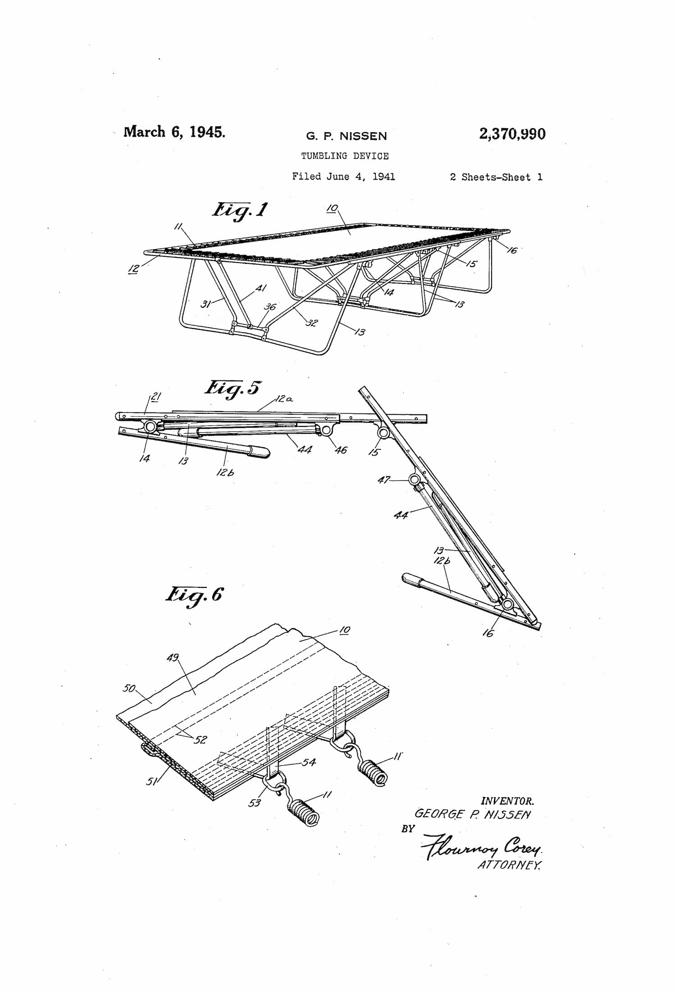

G.P. Nissen’s “Tumbling Device,” patented March 6, 1945, US Patent 2,370,990.
[VISUAL STRATEGY — NOTE] Two patent sheets were sent (Patent_1 and Patent_2) but the tracker and manuscript only account for one. Confirm which sheet is intended, or whether both should appear.
[VISUAL STRATEGY — KEEP] Patent illustration stays as-is.

Starting in the late 1940s, the trampoline began creeping beyond elite circles and into broader standard use. Schools and recreation centers were integrating them into physical education programs, recognizing their value for general fitness and coordination. It was fun and got kids moving without needing more than some open space and a high-enough ceiling. Given the post-war baby boom and a national push toward physical fitness, the timing for the trampoline was just right. America was embracing play, leisure, and outdoor fun, and the trampoline fit right into that cultural moment.

Still, despite its growing popularity in schools and gyms, home use hadn’t quite taken off yet. The idea of installing a giant industrial-strength jungle gym with a sheet attached in your backyard was far from mainstream. Liability concerns, a lack of standardized safety measures, and the sheer size of the equipment kept it confined to institutional settings. It would take a few more decades — and a big shift in consumer culture — before trampolines found their way into suburban backyards.

The Shift Toward Recreation (The 1940s- Early 1950s)

After the trampoline was granted an official patent in 1945 following its success in gymnastics and on military bases, it was only a matter of time before the rest of the world wanted in on the action. From the 1940s to the mid-1950s, the trampoline began to move beyond institutional walls and into something we are far more familiar with today: recreation.

This is when the concept of grouping multiple trampolines together in one location, what can be viewed as an early version of a trampoline park, began to emerge. These setups weren’t confined to training facilities or restricted to athletes. They were wide open, outdoors, and accessible to the general public. Rows of rectangular trampolines were arranged side by side, often surrounded by padded fencing or netting to prevent injury. You could jump from one to the next or even join in on a gravity-defying game of dodgeball.

Early trampoline parks weren’t just a place for kids to bounce around. These spaces welcomed families, teens, and adults. For the first time, ‘‘trampolining’’ was seen as an activity for anyone and everyone — not just the highly trained or highly coordinated (because let’s be real, we weren’t all born athletes). It hit that sweet spot: part fitness, part fun, and a whole new kind of freedom.

There was no gym membership required, no coach shouting corrections — just the open air and a sea of trampolines. For a generation growing up in the era of drive-ins, roller rinks, and soda fountains, this was an exciting new outlet but also different and fresh. Trampoline parks had scale and energy. People were jumping together, challenging each other, showing off, and laughing. It was the beginning of trampoline culture as a shared experience.

By the middle of the century, the trampoline had completed its shift into public recreation. It was all about play, and it had finally caught on.
[VISUAL STRATEGY — ADD] This section describes the earliest trampoline parks directly (“rows of rectangular trampolines arranged side by side... an early version of a trampoline park”), the actual subject of this book, with no image to anchor it. This is the highest-priority sourcing gap in the chapter. A vintage photo of an outdoor 1950s trampoline center would be ideal if one can be found.

NASA’s Involvement Came After That (Mid-1950s–1960s)

By the time trampolines were becoming a fixture of American outdoor recreation, they were also attracting the attention of NASA. The same qualities that made trampolines valuable for gymnasts and soldiers — balance, spatial awareness, and low-impact movement — made them ideal for training and preparing astronauts for outer space. As the space race intensified, NASA began exploring ways to help astronauts adapt to the low-gravity demands of space travel. Trampolines were repurposed to simulate aspects of low-gravity movement, helping astronauts improve their body control and spatial awareness in limited gravity.

Of course, the average American wasn’t strapping in for space missions. But it wouldn’t be long before the trampoline transitioned from elite training programs to a sport in its own right.
[VISUAL STRATEGY — ADD] NASA astronaut training with trampolines is described just above with no visual. NASA archival photos are typically public domain, making this an easy, low-risk, high-authority addition. Recommended.

Trampolining Becomes a Sport (1964)

In 1964, the International Trampoline Federation — or FIT, from its French name, Fédération Internationale de Trampoline — was officially founded in Switzerland. Its purpose was to establish trampolining as a competitive sport with formal rules, global standards, and international oversight, creating a pathway to organized competition.

FIT created a unified rulebook for competitive trampolining, developed judging standards, and coordinated the first international events. The organization attracted elite athletes and coaches from around the world who were eager to legitimize their discipline and take it to the next level.

The formation of FIT meant that trampolining now had a governing body in place. It had a global identity and was no longer fragmented or regionally focused. FIT wanted to elevate trampolining as a sport, pushing performance standards and building a worldwide community of athletes. By establishing the sport’s legitimacy and supporting cooperation at an international level, FIT was also setting the tone for the future of competitive trampolining.

Trampolining Goes for Gold (2000)

After decades of development under FIT’s leadership, trampolining was no longer a side act. In fact, it had reached its biggest milestone yet: In the year 2000, at the Summer Games in Sydney, trampolining made its official debut as an Olympic sport, featuring more than twenty-four men and twenty-four women across seventeen different countries.

The event featured individual competitions for men and women, with athletes competing in qualification routines featuring ten skills judged on difficulty, execution, horizontal displacement, and time of flight. Only the top eight athletes — hailing from countries like China, Russia, Canada, and the United States — advanced to the Olympic finals. These athletes instantly elevated the sport’s visibility by competing in front of millions of viewers.

For many viewers, this was their first time seeing competitive trampolining in a formal setting. For the athletes, it was the moment they had spent years flipping, twisting, and training for, distilled into fewer than two minutes on the Olympic floor. The routines were technical and physically demanding, combining the athleticism of gymnastics with the thrill of aerial movement.

Russia’s Alexander Moskalenko went on to capture the first-ever Olympic gold medal in men’s individual trampoline at the Sydney Games in 2000, marking a historic moment for the sport’s global recognition. Australia’s Ji Wallace earned silver on home soil, while Canada’s Mathieu Turgeon claimed bronze. In the women’s event, Russia’s Irina Karavaeva secured gold, followed by Germany’s Anna Dogonadze with silver and Ukraine’s Oxana Tsyhuleva with bronze.

The trampoline had gone from a canvas stretched across a steel frame to a respected, world-class apparatus under the lights of the most prestigious sports event in the world. And while the Olympic program would remain limited to individual events, the broader sport continued to evolve through synchronized competition, tumbling, and the double mini-trampoline event, expanding both its technical range and its international footprint.

Olympic inclusion meant recognition from the highest authority in world athletics. It confirmed what the trampolining community had known for years: that this was a legitimate, elite sport worthy of global competition on the world’s biggest stage. In the years that followed, Olympic exposure accelerated the sport’s visibility, funding, and global participation.
[VISUAL STRATEGY — ADD] The 2000 Sydney Olympic debut names six medalists in detail just above but has no visual. A Sydney Olympics trampoline competition photo (sourceable through a sports photo agency) would give this section real visual authority.

Honoring the Pioneers

Larry Griswold passed away at the age of ninety on August 24, 1996, having played a defining role in developing and commercializing the trampoline. On April 7, 2010, George Nissen passed away at the age of ninety-six. While the world may have seen them as inventors or entrepreneurs, their real legacy was that of visionaries who believed in the potential of stretched fabric and steel.

For decades, George and Larry championed the trampoline as a platform for fitness and fun. They weren’t in it for the flash, but rather the idea — one that took off, quite literally, and impacted countless industries along the way. From gymnasts and astronauts to kids in backyards and families at entertainment centers, their invention became a global phenomenon.

George’s daughter, Dian Nissen, recalled it simply: “My father knew he was on to something. He took it to a YMCA camp to try it out, and the kids loved it. They wouldn’t even get off it to go to the pool.” That simple moment captures the wonder George brought to everything he built.

George and Larry remained active in the trampoline community well into their later years, attending events, meeting athletes, and witnessing the sport they helped create reach the Olympic stage. Their passing marked the end of an era, but not the end of their impact. Every flip, every bounce, every new park that opens its doors carries a piece of what George and Larry started back in the 1930s. They didn’t just invent the trampoline. They elevated the idea of what movement could be.

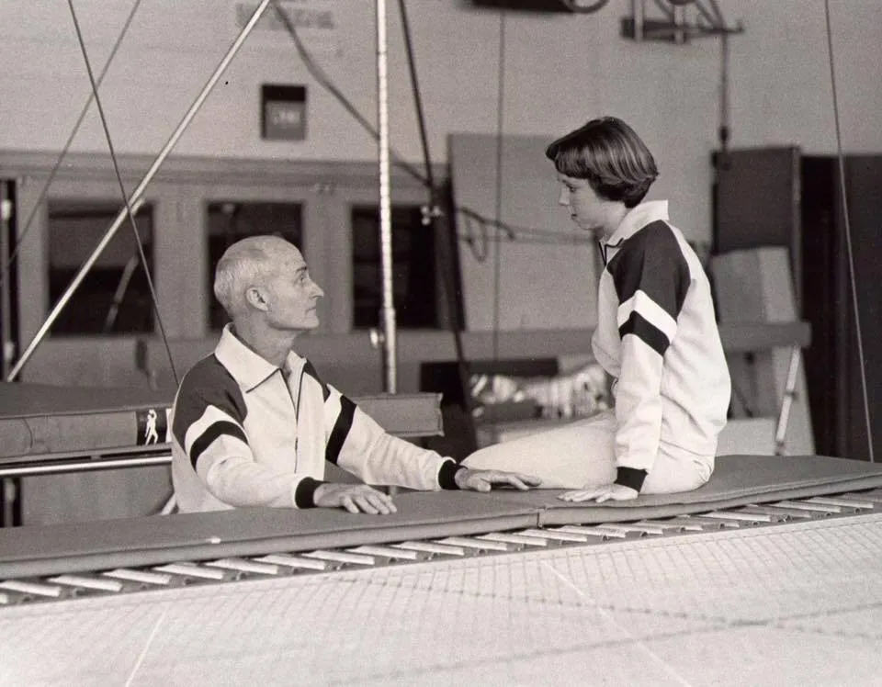
George Nissen and his daughter, Dian, at the Nissen Corp. gym. Courtesy of Dian Nissen.
[VISUAL STRATEGY — NOTE] Also marked “Needs Permission” from Dian Nissen. Between this and the invention photo, two of five tracked visuals in this chapter are pending third-party clearance. Worth tracking as a running item across the whole book.
[VISUAL STRATEGY — KEEP] George_Dian_Nissen.jpg stays as-is.

The Rise of Trampoline Parks (2010 and Beyond)

Even before George passed away in 2010 —and more than a decade after Larry Griswold’s passing in 1996—the trampoline was entering the forefront of another evolution. As the fitness craze of the early 2000s exploded and families looked for new ways to stay active, a new industry emerged: the trampoline park.

The first trampoline parks appeared in the early 2000s. But before they became the global phenomenon we know today, they were scrappy and awkward — held together with a duct tape and a prayer, some might say. While the parks that launched the trampoline industry were simply prototypes, they paved the way for everything that followed.

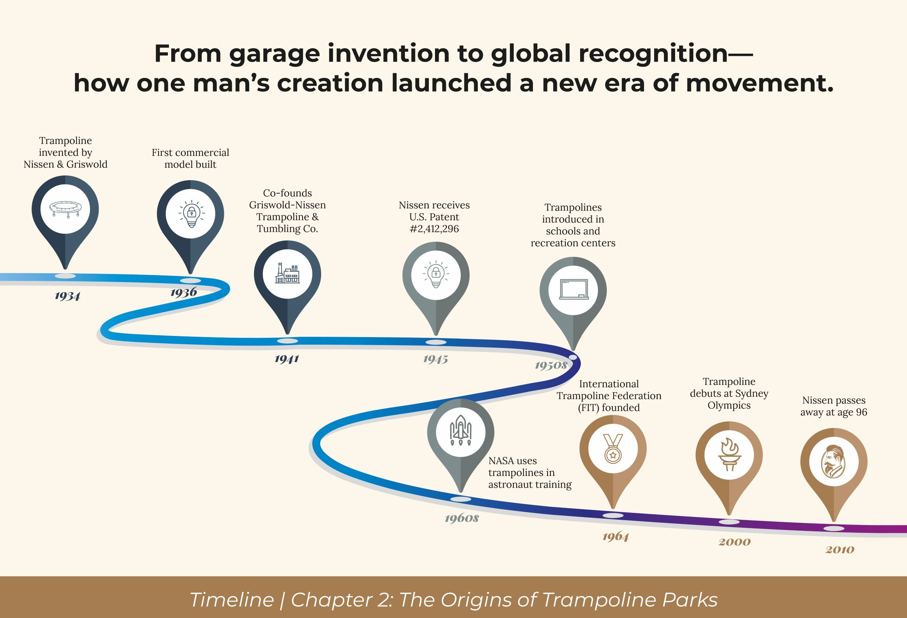
The blueprint: How one man’s obsession with movement sparked a global trampoline legacy.
[VISUAL STRATEGY — KEEP] Trampoline_Timeline.jpg stays as-is. Strong closing recap for the chapter.

