Chapter Four
Innovators and Game-Changers

Innovators and Game-Changers

The first generation of trampoline parks broke ground. But starting something and scaling something are two very different feats.

In the early years of the industry, there were no guarantees. Safety wasn’t standardized. Growth was happening faster than the foundation could catch up. The difference between opening a park and building an industry came down to a handful of people willing to push harder than required.

Before trampoline parks became a global industry, they were a series of calculated bets by people willing to stake something on an unproven idea. This chapter is about the people who were building the industry while everyone else was still figuring out if it was one.

They fall into two groups. The innovators came first, proving that trampoline parks were a worthwhile venture. The game-changers came next, finessing the industry with new standards and systems that solidified its legitimacy.

Innovators

Arch Adams: Fun Spot Manufacturing

Arch Adams welded steel and stretched mats. He started out building durable trampoline frames, safety pads, and beds — the components that would become the standard of trampoline parks everywhere.

In 1978, Arch opened Fun Spot Manufacturing out of a small shop in Hartwell, Georgia. Over the following decades, the company built its business supplying trampoline components, including backyard systems and replacement parts. When trampoline parks began to emerge in the mid-2000s, Fun Spot was already equipped with the manufacturing experience needed to support the new category, working with early operators such as Sky Zone.

When trampoline parks started transitioning into full-scale entertainment centers in the mid-2000s, Fun Spot Manufacturing was one of the first to shift from manufacturing individual parts to providing complete park systems. Arch worked directly with park owners to figure out what worked, walking layouts and pushing for stronger builds long before the industry was subject to formal regulations.

During a 2017 interview, Arch noted that Fun Spot had outfitted around 390 trampoline parks with equipment. Much of that growth extended beyond the United States, with international markets accounting for a significant portion of the company’s footprint.

Their international reach positioned Fun Spot as a foundational player in the early development of the trampoline park industry. Although the sports and leisure equipment company ABEO purchased Fun Spot Manufacturing, LLC in October 2018, Arch’s work lives on in the parks his products helped build. Since then, the company has continued to serve the industry, supplying equipment and parts to more than 525 trampoline parks, including over 275 full installations.
[VISUAL STRATEGY — ADD] No image is tracked or sourced for Arch Adams / Fun Spot Manufacturing. Optional: a portrait or a Fun Spot equipment photo would round out the Innovators section, which otherwise has strong candidates for the next two profiles below. Needs sourcing.

Rick Platt and Jeff Platt: Sky Zone
Before franchise models, supplier networks, or birthday party rotations, there was one man standing inside a Las Vegas warehouse, trying to figure out what to do next. Sky Zone founder Rick Platt wanted to build a training center: a place where professional athletes could use high-energy, low-impact vertical movement to train and condition. The concept made sense, but the sports market didn’t respond the way Rick had hoped. So in 2004, he opened the doors to anyone who wanted to jump.

Sky Zone Las Vegas is recognized as the first public indoor trampoline park. Rick eventually handed off the reins to his son Jeff Platt, who would take Sky Zone into franchising and national growth. Fresh out of college and just twenty-two years old, Jeff found himself leading a new business in a new industry. But instead of backing away from the unknown, he leaned in. Demand was growing but capital remained difficult to secure, so Jeff turned to franchising as a way to scale the concept beyond a single location. Early interest from prospective operators made it clear the model could expand quickly, with owner-operators driving that growth. But the franchise network was growing faster than the systems supporting it, leaving its roughly thirty-five locations operating without standardized systems or processes. Jeff decided it was time to bring in other experienced leaders, including Chief Operating Officer Glenn Lord, to implement the frameworks needed to create consistency across locations and support further scale. Rick Platt passed away in May 2026, but what he built in that Las Vegas warehouse outlasted anything he originally planned for it.

As competition intensified, the trampoline park industry began consolidating under private equity. In 2017, trampoline park developer CircusTrix secured funding from Palladium Equity Partners to acquire Rockin’ Jump, signaling the start of the company’s broader roll-up strategy. In February 2018, CircusTrix acquired Sky Zone, expanding to 287 locations globally before surpassing 300 parks — and nearly 16,000 employees — later that year. At the time, it was the biggest trampoline park operator in the world.

Jeff Platt described the shift as a move toward consolidation, noting that combining competing brands under shared ownership created an opportunity to leverage greater scale and compete more effectively in an increasingly aggressive market.

Jeff held a founding board seat on the International Association of Trampoline Parks (IATP) and served as its inaugural chair. In 2011, he was part of the group that formed the F24 Task Force Committee, which developed the first formal safety standard for trampoline parks, known as American Standards for Testing and Materials (ASTM) F2970-13. His work with F24 led to the founding of IATP in 2012, where he influenced how parks should operate and manage risk in an effort to build credibility with insurers and the public.
[VISUAL STRATEGY — ADD] Add “Jeff and Rick Platt.jpg” here (a joint portrait of father and son at a Sky Zone location). This file was sent in the Chapter 5 batch under “Unassigned Possible Photos,” but it belongs here: it visually tells the succession story the text is already telling (Rick founding the company, then handing the reins to Jeff). A solo Jeff Platt portrait was also sent and could serve as a backup, but the joint photo does more narrative work. Recommend moving both files from the Chapter 5 folder into this chapter's tracker.

Phillip Howell: Best American Trampolines

Phillip Howell left college in the early 2000s to join the family business. His father owned and operated Best American Manufacturing, which produced recreational trampolines and individual parts. After his father stepped away, Phillip expanded the brand in 2004 with a new initiative that sought to take advantage of the trampoline park trend: Best American Trampolines.

By 2007, he was bringing years of experience in residential trampoline manufacturing into the emerging indoor park industry, applying that expertise to the design and production of commercial trampoline systems and attractions. That same year, Best American Trampolines was designing one of the country’s first full-scale indoor parks: Xtreme Trampolines, located in Carol Stream, Illinois.

Phillip also joined IATP as an inaugural board member and contributed to the development of the industry’s first global safety standard. And in 2016, his work was recognized when Best American Trampolines was named Exhibitor of the Year at the IATP Annual Conference, an award given to vendors demonstrating innovation in product design, strong industry engagement, and consistent support of park operators.
[VISUAL STRATEGY — NOTE] The tracker lists an Xtreme Trampolines (2007) photo for this section, status “Requested,” but the file wasn't included in this batch. Nothing to place yet, flagging so it isn't mistaken for an oversight on this end.

Inside the industry, Phillip earned a reputation as a problem-solver. Erick Paulino, owner of Ground Control Parks and a client of Phillip on several park builds, said “He has a way of looking at a space and quickly understanding how all the pieces should come together, both from a guest experience and operational standpoint.”

Phillip was known for quickly translating that vision into fully realized, operational park designs. His team went on to design and install more than 275 parks worldwide, delivering solutions for everything from site planning and layout design to engineering and installation. Their work evolved from manufacturing trampoline systems to designing complete active entertainment environments featuring ninja courses, ropes courses, climbing attractions, aerial attractions, custom glow-in-the-dark attractions, and other innovative experiences tailored to each park.

In addition to working as a manufacturer and park developer, Phillip co-founded Active8 Software in 2016 with park operator Greg Spittle. Active8 was the first purpose-built point-of-sale system built specifically for trampoline parks, consolidating waivers, bookings, memberships, and point-of-sale transactions into a single cloud-based platform. The software was acquired by ROLLER in 2022.
[VISUAL STRATEGY — ADD] Add “Active8.jpg” here (a product screenshot showing the Active8 dashboard across devices). Also sent in the Chapter 5 unassigned batch but belongs to this section, it directly illustrates the software Phillip co-founded, mentioned in the sentence just above.

Phillip also co-founded Intelliplay, a facility management and gamification platform built specifically for trampoline parks and active entertainment venues, with Greg Spittle in 2019. The system integrates wristband-based guest management, including timed access control, attraction gating, and cashless payments, while also supporting customer engagement through interactive experiences and data-driven tracking of guest activity.

Across manufacturing, park development, safety standards, and technology, Phillip’s work spans multiple layers of the industry. From designing early park systems to contributing to safety standards and developing operational software, his involvement extends beyond any one role, influencing both how parks are built and how they operate. As the industry evolves, those combined contributions establish Phillip as a consistent presence across the technical and operational foundation of trampoline parks.

Tom Burnett: CenterEdge Software

In 2001, from his home base in Roxboro, North Carolina, Tom Burnett — owner of Palace Pointe, a 100,000-square-foot family entertainment center (FEC) — began building a completely integrated software platform designed specifically for the chaos of FECs.

Tom was inside a functioning entertainment center every day, testing, breaking, rebuilding, and pushing the system to match real-world demands. In response, he created the first real operating system for trampoline parks and FECs. Ticketing, food and beverage, scheduling, digital waivers, party bookings, staffing, reporting, loyalty programs — all of it lived inside CenterEdge’s Advantage Suite, designed to make operations streamlined and consistent.

As CenterEdge expanded beyond its initial use at Palace Pointe, it was adopted by a growing number of family entertainment centers and trampoline parks. Originally developed to address the operational challenges of a multi-attraction facility, the system evolved into a commercial platform supporting a wide range of entertainment venues. Its growth reflected increasing demand for solutions capable of managing the complexity of high-volume, multi-revenue operations.

For operators, the impact was immediate. One customer described the system as “the lifeblood of our business,” citing its accuracy and reliability as critical to daily operations, while another called it “one of the best business decisions” they had made.

Echoing that sentiment, Brandon Roben, chief executive officer of Oaks Park, noted that after implementation, his team was able to consolidate customer management, improve inventory tracking, and launch online ticketing — capabilities he said would not have been possible without the platform. These responses reflected how deeply the system had integrated with entertainment venues, supporting everything from transactions and bookings to guest experience and operational control.

CenterEdge allowed early franchises and independents alike to track revenue, manage throughput, and build operational models that could sustain expansion. Without it, many parks might have broken under the pressure of their own success. Tom’s work powered some of the biggest names in the business, including Sky Zone, Launch, and Altitude. Operators chose CenterEdge because it held up when the parks were slammed with birthday parties or high-volume Saturday afternoon crowds. Its reporting became the gold standard, winning “Best Ticketing and Access Control Product” at the 2018 Park World Excellence Awards.
[VISUAL STRATEGY — ADD] Add “CenterEdge Manager Console.png” here. Two CenterEdge screenshots were sent in the Chapter 5 unassigned batch (a Manager Console POS screen and a Passes/membership config screen). The Manager Console shot is the stronger single choice, it shows ticketing, food and beverage, and point-of-sale in one view, matching the range of functions the text describes. Recommend using one screenshot rather than both to avoid over-illustrating a single profile.

Paul McGeehan and Dave Schaeffer: House of Air

As co-founders of House of Air in 2010, Paul McGeehan and Dave Schaeffer were less interested in building a trampoline park than in creating an experience around one.

The idea came to them in 2003 while they were practicing snowboard tricks on a trampoline. Located inside the historic Presidio of San Francisco park, House of Air doesn’t resemble any of the parks that came before it, which were often just warehouses with trampolines bolted to the ground. Every element is intentional, from its bold branding to its wide-open hangar space. Paul and Dave designed House of Air as a cultural experience, one that doubles as a training ground for athletes and a playground for weekend warriors.

The park’s programming and experiences spoke to their vision. Rather than focusing solely on children’s recreation, House of Air introduced a mix of adult leagues, fitness classes, and skill-based training alongside open jump sessions. Co-founder Dave Schaeffer described the concept as intentionally inclusive, noting that it was “built … with everyone in mind,” with offerings that ranged from adult dodgeball leagues and conditioning classes to areas designed for learning tricks and action sports movement. Early visitors sometimes approached the House of Air concept with skepticism, expecting a kid-focused environment, but walked out having enjoyed things they hadn’t planned on doing when they walked in.

That positioning proved commercially viable. Early coverage from CBS News highlighted both the unconventional nature of the concept and its strong performance following launch. Schaeffer acknowledged that the scale and format of the business initially seemed risky, noting that some viewed the idea as “a little crazy,” yet the park saw steady demand even during a broader economic downturn. Its programming continued to reinforce a shift beyond youth-focused recreation, with themed adult events, fitness classes, and training-based offerings attracting a wider demographic and supporting a more diversified operating model.

Beyond the success of House of Air, the founders’ work extended into both the development of the park and the broader evolution of the industry. Dave served as secretary/treasurer on the founding IATP board and led the task group that revised ASTM safety practices for trampoline courts. His work has been recognized with an Award of Appreciation from ASTM International. House of Air’s San Francisco facility won a 2012 Architectural Lighting Design Award for its inventive use of lighting. Architect Mark Horton used floor-to-ceiling fluorescent strips set between translucent blue polycarbonate walls to illuminate the space. The fixtures were installed vertically to evoke the up-and-down motion of jumping.

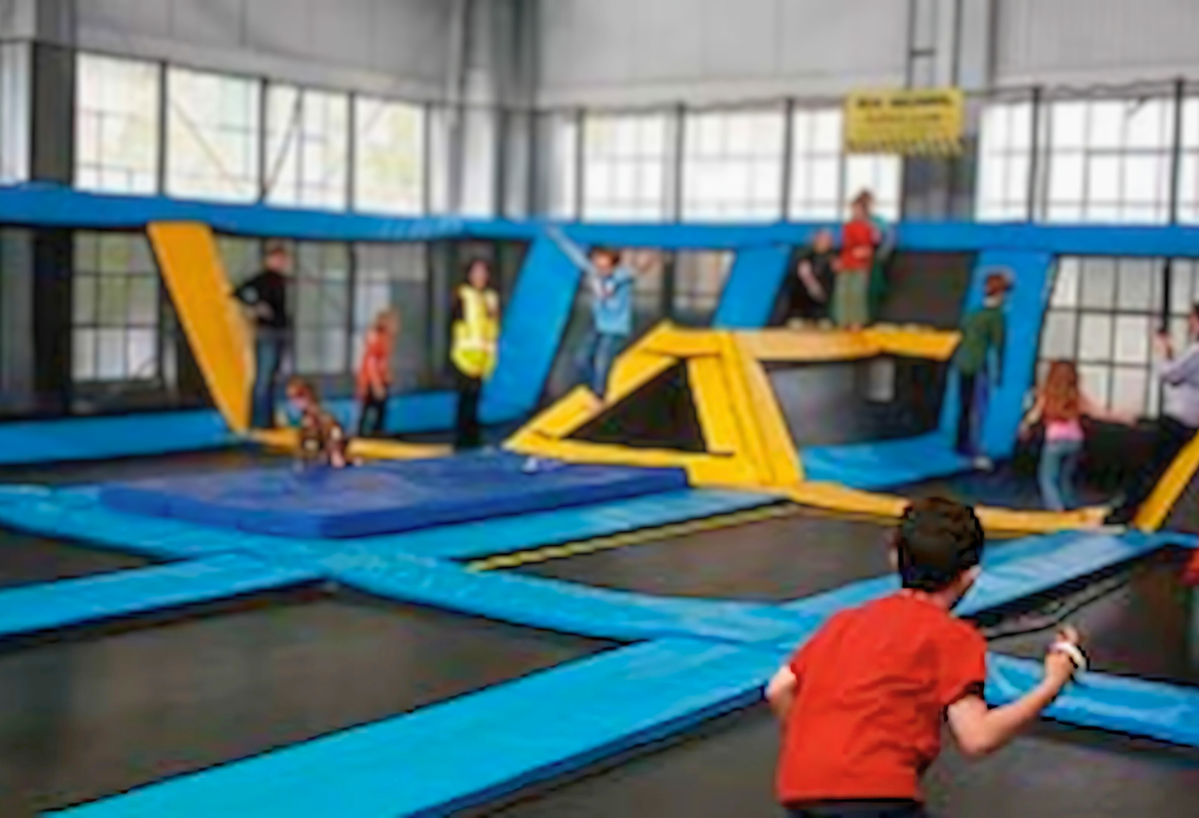
House of Air, San Francisco (2010): A slightly blurry photo, but a crystal-clear moment in trampoline park history.
[VISUAL STRATEGY — NOTE] The manuscript's own caption already flags this as “slightly blurry.” Worth trying to source a higher-resolution version if one exists anywhere, since this is likely to be one of the more visible images in the chapter. If this is the only surviving photo of the moment, it's still worth keeping, just flagging the quality tradeoff.
[VISUAL STRATEGY — KEEP] House of Air 2010.jpg stays as-is, correctly placed.

The first wave of innovators proved that trampoline parks could not only exist, but thrive. Still, the industry needed standards to keep it safe and strategies to keep it growing. That’s where the game-changers came in: they took what the innovators started and developed something stronger, propelling the business toward global legitimacy.

Game-Changers

Val Iverson: Get Air

In the early days of trampoline parks, Val Iverson was scaling the Get Air brand into one of the largest park networks in North America. At its peak, Get Air operated more than seventy parks across the United States, Canada, Western Europe, and Asia. Val’s background in trampoline manufacturing and early exposure to court-based concepts positioned him to recognize the commercial potential of trampoline parks early on. His first location in Roy, Utah, gained traction following a televised segment that introduced the concept to a wider audience and accelerated early demand.

Beyond growth, Val was actively involved in early safety development, contributing to ASTM efforts and designing innovations intended at reducing injury risk, including the waterfall pit.

“The goal was to try to keep people from getting hurt, bottom line,” he said. His safety-first approach guided both his design decisions and the way he shared those innovations with others in the industry, including how his parks handled high guest volumes while minimizing operational risk.
[VISUAL STRATEGY — ADD] No image tracked for Val Iverson / Get Air. Optional: a portrait, or a photo of the waterfall pit safety feature he's credited with designing, would anchor this profile. Needs sourcing.

Marc Gurley: Rebounderz

As the founder of Rebounderz, Marc Gurley saw the potential for trampoline parks to become multi-attraction entertainment centers, adding ninja courses, climbing walls, and arcades to the business model.

Under Mark’s early leadership, Rebounderz implemented this approach by expanding its attraction mix and developing larger-format parks designed to increase guest engagement and length of stay. In the years that followed, the company evolved into larger, multi-attraction family entertainment centers, with facilities reaching 40,000 to 100,000 square feet by 2018.

He holds patents for the trampoline arena design, which is a framework of outwardly sloping walls and interconnected trampolines, with padding assemblies overlying the trampoline peripheries and frame. The original patent was filed in 2011 and granted in 2014. He also filed a patent application for a foam pit assembly design in 2015.
[VISUAL STRATEGY — ADD] No image tracked for Marc Gurley / Rebounderz. Optional: a portrait, or a diagram of the patented trampoline arena frame described just above, similar to the patent illustrations used in Chapter 2. Needs sourcing.

Ed Reed: Adventure Park Contractors and JumpStreet

In 2008, Ed Reed founded Adventure Park Contractors, a firm focused on the design and construction of trampoline and adventure parks. He also served as vice president of construction for JumpStreet, where he played a direct role in building and scaling locations during the brand’s early expansion. Through this work, he oversaw the development of more than one hundred indoor parks across forty-plus states, applying standardized construction and operational frameworks that supported multi-site growth. His role bridged design, construction, and safety, allowing concepts developed at the operator level to be implemented consistently across multiple markets.

Ed played a key role in advancing safety practices within the trampoline park industry through his work with the IATP Certification Committee, helping establish clear, enforceable guidelines for operators. He contributed to the development of the IATP Service Technician Certification program and later served as chair of the association, supporting efforts to improve technical standards, operational consistency, and regulatory alignment across multiple states.
[VISUAL STRATEGY — ADD] No image tracked for Ed Reed / Adventure Park Contractors. Optional: a portrait. Needs sourcing.

Jerry Raymond: Sky High Sports

In 2006, Jerry Raymond and his brother Ron opened the first Sky High Sports location in Santa Clara, California, introducing a large-format indoor trampoline park built for high-volume use. Within months, demand exceeded capacity, with guests often waiting extended periods to enter. Early facilities spanned approximately 40,000 square feet and integrated multiple activity zones — including open jump courts, dodgeball arenas, foam pits, and basketball lanes — designed to keep guests moving continuously throughout the space. Jerry described the concept as “Fill a room with trampolines and hope for the best,” noting that its execution required careful planning to manage flow, safety, and throughput at scale.

Beyond layout, Jerry built a repeatable operating model centered on structured group experiences. Sky High hosted birthday parties, school outings, and corporate events, creating consistent demand beyond individual jump sessions. This approach helped establish trampoline parks as viable family entertainment venues rather than single-use attractions. By combining high-capacity design with programmed group revenue, Sky High expanded into multiple locations and demonstrated an early blueprint for scalable indoor active entertainment.
[VISUAL STRATEGY — ADD] No image tracked for Jerry Raymond / Sky High Sports, despite a direct quote in this section. Optional: a portrait, or an early Sky High Sports facility photo. Needs sourcing.

Scott Hornick: Adventure Solutions

As founder and CEO of Adventure Solutions, Scott Hornick brought a background in kinesiology and experience as a physical education teacher to the design of adventure environments. His approach emphasized adaptable, movement-based design, with modular obstacles that could be adjusted in height, spacing, and difficulty to accommodate a wide range of users, from children to competitive athletes. These environments were engineered to support continuous movement and higher guest throughput while maintaining safety and engagement through variation and progression.

In ninja-based facilities designed by Adventure Solutions, Scott addressed the challenge of supervising high-traffic environments by using modular, lane-based layouts and open sightlines. Obstacles were arranged in parallel or sequential configurations, allowing staff to monitor multiple participants simultaneously, while spacing and adjustable elements helped manage congestion and reduce user overlap. Rather than treating attractions as isolated features, ninja courses, climbing walls, and warped walls were integrated into coordinated layouts that balanced visibility, safety, and throughput.
[VISUAL STRATEGY — ADD] No image tracked for Scott Hornick / Adventure Solutions. Optional: a portrait, or a photo of one of his modular ninja-course layouts. Needs sourcing.

These early industry leaders established the models that defined the trampoline park industry’s initial growth. In 2011, fewer than forty trampoline parks were operating in the United States, but by 2014 that number had grown to more than 280, reflecting the rapid adoption of standardized layouts, programming, and multi-attraction formats developed during this period.

This early expansion was driven in part by the ability of these leaders to translate individual concepts into repeatable business models, laying the groundwork for the broader industry growth that would follow.

