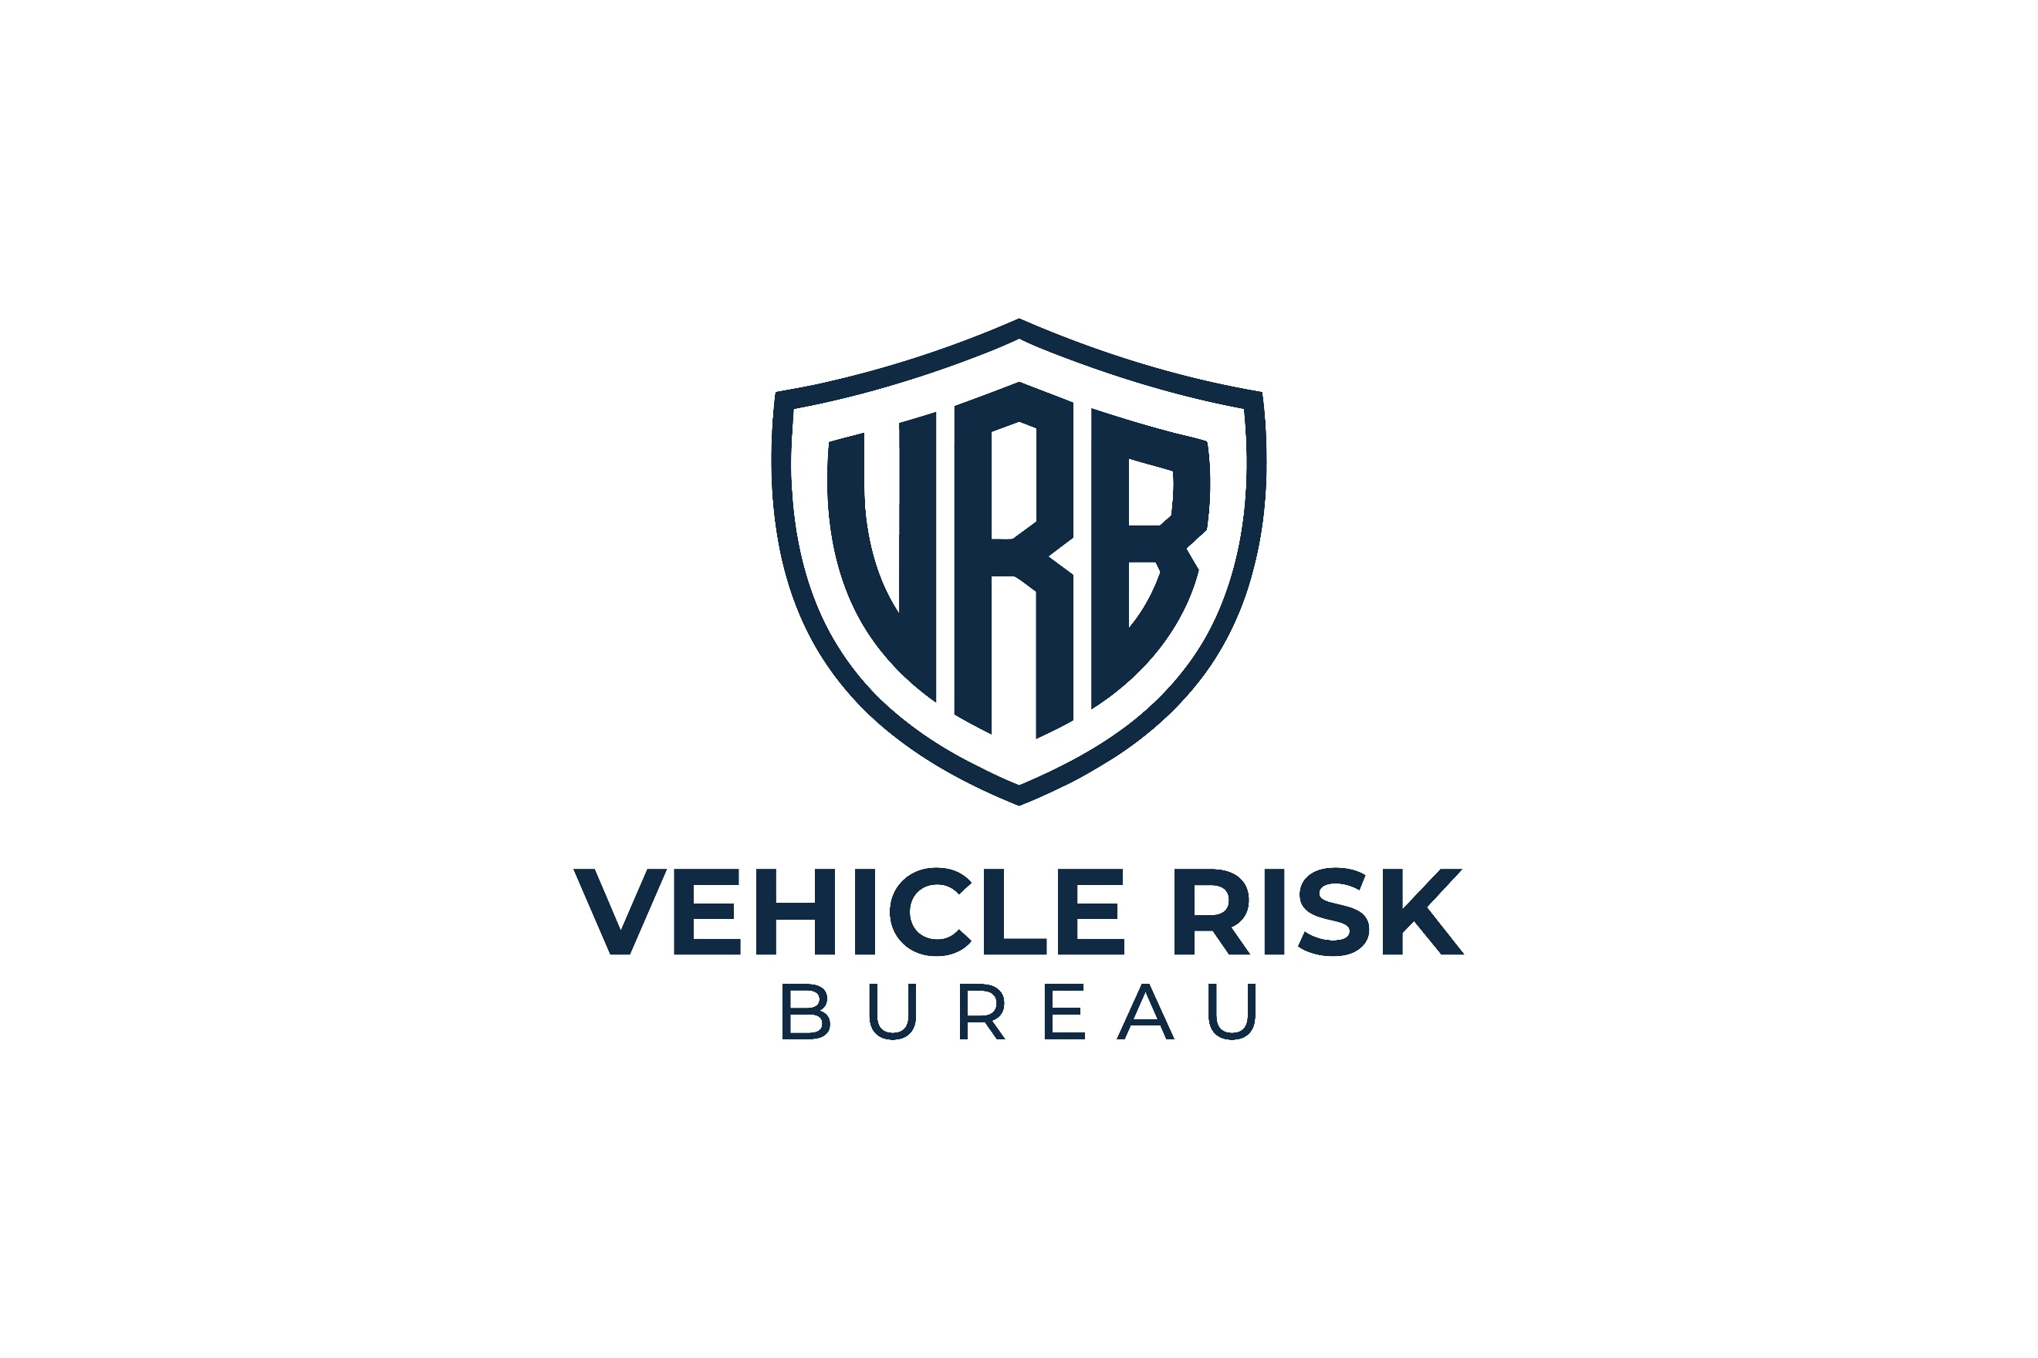
CONFIDENTIAL



VEHICLE THEFT RISK ASSESSMENT
Assessment Date: Assessment Date.

Vehicle Registration:
[Sample]



Vehicle Group:
Range Rover / Range Rover Sport / Defender
Report ID:
RR-02


Distribution:
Restricted
Assessment Type:
Vehicle Theft Risk Assessment

Assessment Outcome
RR02 — SEVERE EXPOSURE

What Caused This Result
The following factors most strongly influenced the current outcome. This combination matters because offenders often compare risk, hassle, and effort. A vehicle with partial protection may still be chosen if more robust signs of difficulty are absent:

- Some protective measures are present, but important controls remain missing or under-strength.
- Physical deterrence is present but not optimal, with weaker visible protection than a circular steering lock setup.
- Recovery capability is limited or incomplete, reducing resilience after theft.
- Storage conditions provide some benefit, but location is still being overvalued relative to vehicle-level protection.
- Owner behaviour or routine use of security measures is not strong enough to offset the vehicle's target appeal.
43/100

Vehicle
Security Score

This vehicle currently presents an elevated theft exposure profile. While some useful security measures are in place, the overall setup still has important weaknesses that make the vehicle more attractive than it should be relative to the threat profile of this vehicle group.

The current arrangement is stronger than a severely exposed setup, but it still relies too heavily on partial protection, weaker deterrents, or location-based reassurance. At present, the vehicle does not yet show the full level of visible
hassle, independent resistance, and recovery strength expected of a stronger layered setup.

This does not mean the vehicle is poorly protected in every respect. It means the current security measures are not yet strong enough, consistent enough, or well-prioritised enough to move the vehicle into a lower-exposure band.


Key Concerns
This vehicle sits in the middle ground where owners often feel reasonably protected, but the setup still lacks the controls that most strongly influence target selection. In practice, this can create a misleading sense of security. Of particular concern is the presence of measures that appear reassuring on paper but lack sufficient deterrent effect in real-world conditions.


Risk Breakdown
Storage and Parking Environment
Score:
9/15

The vehicle benefits from a reasonably controlled overnight parking arrangement, which reduces casual visibility and some opportunistic targeting. However, this advantage is being asked to do too much of the work.
Private driveways, garages, and gated entrances may help reduce exposure at the margins, but they should not be treated as strong substitutes for more meaningful theft resistance.
Assessment note: Storage helps the setup, but it does not compensate for missing or weaker vehicle-level controls.

Key Security
Score:
6/10
Key handling appears broadly reasonable, but not especially strong. There may be some effort to reduce household key exposure, but not enough to materially strengthen the overall position.
This remains relevant because high-value vehicles are still vulnerable to theft routes involving keys, household access, and convenience-led owner habits.
Assessment note: Key security is acceptable, but not yet a meaningful strength.

Immobilisation
Score:
9/25
Some added security may be present beyond factory systems, but not enough to count as a strong, independent theft barrier. This leaves the vehicle more exposed than it should be for its target category.
For this class of vehicle, independent immobilisation should be treated as a major control, not a secondary extra.
Without it, the security setup remains too easy to read and too dependent on systems that offenders already understand.
Assessment note: Immobilisation is currently one of the main reasons the vehicle remains in the elevated exposure band.


Physical Deterrents
Score:
8/20
A visible deterrent may be present, but it does not yet provide the strongest form of visual resistance. A regular steering lock, if used, should not be treated as carrying the same target-selection effect as a circular steering lock.
Visible deterrence matters most when it clearly signals hassle, delay, and extra effort. At present, that message is not strong enough.
Assessment note: This is a moderate area, but still below the standard expected for reduced exposure.

Tracking and Recovery
Score:
5/15
Some recovery capability may be present, but it is not strong enough to materially support rapid action after theft. A passive system, unclear tracker provision, or non-live setup does not offer the same value as live-location capability.
For high-risk vehicles, tracking should support active recovery rather than simply existing as a low-clarity add-on.
Assessment note: Tracking support is present at a basic level, but remains weaker than it should be.
What Matters Most
The following controls would make the greatest difference to this vehicle's current exposure:
1
Independent Immobilisation
This remains one of the clearest missing strengths in the current setup.
2
Circular Steering Lock
A stronger visible deterrent would materially improve target resistance.
3
Live-Location Tracker
A stronger tracking setup would improve resilience after theft and strengthen the overall rating.

Consistent Security Behaviour
4
A reasonable setup can still underperform if it is used inconsistently or selectively.
What Owners Often Overestimate
The following measures are commonly viewed as stronger than they really are. This matters because false confidence is one of the clearest features of a severe exposure setup:
- Regular steering locks
These do not carry the same deterrent effect as circular steering locks.
- Gated driveways
Gates may improve privacy, but they should not be treated as a strong theft barrier.
- Garage or driveway parking alone
These may reduce visibility, but they do not replace layered vehicle security.
- Home location bias
Being parked at home often creates complacency. This is one of the most common ways in which otherwise
reasonable security weakens.
Priority Actions
Essential | - Upgrade to a strong, independent immobilisation system.  - Replace weaker visible protection with a circular steering lock.  - Install a live-location tracker with genuine real-time capability.  - Ensure the vehicle is always locked and never left relying on home location alone.
Strongly Recommended | - Improve key handling and reduce predictable household storage.  - Install bollards where practical.  - Review whether existing security measures are being used consistently.  - Restrict passive keyless functionality where possible.
Good Practice | - Avoid assuming that partial security measures create strong resistance.  - Review how the vehicle is protected when parked at home, not just away from home.  - Reassess the setup if parking conditions or daily routine change.  - Remove convenience habits that weaken otherwise useful controls.

What Quietly Raises Theft Risk
The following habits and assumptions continue to raise exposure:
- Trusting your home location too much
- Using weaker deterrents as if they were stronger ones
- Accepting partial tracking or partial immobilisation as enough
- Inconsistent daily use of security measures
- Leaving the car unlocked at home because it feels protected
Final Assessment Note
This vehicle currently falls within the RR02 — Elevated Exposure band because the setup shows some useful protection, but still lacks the stronger controls needed to materially reduce target appeal and recovery weakness. Until those changes are made, the vehicle remains more exposed than it should be for this category.


Distribution Warning
This report contains configuration-specific risk analysis relating to a high-value vehicle. Circulation should be limited to the vehicle owner and relevant security or insurance professionals.

