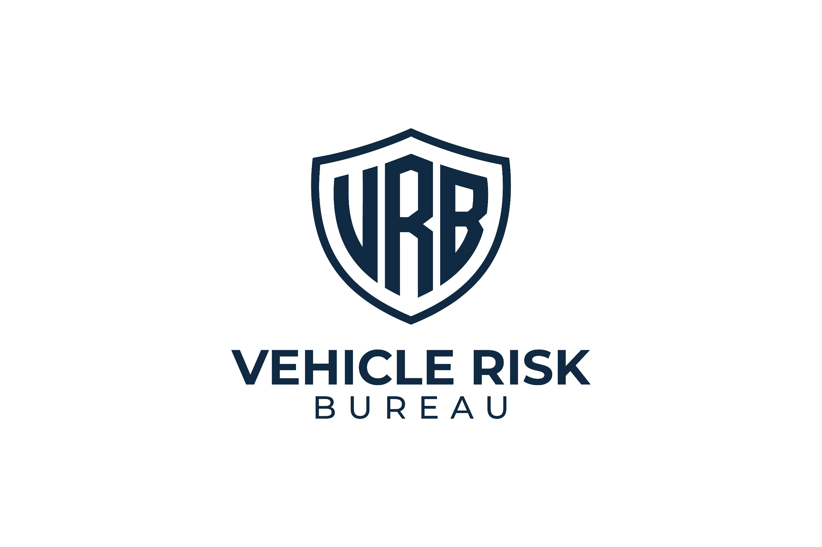
CONFIDENTIAL



VEHICLE THEFT RISK ASSESSMENT
Assessment Date: Assessment Date.

Vehicle Registration:
[Sample]



Vehicle Group:
Range Rover / Range Rover Sport / Defender
Report ID:
RR-02


Distribution:
Restricted
Assessment Type:
Vehicle Theft Risk Assessment

Assessment Outcome
RR03 — SEVERE EXPOSURE

What Caused This Result
The following factors most strongly influenced the current outcome. This combination matters because offenders are often balancing effort, risk, and speed. A vehicle that appears harder to remove, more likely to delay them, and more likely to be tracked becomes less appealing:

- Meaningful layered protection is in place.
- Visible deterrence is stronger than average and has real target-selection value.
- Independent security measures reduce reliance on factory systems alone.
- Recovery support is present, improving resilience after theft.
- Overall, owner discipline appears more consistent, reducing avoidable exposure.
67/100

Vehicle
Security Score

This vehicle currently presents a reduced theft exposure profile. The security setup contains meaningful protective measures that materially improve resistance when compared with a weaker or partially protected arrangement.
At present, the vehicle benefits from a more deliberate layered approach, including stronger deterrence, better control
over the difficulty of theft, and a more credible overall security posture. However, some weaknesses or inconsistencies remain, meaning the setup does not yet reach the strongest band.
This does not mean the vehicle is safe from theft. It remains part of a commonly targeted vehicle group. The current
setup makes the vehicle a less attractive option than a less well-protected alternative.


Key Concerns
Although the current setup is stronger than average, this vehicle group remains attractive to organised offenders. Reduced exposure is not the same as low relevance to thieves. The current band reflects a solid setup, but not the strongest possible one. The remaining gaps are likely to be found in consistency, the strength of individual controls, or in overreliance on protections that matter less than owners think.

\


Risk Breakdown
Storage and Parking Environment
Score:
11/15
The vehicle benefits from a controlled overnight parking environment that reduces casual visibility and helps lower opportunistic targeting. Storage conditions appear reasonably supportive of the wider protection setup.
That said, location remains a supporting factor rather than a primary control. It adds value when combined with stronger vehicle-level security, but should not be treated as the reason the vehicle sits in this band.
Assessment note: Storage is an asset here, but not the main driver of the rating.

Key Security
Score:
7/10
Key security appears sound overall, with a reasonable level of discipline and awareness. Some exposure may remain depending on routine, storage habits, or passive entry settings, but this area is not currently a major weakness.
Assessment note: Key handling supports the overall profile, although it is not among the strongest drivers of the rating.

Immobilisation
Score:
18/25
Independent immobilisation appears to be present and is clearly improving the setup. This is one of the major reasons the vehicle is not sitting in an elevated or severe exposure band. There may still be room for greater certainty around consistency, system strength, or daily use, but overall, this is a clear positive.
Assessment note: Immobilisation is one of the main strengths of the current setup.


Physical Deterrents
Score:
14/20
Visible deterrence is meaningful and appears to provide more than token resistance. This improves the target profile and increases the chance that the vehicle is viewed as more effort than nearby alternatives.
However, this area is not yet at maximum strength. The strongest deterrent effect comes from highly visible, clearly inconvenient barriers that immediately suggest hassle and delay.
Assessment note: A solid strength, though not yet at the highest level.

Tracking and Recovery
Score:
10/15
The tracking or recovery provision is present and provides real support to the current protection profile. This improves resilience after theft and contributes positively to the overall banding.
The setup would be stronger if recovery capability were more clearly immediate, live, and central to the overall strategy.
Assessment note: Useful and meaningful, but not yet top-tier.

What Matters Most
The following controls are doing the most to keep this vehicle out of a higher-exposure band:
1
Independent Immobilisation
This is one of the clearest strengths in the current setup.
2
Circular Steering Lock
This helps alter target selection and adds visible hassle.
3
Live-Location Tracker
This improves resilience after theft and supports the wider setup.
4
Consistent Security Behaviour
The vehicle appears to benefit from more disciplined day-to-day use of security controls.

What Owners Often Overestimate
The following measures are commonly viewed as stronger than they really are. This matters because false confidence is one of the clearest features of a severe exposure setup:
- Regular steering locks
These do not carry the same deterrent effect as circular steering locks.
- Gated driveways
Gates may improve privacy, but they should not be treated as a strong theft barrier.
- Garage or driveway parking alone
These may reduce visibility, but they do not replace layered vehicle security.
- Home location bias
Being parked at home often creates complacency. This is one of the most common ways in which otherwise
reasonable security weakens.
Priority Actions
Essential | - Maintain independent immobilisation as a permanent part of the setup.  - Maintain strong visible deterrence and avoid downgrading to weaker physical controls.  - Keep tracking capability fully active and review whether live-location strength is sufficient.  - Keep the vehicle locked and fully secured at all times, including at home.
Strongly Recommended | - Upgrade any remaining weaker deterrents to a circular steering lock if not already in place.  - Install bollards where practical.  - Tighten any remaining gaps in key discipline.  - Review whether current tracking support is genuinely live and response-oriented.
Good Practice | - Avoid treating the current rating as a permanent state.  - Reassess the setup after changes to routine, parking, or vehicle use.  - Keep all measures consistent rather than selective.  - Avoid complacency created by home storage or familiarity.

What Quietly Raises Theft Risk
The following habits and assumptions continue to raise exposure:
- Using good measures only some of the time
- Assuming the current setup is strong enough in all settings
- Relaxing at-home security habits
- Overvaluing garage, driveway, or gate arrangements
- Accepting second-best deterrents where stronger options exist
Final Assessment Note
This vehicle currently falls within the RR03 — Reduced Exposure band because the setup contains meaningful protection and a credible layered structure, but still leaves room for improvement before it can be considered one of the stronger lower-exposure arrangements. Overall, the setup is solid, but not yet at its strongest possible level.


Distribution Warning
This report contains configuration-specific risk analysis relating to a high-value vehicle. Circulation should be limited to the vehicle owner and relevant security or insurance professionals.

