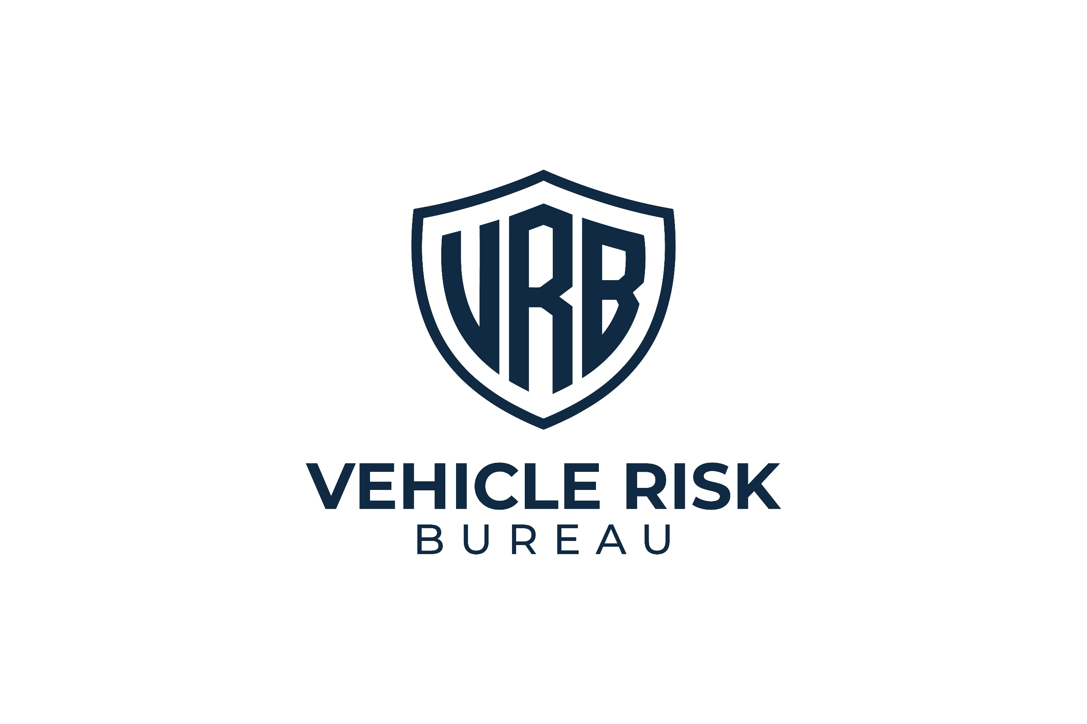
CONFIDENTIAL



VEHICLE THEFT RISK ASSESSMENT
Assessment Date: Assessment Date.

Vehicle Registration:
[Sample]



Vehicle Group:
Range Rover / Range Rover Sport / Defender
Report ID:
RR-02


Distribution:
Restricted
Assessment Type:
Vehicle Theft Risk Assessment

Assessment Outcome
RR04 — SEVERE EXPOSURE

What Caused This Result
The following factors most strongly influenced the current outcome. This combination matters because offenders often choose the easier option. A vehicle that appears difficult, time-consuming, and uncertain becomes less attractive even when it remains valuable:

- Strong independent immobilisation materially reduces reliance on factory systems.
- Circular steering lock provides a visible sign of hassle and changes target selection.
- A live-location tracker strengthens recovery capability after a theft is reported.
- Controlled overnight storage supports the wider setup without being relied on too heavily.
- Consistent owner behaviour helps preserve the strength of the overall protection profile.
- Additional physical barriers, such as bollards, where present, materially increase removal difficulty.
86/100

Vehicle
Security Score

This vehicle currently presents a lower theft exposure profile relative to the known threat profile for this vehicle group. The present setup includes robust layered security measures that materially increase the effort, uncertainty, and delay for a thief, while also improving post-theft recovery prospects.
At present, the vehicle shows many of the features most likely to reduce target appeal: independent immobilisation, strong, visible deterrence, credible recovery support, and a more disciplined day-to-day security posture. This does not remove the vehicle from consideration entirely, but it does make it more difficult and less attractive than
alternatives with weaker protection. This is a strong result for a commonly targeted vehicle category.


Key Concerns
This vehicle group remains desirable to organised thieves, and no setup should be treated as theft-proof. Lower exposure does not mean immunity. The key challenge at this level is maintaining consistency. Strong setups are usually weakened not by a single dramatic failure, but by convenience-led shortcuts, weaker substitutions, or the gradual relaxation of routine.


Risk Breakdown
Storage and Parking Environment
Score:
13/15
The vehicle benefits from a strong overnight parking environment that complements the wider security setup. Storage conditions reduce visibility and help support target rejection without being treated as a substitute for stronger controls.
Assessment note: This is a clear strength, though still secondary to the vehicle-level controls.

Key Security
Score:
9/10
Key handling appears strong and disciplined. Household key exposure is being managed sensibly, and there is no obvious sign that convenience habits are creating unnecessary weakness.
Assessment note: A supportive strength that helps preserve the overall rating.

Immobilisation
Score:
23/25
Independent immobilisation is one of the strongest parts of the current setup. This materially improves theft resistance and is one of the clearest reasons the vehicle sits in the lower exposure band.
Assessment note: A major strength and a core protective control.


Physical Deterrents
Score:
18/20
Visible deterrence is strong. A circular steering lock provides one of the clearest possible signs that the vehicle will involve more hassle than average, and any supporting physical barriers further improve this. Based on offender insight, this area matters because it directly affects target selection.
Assessment note: One of the strongest features of the current setup.

Tracking and Recovery
Score:
14/15
Live-location tracking is in place and materially improves post-theft recovery prospects. This adds resilience to the wider setup and supports a more complete protection profile.
Assessment note: Strong and appropriate for a vehicle in this category.

What Matters Most
The following controls would make the greatest difference to this vehicle's current exposure:
1
Independent Immobilisation
A major theft barrier and one of the strongest controls in the report.
2
Circular Steering Lock
A highly visible signal of hassle and one of the clearest reasons a thief may move on.
3
Live-Location Tracker
A strong recovery tool and an important supporting control.
Consistent Security Behaviour
4
Strong hardware is being reinforced by good routine rather than undermined by complacency.
5
Bollards Where Applicable
Where present, these materially improve removal difficulty.

What Owners Often Overestimate
The following measures are commonly viewed as stronger than they really are. This matters because false confidence is one of the clearest features of a severe exposure setup:
- Regular steering locks
These do not carry the same deterrent effect as circular steering locks.
- Gated driveways
Gates may improve privacy, but they should not be treated as a strong theft barrier.
- Garage or driveway parking alone
These may reduce visibility, but they do not replace layered vehicle security.
- Home location bias
Being parked at home often creates complacency. This is one of the most common ways in which otherwise
reasonable security weakens.
Priority Actions
Essential | - Maintain independent immobilisation as a non-negotiable control.  - Continue consistent use of the circular steering lock.  - Keep the live-location tracker fully active and maintained.  - Keep the vehicle locked and fully secured at all times.
Strongly Recommended | - Maintain strong key discipline and avoid routine drift.  - Keep any bollards or physical barriers in active use where fitted.  - Periodically review whether the current setup still reflects current theft patterns.  - Avoid replacing stronger controls with more convenient but weaker alternatives.
Good Practice | - Reassess the setup after any change in parking, household routine, or vehicle use.  - Avoid assuming that the current band means the vehicle no longer requires discipline.  - Review recovery arrangements regularly.  - Keep layered protection visible and consistent.

What Quietly Raises Theft Risk
The main risk at this level is not total absence of protection. It is gradual slippage. Examples include:
- Using stronger controls less consistently
- Becoming relaxed because the vehicle is parked at home
- Downgrading to weaker deterrents
- Allowing convenience to replace routine
- Treating a good setup as permanent without review
Final Assessment Note
This vehicle currently falls within the RR04 — Lower Exposure band because it demonstrates strong layered
protection, credible visible deterrence, meaningful theft resistance, and supportive owner behaviour relative to the threat profile of this vehicle group. This is a strong result, but it should be preserved rather than assumed. The most important task at this level is maintaining the quality and consistency of the setup over time. Taken together, these materially reduce theft appeal compared with alternatives with weaker protection


Distribution Warning
This report contains configuration-specific risk analysis relating to a high-value vehicle. Circulation should be limited to the vehicle owner and relevant security or insurance professionals.

