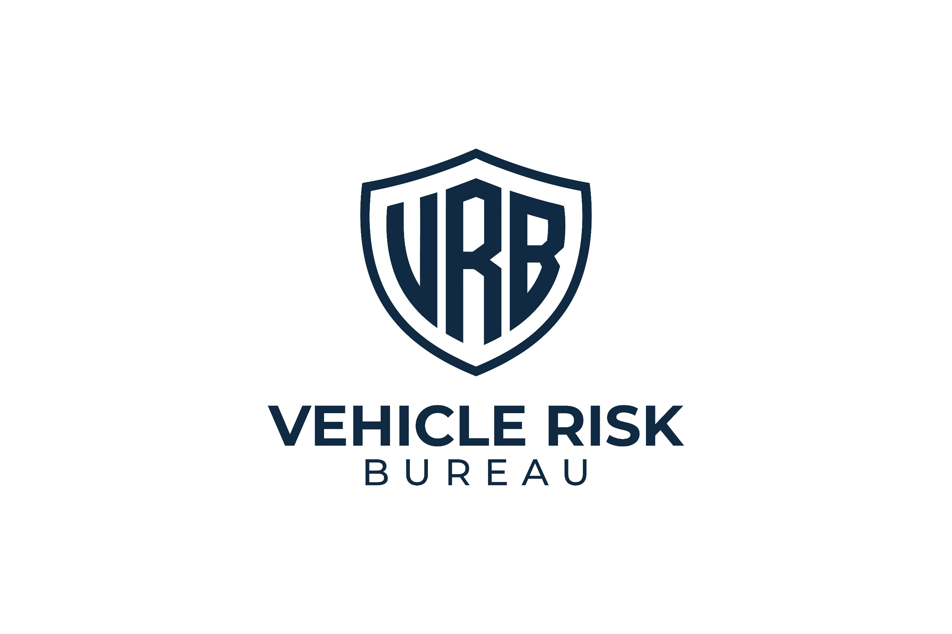
CONFIDENTIAL



VEHICLE THEFT RISK ASSESSMENT
Assessment Date: Assessment Date.

Vehicle Registration:
[Sample]



Vehicle Group:
Range Rover / Range Rover Sport / Defender
Report ID:
RR-01


Distribution:
Restricted
Assessment Type:
Vehicle Theft Risk Assessment

Assessment Outcome
RR01 — SEVERE EXPOSURE

What Caused This Result

This combination matters because offenders often choose the easier vehicle, not simply the most expensive one. Where a target appears straightforward to access, remove, and move without visible hassle, its appeal increases sharply.

The following factors most strongly influenced the current outcome:

- No independent immobilisation
- No circular steering lock
- No live-location tracking
- Storage location is being overvalued
- Owner security habits reduce protection
22/100

Vehicle
Security Score

This vehicle currently presents a severe theft exposure profile. Its present security setup does not provide enough meaningful resistance, visible deterrence, or recovery capability relative to the threat profile associated with this vehicle group.
At present, the vehicle appears more vulnerable than it should be. The absence of stronger independent protection, limited visible signs of real difficulty, weak reliance on location-based security, and owner habits that reduce
day-to-day protection all materially increase exposure.
This does not mean theft is inevitable. It means the current setup leaves the vehicle far more attractive than it needs to be when compared with a correctly layered security arrangement.


Key Concerns
This vehicle group remains attractive to organised thieves due to resale demand, known attack routes, and continued targeting. In its current form, this setup is not doing enough to create the delay, uncertainty, and visible hassle that can influence target selection. Of particular concern is the false sense of security created by private parking, gated access, or garage storage. These conditions may reduce visibility, but they do not replace proper vehicle-level protection.


Risk Breakdown
Storage and Parking Environment
Score:
6/15
The vehicle benefits from some form of private or semi-controlled overnight parking, but too much confidence is being placed in the location alone. A driveway, garage, or gated entrance may reduce casual visibility, but it does not, on its own, create strong theft resistance.
Owners often overrate gated driveways. They can be overridden and should not be treated as a meaningful primary barrier.
Assessment note: Storage slightly improves the vehicle’s security presentation, but not enough to offset the wider weaknesses in the setup.

Key Security
Score:
4/10
Current key security appears only moderate. While there may be some awareness of key-related risks, the setup does not demonstrate strong, disciplined handling that materially reduces exposure.
This is particularly relevant where owners rely on home location for reassurance. When a vehicle is parked at home, there is often a tendency to relax key discipline or assume theft is less likely. That can quietly undermine otherwise reasonable precautions.
Assessment note: Key security is not catastrophic here, but it is not strong enough to meaningfully improve the overall rating.

Immobilisation
Score:
3/25
This is one of the weakest areas in the current setup. There is no strong evidence of an independent immobilisation system that materially increases resistance beyond factory security alone.
For this vehicle type, that is a major weakness. Independent immobilisation should be treated as one of the most important controls available. Without it, the setup remains too dependent on protections that offenders already understand and expect.
Assessment note: Factory security alone is not enough for a vehicle in this target category.


Physical Deterrents
Score:
5/20
The current use of physical deterrents is weaker than recommended for this vehicle type. A regular steering lock, if present, should not be treated as equivalent to a circular steering lock.
Circular steering locks are among the clearest signs that a vehicle will involve more hassle. Regular steering locks do not carry the same weight and are often overvalued by owners. Where no meaningful, visible deterrent is present, the vehicle shows fewer signs of resistance.
Assessment note: This is a major missed opportunity, because visible hassle strongly affects target appeal.

Tracking and Recovery
Score:
2/15
This is another major weakness. No live location tracker is present, or the current recovery capability is too weak to support rapid response after theft.
For high-risk vehicle types, live tracking should be treated as a core supporting control rather than a luxury add-on. While it does not usually stop the initial theft attempt, it materially strengthens post-theft recovery potential.
Assessment note: Recovery capability is currently too weak for a vehicle in this threat category.
What Matters Most
The following controls would make the greatest difference to this vehicle's current exposure:
1
Independent Immobilisation
This is the single most important weakness in the current setup. Without it, the vehicle remains overly reliant on factory systems.
2
Circular Steering Lock
This would add one of the clearest visible signs of hassle and materially improve deterrence.
3
Live-Location Tracker
This would strengthen recovery capability and improve the overall resilience of the setup after theft is reported.
4
Consistent Security Behaviour
Even a better hardware setup can be undermined by relaxed day-to-day habits. Security controls must be used consistently, not selectively.
What Owners Often Overestimate
The following measures are commonly viewed as stronger than they really are. This matters because false confidence is one of the clearest features of a severe exposure setup:
- Regular steering locks
These do not carry the same deterrent effect as circular steering locks.
- Gated driveways
Gates may improve privacy, but they should not be treated as a strong theft barrier.
- Garage or driveway parking alone
These may reduce visibility, but they do not replace layered vehicle security.
- Home location bias
Being parked at home often creates complacency. This is one of the most common ways in which otherwise reasonable security weakens.
Priority Actions
Essential | - Install a strong, independent immobilisation system and treat it as a permanent control.  - Use a circular steering lock consistently.  - Install a live location tracker with clear real-time recovery capability.  - Ensure the vehicle is always locked, including when parked on a drive or inside a garage.
Strongly Recommended | - Install bollards where the parking layout allows.  - Improve key discipline and avoid predictable household storage.  - Restrict passive keyless functionality where possible.  - Stop relying on gates, private drives, or garages as substitutes for proper vehicle-level security.
Good Practice | - Review the full security setup whenever the vehicle's storage location or routine changes.  - Do not assume a regular steering lock offers sufficient visible deterrence.  - Use every security layer consistently, not just when parking away from home.  - Avoid any convenience habit that lowers the real-world effect of stronger controls.

What Quietly Raises Theft Risk
A severe exposure profile is often created not only by missing hardware, but also by owner behaviour. The following habits materially increase exposure. These are important because they turn a weak setup into an easier target:
- Leaving the vehicle unlocked because it is on a private drive
- Leaving the vehicle unlocked because it is inside a garage
- Assuming gates provide meaningful theft protection
- Treating a regular steering lock as equivalent to a circular steering lock
- Relying on location rather than layered security
Final Assessment Note
This assessment is not a guarantee that the vehicle will be stolen. It is a structured judgement of current theft exposure based on vehicle type, deterrence, immobilisation, recovery capability, storage conditions, and owner behaviour.
At present, this vehicle falls within the RR01 — Severe Exposure band because the current setup does not create enough meaningful difficulty relative to the known threat profile for this class of vehicle. In its current state, it remains more attractive to an offender than it should be when compared to other targets.


Distribution Warning
This report contains configuration-specific risk analysis relating to a high-value vehicle. Circulation should be limited to the vehicle owner and relevant security or insurance professionals.

