Junhao Zhang “Freddie”

USC ID:

CSCI 567 – HW5

11/23/2021

**[Problem 1]**

**(*1.1.1*)**

For any given *n*, we have:

We take derivative w.r.t , and set to 0:

Since, thus , so:

**(*1.1.2*)**

We plug back to the original function:

which is equal to:

Since, thus , so the Lagrangian of this problem is:

Take derivative of the Lagrangian w.r.t and set to (zero vector):

For the same reason in the lecture, we had proven that *v* is the first principal component of the dataset.

**(*1.2.1*)**

Reconstructed dataset:

And the analogue of (1) is:

**(*1.2.2*)**

For any given *n*, we have:

We take derivative w.r.t , and set to :

**(*1.2.3*)**

We plug back to the original function:

which is equal to:

Since for any given , . Thus, , so for any given *n*, the Lagrangian is:

Take partial derivative of the Lagrangian w.r.t each given and set to :

We can see that , which means . Therefore, for each given *n*, the eigenvalue is always . We can find all eigenvalues this way, and use these eigenvalues to find top *p* eigenvectors with unit norm, and these eigenvectors are what really are and they compose *V*.

**[Problem 2]**

**(*2.1*)**

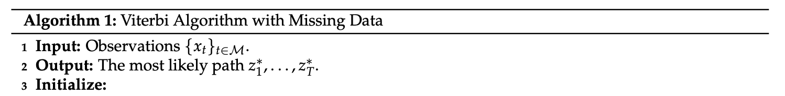

𝛿[state][t], initially 𝛿[*s*][1] = for all *s* ∈ [*S*]



𝛿[*s*][*t*] = # for all *s’*∈ [*S*]



, then for *t* = *T* – 1, …, 1 # for all *s’*∈ [*S*]

**(*2.2*)**

And then, we normalize:

**(*2.3*)**