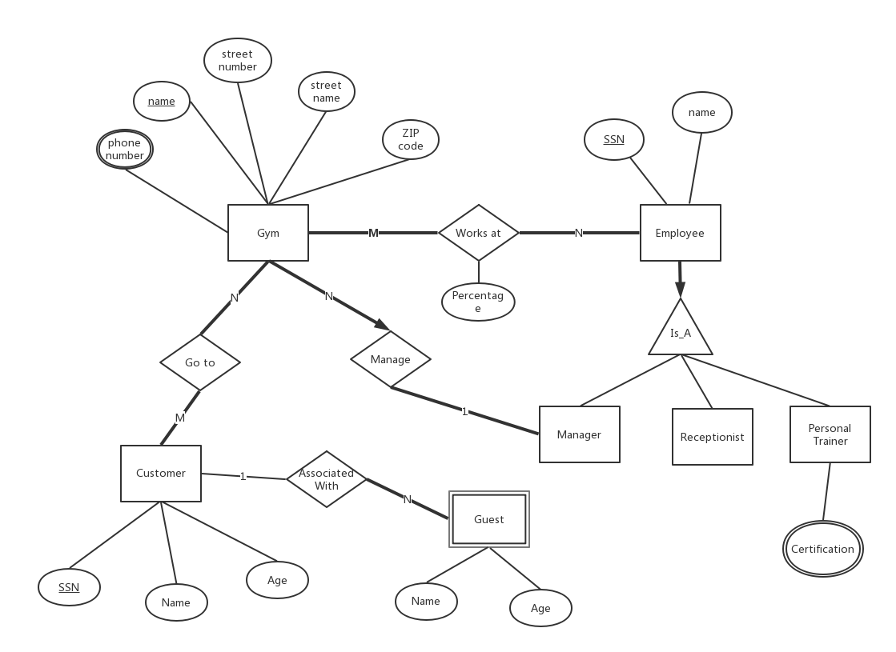Homework1_1:

**CREATE TABLE** Customer  
(  
 SSN **VARCHAR**(20) **NOT NULL  
 PRIMARY KEY**,  
 customerName **VARCHAR**(20) **NULL**,  
 customAge **INT NULL**)  
 **ENGINE** = InnoDB;  
  
**CREATE TABLE** Employee  
(  
 SSN **VARCHAR**(20) **NOT NULL  
 PRIMARY KEY**,  
 employeeName **VARCHAR**(20) **NULL**)  
 **ENGINE** = InnoDB;  
  
**CREATE TABLE** Goes_to  
(  
 gymName **VARCHAR**(20) **NOT NULL**,  
 customerSSN **VARCHAR**(20) **NOT NULL**,  
 **PRIMARY KEY** (gymName, customerSSN),  
 **CONSTRAINT** Goes_to_Gym_gymName_fk  
 **FOREIGN KEY** (gymName) **REFERENCES** homework1_1.Gym (gymName),  
 **CONSTRAINT** Goes_to_Customer_SSN_fk  
 **FOREIGN KEY** (customerSSN) **REFERENCES** homework1_1.Customer (SSN)  
)  
 **ENGINE** = InnoDB;  
  
**CREATE INDEX** Goes_to_Customer_SSN_fk  
 **ON** Goes_to (customerSSN);  
  
**CREATE TABLE** Guest  
(  
 guestName **VARCHAR**(20) **NOT NULL**,  
 guestAge **INT NOT NULL**,  
 customerSSN **VARCHAR**(20) **NOT NULL**,  
 **PRIMARY KEY** (guestName, guestAge),  
 **CONSTRAINT** Guest_Customer_SSN_fk  
 **FOREIGN KEY** (customerSSN) **REFERENCES** homework1_1.Customer (SSN)  
)  
 **ENGINE** = InnoDB;  
  
**CREATE INDEX** Guest_Customer_SSN_fk  
 **ON** Guest (customerSSN);  
  
**CREATE TABLE** Gym  
(  
 gymName **VARCHAR**(20) **DEFAULT '' NOT NULL  
 PRIMARY KEY**,  
 strNo **INT NULL**,  
 strName **VARCHAR**(20) **NULL**,  
 zip **INT NULL**)  
 **ENGINE** = InnoDB;  
  
**CREATE TABLE** Manager  
(  
 employeeSSN **VARCHAR**(20) **DEFAULT '' NOT NULL**,  
 gymName **VARCHAR**(20) **DEFAULT '' NOT NULL**,  
 **PRIMARY KEY** (employeeSSN, gymName),  
 **CONSTRAINT** Manager_Employee_SSN_fk  
 **FOREIGN KEY** (employeeSSN) **REFERENCES** homework1_1.Employee (SSN),  
 **CONSTRAINT** Manager_Gym_gymName_fk  
 **FOREIGN KEY** (gymName) **REFERENCES** homework1_1.Gym (gymName)  
)  
 **ENGINE** = InnoDB;  
  
**CREATE INDEX** Manager_Gym_gymName_fk  
 **ON** Manager (gymName);  
  
**CREATE TABLE** PersonalTrainer  
(  
 employeeSSN **VARCHAR**(20) **DEFAULT '' NOT NULL**,  
 certification **VARCHAR**(20) **DEFAULT ' ' NOT NULL**,  
 **PRIMARY KEY** (employeeSSN, certification),  
 **CONSTRAINT** PersonalTrainer_Employee_SSN_fk  
 **FOREIGN KEY** (employeeSSN) **REFERENCES** homework1_1.Employee (SSN)  
)  
 **ENGINE** = InnoDB;  
  
**CREATE TABLE** Receptionist  
(  
 employeeSSN **VARCHAR**(20) **NOT NULL  
 PRIMARY KEY**,  
 **CONSTRAINT** Receptionist_Employee_SSN_fk  
 **FOREIGN KEY** (employeeSSN) **REFERENCES** homework1_1.Employee (SSN)  
)  
 **ENGINE** = InnoDB;  
  
**CREATE TABLE** Works_at  
(  
 gymName **VARCHAR**(20) **NULL**,  
 employeeSSN **VARCHAR**(20) **NULL**,  
 percentage **FLOAT NULL**,  
 **CONSTRAINT** Works_at_Gym_gymName_fk  
 **FOREIGN KEY** (gymName) **REFERENCES** homework1_1.Gym (gymName),  
 **CONSTRAINT** Works_at_Employee_SSN_fk  
 **FOREIGN KEY** (employeeSSN) **REFERENCES** homework1_1.Employee (SSN)  
)  
 **ENGINE** = InnoDB;  
  
**CREATE INDEX** Works_at_Gym_gymName_fk  
 **ON** Works_at (gymName);  
  
**CREATE INDEX** Works_at_Employee_SSN_fk  
 **ON** Works_at (employeeSSN);  
  
**CREATE TABLE** phoneNumber  
(  
 phoneNumber **VARCHAR**(20) **DEFAULT '' NOT NULL**,  
 gymName **VARCHAR**(20) **DEFAULT '' NOT NULL**,  
 **PRIMARY KEY** (phoneNumber, gymName),  
 **CONSTRAINT** phoneNumber_Gym_gymName_fk  
 **FOREIGN KEY** (gymName) **REFERENCES** homework1_1.Gym (gymName)  
)  
 **ENGINE** = InnoDB;  
  
**CREATE INDEX** phoneNumber_Gym_gymName_fk  
 **ON** phoneNumber (gymName);

Homework1_2

1. **SELECT sname   
   FROM** Suppliers   
   **WHERE** *EXISTS*(  
    **SELECT** Catalog.**sid from** Catalog **WHERE** Catalog.**sid**=Suppliers.**sid**);
2. **SELECT DISTINCT sid  
   FROM** Catalog C1  
   **WHERE** C1.**cost**>(  
    **SELECT** *AVG*(C2.**cost**)  
    **FROM** Catalog C2  
    **WHERE** C1.**pid**=C2.**pid**);
3. **SELECT** P.**pid**,S.**sname  
   FROM** Suppliers S, Parts P,Catalog C  
   **WHERE** C.**sid**=S.**sid  
   AND** C.**pid**=P.**pid  
   AND** C.**cost**=(**SELECT** *MAX*(C1.**cost**)  
    **FROM** Catalog C1  
    **WHERE** C1.**pid**=C.**pid**)
4. **SELECT DISTINCT** C.**sid  
   FROM** Catalog C  
   **WHERE NOT** *EXISTS*(  
    **SELECT** *\** **FROM** Parts P  
    **WHERE** P.**pid**=C.**pid  
    AND** P.**color**<>**'red'**)
5. **SELECT DISTINCT** C.**sid  
   FROM** Catalog C  
   **WHERE** *EXISTS*(  
    **SELECT** *\** **FROM** Parts P  
    **WHERE** P.**pid**=C.**pid  
    AND** P.**color**=**'red'**)  
   **UNION  
   SELECT DISTINCT** C.**sid  
   FROM** Catalog C  
   **WHERE** *EXISTS*(  
    **SELECT** *\** **FROM** Parts P  
    **WHERE** P.**pid**=C.**pid  
    AND** P.**color**=**'green'**)

Solution 2:

**SELECT DISTINCT** C.**sid  
From** Catalog C,Parts P  
**WHERE** C.**pid**=P.**pid  
AND** P.**color**=**'red'  
UNION  
SELECT DISTINCT** C.sid  
**FROM** Catalog C1, Parts P1  
**WHERE** C1.**pid**=P1.**pid  
AND** P1.**color**=**'green'**

1. **SELECT** P.**pname** ,*MAX*(C.**cost**) **AS** MAXCost  
   **FROM** Suppliers S,Catalog C,Parts P  
   **WHERE** P.**pid**=C.**pid  
   AND** C.**sid**=S.**sid  
   AND** P.**color IN** (**'red'**,**'green'**);

Homework1_3

1. **SELECT** M.**MovieName  
   FROM** MovieSupplier MS, Movies M,Suppliers S  
   **WHERE** M.**MovieID**=MS.**MovieID  
   AND** S.**SupplierID**=MS.**SupplierID  
   AND** S.**SupplierName IN**(**'Ben**''**s Video'**,**'Video Clubhouse'**);
2. **SELECT** M.**MovieName  
   FROM** Movies M,Rentals R,Inventory I  
   **WHERE** I.**TapelID**=R.**TapelID  
   AND** I.**MovieID**=M.**MovieID  
   AND** R.**Duration** >= **ALL**(**SELECT Duration FROM** Rentals);
3. **SELECT** S.**SupplierName  
   FROM** Suppliers S  
   **WHERE** S.**SupplierID NOT IN** (  
    **SELECT** MS.**SupplierID  
    FROM** MovieSupplier MS,Inventory I  
    **WHERE NOT** *EXISTS*(  
    **SELECT** *\** **FROM** Inventory I1,MovieSupplier MS1  
    **WHERE** MS1.**MovieID**=I1.**MovieID  
    AND** MS.**SupplierID**=MS1.**SupplierID  
    AND** I1.**MovieID**=I.**MovieID** )  
   );
4. **SELECT** S.**SupplierName**, *COUNT*(**DISTINCT MovieID**)  
   **FROM** Suppliers S, Movies M, MovieSupplier MS  
   **where** S.**SupplierID**=MS.**SupplierID  
   AND** M.**MovieID**=MS.**MovieID  
   GROUP BY** S.**SupplierName**
5. **SELECT** M.**MovieName  
   FROM** Movies M,Orders O  
   **WHERE** O.**MovieID**=M.**MovieID  
   GROUP BY** M.**MovieName  
   HAVING** *SUM*(**Copies**)>4;
6. **SELECT** C.**LastName**,C.**FirstnAME  
   FROM** Rentals R,Movies M,Inventory I, Customers C  
   **WHERE** R.**TapelID**=I.**TapelID  
   AND** C.**CustID**=R.**CustomerID  
   AND** I.**MovieID**=M.**MovieID  
   AND MovieName**=**'Kung Fu Panda'  
   UNION  
   SELECT** C.LastName,C.FirstnAME  
   **FROM** Rentals R1,Movies M1,Inventory I1, Customers C1,MovieSupplier MS1,Suppliers S1  
   **WHERE** R1.**TapelID**=I1.**TapelID  
   AND** C1.**CustID**=R1.**CustomerID  
   AND** I1.**MovieID**=M1.**MovieID  
   AND** MS1.**MovieID**=M1.**MovieID  
   AND** MS1.**SupplierID**=S1.**SupplierID  
   AND** S1.**SupplierName**=**'Palm Video'**
7. **SELECT** M.**MovieName  
   FROM** Inventory I1,Inventory I2,Movies M  
   **WHERE** I1.**MovieID**=M.**MovieID  
   AND** I1.**MovieID**=I2.**MovieID  
   AND** I1.**TapelID**<>I2.**TapelID**;
8. **SELECT** C.**FirstnAME**,C.**LastName  
   FROM** Customers C,Rentals R  
   **WHERE** C.**CustID**=R.**CustomerID  
   AND Duration**>=5;
9. **SELECT** S.**SupplierName  
   FROM** Suppliers S, Movies M, MovieSupplier MS  
   **WHERE** MS.**MovieID**=M.**MovieID  
   AND** MS.**SupplierID**=S.**SupplierID  
   AND** M.**MovieName**=**'Cinderella 2015'  
   AND** MS.**Price**<=**ALL**(  
    **SELECT** MovieSupplier.**Price  
    FROM** MovieSupplier , Movies  
    **WHERE** MovieSupplier.**MovieID**=Movies.**MovieID  
    AND** Movies.**MovieName**=**'Cinderella 2015'**);
10. **SELECT** M.MovieName  
    **FROM** Movies  
    **WHERE MovieID NOT IN** (  
     **SELECT MovieID  
     FROM** Inventory  
    );

Homework1_4

1. 4->2>3
2. 4>3>1.5
3. 4>1.5