**1. Use Case Diagram for ATM**

[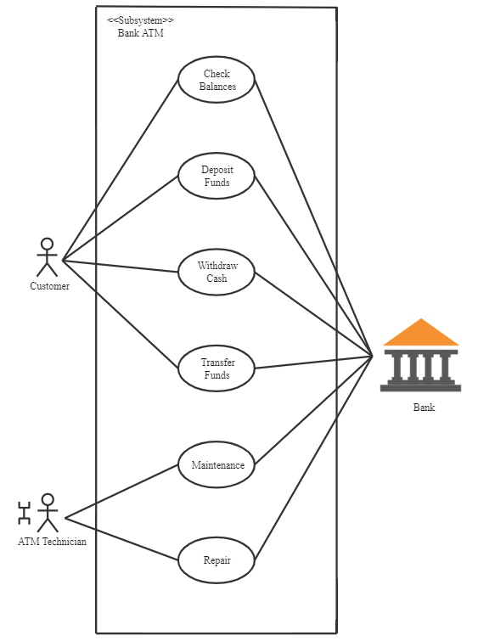](https://www.edrawmax.com/preview/?workid=1001501)

The Automatic Teller Machine (ATM) is the banking subsystem that enables the end-users to interact with the multiple functionalities of the bank like transactions, depositing, etc.

In this diagram, we have two actors, the customer, and the technician. The customer needs to check the balance, withdraw cash, deposit funds, and transfer funds. All these functionalities are the use cases. The technician repairs and maintains the ATM so that customers have no complaints. These are the use-cases too.

There is a relationship between the bank and the ATM because the user will only do such acts when the bank authenticates them.

**2. Use Case Diagram for Website**

[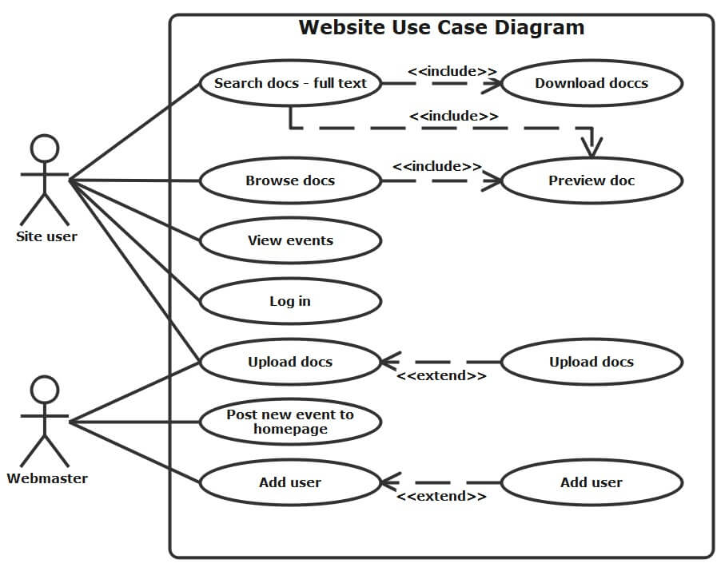](https://www.edrawmax.com/preview/?workid=1000276)

In the above diagram, the site user and the webmaster are the actors of the UML diagram. The site user wants to search for documents, browse documents, and view events. These are the use cases or the functionality the user wants to do. The download and preview documents are the use cases too, and they are in relation to each other based on user requirements.

The webmaster upload documents, post new events to the homepage and add a user and these use cases are in relation with the managed folders and add company but still based on what the actor wants.

**3. Use Case Diagram for Library Management System**

[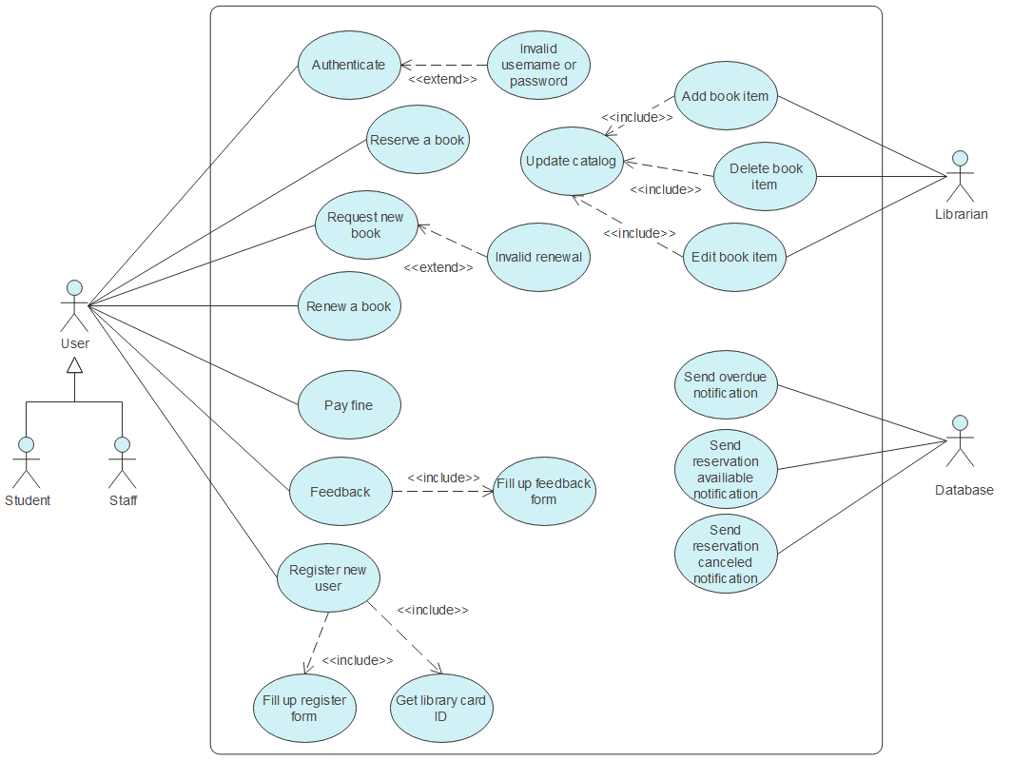](https://www.edrawmax.com/preview/?workid=1007464)

In the diagram, we can see the multiple actors: staff and the student, librarian, and library database. And we have dozens of use cases like authenticating, reserve a book, renewing a book, paying a fine, etc. Some use cases are related to each other, like invalid renewal and renewing a book, registering a new user, getting a library card ID, etc.

The librarian also does multiple tasks. The thing to notice here is that one actor is a machine that is the library database. As mentioned above, the actor can be anyone, either a human and a machine.

**4. Use Case Diagram for Online Shopping**

[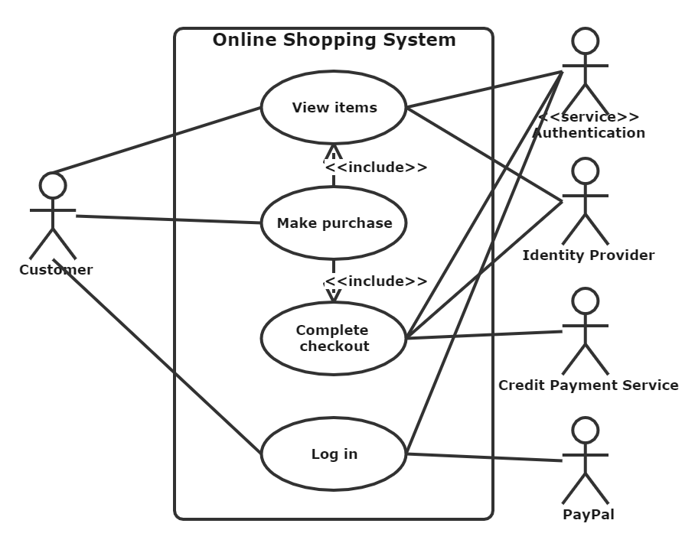](https://www.edrawmax.com/preview/?workid=1000273)

In this illustration, we have an online shopping subsystem. It has use cases like view items, make a purchase, checkout, and client register. Then we have multiple actors like the registered user, web customer, and new customer. These actors are related to each other. The use cases are also in a relationship.

The actors PayPal and credit payment service are the organizations interacting with the subsystem with different use-cases.

**5. Use Case Diagram for Hospital Management System**

[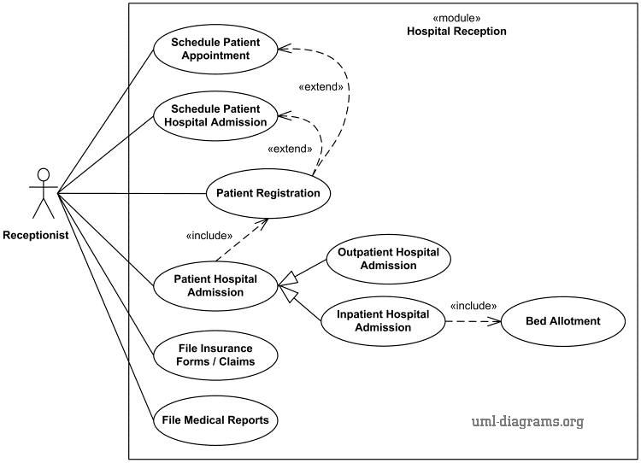](https://www.edrawmax.com/preview/?workid=1005520)

It is the use case diagram of the hospital management system. In this diagram, the receptionist is the leading actor. The receptionist interacts with multiple use cases like a scheduled patient appointment, patient admission in the hospital, etc. These cases are related to each other.

**6. Use Case Diagram for Car Rental System**

[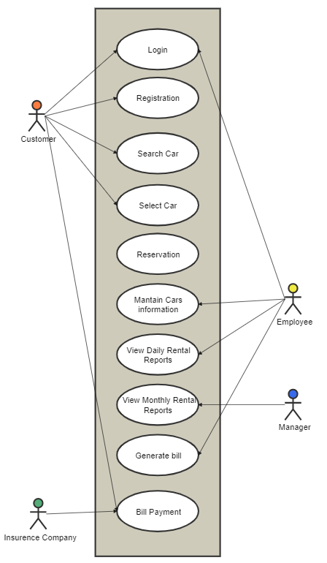](https://www.edrawmax.com/preview/?workid=1004317)

It is an illustration of the car rental system use-case UML. Here, the insurance company is the actor that is the organization interacting with bill payment use-case and the customer is also an actor. Through the customer, the insurance company is also interacting with other use-cases of the car rental system. The employee and the manager are also the actors in this system.

**7. Use Case Diagram for Student Registration System**

[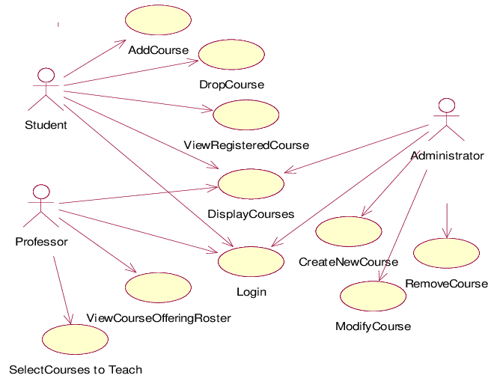](https://www.edrawmax.com/preview/?workid=1037645)

It is the student registration system use-case UML diagram. Students, professors, and administrators are the actors. The system also has dozens of use-cases.