SEN371 – Milestone 1: System Plan
Sections prepared: Design Patterns Choice, Version Control Plan (Git Workflow), Database Design Schema. Team members and group cover page details to be added by the group.
Confirmed tech stack: React (frontend), Node.js + Express (backend), PostgreSQL (database), REST API, JWT authentication, roles = Customer & Admin. Architecture: Controller → Service → Repository → Model. Hosting: Vercel/Netlify (frontend), Render/Railway (backend + managed Postgres), GitHub Actions CI/CD.

1. Design Patterns Choice
The application follows the confirmed layered architecture: Controller → Service → Repository → Model, an extension of MVC. Within that architecture, the following supporting design patterns keep the codebase maintainable, testable, and loosely coupled.

1.1 Layered Architecture: Controller → Service → Repository → Model
Controllers handle HTTP concerns only (parsing requests, returning responses). Services hold business rules (e.g. “cart must not be empty at checkout”, “stock must be validated before an order is created”). Repositories are the only layer that talks to PostgreSQL, isolating SQL/query logic. Models represent the shape of the data.
- Decouples business logic from both HTTP handling and data access, so each layer can be unit-tested independently (a direct requirement of the Testability NFR).
- The Service layer is where atomic operations like checkout (order creation + stock decrement) are coordinated inside a single DB transaction.
- Alternative considered: putting query logic directly in controllers. Rejected because it mixes HTTP and business concerns, making unit testing without a live HTTP server difficult, and duplicates logic across routes.

1.2 Singleton Pattern
Used for the PostgreSQL connection/pool, ensuring only one connection pool instance is created and shared across the application rather than opening a new connection per request.
- Avoids the overhead and resource exhaustion of repeatedly opening connections.
- Provides a single, predictable point of configuration for the database client.
- Alternative considered: a new client connection per request. Rejected as wasteful and unnecessary given a stateless backend design.

1.3 Factory Pattern
Used to create objects that vary by type at runtime, such as order-status transition handlers (pending → paid → shipped → delivered/cancelled) or notification types (e.g. stubbed order-confirmation logs vs future email delivery).
- New status transitions or notification types can be added without changing existing calling code (Open/Closed Principle).
- Keeps object-creation logic in one place instead of scattered conditional checks.
- Alternative considered: a single large if/else block per transition inside the Order Service. Rejected as harder to extend and test in isolation.

1.4 Observer Pattern
Used for event-driven actions, such as when an order's status changes (e.g. order placed, order shipped): the event is published once, and any interested listener (stubbed email/order-log, admin dashboard count) reacts independently.
- Decouples the action that triggers an event (e.g. order placed) from the code that reacts to it (e.g. log a stub notification, update dashboard metrics).
- Supports adding new reactions to an event later without modifying the original trigger code.
- Alternative considered: calling notification/logging code directly inside the Order Service. Rejected because it couples unrelated concerns and complicates testing the core order logic alone.

1.5 Middleware / Chain of Responsibility (Authentication & Authorization)
JWT authentication and role checks (Customer vs Admin) are implemented as Express middleware functions that run before a route's controller logic, forming a request-processing chain.
- A verifyToken middleware validates the JWT and attaches the authenticated user to the request.
- A requireRole('admin') middleware restricts admin-only endpoints (e.g. managing products) without duplicating auth logic in every controller.
- Keeps authentication/authorization concerns separate from business logic in controllers, matching the Security NFR that all admin routes must enforce role-based authorization server-side.

2. Version Control Plan (Git Workflow)
The team will use GitHub for version control, following a simplified Gitflow model suited to a small team (up to 4 members) working in sprints, tied into the GitHub Actions CI/CD pipeline used for deployment.

2.1 Branch Structure
Branch | Purpose
main | Always reflects the current production-ready / deployed version. Protected: no direct pushes, PR + passing CI checks + 1 approval required to merge.
develop | Integration branch for completed features ahead of the next milestone/release. All feature branches merge here first. Also protected: PR + passing CI required.
feature/<name> | One branch per feature or task, created from develop (e.g. feature/product-catalog, feature/cart-api). Deleted after merge.
hotfix/<name> | For urgent fixes to main outside the normal sprint cycle.

2.2 Commit Convention
Commits follow the Conventional Commits style: <type>: <short description>, for example feat: add product listing endpoint or fix: correct cart total calculation.
- feat: a new feature
- fix: a bug fix
- docs: documentation changes
- test: adding or updating tests
- refactor: code change that neither fixes a bug nor adds a feature

2.3 Pull Request & Code Review Process
- Work is done on a feature branch created from develop; direct pushes to develop or main are not allowed (enforced via GitHub branch protection rules).
- A pull request (PR) is opened against develop once the feature is complete and self-tested, using a shared PR template (summary, related task/user story, testing notes, checklist).
- GitHub Actions CI runs automatically on every PR (lint + automated tests); a PR cannot be merged if CI fails.
- At least one other team member reviews and approves the PR before it is merged.
- Issues/tasks are labelled (e.g. feature, bug, milestone-2) to keep the board organised across milestones.
- develop is merged into main at the end of each milestone once the milestone is stable and tested; merging to main triggers the deployment pipeline.

2.4 Merge Strategy
Feature branches are merged into develop using squash merges to keep history readable. Conflicts are resolved locally by the branch owner before requesting review.

3. Database Design Schema
The team has confirmed PostgreSQL, a relational database, as the primary data store. E-commerce data (users, orders, payments, inventory) is highly structured and benefits from PostgreSQL's relational integrity, foreign key constraints, and transaction support (ACID compliance) — particularly important for order and payment consistency. It integrates cleanly with the confirmed Node.js/Express backend via an ORM such as Prisma or Sequelize, and pairs naturally with JWT-based authentication (the users table stores the password hash and role used to issue and validate tokens).
Scope notes, aligned to the confirmed System Plan:
- No payment gateway is integrated (checkout is simulated per assumption A4), so payment status lives as a field on orders rather than a separate payments table.
- Product reviews/ratings are explicitly out of scope (“Won't Have” list), so no reviews table is included.
- Products are soft-deleted (is_active flag) rather than hard-deleted, per the admin “deactivate product” requirement (T-18), to preserve referential integrity with historical orders.
- Order status follows the enforced state machine from requirement T-21: pending → paid → shipped → delivered, or cancelled.
- Gap to flag with the team: functional requirements T-08–T-11 describe persistent cart add/update/remove operations, but the confirmed API endpoint list (auth, users, products, orders) has no /api/cart routes yet. The schema below still includes cart / cart_items to support this — worth confirming with whoever owns API Design before Milestone 3.

3.1 Entity-Relationship Diagram
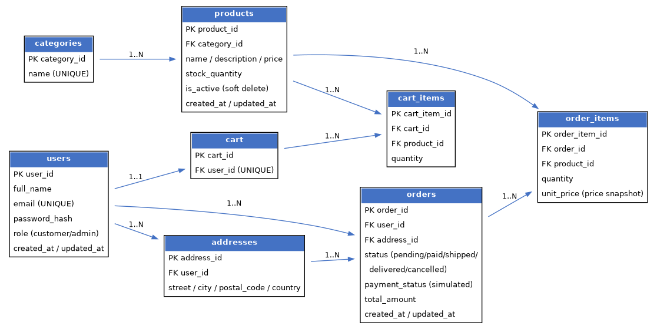

3.2 Entity Overview
- A User can have multiple Addresses, one Cart, and many Orders.
- A Product belongs to one Category and can appear in many CartItems / OrderItems.
- A Cart has many CartItems; an Order has many OrderItems (snapshot of product name/price at purchase time so historical orders remain accurate if a product's price changes later).
- An Order references one shipping Address and tracks its own status and simulated payment_status.
- A Category cannot be deleted while Products still reference it (ON DELETE RESTRICT), per requirement T-19.

3.3 Indexing Notes
To support the ~300ms typical response time target under the Performance NFR, the following indexes are planned in addition to primary/foreign keys:
- UNIQUE index on users.email (login lookups).
- Index on products.category_id (catalog filtering by category).
- Index on products.is_active (catalog queries exclude deactivated products by default).
- Index on orders.user_id (order history lookups).

3.4 Table Definitions

users
Field | Type | Constraints
user_id | UUID / SERIAL | Primary Key
full_name | VARCHAR(150) | NOT NULL
email | VARCHAR(255) | NOT NULL, UNIQUE (indexed)
password_hash | VARCHAR(255) | NOT NULL (bcrypt hash, never plaintext)
role | VARCHAR(20) | NOT NULL, DEFAULT 'customer' (customer/admin)
created_at / updated_at | TIMESTAMP | NOT NULL, DEFAULT now()

addresses
Field | Type | Constraints
address_id | UUID / SERIAL | Primary Key
user_id | UUID / INT | Foreign Key -> users.user_id
street | VARCHAR(255) | NOT NULL
city | VARCHAR(100) | NOT NULL
postal_code | VARCHAR(20) | NOT NULL
country | VARCHAR(100) | NOT NULL

categories
Field | Type | Constraints
category_id | UUID / SERIAL | Primary Key
name | VARCHAR(100) | NOT NULL, UNIQUE

products
Field | Type | Constraints
product_id | UUID / SERIAL | Primary Key
category_id | UUID / INT | Foreign Key -> categories.category_id, ON DELETE RESTRICT (indexed)
name | VARCHAR(200) | NOT NULL
description | TEXT
price | DECIMAL(10,2) | NOT NULL
stock_quantity | INT | NOT NULL, DEFAULT 0
is_active | BOOLEAN | NOT NULL, DEFAULT true (soft delete, indexed)
image_url | VARCHAR(500)
created_at / updated_at | TIMESTAMP | NOT NULL, DEFAULT now()

cart / cart_items
Field | Type | Constraints
cart_id | UUID / SERIAL | Primary Key (cart)
user_id | UUID / INT | Foreign Key -> users.user_id, UNIQUE (cart)
cart_item_id | UUID / SERIAL | Primary Key (cart_items)
cart_id | UUID / INT | Foreign Key -> cart.cart_id (cart_items)
product_id | UUID / INT | Foreign Key -> products.product_id (cart_items)
quantity | INT | NOT NULL, DEFAULT 1, >= 1 (cart_items)

orders / order_items
Field | Type | Constraints
order_id | UUID / SERIAL | Primary Key (orders)
user_id | UUID / INT | Foreign Key -> users.user_id (indexed) (orders)
address_id | UUID / INT | Foreign Key -> addresses.address_id (orders)
status | VARCHAR(20) | NOT NULL, DEFAULT 'pending' — CHECK IN (pending, paid, shipped, delivered, cancelled) (orders)
payment_status | VARCHAR(20) | NOT NULL, DEFAULT 'pending' — simulated, no live gateway (orders)
total_amount | DECIMAL(10,2) | NOT NULL (orders)
created_at / updated_at | TIMESTAMP | NOT NULL, DEFAULT now() (orders)
order_item_id | UUID / SERIAL | Primary Key (order_items)
order_id | UUID / INT | Foreign Key -> orders.order_id (order_items)
product_id | UUID / INT | Foreign Key -> products.product_id (order_items)
quantity | INT | NOT NULL (order_items)
unit_price | DECIMAL(10,2) | NOT NULL — price snapshot at purchase time (order_items)

