Задание 2.
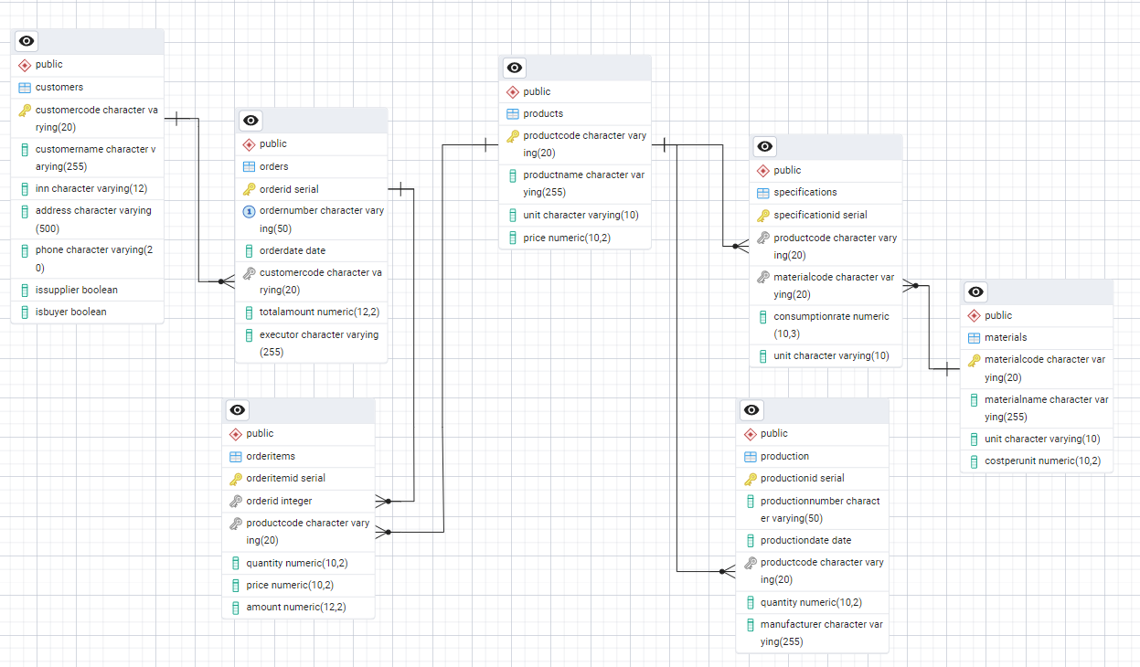
Запрос 1. Создание представления

CREATE OR REPLACE VIEW vw_order_cost_calculation AS
SELECT
o.OrderNumber AS order_number,
o.OrderDate AS order_date,
c.CustomerName AS customer_name,
oi.ProductCode AS product_code,
p.ProductName AS product_name,
oi.Quantity AS order_quantity,
oi.Price AS sale_price,
oi.Amount AS sale_amount,

-- Расчет себестоимости материалов для одной единицы продукции
COALESCE(SUM(s.ConsumptionRate * m.CostPerUnit), 0) AS material_cost_per_unit,

-- Общая себестоимость материалов для всего количества в заказе
COALESCE(SUM(s.ConsumptionRate * m.CostPerUnit), 0) * oi.Quantity AS total_material_cost,

-- Прибыль от продажи
oi.Amount - (COALESCE(SUM(s.ConsumptionRate * m.CostPerUnit), 0) * oi.Quantity) AS profit

FROM Orders o
JOIN Customers c ON o.CustomerCode = c.CustomerCode
JOIN OrderItems oi ON o.OrderID = oi.OrderID
JOIN Products p ON oi.ProductCode = p.ProductCode
LEFT JOIN Specifications s ON p.ProductCode = s.ProductCode
LEFT JOIN Materials m ON s.MaterialCode = m.MaterialCode
GROUP BY
o.OrderNumber,
o.OrderDate,
c.CustomerName,
oi.ProductCode,
p.ProductName,
oi.Quantity,
oi.Price,
oi.Amount;

COMMENT ON VIEW vw_order_cost_calculation IS
'Расчет стоимости заказа с учетом себестоимости материалов';

Основной запрос.

SELECT
o.OrderNumber AS "Номер заказа",
o.OrderDate AS "Дата заказа",
c.CustomerName AS "Заказчик",
p.ProductName AS "Продукция",
oi.Quantity AS "Количество продукции в заказе",

-- Полная стоимость материалов для всего количества
ROUND(COALESCE(SUM(s.ConsumptionRate * m.CostPerUnit), 0) * oi.Quantity, 2)
AS "Стоимость всех материалов",

-- Выручка от продажи
oi.Amount AS "Сумма продажи",

-- Прибыль
ROUND(oi.Amount - (COALESCE(SUM(s.ConsumptionRate * m.CostPerUnit), 0) * oi.Quantity), 2)
AS "Прибыль"

FROM Orders o
JOIN Customers c ON o.CustomerCode = c.CustomerCode
JOIN OrderItems oi ON o.OrderID = oi.OrderID
JOIN Products p ON oi.ProductCode = p.ProductCode
LEFT JOIN Specifications s ON p.ProductCode = s.ProductCode
LEFT JOIN Materials m ON s.MaterialCode = m.MaterialCode
GROUP BY
o.OrderNumber,
o.OrderDate,
c.CustomerName,
oi.ProductCode,
p.ProductName,
oi.Quantity,
oi.Amount
ORDER BY o.OrderNumber;

Итоговый запрос о всех заказах.

SELECT
o.OrderNumber AS "Номер заказа",
c.CustomerName AS "Заказчик",
COUNT(oi.OrderItemID) AS "Количество позиций",
SUM(oi.Quantity) AS "Общее количество продукции",
ROUND(SUM(oi.Amount), 2) AS "Общая выручка",
ROUND(SUM(COALESCE(s.ConsumptionRate * m.CostPerUnit, 0) * oi.Quantity), 2)
AS "Полная стоимость материалов",
ROUND(SUM(oi.Amount) - SUM(COALESCE(s.ConsumptionRate * m.CostPerUnit, 0) * oi.Quantity), 2)
AS "Общая прибыль"
FROM Orders o
JOIN Customers c ON o.CustomerCode = c.CustomerCode
JOIN OrderItems oi ON o.OrderID = oi.OrderID
JOIN Products p ON oi.ProductCode = p.ProductCode
LEFT JOIN Specifications s ON p.ProductCode = s.ProductCode
LEFT JOIN Materials m ON s.MaterialCode = m.MaterialCode
GROUP BY o.OrderNumber, c.CustomerName
ORDER BY o.OrderNumber;

