
ARAB UNITY SCHOOL, DUBAI
END OF TERM 3 ASSESSMENT June 2026

SUBJECT: HUMANITIES (Modified) DATE:
MAX.MARKS: 30 |  |  |  |  |  |  |  |  | TIME: 1 Hour 20 min
STUDENT NAME
YEAR GROUP/SECTION | 4
SUBJECT TEACHER

Assessment Objectives/Focuses: Writing
AF1 I can explain the invasion of Britain after the Romans. | AF2 I can identify who the Anglo-Saxons and Scots were and why they came to Britain
AF3 I can identify evidence of Anglo-Saxon influence in Britain today. | AF4 I can explain how Anglo-Saxons influenced life in Britain.
AF5 I can analyse the social structure of the Anglo-Saxon community. | AF6 I can analyse the social structure of the Anglo-Saxon community through their Housing and religious beliefs.
AF7 I can identify and locate the climate zones around the world. | AF8 I can explain the role of rivers in the water cycle.

STUDENT REFLECTION
(Use this space to comment on what you feel went well and how you are going to improve)
Q.NO or AF | What went well? | How would you improve on this question? What are your next steps?
Teacher Feedback/Next Steps
Assessment Point Scale: | New CWPS: | New Target PS:
Teacher signature: | Student signature: | Date:

Section A
Q1) Choose the correct answer. (AF1, AF2, AF5) (4×1 = 4 Marks)
a) Who came to Britain after the Romans?
a) Romans
b) Anglo-Saxons
c) Egyptians
b) Anglo-Saxons houses were made of __________.
a) Wood and straw
b) Glass
c) Bricks
c) Who was the leader of the Anglo-Saxon people?
a) Farmer
b) King
c) Doctor
d) An artefact is ______________________.
a) A fruit
b) A toy
c) an old item from long ago

Q2) Write True or False. (AF1, AF3, AF4) (4×1 = 4 Marks)
a) Anglo-Saxons travelled to Britain by airplane.
b) Floods made some Anglo-Saxons leave their homes.
c) The Thegns were warriors.
d) Anglo-Saxon houses had many rooms.
Q3) Match the following. (AF3, AF4, AF5) (3×1 = 3 Marks)
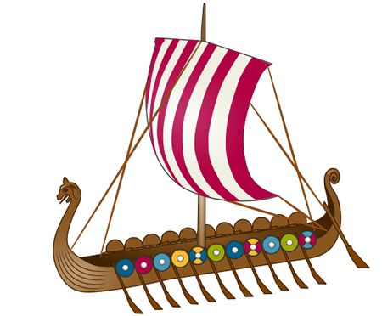
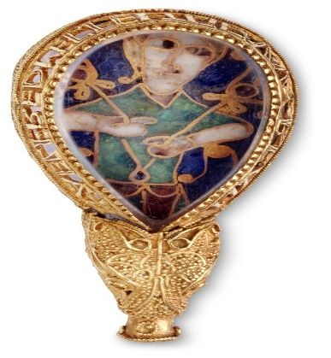
- Alfred Jewel
- Anglo- Saxon home
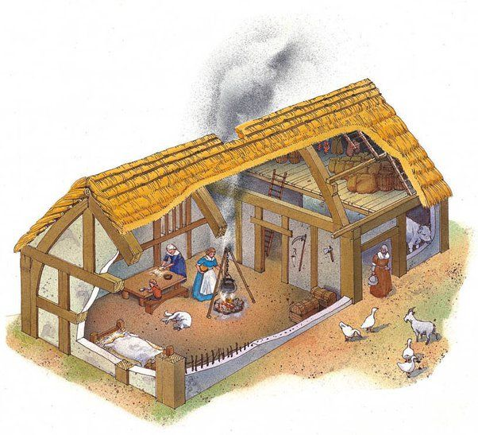
- Longboat

Q4) Fill in the blanks: (AF1, AF2, AF4, AF5) (4×1 = 4 Marks)
Word Bank: Germany, slaves, 410AD, whalebone

  - Romans left Britain in _______________.
  - Anglo-Saxons came from _________________.
  - Franks casket is made of _______________.
  - People who had no freedom at all were known as _____________.
Section B – Geography
Q1) Choose the correct answer. (AF6, AF7, AF8) (4×1 = 4 Marks)
- Weather means ………?
a) The food we eat
b) The clothes we wear
c) The temperature and rain today

- Rivers carry __________.
a) Water
b) Cars
c) Sand only
- Rain comes from __________.
a) Trees
b) Clouds
c) Roads
- Desert climate is usually __________.
a) Cold
b) Hot and dry
c) Wet
Q2) Write True or False. (AF6, AF7, AF8) (4×1 = 4 Marks)
a) Rivers are not a part of the water cycle.
b) Tropical places are usually warm.
c) Sunny weather is full of snow
d) UAE has a desert climate.

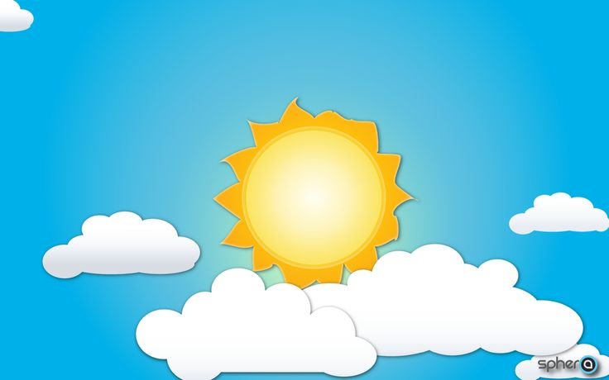
Q3) Match the following: (AF8) (4×1 = 4 Marks)
Column A | Column B
1. Rainy
2. Cloudy | 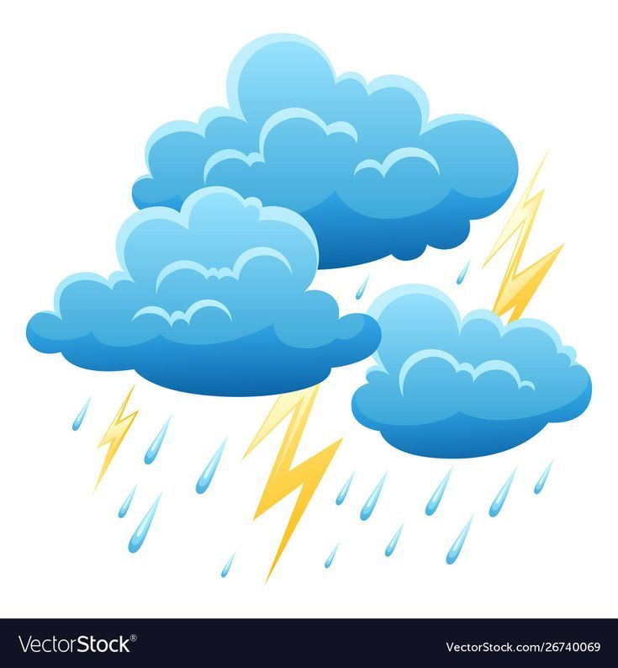
3. Sunny | 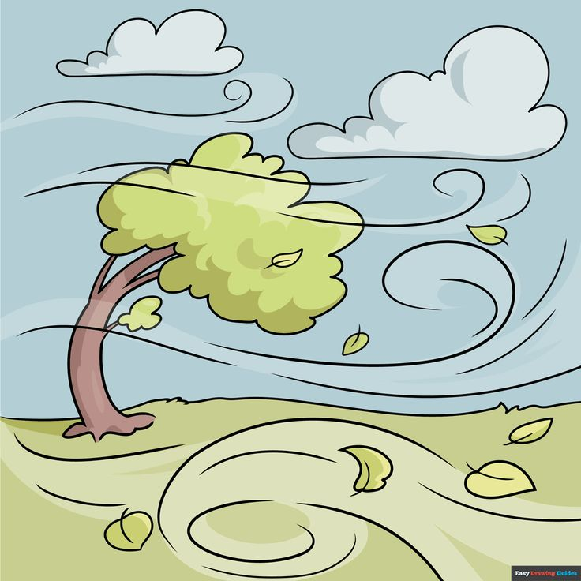
4. Windy | 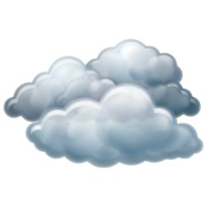

Q4) Give one-word answers for the following: (AF6, AF7) (3×1 = 3 Marks)
Word Bank: Nile, cold, ocean

- The longest river is the _______________.

- Rivers carry water to the _______________.

- Polar places are ________________

