whale microorganism

Shiri

9/13/2022

Main analysis

## Linear mixed model fit by REML ['lmerMod']  
## Formula: correctedLength ~ meaning + (1 | language) + (1 | familyGeneral) +   
## (1 | familyGeneral:familySpecific) + (1 | Macroarea)  
## Data: bigSmall  
##   
## REML criterion at convergence: 4896.1  
##   
## Scaled residuals:   
## Min 1Q Median 3Q Max   
## -2.7022 -0.6290 -0.0894 0.4947 5.6372   
##   
## Random effects:  
## Groups Name Variance Std.Dev.  
## language (Intercept) 0.50617 0.7115   
## familyGeneral:familySpecific (Intercept) 0.09214 0.3035   
## familyGeneral (Intercept) 0.52348 0.7235   
## Macroarea (Intercept) 0.45220 0.6725   
## Residual 1.91716 1.3846   
## Number of obs: 1294, groups:   
## language, 647; familyGeneral:familySpecific, 142; familyGeneral, 66; Macroarea, 6  
##   
## Fixed effects:  
## Estimate Std. Error t value  
## (Intercept) 4.73474 0.31634 14.967  
## meaningsmall 0.53478 0.07698 6.947  
##   
## Correlation of Fixed Effects:  
## (Intr)  
## meaningsmll -0.122

Figure 2 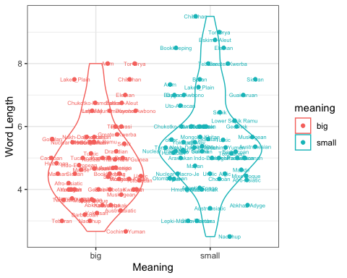

only vowels

## Linear mixed model fit by REML ['lmerMod']  
## Formula: vowelLength ~ meaning + (1 + meaning | familyGeneral) + (1 |   
## familyGeneral:familySpecific) + (1 | Macroarea)  
## Data: bigSmallAuto  
##   
## REML criterion at convergence: 3232.9  
##   
## Scaled residuals:   
## Min 1Q Median 3Q Max   
## -2.4382 -0.6280 -0.1288 0.5557 6.2003   
##   
## Random effects:  
## Groups Name Variance Std.Dev. Corr   
## familyGeneral:familySpecific (Intercept) 0.04927 0.2220   
## familyGeneral (Intercept) 0.23364 0.4834   
## meaningsmall 0.03462 0.1861 -0.32  
## Macroarea (Intercept) 0.11709 0.3422   
## Residual 0.62436 0.7902   
## Number of obs: 1294, groups:   
## familyGeneral:familySpecific, 142; familyGeneral, 66; Macroarea, 6  
##   
## Fixed effects:  
## Estimate Std. Error t value  
## (Intercept) 2.26048 0.16641 13.583  
## meaningsmall 0.22152 0.05703 3.884  
##   
## Correlation of Fixed Effects:  
## (Intr)  
## meaningsmll -0.194

only consonants

## Linear mixed model fit by REML ['lmerMod']  
## Formula: consonantLength ~ meaning + (1 + meaning | familyGeneral) + (1 |   
## familyGeneral:familySpecific) + (1 | Macroarea)  
## Data: bigSmallAuto  
##   
## REML criterion at convergence: 3666.5  
##   
## Scaled residuals:   
## Min 1Q Median 3Q Max   
## -3.5554 -0.5799 -0.1128 0.5188 6.2546   
##   
## Random effects:  
## Groups Name Variance Std.Dev. Corr  
## familyGeneral:familySpecific (Intercept) 0.05131 0.2265   
## familyGeneral (Intercept) 0.11039 0.3323   
## meaningsmall 0.05916 0.2432 0.17  
## Macroarea (Intercept) 0.12908 0.3593   
## Residual 0.90020 0.9488   
## Number of obs: 1294, groups:   
## familyGeneral:familySpecific, 142; familyGeneral, 66; Macroarea, 6  
##   
## Fixed effects:  
## Estimate Std. Error t value  
## (Intercept) 2.46921 0.16942 14.57  
## meaningsmall 0.36775 0.06965 5.28  
##   
## Correlation of Fixed Effects:  
## (Intr)  
## meaningsmll -0.130

Figure 3 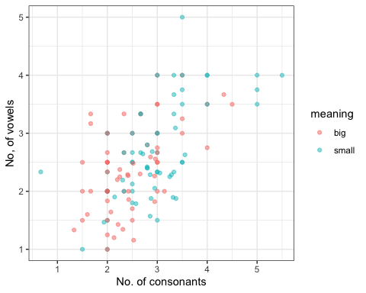

## Drawing the location of the languages in the sample