README FILE FOR ANCOM 2.0

The current code implements ANCOM in cross-sectional and longitudinal datasets while allowing the use of covariates. The following libraries need to be included for the R code to run:

library(exactRankTests)
library(nlme)

Data files required:

- OTU data or taxa data: This should be a data frame with each sample in rows and OTUs (or taxa) in columns. The first column should be the sample identifier with column name “Sample.ID”.
- Metadata: This is the datafile with all variables and covariates of interest. Should be a data frame with the first columns being the sample identifier with column name “Sample.ID” and each following column being the variables.

Arguments for the function (ANCOM.main) to implement ANCOM:

OTUdat: Data frame representing OTU data or taxa data (must meet specifications as mentioned earlier).

Vardat: Data frame of variables (must meet specifications as mentioned earlier).

adjusted: Logical. TRUE if covariates are to be included for adjustment.

repeated: Logical. TRUE if data to be analyzed has repeated measures.

main.var: Character. The name of the main variable of interest.

adj.formula: Character string representing the formula for adjustment (see example).

repeat.var: Character. The name of the variable which represents the id over which repeated measurements are made. This is only for Friedman's test.

longitudinal: Logical. TRUE if longitudinal analysis is required.

random.formula: Character string representing the formula for random effects in lme (see example).

multcorr: Takes values 1, 2 or 3. 1: Strict overall multiple correction; 2: Taxa-wise multiple correction (recommended); 3: No multiple correction.

sig: Level of significance.

prev.cut: Numeric fraction. OTUs with proportion of zeroes greater than prev.cut are not included in the analysis.

A flowchart of the tests within ANCOM depending on the research question:

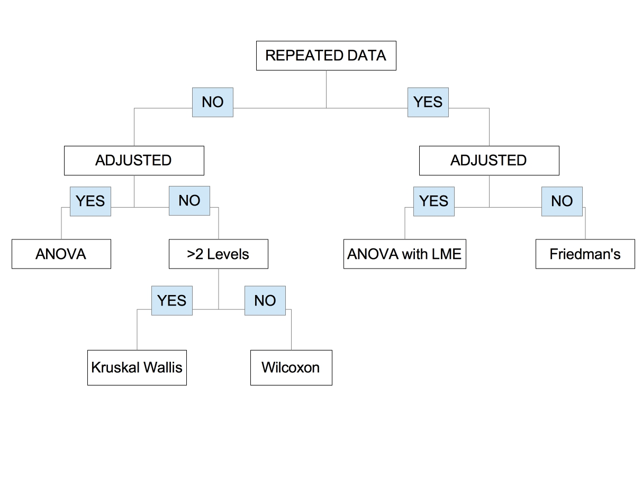
What does the function return?

W.taxa: A data frame with the W statistic for each taxa and subsequent columns which are logical indicators of whether an OTU or taxon is differentially abundant under a series of cutoffs (0.9, 0.8, 0.7 and 0.6).

Plot.zeroes: A plot showing distribution of zeroes in the OTUs represented in the dataset.

Volcano plot: To be added.

Examples:

1. Standard analysis: Detection of differentially abundant genera between countries

## Example

## otu_test is a data frame with OTU counts
## map_test is the metadata file

comparison_test=ANCOM.main(OTUdat=otu_test,
Vardat=map_test[which(map_test$SEX!="unknown"&map_test$COUNTRY!
="GAZ:Venezuela"),],
adjusted=FALSE,
repeated=F,
main.var="COUNTRY",
adj.formula=NULL,
repeat.var=NULL,
longitudinal=FALSE,
random.formula=NULL,
multcorr=2,
sig=0.05,
prev.cut=0.90)

comparison_test$W.taxa

2. Adjusted analysis: Detection of differentially abundant genera between countries, adjusted for age and sex.

## Example

## otu_test is a data frame with OTU counts
## map_test is the metadata file

comparison_test=ANCOM.main(OTUdat=otu_test,
Vardat=map_test[which(map_test$SEX!="unknown"&map_test$COUNTRY!="GAZ:Venezuela"),],
adjusted=TRUE,
repeated=F,
main.var="COUNTRY",
adj.formula="SEX+AGE",
repeat.var=NULL,
longitudinal=FALSE,
random.formula=NULL,
multcorr=2,
sig=0.05,
prev.cut=0.90)

comparison_test$W.taxa

3. Longitudinal analysis:

OTU_ANCOM_Test <- read.delim("OTU_Ancom_Test_Counts.txt")

Mapping_File_ANCOM_Test <- read.delim("OTU_Ancom_Test_Mapping.txt")

## Testing longitudinal differences between three groups

longitudinal_comparison_test=ANCOM.main(OTUdat=OTU_ANCOM_Test,
Vardat=Mapping_File_ANCOM_Test[Mapping_File_ANCOM_Test$group_info%in%c("2FL","3SL","pHMO"),],
adjusted=F,
repeated=T,
main.var="group_info",
adj.formula=NULL,
repeat.var="day_of_treatment",
longitudinal=T,
random.formula="~1|host_subject_id",
multcorr=2,
sig=0.05,
prev.cut=0.90)

longitudinal_comparison_test$W.taxa

