O Impacto do Dataset

Teste
O Teste utilizado nesta comparação de datasets tem como objectivo classificar círculos e quadrados, ao seja, um problema de classificação binário.

Modelo

x = layers.Rescaling(1./255)(inputs)
x = layers.Conv2D(filters=32, kernel_size=3, activation="relu")(x)
x = layers.MaxPooling2D(pool_size=2)(x)
x = layers.Conv2D(filters=64, kernel_size=3, activation="relu")(x)
x = layers.MaxPooling2D(pool_size=2)(x)
x = layers.Conv2D(filters=128, kernel_size=3, activation="relu")(x)
x = layers.MaxPooling2D(pool_size=2)(x)
x = layers.Conv2D(filters=128, kernel_size=3, activation="relu")(x)
x = layers.MaxPooling2D(pool_size=2)(x)
x = layers.Flatten()(x)
x = layers.Dense(512, activation="relu")(x)
outputs = layers.Dense(1, activation="sigmoid")(x)
model.compile(
loss='binary_crossentropy',
optimizer=tf.keras.optimizers.RMSprop(learning_rate=1e-4),
metrics=['accuracy'])

1.000 Test 3.000 Train
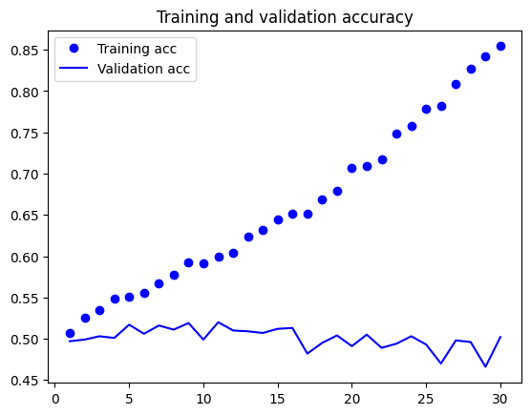
Validation Accuracy: 0.5020
Training Accuracy: 0.8543
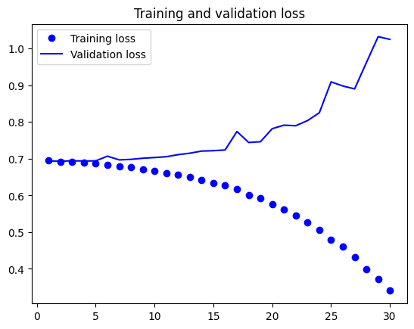
3.000 Test 7.000 Train
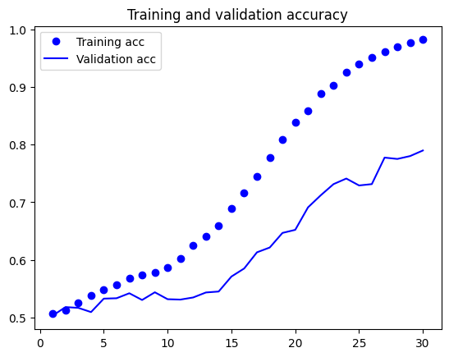

Validation Accuracy: 0.7897
Training Accuracy: 0.9817
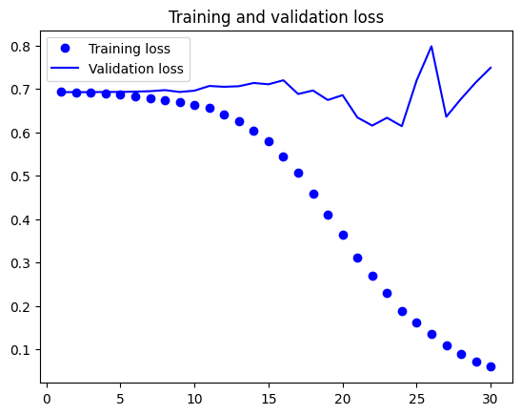
5.000 Test 11.000 Train

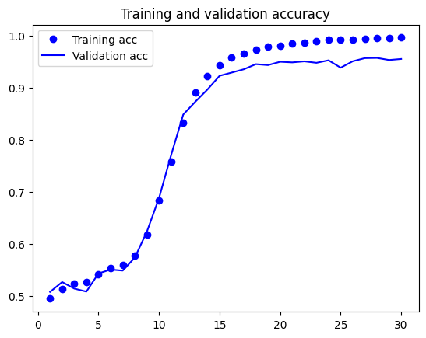
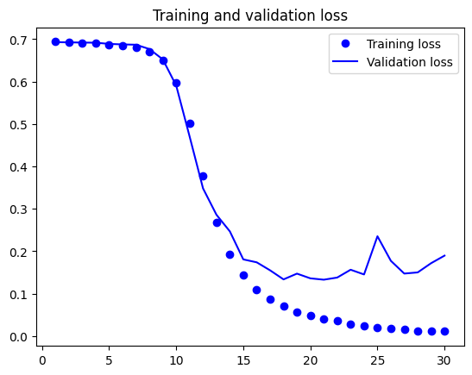
Validation Accuracy: 0.9556
Training Accuracy: 0.9965

