1. Build AnalysisSitus:

Choose CMAKE_BUILD_TYPE: Release

Run CMAKE:

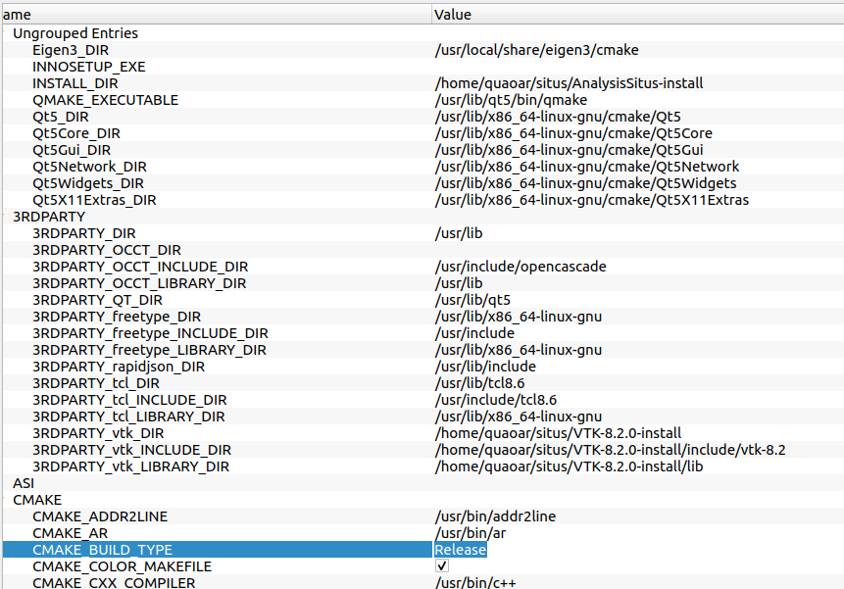

Go to build directory, and run command:

make; make install

2. Create AnalysisSitus.AppDir directory in the place where you want to create AppImage.
3. Go to AnalysisSitus.AppDir and create the directory with the name `usr`.
4. Go to AnalysisSitus install directory and copy `bin` directory.
5. Go to the directory `usr` and paste bin directory here.
6. Go to AnalysisSitus directory, data, AppImage: AnalysisSitus/docs/AppImage. And copy all files from this directory to the AnalysisSitus.AppDir

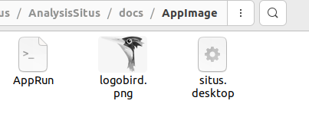

7. Your final directory AnalysisSitus.AppDir should look like:
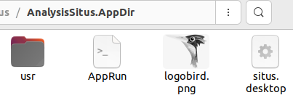

8. You can copy build-AppImage.sh file to your AnalysisSitus.AppDir and run it. Or if you want to do every step manually, you need to run:

> wget -O appimage-builder-x86_64.AppImage https://github.com/AppImageCrafters/appimage-builder/releases/download/v1.1.0/appimage-builder-1.1.0-x86_64.AppImage
> chmod +x appimage-builder-x86_64.AppImage
> sudo apt install -y binutils coreutils desktop-file-utils fakeroot fuse libgdk-pixbuf2.0-dev patchelf python3-pip python3-setuptools squashfs-tools strace util-linux zsync
> ARCH=x86_64 /usr/local/bin/appimagetool ./AnalysisSitus.AppDir

