1. Build AnalysisSitus:

Choose CMAKE_BUILD_TYPE: Release

Run CMAKE:

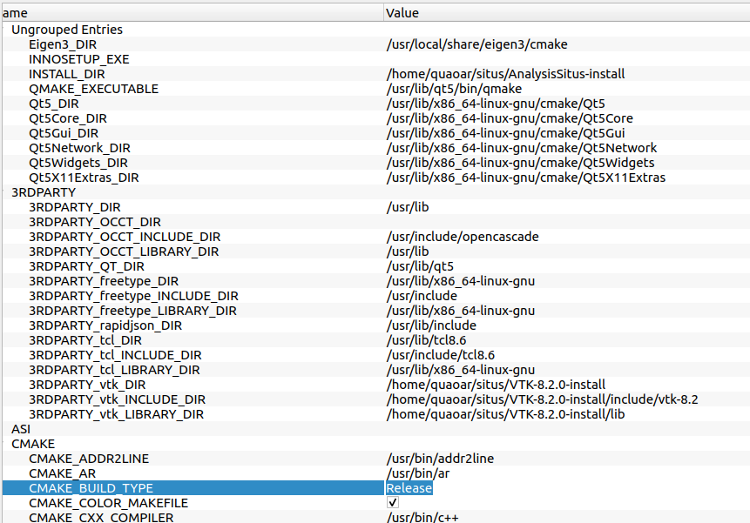

Go to build directory, and run command:

make; make install

2. Create AnalysisSitus.AppDir directory in the place where you want to create AppImage.
3. Go to AnalysisSitus.AppDir and create the directory with the name `usr`.
4. Go to AnalysisSitus install directory and copy `bin` directory.
5. Go to the directory `usr` and paste bin directory here. Also you need to copy file `libasiTestEngine.so` from AnalysisSitus-install_directory/lib` and paste it to the already copied directory bin.
6. Go to AnalysisSitus directory, data, AppImage: AnalysisSitus/docs/AppImage. And copy all files from this directory to the AnalysisSitus.AppDir

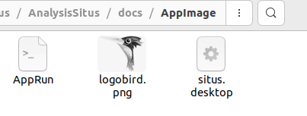

7. Your final directory AnalysisSitus.AppDir should look like:
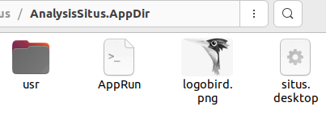

8. Go to https://github.com/AppImage/appimagetool/releases and download appimagetool.
9. From Linux terminal run

> ./appimagetool-x86_64.AppImage ./

This should generate a runnable appimage file named AnalysisSitus-x86_64.AppImage

Notice that to run appimage on Ubuntu 22_04 libfuse2 needs to be installed.

